**HOW TO ACCESS THE EXPRESSION OF INTEREST FORM**

The expression of interest will be conducted via ‘The Chest’, operated by Due North, which is the North West portal for tender/business opportunities. All tender documentation and correspondence will be issued electronically via this portal.

*\*\*\* If you are already registered on “The Chest” then please go straight to step 2 \*\*\**

***1. Registration on The Chest***

Any suppliers who seek to express their interest must ensure their organisation is registered on “The Chest” in order to access the form to be submitted. Please use the link below to register for free and you will be able to download the form;

<https://procontract.due-north.com/register>

If you have any difficulties in registering on “The Chest” then please contact the Due North support team on 0330 005 0352 (08:30 - 17:30) or via [ProcontractSuppliers@proactis.com](mailto:ProcontractSuppliers@proactis.com) or directly to http://proactis.kayako.com/default. For critical and time-sensitive issues (normally requiring resolution within 60 minutes) call 0330 005 0352.

***2. Register an Interest***

Once the opportunity has been published, you can register an interest:-

From the Home page, click on the blue hyperlink called “Find opportunities”

In the “Narrow your results” section on the left hand side of the screen, in the Portals field select “The Chest” then use the green “Update” button at the bottom of this section.

In the “Narrow your results” section on the left hand side of the screen, in the Organisations field select “Knowsley Council”  and use the green “Update” button at the bottom of this section.

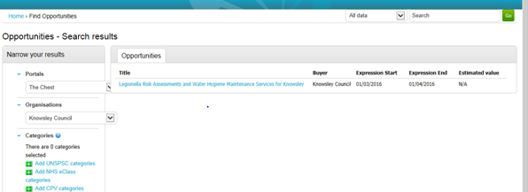

You will then be able to see the opportunity. Click on the title of the opportunity to open up the details. On the right hand side of the screen, you will see a green button to “Login/register an interest in this opportunity”

***3. Downloading the form***

Once you have expressed your interest in this opportunity in the system, you need to go back to the home page of your account (making sure that you are logged in).  Once there, you will need to go to:

* My Activities
* Active Activities
* Select Knowsley MBC from the list
* All of your opportunities for Knowsley will then appear
* You need to then find the opportunity
* Click on the blue Hyperlink (Which is usually the contract title)  this will take you to a screen similar to the following screen:

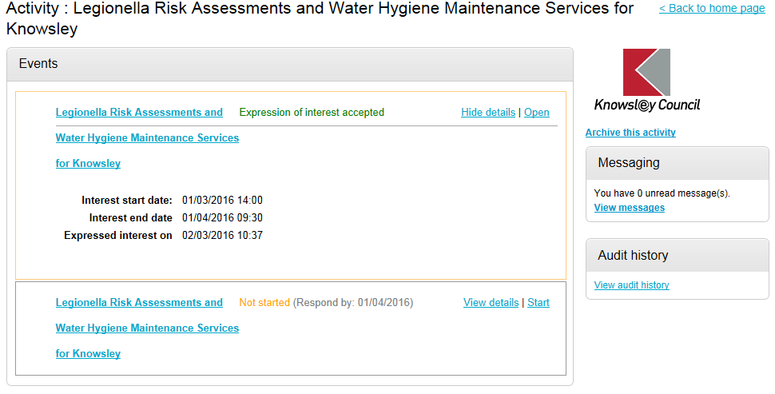

In the bottom box on this screen, you need to click ‘Start’ this will then give you access to all of the relevant documentation.

***It is Bidders responsibility to ensure they access and download the form from The Chest once they have been published by Knowsley MBC.***