**For Information Only:**

**Cornwall Council and Social Value**

**Please note, the Social Value TOMs Spreadsheet is only required when** **the total value of Call Off’s for placements hits £100K or above for one Provider, that Provider will be asked to submit the completed Social Value TOMs with support from the Council if required.**

1. **Background**

The Covid-19 pandemic will drive policy for many years to come as we start to recover from the social and economic effects of lockdowns and restrictions including social deprivation, food poverty and mass unemployment. The need for all local authorities to use the money they spend to drive sustainability, promote social wellbeing, minimise environmental damage and build community wealth is vital. This combined with potential procurement reform following our exit from the European Union, gives Cornwall Council an opportunity to make a real difference in our communities and ensure that we use our sourcing to drive change and embed social improvements that benefit our whole community and helps contribute to the Cornwall we want.

It is a position supported from Central Government, using commissioning to support key social outcomes and build community wealth. There is a need to apply Social Value requirements in procurement, as it has clearly been shown to have a significant and positive impact on the local economy, sustainability and community wealth.

What is Social Value?

It is the additional financial and non-financial value created by an organisation through its day to day activities, in terms of social and economic wellbeing of individuals and communities.

It is a move from purely financial and cost-based measures of value to a wider holistic consideration across economical, societal and environmental wellbeing of regions.

Measuring Social Value

Bringing consistency in performance and our outcomes will mean that the process for defining social value will be standardised. It will provide a clear and systematic way to evaluate Council priorities in the award of our contracts and in ongoing contract management and allow for key reporting mechanisms to be implemented. For Social Value this will include using a selection of National TOMs (defined below) which have been aligned to the Gyllyn Warbarth strategic themes 2020 – 2050.

**Themes** – the components of an organisation’s “vision” for social value

**Outcomes** – the positive changes that the organisation wants to see. In effect, what “good” looks like to that organisation.

**Measures** – what objective indicators will be used to measure whether these outcomes are being met.

The TOMs selection within the tender provides a framework of **outcomes** and related **measures** and will be used in both the evaluation stage and the performance framework of the contract.

1. **Tender requirements**

When the total value of Call Off’s for placements hits £100K or above for one Provider, that Provider will be asked to submit the completed Social Value TOMs spreadsheet. Cornwall Council can support you with this if required as this will be for information purposes only.

When requested on an individual basis, Providers must complete the Social Value appendix within the tender documentation, to quantify, demonstrate and commit to how they will address the Council’s Social Value priorities.

Note: Information and initiatives must be project specific, they cannot be those at a corporate level, such as relating to CSR policies e.g. savings of carbon from an initiative at the Company HQ office

Providers must review the definitions and evidence requirements set out in the document for each of the selected measures as these are used for evaluating the commitments made, as well as playing a key role in contract management. All required information is included in the Definitions & Guidance tab.

Providers must then complete the highlighted yellow boxes of the Calculator Procurement tab with details of their social value commitments.

Where Providers provide a high quantitative proxy value which is not sufficiently evidenced within the qualitative assessment, the Authority will seek clarification from the provider.

**Evaluation – Note: this information will not be evaluated unless in the form of a mini competition where both Providers are at a value of £100K or above.**

The evaluation will be split in quantitative and qualitative scores, and these will be calculated using the “Calculator Procurement” tab of the CC Social Value Calculator document.

The quantitative score is generated automatically on the calculator in the Excel spreadsheet (social value in £ - totalled in cell M9)

The qualitative score is derived from the description of commitments provided by the Provider against each measure.

The full social value section shall be split 50/50 into quant and qual scoring. As set out below.

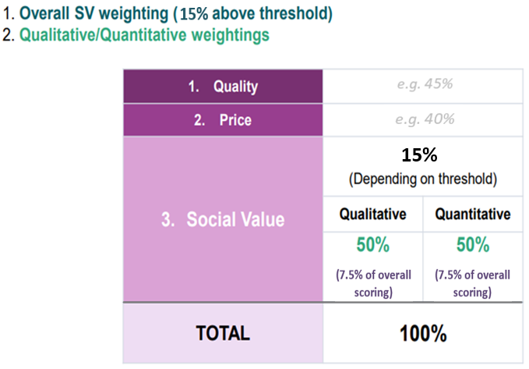

The **quantitative** score will be calculated using the formula below:

The Provider submitting the highest quantitative Social Value offer will be scored 100% for this section. All other Providers will be scored in relation to the highest quantitative Social Value offer as follows:

*Provider's total quantitative Social Value offer / Value of the highest quantitative Social Value offer submitted x 100*

To gain a **qualitative** score Providers must accompany input target figures with a rationale for how each target will be achieved. This should be provided in the description boxes associated with each measure in the calculator (column P). The Provider should use the description to demonstrate that credible processes are in place to deliver what is being offered. Additional supporting documentation may be provided where necessary to justify the Provider’s approach.

A high scoring description should include:

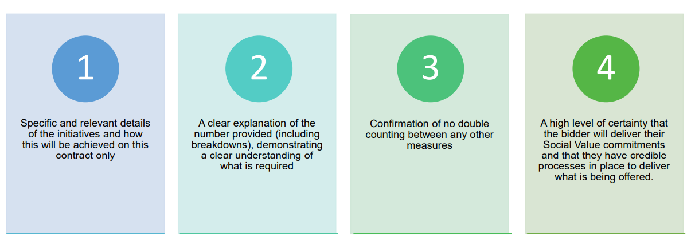

The descriptions will be evaluated using the following score classification:

The Provider achieving the highest qualitative score (when scores for all descriptions are totalled) will be scored 100% for this section. All other Providers will be scored in relation to the highest total qualitative score as follows:

*Provider's total qualitative Social Value offer / Value of the highest qualitative Social Value offer submitted x 100*

Please refer to the “Calculator_(Worked Example)” tab of the CC Social Value Calculator document which provides an exemplar Provider response.

Please note that when requested to complete the TOMs spreadsheet, this will be on an individual Provider basis subject to the total value of Call Off’s for placements being £100K or above. The Provider will be asked to submit the completed Social Value TOMs with support from the Council if required. This request will be for information purposes only and will not be evaluated unless in the form of a mini competition where both Providers are at a value of £100K or above.