Scaffold Specification Template

*(Guide to Managing and Appointing Scaffolding Contractors)*

Management Guide



NASC Guidance

April 2016

**Contents Page No.**

**1. APPLICATION 5**

**1.1 Tube & Fitting Scaffolding 5**

**1.2 System Scaffolding 5**

**1.3 Lightweight Mobile Tower 5**

**2. REGULATIONS, CODES OF PRACTICE & BEST PRACTICE 6**

**3. COMPETENCE 6**

**3.1 Scaffolding Companies 6**

**3.2 Scaffolding Operatives 7**

**3.2.1 Scaffolding Labourer 7**

**3.2.2 Trainee Scaffolder 7**

**3.2.3 Scaffolder 8**

**3.2.4 Advanced Scaffolder 9**

**4. SCAFFOLDERS SAFETY AND PPE 9**

**5. SCAFFOLDING DESIGN 10**

**6. MINIMUM SCAFFOLD REQUIREMENTS 10**

**6.1 Scaffold Tube 10**

**6.2 Scaffold Boards 11**

**6.3 Scaffold Fittings 11**

**6.4 Brick guards, Sheeting and Debris Netting 11**

**6.5 Loading Bays 11**

**6.6 Access/Egress to Scaffolds 11**

**6.7 Internal Edge Protection 12**

**6.8 Scaffold Ties 12**

**6.9 Hop Up/Stage Brackets 12**

**7. SCAFFOLD HANDOVERS AND STATUTORY INSPECTIONS 13**

**8. RISK ASSESSMENTS AND METHOD STATEMENTS 14**

**9. CLIENT INFORMATION 14**

**Appendix A NASC guidance listing referred to within this document 15**

**Appendix B Example of CISRS Scaffolders cards 16**

**Appendix C Scaffold Inspection Report Sheet 17**

**Appendix D TG20:13 Compliance Sheet (Examples) 18**

**Appendix E Client Information 19**

1. **APPLICATION**

This specification identifies the minimum requirements and standards for all scaffolding and edge protection designed, erected, altered, inspected, used and/or dismantled. This specification may be enhanced by an individual company’s specific scaffolding policy and branding.

Hoists, Ladders, Stepladders and Podium Steps are not included as part of this standard.

* 1. **Tube and Fitting Scaffolding**

This applies to traditional steel tube and fitting scaffolds and includes the use of “system type” components such as “Readylok or Easifix transoms”, extending transoms, steel and aluminium ladder beams and unit beams. All such components must be used in strict accordance with the manufacturer’s instructions, design drawing guidance, the TG20:13 Compliance Sheet and the information supplied to site upon request.

* 1. **System Scaffolding**

All types/brands of Systems Scaffolding used on site, must conform to the relevant British and European Standards BS EN 12810/12811. The lead hand of a scaffold gang using systems scaffolding must have successfully completed the relevant CISRS Systems product training. CISRS Scaffolders or Trainee operatives will be able, as a member of this gang to erect, alter or dismantle this equipment under the direct supervision of the CISRS systems qualified operative. It would be preferable for all operatives using systems to undertake System Training. The makeup of the scaffolding gang should also be considered. i.e. the ratio of qualified Advanced/Scaffolders to Trainee/Labourers dependent upon the size and complexities of the work undertaken.

See [www.cisrs.org.uk](http://www.cisrs.org.uk) for the current list of system product training available.

* 1. **Lightweight Mobile Tower**

A nominated person is permitted to erect, inspect, use, move, alter and/or dismantle a lightweight Mobile Tower if they are competent and hold a recognised qualification that specifically includes mobile towers.

Mobile towers must be inspected as often as is necessary to ensure safety.

Recommended best practice is that they be inspected and a report made by a competent person after assembly, or significant alteration, and before use. Thereafter, they should be inspected as often as necessary but at least every 7 days, or after any event likely to have affected stability or structural integrity, such as adverse weather conditions. There is no need to inspect and report every time the mobile tower is moved at the same location.

Mobile Access Tower training is now included in part 1,2 and Advanced CISRS training courses. It negates the requirement for those modules to carry out further 3rd party e.g. PASMA. See reverse of card for endorsement.

1. **Regulations, Codes of Practice and best practice requirements**

All scaffolding works shall be carried out in accordance with the following Regulations, Codes of Practice and industry best practice requirements:

* 1. The Health and Safety at Work etc Act 1974
  2. The Management of Health and Safety at Work Regulations 1999 – as amended
  3. The Work at Height Regulations 2005 – as amended
  4. The Construction (Design and Management) Regulations 2015
  5. BS EN 12811 2003 – Scaffolds performance requirements
  6. BS EN 12810 2003 – Facade scaffolds made of prefabricated components
  7. NASC TG20:13 – A Comprehensive Guide to Good Practice for Tube and Fitting Scaffolding
  8. NASC SG4:15 – Preventing falls in scaffolding (Latest Edition)
  9. CISRS CAP 609 General Information (Latest Edition)

THIS LIST IS NOT EXHAUSTIVE.

1. **COMPETENCE**
   1. **Scaffolding Companies**
      1. Should operate under auditable processes and must have a recorded training scheme in place and be full members of the NASC.
      2. Must maintain current insurances of a minimum of £10 million for Employers Liability and £5 million for Public Liability.
      3. Must be able to demonstrate that they have competent supervision (e.g. CISRS Scaffold Supervisor training course and hold a CISRS Scaffold Supervisor card or CISRS Scaffolder/Advanced card plus an industry recognised Supervisory qualification e.g. SSSTS,SMSTS).
      4. A qualified CISRS Scaffolder or CISRS Advanced Scaffolder working within his capability is suitably qualified to lead the scaffold operations within a gang of scaffolders and to direct the practical operations on site.
      5. They must employ competent scaffolders for the type of scaffolding to be undertaken on site as defined in item 3.2 below.
      6. Management, Supervision and operatives must have received relevant training on TG20 and SG4 (Latest Editions).
      7. The company must have access to competent scaffold designers and manage TG20:13 compliance sheets.
      8. The company must ensure that all deliveries of scaffolding materials are undertaken in a safe manner and consideration is given to the risk of falls from vehicles and as such this work is undertaken in line with NASC SG30 (Latest Edition)“Working from Vehicles”.
      9. All deliveries where powered lifting is used (e.g.: HIAB) will require proof of operator competence and that the lifting equipment has a current certificate of test and thorough examination.
   2. **Scaffolding Operatives**
      1. **Scaffolding Labourers** 
         1. A CISRS Scaffolders labourer’s card must be held for operatives carrying out these duties.
         2. Must have received Manual Handling Training in accordance with NASC Guidance note SG6 Manual Handling.
         3. Must have attended a recognised 1 day training course prior to commencement of their duties. The CISRS COTS Course covers this requirement.
      2. **Trainee Scaffolder**
         1. Trainees must hold a current CISRS Trainee Scaffolders card

(See appendix B)

* + - 1. They must have received SG4 (Latest Edition) training and work in compliance with the guidance.
      2. They can only work under the direct supervision of either a CISRS Scaffolder or CISRS Advanced Scaffolder at all times.
      3. An operative is considered a Trainee Scaffolder until they have completed all requisite training and assessment up to and including, CISRS Part 2, S/NVQ 2, H&S testing and hold a CISRS Scaffolder Card, regardless of their time in the industry.
    1. **Scaffolder**
       1. The Scaffolder must hold a current CISRS Scaffolders card.

(See appendix B).

* + - 1. They must have received SG4 (Latest Edition) training and work in compliance with the guidance.
      2. The lead hand of a scaffold gang using system scaffolding must have successfully completed the relevant CISRS Systems product training however it would be preferable for all operatives to undertake CISRS System Training.
      3. Scaffolders can work on the following structures:
* Independent tied scaffolding
* Putlog scaffolding
* Birdcage scaffolding
* Mobile Tower (T/F or Aluminium)
* Tower scaffolding (steel)
* Truss-out scaffold
* Scaffolds with beams
* Protective fans
* Pavement gantry
* Loading bay
* Roof saddle scaffold
* Splay scaffold
* Roof edge protection
* Tie testing
* They are entitled to work on Advanced or complex design structures but only under the direct supervision of an Advanced Scaffolder.

THIS IS NOT AN EXHAUSTIVE LIST

* + 1. **Advanced Scaffolder**
       1. Must hold a current CISRS Advanced Scaffolders card

(See appendix B).

* + - 1. They must have received SG4 (Latest Edition) training and work in compliance with the guidance.
      2. The lead hand of a scaffold gang using systems scaffolding must have successfully completed the relevant CISRS Systems product training however it would be preferable for all operatives to undertake CISRS System Training. Advanced Scaffolders can work on any tube and fitting steel scaffolding structure including the following:
      * Tubular drop scaffold from steelwork
      * Cantilever drop scaffold
      * 2 Cord Raking shore
      * 3 Cord Raking shore
      * Dead shore
      * Flying shore
      * Temporary roof scaffold
      * Stairways
      * Ramps

THIS IS NOT AN EXHAUSTIVE LIST.

1. **SCAFFOLDERS SAFETY AND PERSONAL PROTECTIVE EQUIPMENT**
   1. Scaffolders shall at all times wear the following minimum PPE at all times whilst working on site:
      1. Safety helmet
      2. Safety footwear
      3. High Visibility vest
      4. Gloves
      5. Fall arrest harnesses, which must be used in accordance with the Task specific Risk Assessment. This could be, single, double, retractable or fixed lanyard to suit the particular application.
      6. Other PPE as required by the work task RA or local site requirements.
   2. Whenever harnesses being are used, rescue plan(s) in line with NASC SG19 (Latest Edition) “Guide to Formulating a Rescue Plan” must be in place before commencement of work on site.
   3. All scaffolding shall be erected in strict accordance with NASC SG4 (Latest Edition) and contractors shall adhere to recommended methods of work within the guidance.
   4. All Scaffolding materials must be passed from hand to hand or raised and lowered in a controlled manner (light line or Gin Wheel & Rope etc). The uncontrolled passing or dropping of any scaffolding materials is not permitted.

*Note: NASC Guidance Note SG6 Manual handling in the Scaffolding Industry contains further guidance.*

* 1. All lifting operations that include the use of lifting equipment must be undertaken within the scope of the Lifting Operations & Lifting Equipment Regulations (LOLER).

1. **SCAFFOLDING DESIGN**

5.1 Where additional scaffolding design input is required (i.e. those scaffolds that do not meet or fall within the scope of a TG20 Compliance Sheet – See Appendix D) the design shall be provided by a competent scaffold designer and the appropriate design standard followed.

5.2 System Scaffolds shall be designed to prove adequate strength, stability and rigidity whilst erected, used and dismantled.

* 1. Where design drawings are produced, they shall include an elevation of the scaffold with all tie positions marked on the drawing clearly stating the required tie classification light duty (3.5 KN), standard (6.1KN) or heavy duty (12.2KN).
  2. Where appropriate, standard scaffold design solutions may be permitted to determine design input of certain scaffold structures (Stair towers etc)
  3. Copies of scaffold design must be issued to user/client for acceptance and sign off and held on site.
  4. A system for the management of design variations shall be in place.
  5. All designers must consider and evaluate the risks involved in the erecting and dismantling of their proposals and design accordingly to eliminate risk as part of their brief.

1. **MINIMUM SCAFFOLD REQUIREMENTS**

The following minimum scaffold requirements shall be in place on all sites:

* 1. **Scaffold Tube**

All scaffold tube must be galvanised and comply with BS EN 39 type 4, or high tensile steel tube of BS EN 10210-1 and the NASC recommend that all tubes should be marked in such a way as to identify the scaffolding company who own it.

* 1. **Scaffold Boards**
     1. All timber scaffold boards must comply with BS2482:2009. Other boards such as laminated veneer or plastic manufacture shall comply with the general requirements of TG20:13 section 4.2.

* + 1. Short boards (less than 2.4 metres long) should be secured to prevent displacement as should internal boards that are considered likely to be displaced accidently.
    2. Other than at returns of scaffolds, lapped boards to be avoided so far as is reasonably practical.

* 1. **Scaffold Fittings**
     1. All scaffold fittings must comply with current UK industry standards. (BS EN 74-1 etc.) NOTE NOW 2 TYPES CLASS A 6 kN AND CLASS B 9 kN.
  2. **Brick guards, Sheeting and Debris netting**
     1. In accordance with the contract specifications (which should include a suitable risk assessment by the main contractor) scaffolds may require brick guards, sheeting or debris netting fitted and if not TG20:13 compliant a design must be in place prior to erection.

* 1. **Scaffold Loading Bays**
     1. All Scaffold loading bays (except where cranes are used) shall be fitted with scaffold loading bay gates that FULLY protect operatives from the exposed edge when in an open position and prevent falls of operatives and/or materials when in a closed position.
     2. Scaffold loading bays to be provided with brick guards or similar protection to the perimeter.
     3. Scaffold loading bays must have clear signage to provide users with clear information regarding safe working loads. It is recommended that this signage should be fitted at the eye level of the fork truck driver.
  2. **Access/egress to Scaffolds** 
     1. Access/egress to scaffolds must be provided in order to comply with the Work at Height Regulations 2005, HSE guidance and NASC SG25 (Latest Edition) “Access and egress from scaffolds” with regard to the hierarchy as follows:

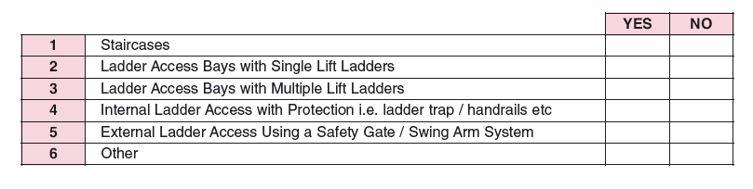

* + 1. Where external ladder access is chosen it should be erected to a step off level no more than 4.7m Maximum.
    2. Considerations that need to be made regarding the assessment of suitable access and egress from scaffolds may include:
* Height and width of scaffold.
* Number of people using the scaffold at any one time.
* Duration of scaffold hire.
* Localised emergency requirements (fire, evacuation etc.)
* Type of work to be undertaken on scaffold (e.g. access to confined space entry work and asbestos removal enclosures whilst using full face respirators etc. requires a higher degree of assessment for access and egress).
  1. **Internal Edge Protection**

6.7.1. Internal edge protection on scaffold platforms to conform to NASC SG29 (Latest Edition) “Internal Edge Protection on Scaffold Platforms”.

* 1. **Scaffold Ties**
     1. All concrete/masonry anchors that are used for the installation of scaffold ties must be tested in accordance with NASC TG4 (Latest Edition) “Anchorage systems” (i.e.: minimum of 3 per scaffold or 5% of total number of ties whichever is the greater) with a proof load of 1.25 times the required tensile load using a purpose made scaffold tie tester. Records of tie test result must be maintained.
     2. When working on domestic premises it is recommended that the occupier be informed prior to any drilling taking place for masonry anchors, or where it may be necessary to rake out brickwork joints to support a “putlog” scaffold.
  2. **Hop Up/ Stage Brackets**

6.9.1 Hop up/stage brackets shall be used in accordance with NASC Guidance Note SG32 Guidance on the Provision of Inside Board Brackets (Hop up/Step down) (Latest Edition).

1. **SCAFFOLD HANDOVERS AND STATUTORY INSPECTIONS**
   1. All Scaffolding should display a “DO NOT USE” notice for restricting access to the scaffold until the scaffolding has been inspected and handed over for use.

**Scaffold Handover**

* 1. When each scaffold is completed, a competent employee of the Scaffolding Contractor will inspect the scaffold for compliance with regulations, codes of practice and TG20:13 Compliance Sheet and then complete a Scaffold Handover Certificate. This should conform to the current NASC template SG35 Handover of Scaffold Structures as a minimum and ensure that the client’s representative receives a copy. Where applicable, the green insert of a tag type inspection system (if used) shall be completed and located at the access point of the scaffold, and the first entry made in the statutory scaffold inspection register by the competent person. The Handover Certificate is now considered to be the first inspection.

**Scaffold Inspection**

* 1. Regular statutory inspections of the scaffolding shall take place at least every 7 days or after any event likely to have affected the scaffold’s stability and recorded in the scaffold register (See appendix C). The tag type system insert (if used) will also be updated to record the inspection. (Where applicable).

*Note: Any tag system is a supplementary check only and does not replace the statutory inspection and report as required within the Work at Height Regulations 2005.*

NB. The responsibility for the 7 day inspection is with the Contractor/user and not the scaffolder.

* 1. All initial and weekly scaffold inspections must be undertaken by a competent person who has attended a nationally recognised scaffold inspection training course. (e.g. CISRS Scaffold Inspection Training Scheme (SITS) Basic or Advanced), alternatively a CISRS Scaffolder or Advanced card holder is competent to inspect structures up to the grade of their card i.e. CISRS Scaffolder Basic Structures, and Advanced Scaffolder all structures.



CISRS Basic and Advanced Scaffold Inspection Cards

Should the Contractor not have in his employ a qualified inspector, he may instruct the scaffolding contractor to carry out this duty on his behalf. This should be by separate instruction to the main contract.

1. **RISK ASSESSMENT AND METHOD STATEMENT**
   1. Each individual scaffold structure should have a job and site specific risk assessment recorded in writing which is accepted by the Contractor that the Scaffolding Contractor is working for before work commences to erect, alter or dismantle a scaffold.
      1. All Risk Assessments and Method Statements will be carried out in line with the Scaffold Contractors Health and Safety Policy which as a minimum standard shall follow the requirements and recommendations within NASC SG7: (Latest Edition) Risk Assessments & Method Statements (RAMS)
      2. Risk Assessment and Method Statements must be communicated to operatives prior to the commencement of work. The operative must sign the document to demonstrate that they have been briefed on the particular job. Copies of all Risk Assessments and Method Statements should be held as a minimum for the duration of the contract but the NASC would also recommend that it should be saved for 3 years to cover any insurance claims.
2. **CLIENT INFORMATION**
   * 1. An example of information required by the scaffolder is shown in Appendix **E.**

**APPENDIX A – LIST OF NASC REFERENCE GUIDANCE REFERRED TO   
WITHIN THIS DOCUMENT**

Note: Refer to NASC website at [www.nasc.org.uk](http://www.nasc.org.uk) for latest editions of the guidance listed below.

**Health & Safety Guidance Notes**

SG4 Preventing Falls in Scaffolding

SG6 Manual Handling in the Scaffolding Industry

SG7 Guide to Risk Assessment & Method Statement (RAMS)

SG19 A Guide to Formulating a Rescue Plan

SG25 Access and Egress from Scaffolds

SG29 Internal Edge Protection on Scaffold Platforms

SG30 Working from Vehicles

SG32 Guidance on the Provision of Inside Board Brackets

SG35 Handover of Scaffold Structures

**Technical Guidance Notes**

TG4 Anchorage Systems

TG20 A Comprehensive Guide to Good Practice for Tube and Fitting Scaffolding.

**Competence Guidance Documents**

CISRS Cap 609 General Information Booklet

**APPENDIX B – EXAMPLE OF CISRS SCAFFOLDERS CARDS**



Only to work at ground level or on a fully boarded and double guard railed scaffold platform passing scaffolding equipment.



Work under the direct and immediate supervision of either a CISRS Scaffolder or Advanced Scaffolder at all times.

Have a CISRS Scaffolders card endorsed for tube and fitting scaffolding or system scaffold to be used. Can work on scaffolds listed in Section 3.2.3.4 and any other scaffold not included on this list but only under the direct and immediate supervision of an Advanced Scaffolder.



Have a CISRS Scaffolders card endorsed for tube and fitting scaffolding or system scaffold to be used.

Can work on any steel scaffolding structure.



Card is used to provide proof that the Scaffold Supervisor is trained and competent.

| **No** | **Location and description of workplace inspected** | **Date & Time of inspection** | **Matters observed that give rise to  any health and safety risks** | **Details of action taken at time of inspection** | **Details of any further action considered necessary** | **Name, signature & position of inspector** |
| --- | --- | --- | --- | --- | --- | --- |
|  |  |  |  |  |  |  |
|  |  |  |  |  |  |  |
|  |  |  |  |  |  |  |
|  |  |  |  |  |  |  |
|  |  |  |  |  |  |  |

**APPENDIX C – SCAFFOLD INSPECTION REPORT SHEET (EXAMPLE)**

|  |  |  |  |
| --- | --- | --- | --- |
| Scaffold Inspection Report (in line with regulation 12 of The Work at Height Regulations 2005) | | | |
| **Company Name**  **& Address:** |  | **Sheet:** |  |
| **Site Address:** |  | | |

**APPENDIX D – TG20:13 COMPLIANCE SHEETS (EXAMPLES)**

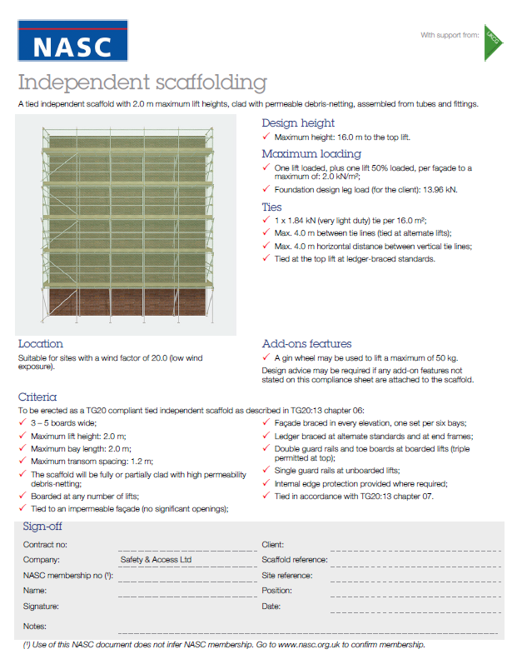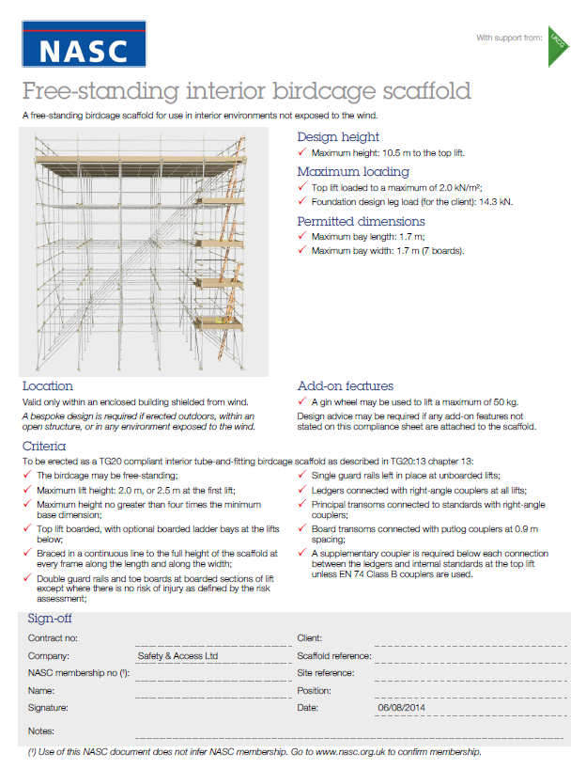

**APPENDIX E – CLIENT INFORMATION**

|  |  |  |  |
| --- | --- | --- | --- |
|  | **SCAFFOLD** |  | |
|  | **SCHEDULE** | **Contractor:**  **Site:** | |
|  |  |
|  | **NOTES** | | **Date:** |
| **Compiled By:** |
| **A** | All scaffold structures must be TG20 13 Compliant or have design and calculations completed to prove their strength and stability. | | |
| **B** | All operatives must be competent to carry out the works. CISRS qualified Scaffolder or Advanced for designed structures. | | |
| **C** | Full information on the structure must be detailed below and must include what it is required for. | | |
| **D** | Adaptions MUST be highlighted and shown as a separate item. | | |
| **E** | Additional ancillary items such as brick guards, extra guardrails etc. must be listed and highlighted separately. | | |
| **F** | Width of platforms including numbers of boards on platform and inner must be stated clearly. | | |
| **G** | Lift heights and number of boarded lifts must be clearly stated. | | |
| **H** | Method of access i.e. Stair or Ladder must be stated for every scaffold. NB. Ladder access and some proprietary stars, are not suitable for emergency access and egress or rescue. | | |
| **I** | Method of tying in must be stated for every Scaffold. | | |
| **J** | Sequence of Erect and Dismantle must be stated for every scaffold, i.e. Progressive or One operation. | | |
| **K** | Information on Logistics must be stated for every structure. i.e. storage, crane, fork lift etc. | | |
| **L** | If Sheeting is required this must be stated separately and may impact on the design of the scaffold. | | |
| **M** | It is the responsibility of the contractor to ensure the ground or base is suitable for the scaffold being constructed. | | |
| **N** | Weekly hire period for each task must be stated. | | |
| **O** | Any other instruction | | |

|  |  |  |  |  |  |  |  |  |  |
| --- | --- | --- | --- | --- | --- | --- | --- | --- | --- |
| **Item No** | **Description of Scaffold** | **Board Width** | **Length  (m)** | **Height (m)** | **No of lifts** | **Lift height (m)** | **Boarded Lifts** | **Access Stair or Ladder** | **Hire  Period** |
| **1** |  |  |  |  |  |  |  |  |  |
| e.g. | Independent Access scaffold for external brickwork. | 5+1 | 50.00 | 9.00 | 6 | 1.500 | 1 | Stair | 10 |
|  | Include brick guards to all lifts. |  | 50.00 |  | 6 |  |  |  | 10 |
| **2** |  |  |  |  |  |  |  |  |  |
| **e.g.** | Adapt items 1, to 4 number fully boarded 2m lifts for render work. NB. This will leave an inner gap of 225mm | 5 | 50.00 | 8.00 | 4 | 2000 | 4 | Stair | 8 |
|  |  |  |  |  |  |  |  |  |  |
|  |  |  |  |  |  |  |  |  |  |
|  |  |  |  |  |  |  |  |  |  |
|  |  |  |  |  |  |  |  |  |  |
|  |  |  |  |  |  |  |  |  |  |
|  |  |  |  |  |  |  |  |  |  |