Route Map into Lakeside from The Parks (on topo survey)

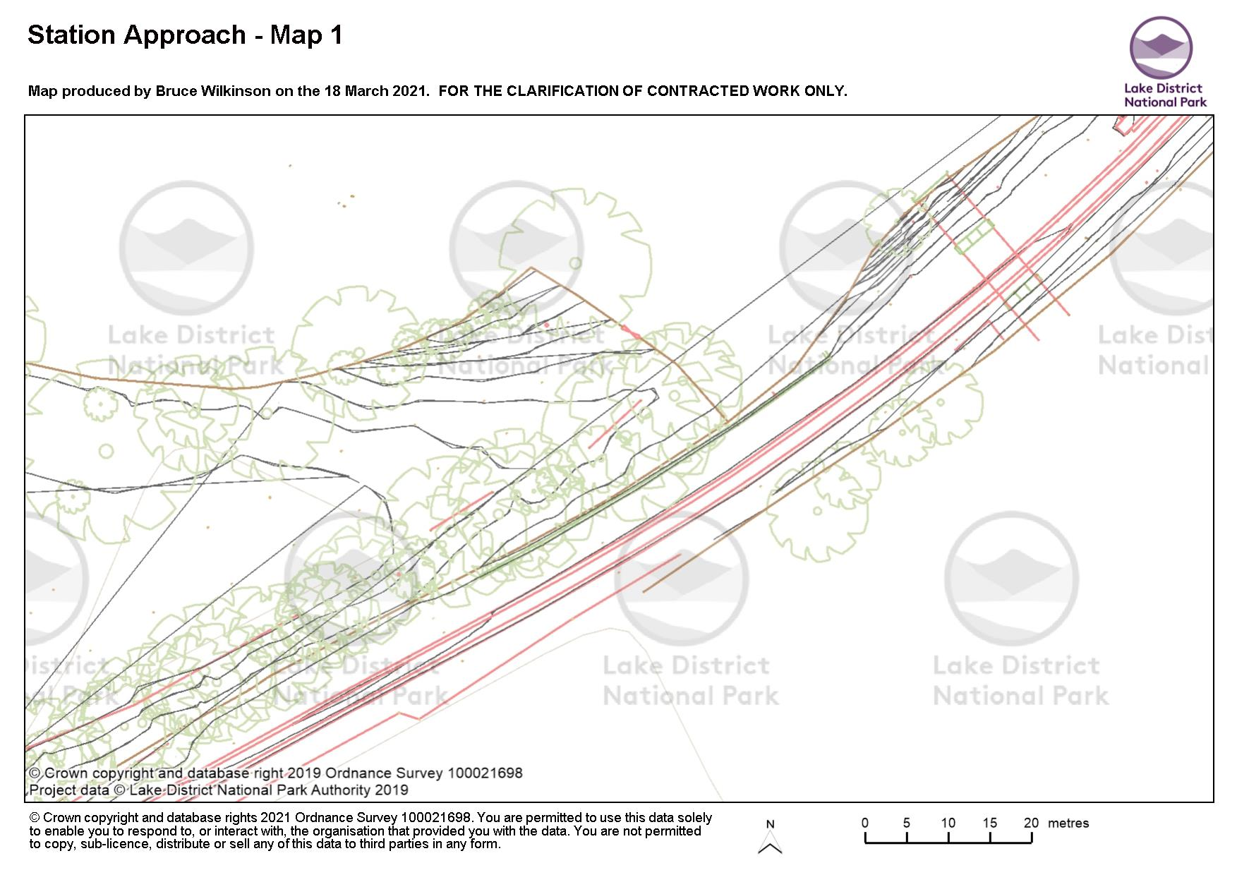

KEY

Trail

Fence / retaining wall

Note this map shows land owner / manager in relation to the trail and not the actual extent of any land holding.

The Parks

LANDING HOW

L&HR

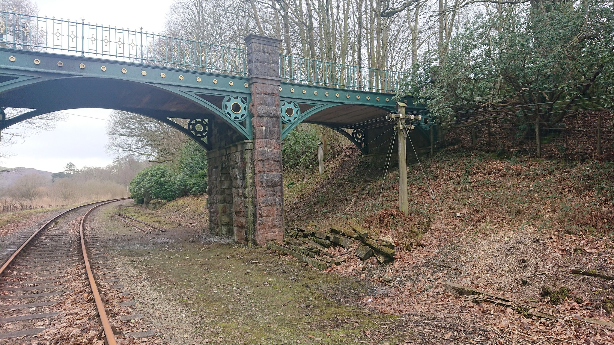

**D**

A – Ramp down from Landing How Section 1:10m gradient

B – Pole removed

C – Pole removed

D – trail passes through the arch @ 150mm – 300mm above track bed. Trial width @ 2.5-3.0m through arch with retaining wall against bank.

E – trail ramps up

**E**

**B**

**C**

**A**

Map Two – Station

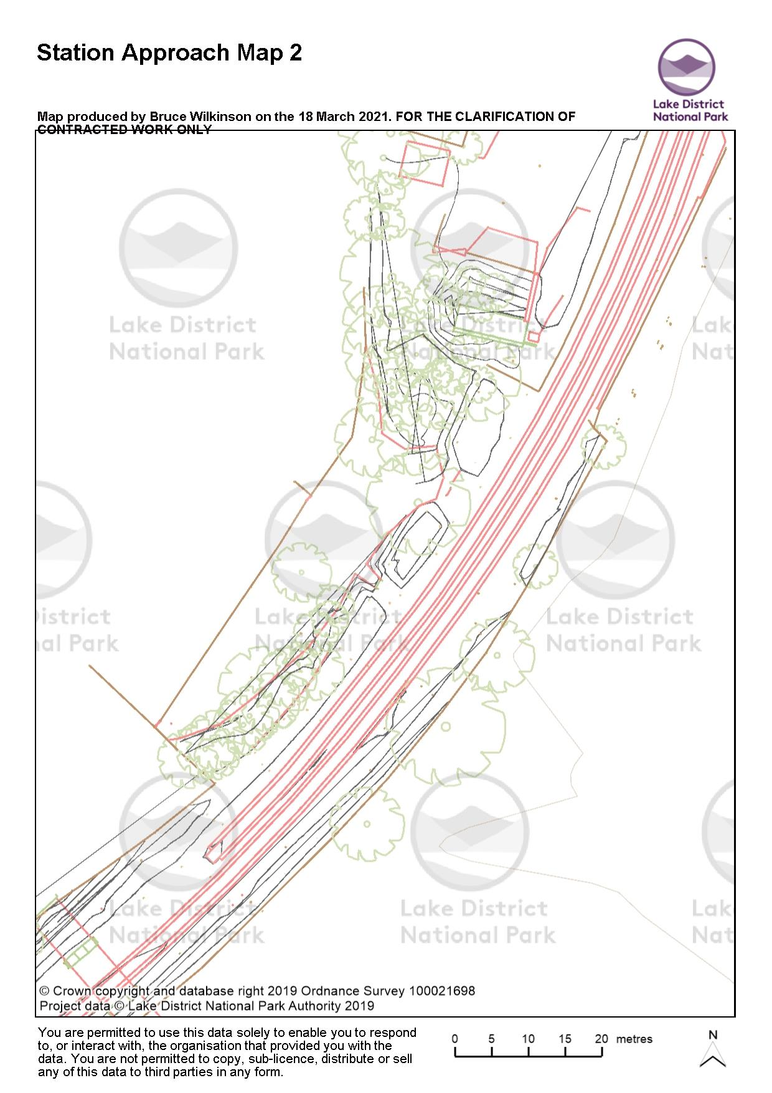

Cabinet to be screened or fenced / gated access from car park. Route passes to E (left). Trail @ 2.5mwide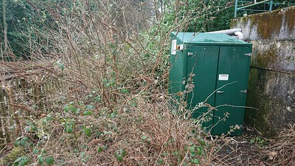

Please confirm nature of cabinate & if connected to services? It will require moving or romoval.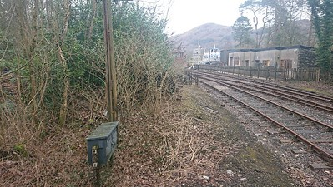

Fence / retaining wall

Trail

Box Culvert

Station Approach

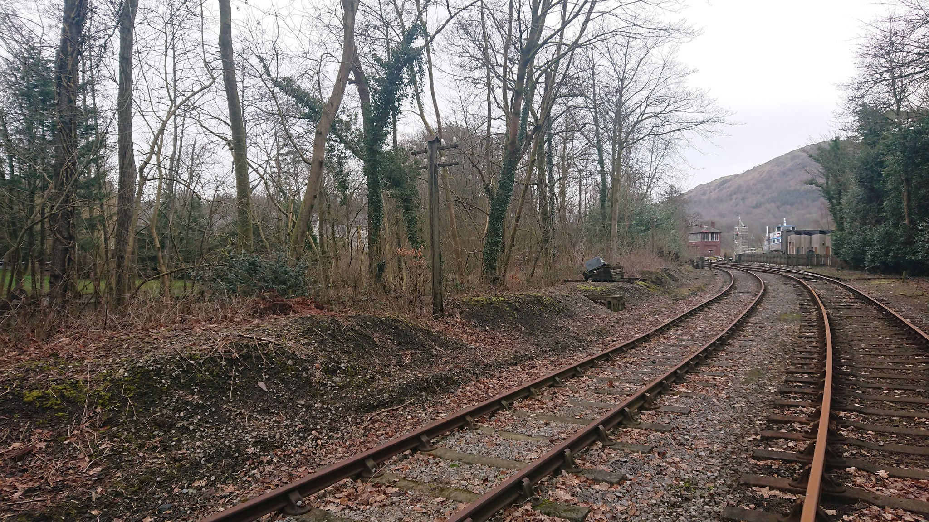

1 – fence / retaining wall edge taken as ‘step’ up from ballast / track bed. Please confirm distance from rail required?

2 – ballast used as sub base. Level reduced by 300mm.

3 – Telegraph pole removed. Can be replaced if required but location would need to be identified.

4 – Concrete box culvert to prevent impounding

5 – Concrete box culvert to prevent impounding

**4**

**5**

**2**

**3**

**1**