1. **To Search for this Opportunity**

To access the opportunity, click ‘find opportunities’

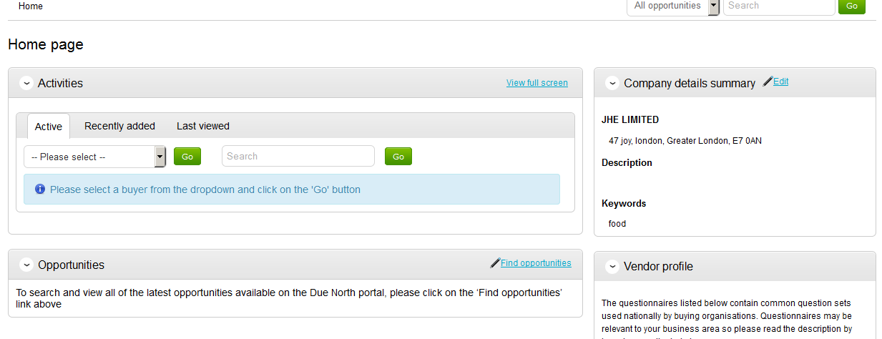

Search by selecting ‘Tower Hamlets’ in the Organisations box to bring all LB Tower Hamlets contract opportunities .Click on the opportunity you would are interested.

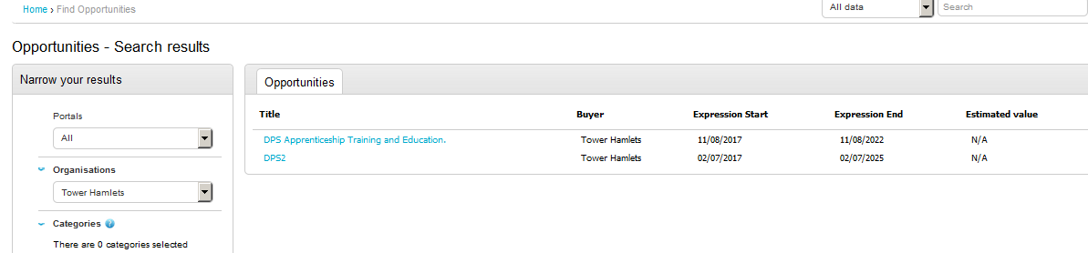

1. **Register Intent** Click the “Register Interest in this Opportunity” button which will allow you to receive further information and respond to this opportunity. 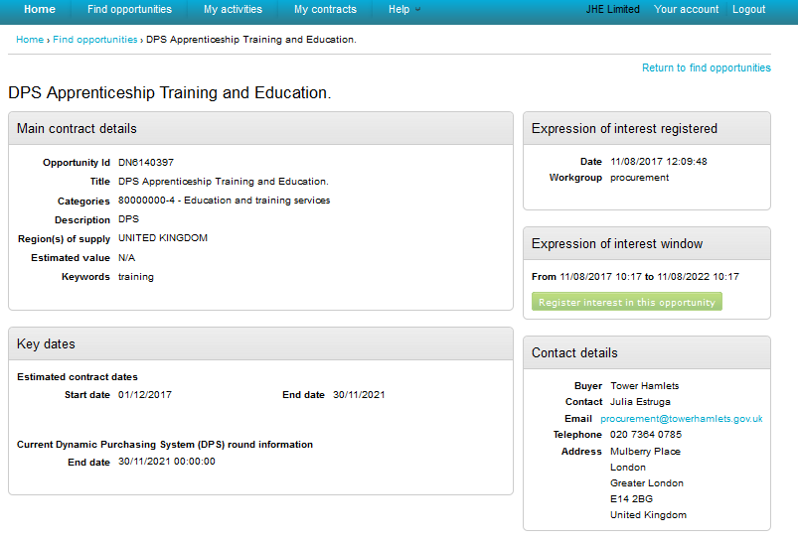

A pop up notification will show your expression of interest has been successful. You can then access the opportunity.

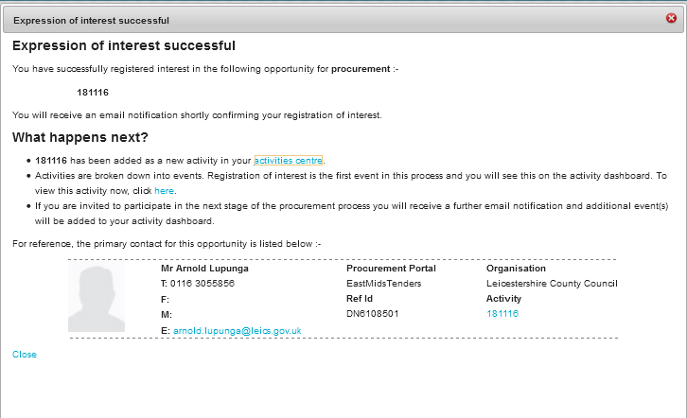

If an Organisation does not wish to, or is unable to submit an Application and not interested in proceeding, then they are required to click on “Opt Out” to decline the opportunity.

Click ‘Start’

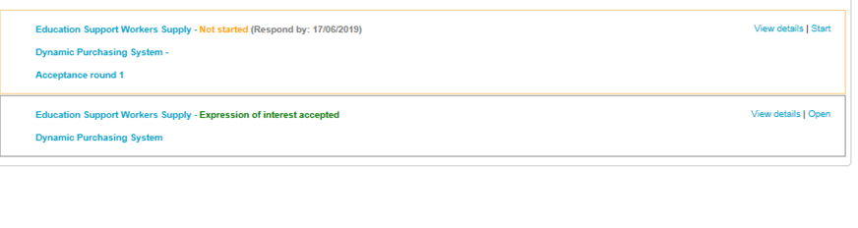

Click on the Round ‘Start My Response’ button to access the contract opportunity documentation.

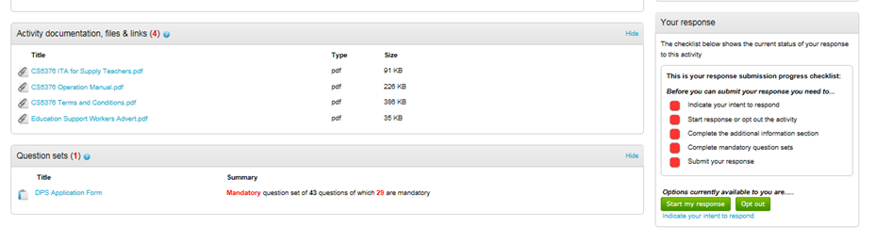

Now click ‘Edit’

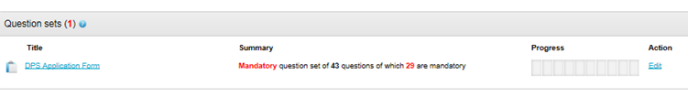

1. **Response Wizard**

After registering intent, Organisations may then proceed to respond to the on-line questions.

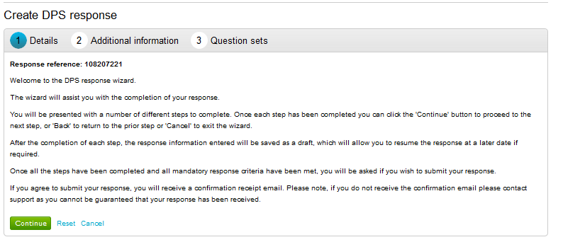

Include your own organisation details and information ‘optional’. This is not seen by the Council.

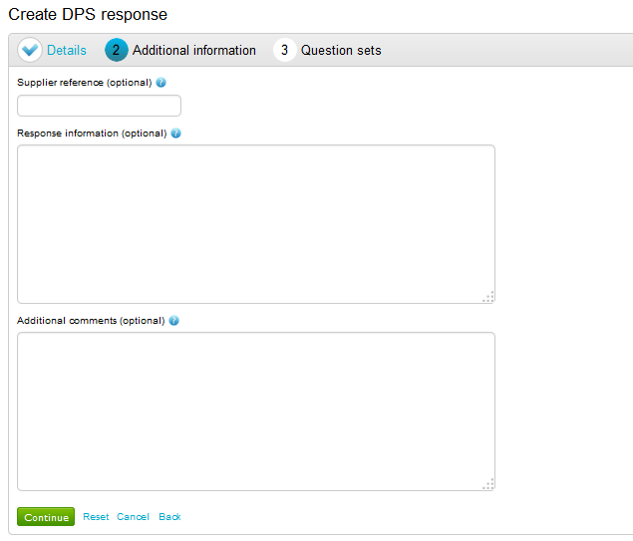

All the questions have a colour status. Check the Key to understand whether the question has already been provided, it is mandatory or need to be reviewed.

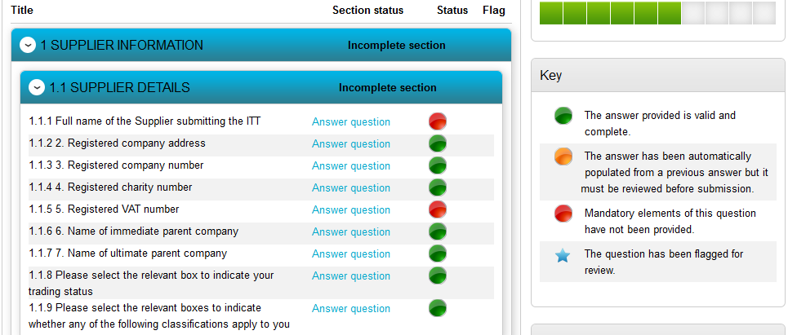

When all the questions have been answered they will become green. Now you can scroll to the bottom of the page and click back.

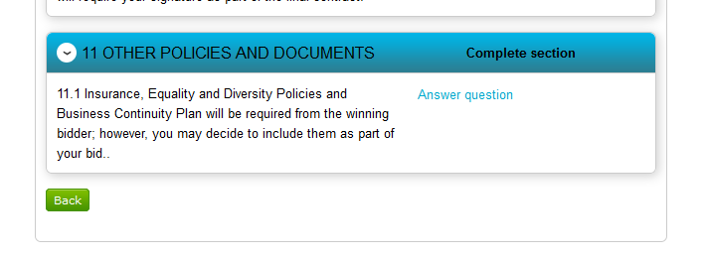

You must accept the terms and conditions in order to activate the ‘Submit Response’.

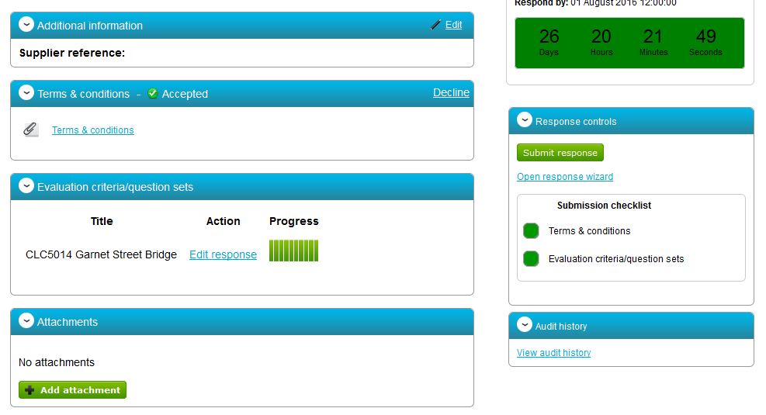

While there is time remaining for submitting a response, you can modify or withdraw your submission.

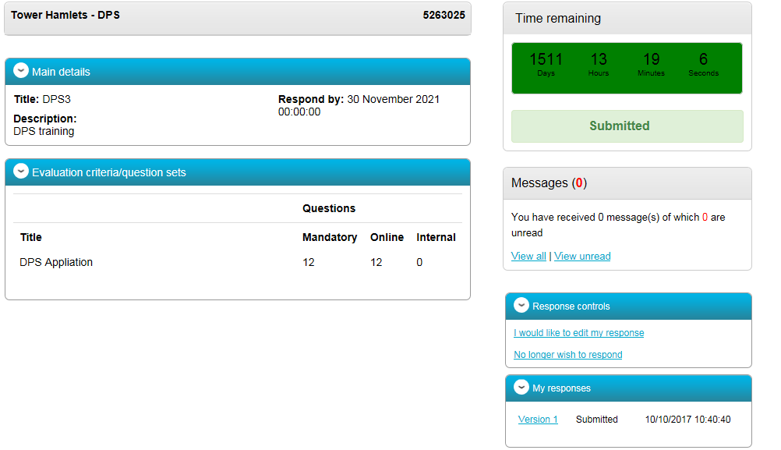

If you decide to edit your response, your amended or revised version must still be submitted **on time before the deadline.**

If you submit an **amended response** outside the deadline, your submission will be considered late.

The Council is only able to see **submitted** responses. Where there is more than one version only the **last version submitted** will be seen by the Council.

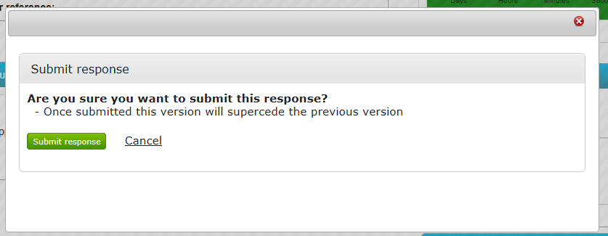

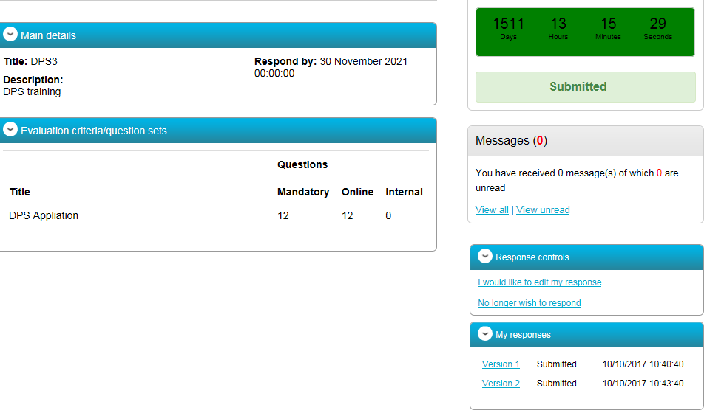

If you submit a response when the time is over, it may not be considered.

