**Family Innovation Fund**

**2023-2026**

**Grant Prospectus**

**Brief Solution Focussed Support**

**(To be read in conjunction with the Grant Agreement)**

**1st April 2023 – 31st March 2026**

|  |  |
| --- | --- |
| **CONTENT** | **PAGE** |
| Foreword | 4 |
| 1. Effective Support for Families in Essex | 4 |
| 1. Early Intervention in Essex | 4 |
| 1. Purpose of the Family Innovation Fund | 5 |
| 1. Outcomes | 6 |
| 1. The Grant Size and Geographic Model | 6 |
| 1. Minimum Targets and Pricing | 7 |
| 1. Collaborative Working | 9 |
| 1. The Delivery Model | 9 |
| 1. The Interventions and Approach | 10 |
| 1. Eligibility | 11 |
| 1. Period of Funding and Payment Structure | 11 |
| 1. Restrictions of Grant | 12 |
| 1. Monitoring Arrangements | 12 |
| 1. The Application and Decision Making Process | 13 |
| 1. Safeguarding | 13 |

**Foreword**

The vast majority of children and young people in Essex lead happy, healthy and fulfilling lives and are protected from or able to make decisions that keep them safe from harm. Most children and young people are afforded opportunities to help them do so through their families, school or college, and wider community groups and therefore do not need access to additional publicly funded local authority provision. For some families, however, life circumstances or events result in them needing additional help and support and as families recover from the pandemic and feel the pressures of the current economic situation that help is more important than ever. For those families, we want to offer the support they need in a consensual basis to enable them to maintain stability and resilience, fulfil their potential and sustain long term positive outcomes.

At Essex County Council (ECC), we are committed to ensuring we target our limited resources in the most efficient and effective way to get the best outcomes for our most vulnerable families. We cannot do this without our partners and the Essex Children and Young People’s Strategic Plan, the Essex Early Help Offer and the Effective Support for Children and Families in Essex’ approach aim to establish a shared understanding of how we will work with families in Essex. The approach outlines how we will respond to children, young people and families across four levels of need: Universal, Additional, Intensive and Specialist and how all our partners such as schools, the newly established Integrated Care Systems , police and district/borough/city councils provide support across the children system.

From a Council perspective we invest across the children’s system and spectrum of needs through the Essex Child and Family Wellbeing Service, Family Solutions and Social Care as well as education, youth and public health services and programmes. We also integrate funding with the 3 Integrated Care Systems to commission the Child and Adolescent Mental Health Service. We are doing increasingly more work to support parents who are in conflict in order to mitigate the impact that has on their children’s lives and with the advent of new duties under the 2021 Domestic Abuse Act we are able to do increasingly more early intervention for children and young people who are impact by domestic abuse.

We recognise that even with this significant investment, there are still some gaps to support vulnerable families at the earliest signs of need. Despite continued and increasingly challenging financial circumstances and lack of early intervention funding from central government, we are able to present this grant opportunity to continue to deliver early intervention for those children and young people exhibiting the first indications of need and compliment those services already delivering support to families across Essex.



Councillor Beverely Egan

Cabinet Member for Children and Families

Essex County Council

**1. Effective Support for Families in Essex**

1.1 In Essex, partners have developed an ‘Effective Support for Children and Families’ approach to establish a shared understanding of how all services will respond to children, young people and families across four levels of need: **Universal, Additional, Intensive and Specialist**.

`

**Family Innovation Fund**



1.2 The Family Innovation Fund (FIF) is targeted at families, addressing the needs within lower Level 2 (Additional) need as represented on the diagram. This is when the child, young person and/or parent/carer needs can usually be met through the provision of extra help from one or two universal or targeted services.

1.3 FIF is a provision of services for when a referrer who, through developing an Early Help Plan [Early Help Plan](https://www.essexeffectivesupport.org.uk/early-help/), has identified that the interventions available will ensure the desired outcomes will be delivered.

**2. Early Intervention in Essex**

2.1 Our approach continues to build on our progress in shifting the focus away from managing short-term crises and towards effective support for children and young people and their families at an earlier stage, with them at the centre of enabling environments rather than them being dependent on organised public services.

2.2 Wherever possible the needs of children, young people and families will be met by universal services. However, as soon as any practitioner is aware that they may have any additional needs he/she will talk with them to offer advice and support in order to meet that need. Please see link to [Early Intervention](https://www.youtube.com/watch?v=657XUhM1hbM) in Essex.

2.3 In Essex we have a shared partnership system vision that, in the event that Early Help is needed, we will ensure we;

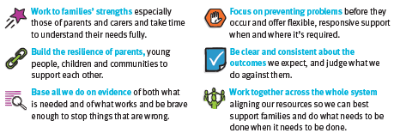

**and we will know if we have been successful when …**

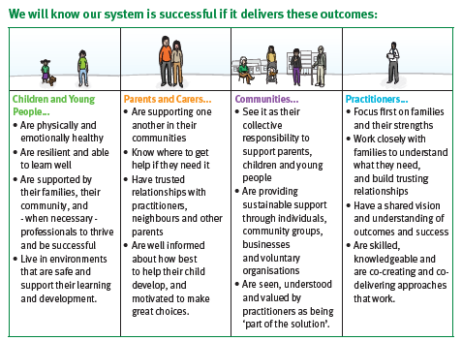

**3.**

**Purpose of the Family Innovation Fund**

3.1 The Family InnovationFund enables ECC to work with its partners in the voluntary and community sector to deliver good outcomes as early as possible. The services will not support those children, young people and families already known to and in receipt of support from specialist and statutory services, rather they will ensure delivery of support that complements, not duplicates existing services such as;

* School funded support at additional levels of need
* Essex Child and Family Wellbeing Service
* Essex Integrated Wellbeing Service
* Child and Adolescent Mental Health Service
* Family Solutions

3.2 By Early Intervention we mean stopping something occurring or getting worse and for the purposes of this funding will provide brief, light touch interventions that will enable children, young people, parents and carers to draw on their own resources and resilience to resolve future problems.

3.3 This Grant is concerned with working with children and young people, parents/carers and families who will benefit from receiving support by way of ***Brief Solution Focussed Support (BSFS)*** such as coaching, mediation, conflict resolution, counselling, through 1:1, group and family/parent/couples work. This will usually take place in face to face however, it may also take place using on-line platforms if that is deemed appropriate, for example during holiday periods or weekends/evenings.

**4. Outcomes**

4.1 ECC will consider applications from organisations that can demonstrate they can deliver the following high-level outcomes for children, young people aged 8 – 19 years and/or their families/parents/carers/couples.

|  |  |  |  |  |
| --- | --- | --- | --- | --- |
| **Priority** | **Stable, Resilient and Safe Families** | | | |
| **High level outcomes** | **Behaviour choices that promote safety and wellbeing** | **Socially connected, resilient and resourceful families** | **Healthy family and social relationships** | **Emotionally healthy, happy and resilient** |

* + 1. **Behaviour choices that promote safety and wellbeing:** Many children, young people who are on the margins of society are more exposed to the risks of being exploited and participating in ‘risky behaviours’ including involvement in for example, drugs, alcohol, gang crime and sexual exploitation which compounds their problems and results in poor outcomes.
    2. **Socially connected, resilient and resourceful families:** We know that many children, young people and families are socially isolated and we expect that as a result of the work undertaken children, young people and parents/carers will be supported to connect to their local communities in ways that are meaningful to them.
    3. **Healthy family and social relationships:** Many families live in circumstances that place pressures on relationships and/or their ability to function effectively. Some parents and children lack the skills needed to communicate effectively and resolve things with each other. This can often result in relationship breakdown and poor outcomes for children and young people. Additionally some of the modern day pressures and circumstances young people are operating in can result in the forming of unhealthy, too often which are not recognized until personal wellbeing has been impacted
    4. **Emotionally healthy, happy and resilient:** Enabling positive behaviour change and choices; connecting people with peers and their communities; and supporting parents, carers, children and young people to have positive relationships, inevitably results in emotionally healthy, happy and resilient children and young people.
  1. To enable us to continue to build on the evidence for early intervention and the impact of FIF, successful applicants will be expected to evidence the outcomes being delivered by adopting the use of the Outcomes Star tools that are:
* Family Star
* Family Star (relationships)
* My Star (young people)

**5. The Grant Size, Geographic Model**

5.1 The total Family Innovation Fund is £1,200,000 over three years, with £720,000 allocated to BSFS through 1:1, group and family/couples work.

Year 1 2023/24 £300,000

Year 2 2024/25 £210,000

Year 3 2025/26 £210,000

5.2 BSFS willbe delivered across Essex but priority will be given to The Essex Levelling Up areas set out in the table in 6.1 to support the delivery of our levelling ambitions and Everyone’s Essex Plan [Everyones Essex](https://www.essex.gov.uk/plans-and-strategies/everyones-essex)

5.3 There will be provision within the Grant Agreement, at the discretion of ECC to extend the grants for up to two years on a one plus one year basis. There will be further provision for the value to be varied within any extension up to the original year one value namely £300,000.

5.4 Provision in the Grant Agreement (clause 12) outlines the conditions under which ECC will either withhold or claim back funds paid to the provider.

**6. Minimum Targets and Pricing**

6.1 The minimum number of young people to be supported is set out below. The figures are based 1:1 work, small group work 4-6 maximum and family/couples working.

|  |  |  |  |  |  |
| --- | --- | --- | --- | --- | --- |
| **Essex Quadrants**  (a) | **Grant Value**  **Year 1**  (b) | **Minimum reach Year 1**  (c) | **Grant Value**  **Year 2 & Year 3**  (d) | **Minimum reach Year 2 to 3 per annum** (e) | **Levelling up priority areas** |
| **South 29%**   * Basildon * Brentwood * Castle Point * Rochford | £87,000 | 460 | £60,900 | 321 | 50% of reach   * Lee Chapel Laindon * Five Links Laindon * Felmores, Pitsea * Canvey Island |
| **Mid 23%**   * Braintree * Chelmsford * Maldon | £69,000 | 364 | £48,300 | 255 | 50% of reach   * Braintree rural north |
| **North-East 28%**   * Colchester * Tendring | £84,000 | 443 | £58,800 | 310 | 50% of reach   * Greenstead Estate * Clacton, Jaywick, * Harwch |
| **West Essex 20%**   * Epping * Harlow * Uttlesford | £60,000 | 317 | £42,000 | 222 | 50% of reach   * Harlow |
|  | £300,000 | 1,584 | £210,000 | 1,108 |  |

6.1.1 Column C outlines a ***minimum*** target of referrals to be worked with in conjunction with BSFS through 1:1 and group work per annum based on a grant of £300,000.

6.1.2 A minimum number of referrals will be expected to be supported with at least 20% of the total provided via 1:1 support. Please refer to the Grant Spending plan for further detail. Therefore, 80% of referrals will be supported through group work with an average of 4 per group.

6.1.3 Column E outlines a minimum target of young people to be worked with using BSFSthrough 1:1 and group work for Years 2 and 3 based on a grant of £210,000.

**Example (for illustrative purposes only)**

|  |  |  |  |
| --- | --- | --- | --- |
| **Solution Focussed Support Programme** | | | |
| **Quadrant** | **1:1** | **Group Work** | **Total** |
| **Min. Volume** | **Min. Volume** |  |
| **South** | 170 | 290 | **460** |
| **West** | 117 | 200 | **317** |
| **North East** | 163 | 280 | **443** |
| **Mid** | 134 | 230 | **364** |
| **Total** | **584** | **1,000** | **1,584** |

The referrals for South total 460. Of the 460 target it is expected that 170 will be 1:1 referrals and an further 290 will be supported through group work. Based on a group of 4 this would be 73 groups delivered across South Essex. In total the BSFS will reach a minimum of 1,584 in Year 1.

6.2 Within the pricing element a score will be given to the number of referrals reached of which the minimum number of referrals must be achieved. Where the minimum number is not reached no score will be awarded. The maximum score available is 30%. The applicant with the highest number of children supported will achieve the maximum score. The pricing schedule sets out the format and guidance for your financial submission.

6.3 As a guide to help you, the evidence tells us that early intervention can deliver good outcomes over an average of 12 hours direct delivery across an average of 12 weeks of starting support.

6.4 A 1:1 referral means the person/couple referred for support (any group work will required individual referrals).

6.5 Group work ratios should be reasonable in that the worker can identify outcomes have been delivered as a result of the work. Large groups such as classes, year groups and assemblies are not deemed appropriate.

6.6 When supplying costs these should be realistic and demonstrate value for money.

6.7 Subsidy: takes the meaning given in the Subsidy Control Rules, generally any support measure that:

6.7.1 Constitutes a financial (or in kind) contribution provided by a public authority; and

6.7.2 Confers a benefit on the recipient in the sense of an economic advantage that in not available on market terms; and

6.7.3 Affects international trade.

6.8 Subsidy Control Rules: means the law in force from time to time in the UK including the law embodied in the European Union (Future Relationship) Act 2020, the Trade Agreements and any other UK or international law relating to subsidy control in the UK and all other legislation and regulatory requirements in force from time to time which apply to measure granted by a public body to an economic actor, as may be updated from time to time.

**7. Collaborative Working**

7.1 Collaborative applications are permitted but there must be a designated lead who will make the grant application and demonstrate how their partners will work together as a system to deliver the BSFS in accordance with expectations set out in this guidance. That designated lead will ensure the Grant Agreement is adhered to and will be with ECC will have the Grant Agreement.

7.2 We expect the successful provider to understand the early help partnership and delivery landscape in Essex and to work collaboratively within that landscape to ensure children and young people are able to access the right help at the right time.

**8. The Delivery Model**

8.1 The delivery model is built on a range of evidence and intelligence including:

* The independent evaluation findings of the original 2017 FIF Programme
* The independent evaluation of the current FIF Xtra
* Current needs analysis and local intelligence
* What is already being delivered within the children’s system.

8.2 We want to ensure we continue to support the positive progress and learning from previous FIF programmes and ensure that what we know works continues to be adopted. Therefore, the following elements of delivery are mandatory:

8.2.1 Applicants agree to use the request for support form that will be jointly agreed and provided by ECC

8.2.2 The agreement to take up the Family Innovation Fund service forms part of the individuals’ agreement to access the service provision, the form to be used for this purpose will be supplied following award of the grant, as part of mobilisation in readiness for commencement of services from 1st April 2023.

8.2.3 There should be one access point in for referrals appropriate assessment should be carried out and, if accepted, allocated appropriately. Where the referral is not appropriate, or there are capacity issues, the provider should undertake to work with other local agencies who could support the person(s) being referred.

8.2.4 Practitioners will take a whole family approach to support a referral to ensure the successful delivery of an outcome for the person referred.

8.2.5 Applicants will have developed appropriate and jointly planned strategies and pathways for individuals’ exit from the interventions being delivered.

8.2.6 We know there will be a high volume of referrals and that demand will outstrip supply. Applicants must manage these waiting times appropriately and where possible signpost and refer to other services.

8.3 Except where noted in the below section 8.5 children, young peopleaged 8 – 19 year and/or their parents/carers/couples can access FIF regardless of ethnicity, gender, culture, religion, special educational and/or disability.

* 1. As noted in section 6.1, 50% reach should target the identified “levelling up” areas and in addition to that every effort should be made to ensure support for those on part-time school timetables and/or at risk of exclusion or socially isolated and that support is fully accessible to those learning disabilities/needs and/or autism so they are able to participate in a meaningful way.

8.5 Exclusions from accessing FIF support are those who are already open to specialist and statutory services for example:

* Children’s Social Care
* Family Solutions
* Child and Adolescent Mental Health Service
* Drug and Alcohol Services
* Youth Offending Service

8.6 The provider will liaise closely with the Essex Family Hub, the Essex Children and Family Hub and the Child and Adolescent Mental Health Service Single Point of Access to ensure a relevant pathway for referrals that have not met their criteria or received a service from them prior to the date of the referral.

8.7 Referrals for children and young people who meet the Child and Adolescent Mental Health Service eligibility criteria and/or have medically or clinically diagnosed mental health condition should not be accepted.

**9. The Interventions and Approach**

9.1 The support and interventions to be delivered have been determined through the original 2015 FIF evidence review of what works and the 2017 evaluation of the current FIF programme and research for what works. These are expected to include brief solution focussed therapeutic approaches/techniques, coaching, mediation and conflict resolution.

9.2 The successful applicants will have a robust track record of and capability to deliver brief solution focussed support for 8-19 year olds, families and couples.

9.3 Practitioners be qualified/skilled workers to deliver the support and interventions set out in providers bids and they should have extensive knowledge about child, adolescent, parental risks, behaviours and impacts to achieving good outcomes.

9.4 Applicants will be expected to confirm their collaborative can deliver all the above and that their proposals will be delivered by suitably qualified/trained/experienced practitioners who have been employed under their Safer Recruitment Processes and have undertaken induction, safeguarding training and will receive on-going suitable management and supervision support.

9.5 Children and young people have told us that they do not like missing lessons at school and that when they do it is always the same lesson because of the times practitioners set. We expect every effort to be made to avoid this happening.

**10. Eligibility**

10.1 The Family Innovation Fund is available to voluntary and community sector organisations delivering appropriate services if delivery will benefit children and young people as individuals, or families as a whole. The fund is available to organisations that focus on wider public benefit as opposed to statutory service delivery or profit and as such the following can apply:

* Registered voluntary and charitable organisations
* Most co-operatives and social enterprises (provided profits are retained for the benefit of the members or community served).

10.2 Organisations may take a variety of forms including one or more of the following:

* Mutuals
* Community interest companies
* Industrial and provident societies
* Not for profit trade associations
* Charitable trusts
* Companies limited by guarantee
* Unincorporated groups.

10.3 Applicants will be expected to ensure they and the organisations they are collaborating with, promote equality of opportunity and fair access, support for employees who have unpaid caring responsibilities as well as ensuring there are safeguarding and health and safety policies in place.

**11. Period of Funding and Payment Structure**

11.1 Family Innovation Fund services will commence on the date that ECC is in receipt of the signed Grant Agreement, that being no later than 1st April 2023 and all work MUST be completed no later than 31st March 2026.

11.2 Grants will be paid in instalments outlined below:

11.2.1 25% of the total grant awarded will be paid directly into the Provider recipient’s bank account on 1st April 2023 provided ECC, as the local authority, is in receipt of the signed Grant Agreement and the required safeguarding, equality and health and safety policies, and other documentation agreed during the application period and quarterly thereafter on receipt of satisfactory grant monitoring returns as set out in section 13 of this Grant Prospectus.

11.2.3 Following the first payment 1st April 2023, payment of interim and final instalments will be delayed or cancelled where it is found that recipients are not adhering to the Grant Agreement of the grant. ECC reserves the right to claw back payments of grant monies in part or in full as detailed in the Grant Agreement.

11.2.4 Any breakdown in the collaborative agreement(s) is the responsibility of the designated lead to manage and resolve and to ensure no disruption to the service delivery.

11.2.5 Any grant monies held by the designated lead that remains unspent will be returned to the Local Authority.

**12. Restrictions of Grant Use**

* 1. Family Innovation Fund grants cannot be used for:
* costs to existing core services/delivery not directly related to FIF
* core staff expenses not directly related to FIF
* capital expenditure not related directly to FIF
* rent or utility bills not directly related to FIF
* goods or services received before the award of the funding
* activities that promote one particular religious belief/political cause
* loan repayments

**13. Monitoring Arrangements**

13.1 Self-monitoring returns will be required quarterly; June, September, December, March on a pro-forma agreed with the designated lead and provided by ECC.

13.2 As part of the monitoring arrangements, ECC will expect organisations to report on qualitative and quantitative measures, including outcomes star reports and financial returns.

13.3 There will be a minimum of two contacts per annum with providers during the course of the grant and additional contacts/visits carried out where it is judged that these are necessary to ensure all grants are completed in accordance with the Grant Agreement.

13.4 ECC will take a simple approach to monitoring, focussing on effect and impact as outlined below and successful applicants will be provided with the pro-forma from the ECC Performance via email when the grant awards are made.

**Effort - What and how much**

**No. of referrals**

**By Primary outcome**

**By Age**

**By Gender**

**By Disability (category)**

**By Postcode**

**By Intervention - 1:1 & Groups**

**By Received & By Accepted**

**Signposted (destination)**

**Levelling up**

**Effort - How well have we done it**

**Demographics**

**Expenditure**

**Provider feedback from; Service users;**

**Referrers; Stakeholders**

**Working with more than the referred person**

**Effect - How many are better off**

**No. Closed successfully (time)**

**No. Closed prematurely (reasons)**

**Average case time by both hours and weeks**

**Effect - What % are better off**

**What change / impact**

**Outcome Star database generated reports for; Family Star; Family Star (relationships); My Star.**

**With short analysis**

**Collaborative Enquiry**

13.4 As part of our commitment to involve the public in service development and improvement, contacts and visits may involve children, young people and families themselves.

13.5 Essex County Council will be asking the successful provider to supply information on those accessing the service and where support has been successful and outcomes delivered that meet the Department of Work and Pensions Supporting Families outcomes framework. This enables the council to make a claim under the Supporting Families Payment by Results (PBR) allocation for Essex, funding for which supports the continued delivery of Early Help. Supporting Families

**14. The Application and Decision Making Process**

14.1 Applications should be completed and will only be accepted via the ProContract. Organisations must register using the following link:

[**https://procontract-ufe.due-n****orth.com/register**](https://procontract-ufe.due-north.com/register)(Supplier Registration)

14.2 All sections within the application form must be completed for an application to be considered. There are a number of pre-requisite questions that must be answered satisfactorily before a full application can be made and considered.

14.3 Each application will be scored against the criteria set out in the application guidance which you should review with your application to ensure you have fully addressed all the salient points.

14.4 All written applications must be submitted via the e-portal by **12 noon on Friday 16th December 2022**. Please note that for your submission to be considered compliant, the Council **MUST** receive your written response by the specified deadline. Any late submissions will be rejected as non-compliant.

14.5 Applications will be evaluated by a panel of commissioners and moderated through a process supported by the ECC Procurement Team.

14.6 Successful applicants will be required to sign the Terms and Conditions that are to be read in conjunction with this Grant Prospectus. Any queries about the Grant and the Grant Terms and Condition must be raised during the clarification period.

14.7 Successful and unsuccessful applicants will be notified of our intentions and unsuccessful applicants will receive feedback as to why they were not successful within that notification.

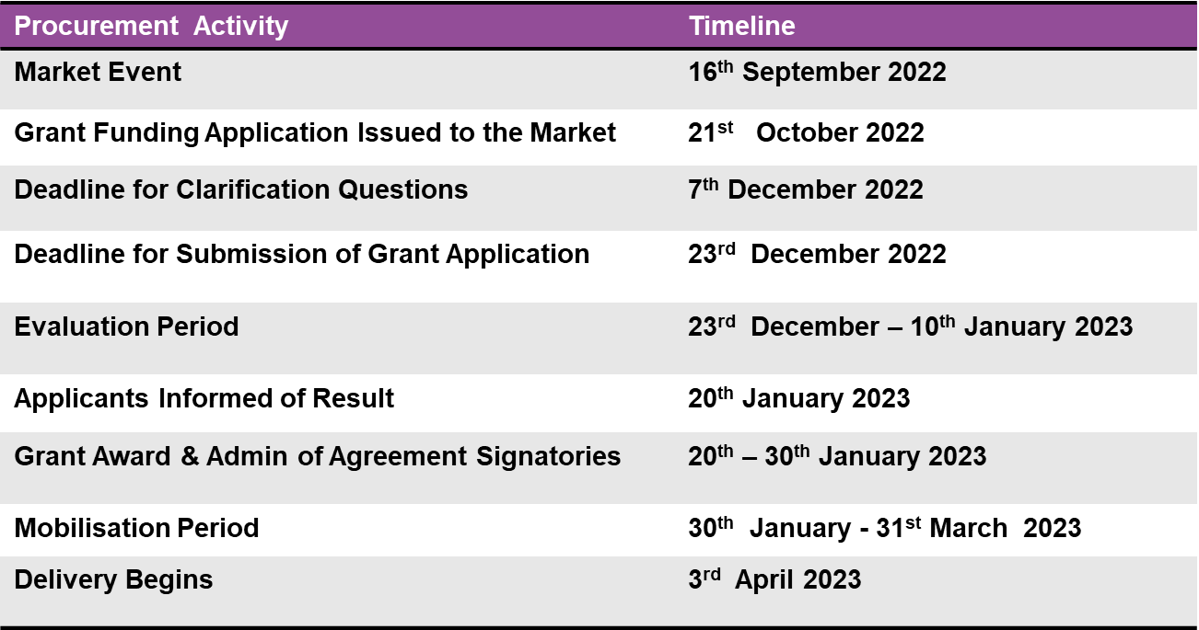14.8 Procurement timetable:

1. **Safeguarding**

15.1 The service will take all reasonable steps to support vulnerable children, young people or vulnerable adults (“vulnerable people”) that you work with and will take all reasonable steps to ensure their safety. You will apply the Southend, Essex and Thurrock (SET) safeguarding and child protection procedures. You will obtain the written agreement from the legal carer or guardian before having any direct contact with any vulnerable person. You will have and carry out an appropriate written policy and set of procedures in place at all times to safeguard vulnerable people, which will include obtaining appropriate qualification and disclosure checks for all employees, volunteers, trustees or contractors who will supervise, care for or otherwise have significant direct contact with vulnerable people.