|  |  |  |
| --- | --- | --- |
| **Project Name:** | **Southern Windermere Trails** | LDNP2016 |
|  |  |
|  | **Route Visualisation Section 4 and 5** |
|  | | |

### Section 4 – Great Knott Wood to Stott Park Bobbin Mill via Finsthwaite

**Section 4a 000 – View N**

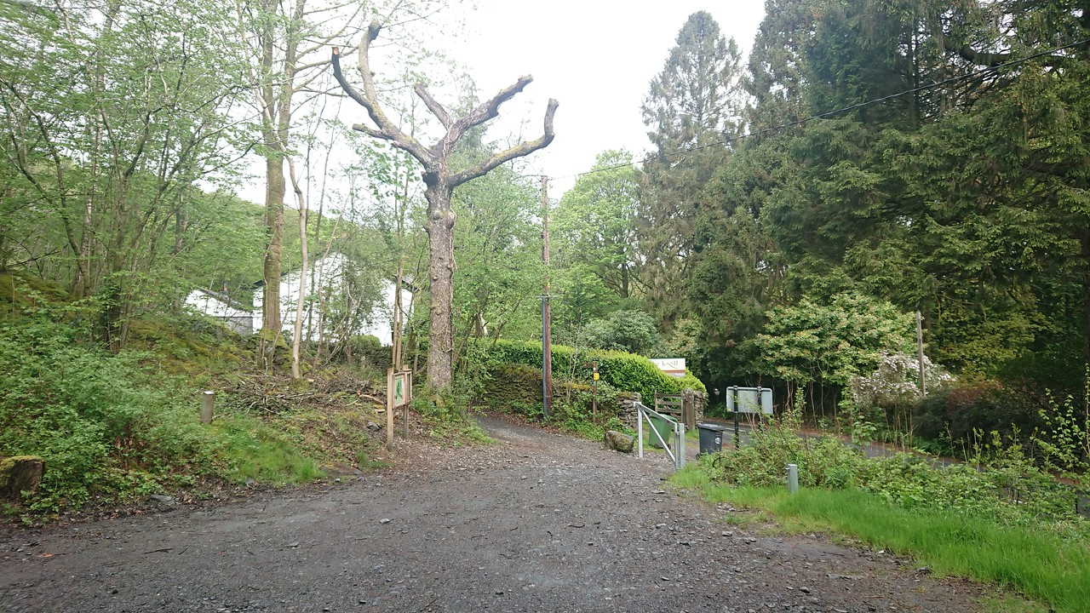

000

**Section 4a 100 – View W**

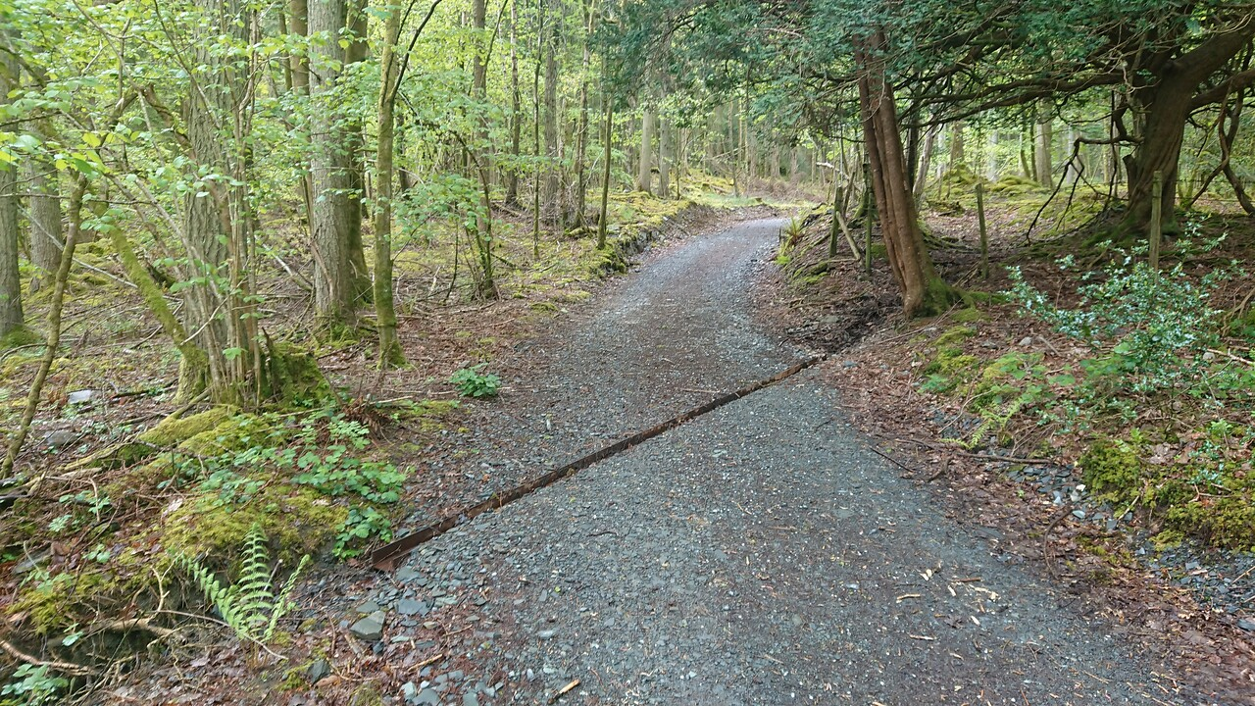

4 a

**Section 4b 400 – View W**

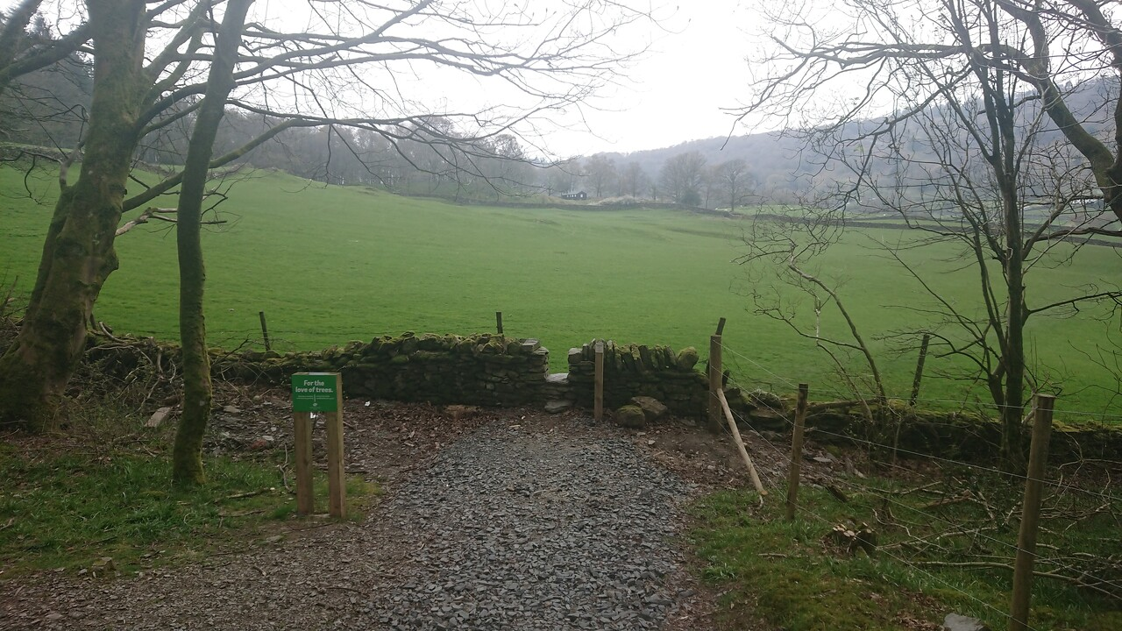

4 b

4 a

400

**Section 4b 400 – View E**

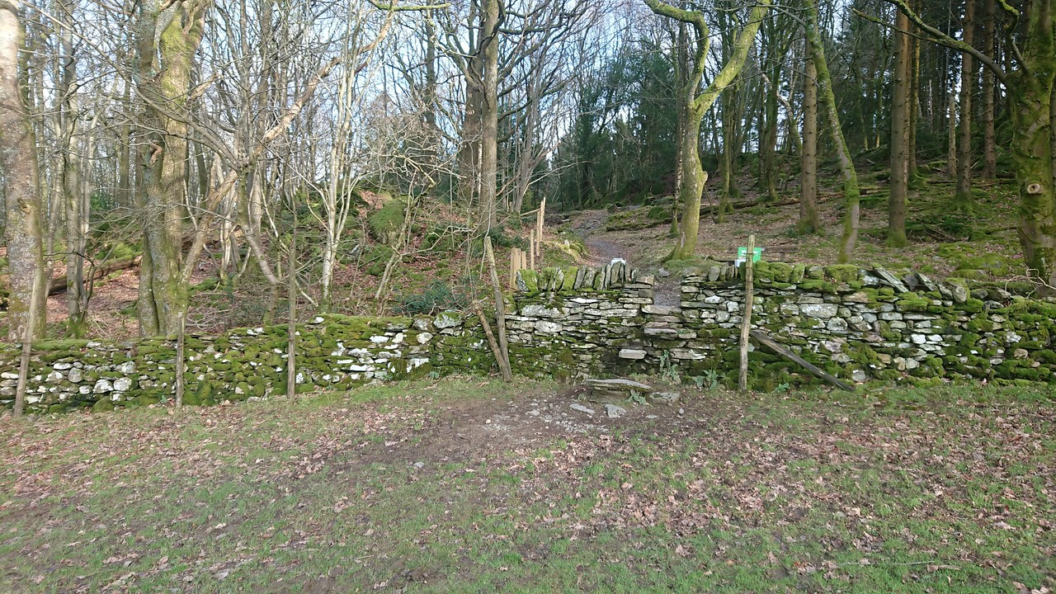

4 b

400

**Section 4b 420 – View W**

[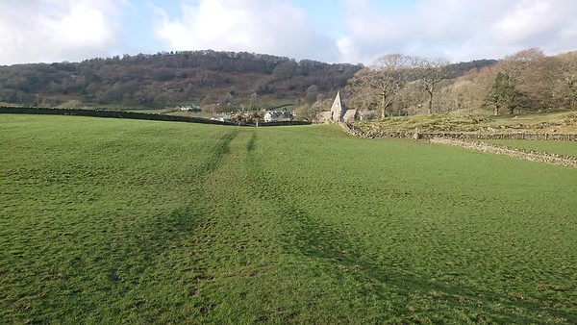](https://bruce-wilkinson.smugmug.com/SWT-Photos-/n-st8nqD/i-MbjKBN6)

4 b

582

**Section 4b 582 – View W**

[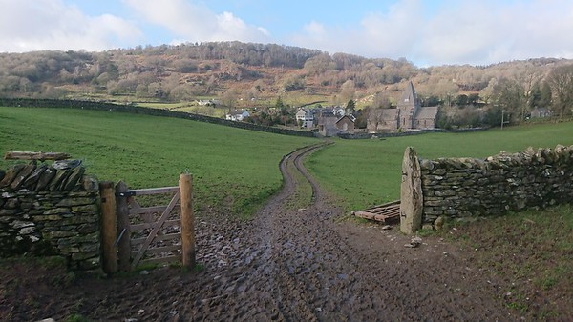](https://bruce-wilkinson.smugmug.com/SWT-Photos-/n-st8nqD/i-CCjqFg7)

4 b

702

582

**No images of 4c – Existing Highway**

### Section 5 – High Dam to High Stott Park

**Section 5a 030 – View NW**

[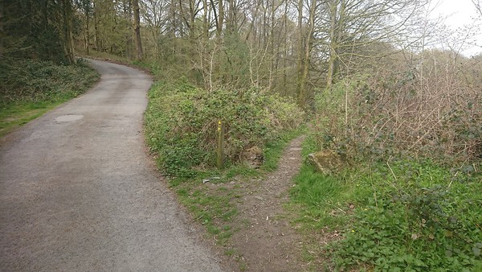](https://bruce-wilkinson.smugmug.com/SWT-Photos-/n-st8nqD/i-TFnFWJ9)

036

5 a

**Section 5a 050 – View N**

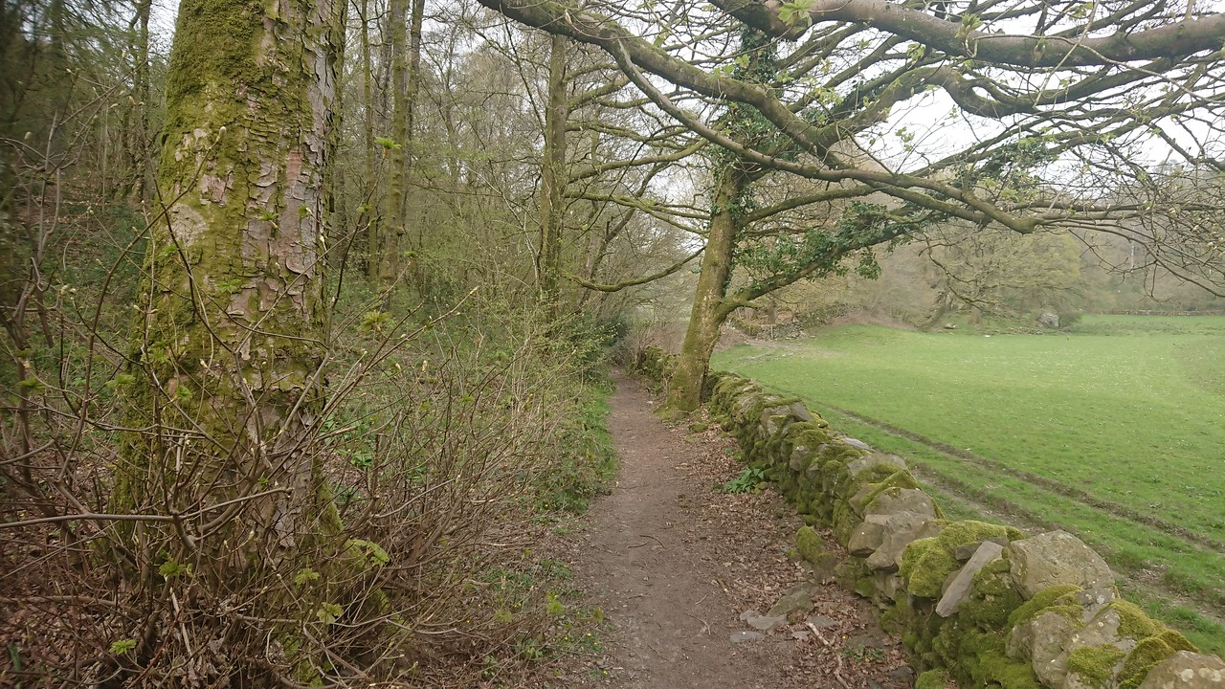

5 a

**Section 5a 128 – View N**

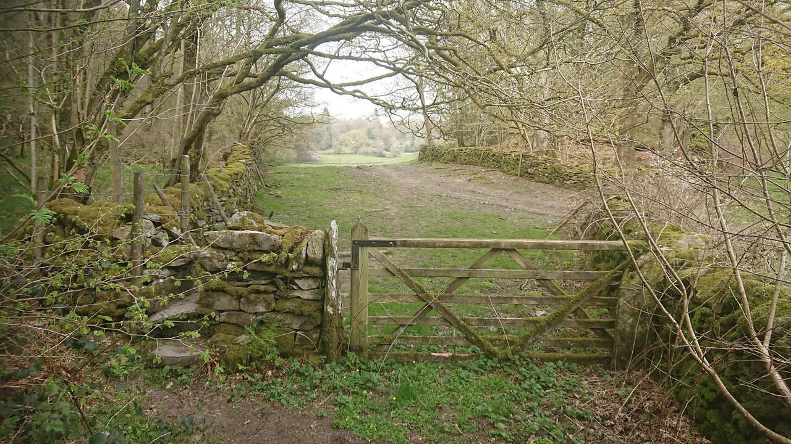

126

5 b

5 a

**Section 5b 250 – View S**

[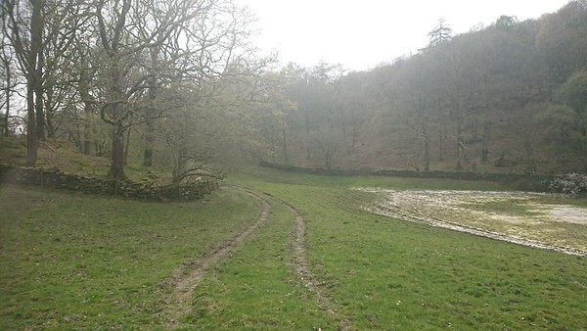](https://bruce-wilkinson.smugmug.com/SWT-Photos-/n-st8nqD/i-HZ4BsCW)

377

5 b

**Section 5b 250 – View N**

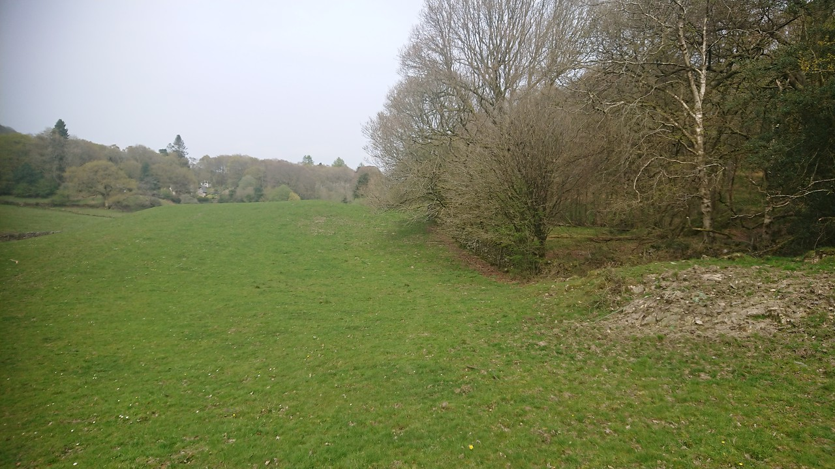

5 b

**Section 5c 500 – View S**

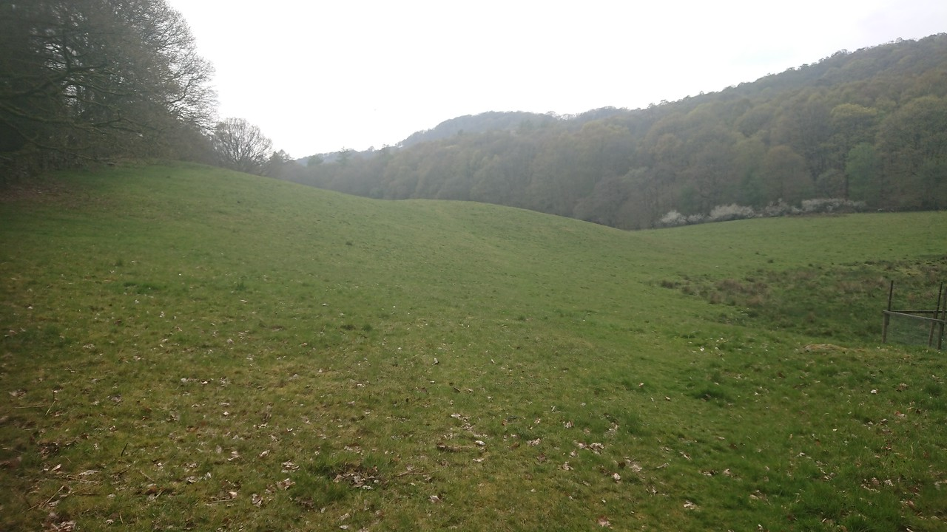

5 c

**Section 5c 500 – View N**

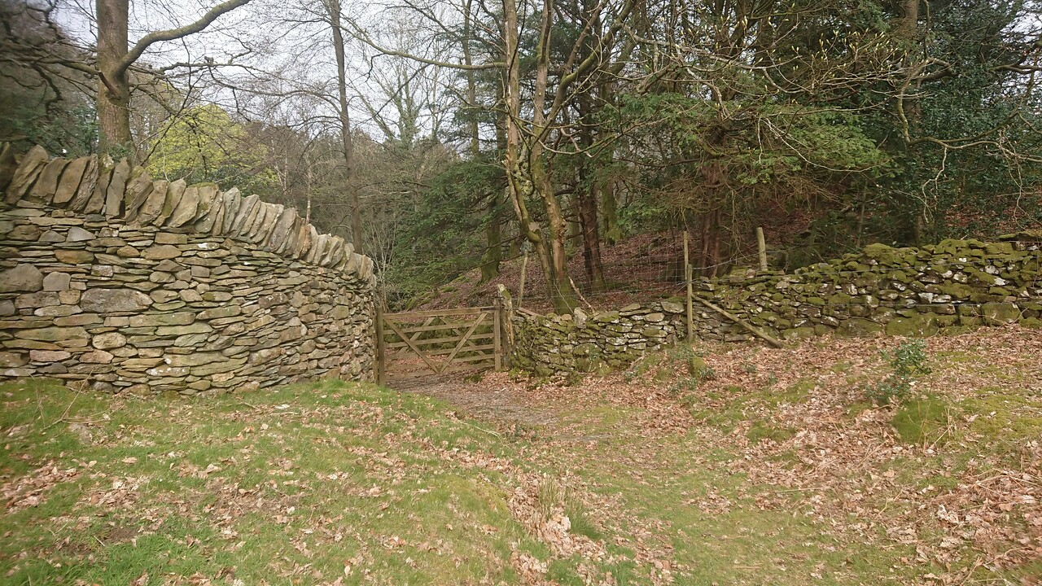

5 c

502

**Section 5d 550 – View N from 500m mark in section 5c**

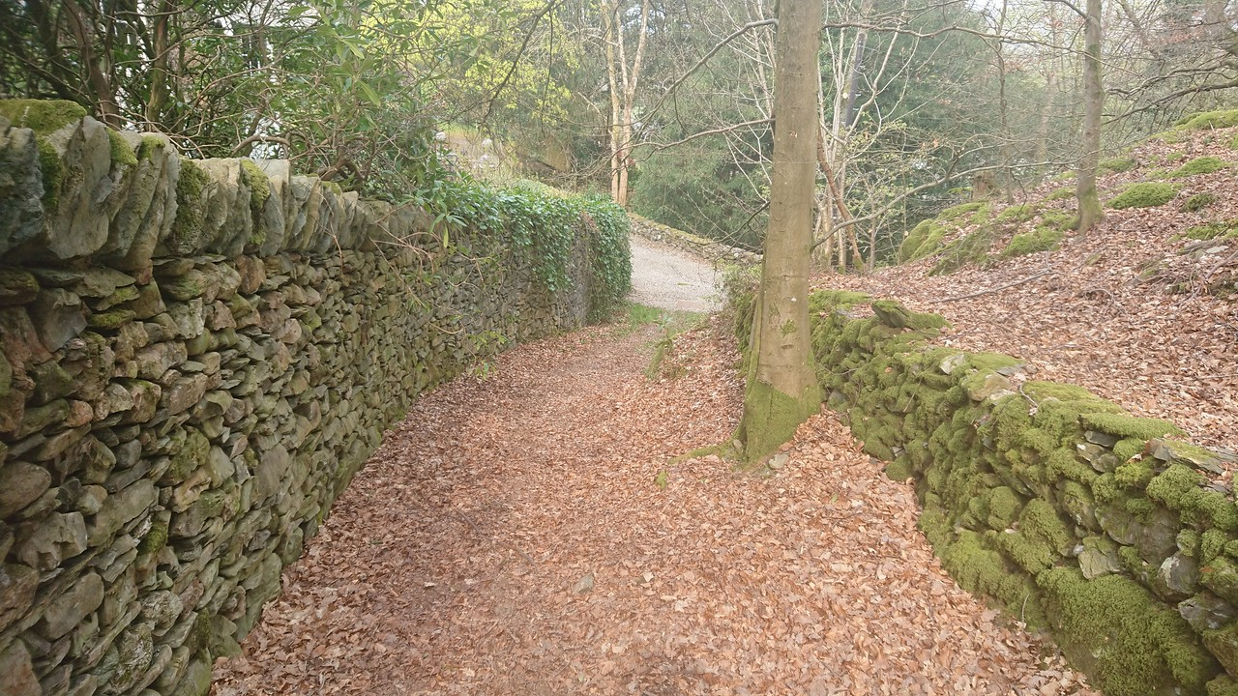

526

5 d

**No images of 5e – Existing Highway C5026**