

Council

**Soft Market testing**

Microfiche Scanning Project

Contract Period:

**TBC**

1. **Background**

Stockport Council has a requirement to digitise and index microfiche records and make them available in a secure, searchable format on the Council network.

These microfiche records relate to the following services and will therefore be in 3 lots:

1. Children’s Services – social care and adoption documents
2. Planning – planning applications, plans and drawings
3. Human Resources – payslips, contracts and letters

Suppliers are asked to respond on the basis of doing all 3 lots.

The volume of records has not been fully quantified at this time. Records are held on standard 4 inch by 6 inch cards. The records are held in a variety of sized filing cabinets and boxes as follows:

|  |  |  |  |
| --- | --- | --- | --- |
| Service Area | Number of Drawers | Rows per drawer | Cabinet Size |
| Children’s Services | 8 | 2 | H: 132 cm , W: 39 cm, D: 62 cm |
| Planning | 20 | 3 | H: 136 cm, W: 57 cm, D: 62 cm |
| Planning | 15.5 | 2 | H: 136cm, W: 57cm, D: 62cm |
| Human Resources | 2 | 2 | H: 40 cm, W: 32 cm, D: 63 cm |
| Service Area | Number of Boxes | Rows per box | Box Size |
| Human Resources | 70 | 2 | H: 13 cm, W: 16 cm, D: 10.5 cm |

We would like to take the opportunity to do some `soft market testing’ to support us in finding the right solution for digitising these microfiche records. Through this exercise we are looking for providers to advise us of the solutions they can offer to meet a range of initial requirements as outlined below.

1. **Key Aims**

To gain an understanding of the digitisation process in particular the following areas:

* Quantities – at this stage there is no reliable estimate of quantities of records held therefore any assistance with how to estimate is sought (record storage details provided above and in Appendices)
* Collection methodology - all microfiche records must be collected from Stockport Council
* Timescale for turnaround/ digitisation of data – there are currently no specific timescales attached to this work
* Access to records during the scanning process – some of the records are in constant use and may be required for casework at any time therefore arrangements need to be considered to enable timely access
* Output format – file format to enable records to be text searchable (preferred PDF) and not unnecessarily large (not exceeding 10MB)
* Record indexing - digital records to be indexed according to service specifications (this will be different for each lot) and searchable on index references
* Returns methodology – all records must be securely returned to Stockport Council preferably direct to SharePoint
* Confidentiality - information held on the microfiche films by the Council includes information of a highly confidential/restricted and sensitive nature; security and protection of information in both physical and electronic records is paramount
* Records disposal - secure destruction and disposal of all microfiche records following a period of user acceptance/ quality assurance testing

**Project Timescales**

|  |  |
| --- | --- |
| **Stage of the project** | **Anticipated deadline** |
| Soft market testing | 6th June |
| Q&A Meetings/Demo | w/c 20th June |
| Progress to tender | July |
| Closing date for suppliers to have submitted documents | August |
| Result of Procurement Process | End August |
| Contract Start Date | September |

1. **Soft Market Testing**

**THIS IS NOT A CALL FOR COMPETITION**

The Soft Market Test is intended to allow interested organisations with relevant experience to outline their views and provide information with no commitment to themselves or the Council.

The Council is looking to award a contract commencing September 2022. We are using this as an opportunity to determine a budget range for digitisation of the data and also project delivery.

**Stage 1 -** Interested suppliers are required to complete the following company information form and a short questionnaire (at appendix 1). Suppliers who complete and return the questionnaire ***may*** be invited to meet with Council representatives to discuss its requirements.

The questionnaire should be returned via The Chest - <https://www.the-chest.org.uk/> by 5pm on 6th June 2022

If Suppliers have any questions about this soft market test, such questions should be submitted to the Council using the ‘Question and Answer’ facility within the opportunity advertised on The Chest. A copy of the question and a copy of the written reply may be circulated to all Suppliers, with anonymity of the Supplier preserved. Suppliers must not raise questions through any other channels, including emails direct to the Council or to STAR Procurement. No questions will be responded to, other than those raised through The Chest as described above

**We encourage your participation in this soft market testing exercise, but must emphasise that your involvement in this exercise will not carry any commercial advantage in any ensuing procurement process.**

**No information provided in response to this soft market testing exercise will be used in any evaluation of any subsequent response to a procurement exercise.**

1. **General Information**

|  |  |  |
| --- | --- | --- |
| **3.1** | Full name of your organisation: | Stockport Metropolitan Borough Council |
| Contact Details Name: | TBC |
| Job Title: | TBC |
| Address: | Fred Perry House |
| Telephone no: | N/A |
| Fax No: | N/A |
| Mobile No: | N/A |
| Email Address: | [samantha.power@star-procurement.gov.uk](mailto:samantha.power@star-procurement.gov.uk) |
| Web Address (if any): | [www.stockport.gov.uk](http://www.stockport.gov.uk) |

1. **Undertaking from the supplier**

|  |  |
| --- | --- |
| Name:* |  |
| Signed: | Duly authorised on behalf of the Supplier  (Electronic signature required here) |
| Position: |  |
| Date: |  |

**Appendix 1 – Questionnaire**

**Please complete the following questionnaire fully, highlighting any information that you consider to be commercially sensitive\***

1. Please detail how you will meet the current and future requirements. Please pay particular attention to key aims detailed in section 2.
2. When/if the Council go to tender following the soft market test, is there anything in addition to the information in this brief that suppliers would need to be advised of in order to aid in their response. Max. 500 words
3. Please provide a case study example of where you have provided a comparable service to a similar organisation. Max 500 words
4. We have microfiche stored in a variety of different sized cabinets and boxes and hope that you will be able to estimate the volume and provide pricing information below. Please refer to appendix 2 below for pictures of storage cabinets and boxes.

|  |  |  |  |  |  |
| --- | --- | --- | --- | --- | --- |
| **Service Area** | **Number of Drawers** | **Rows of Microfiche per drawer** | **Cabinet Size** | **Estimated Volume** | **Pricing Information** |
| Children’s Services | 8 | 2 | H: 132 cm  W: 39 cm  D: 62 cm |  |  |
| Planning A | 20 | 3 | H: 136 cm  W: 57 cm  D: 62 cm |  |  |
| Planning B | 15.5 | 2 | H: 136cm  W: 57cm  D: 62cm |  |  |
| Human Resources A | 2 | 2 | H: 40 cm  W: 32 cm  D: 63 cm |  |  |
| **Service Area** | **Number of Boxes** | **Rows of Microfiche per box** | **Box Size** | **Estimated Volume** | **Pricing Information** |
| Human Resources B | 70 | 2 | H: 13 cm  W: 16 cm  D: 10.5 cm |  |  |

1. Please provide information on any additional project delivery costs outside of those quoted above.

**Appendix 2 – Storage Cabinets and Boxes**

**Children’s Social Care:**

1 x Cabinet: Height 132cm, Width 39cm, Depth 62cm

8 x Full Drawers

2 rows across

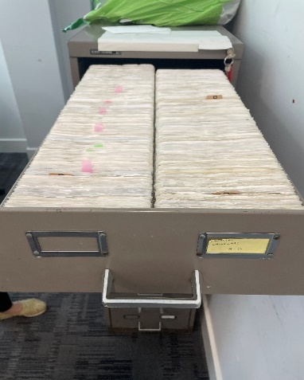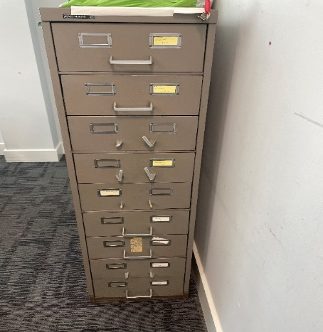

**Planning A:**

2 x Cabinet: Height 136cm, Width 57cm, Depth 62cm

20 x Full Drawers

3 rows across

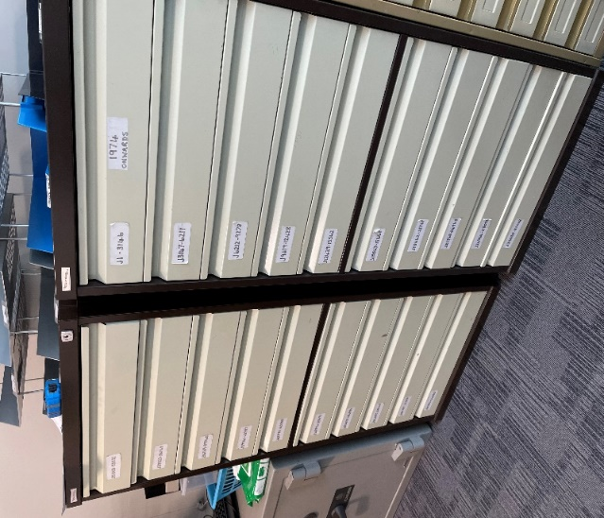

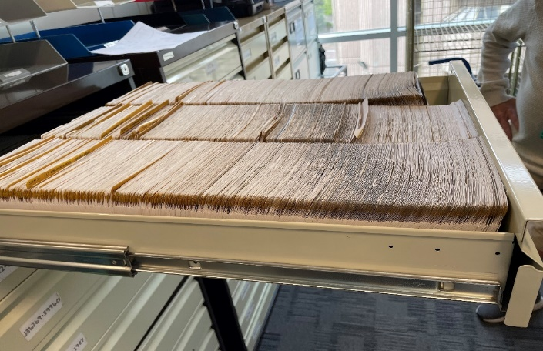

**Planning B**

2 x Cabinet: Height 132cm, Width 40cm, Depth 62cm

15.5 x Full Drawers

2 rows across  
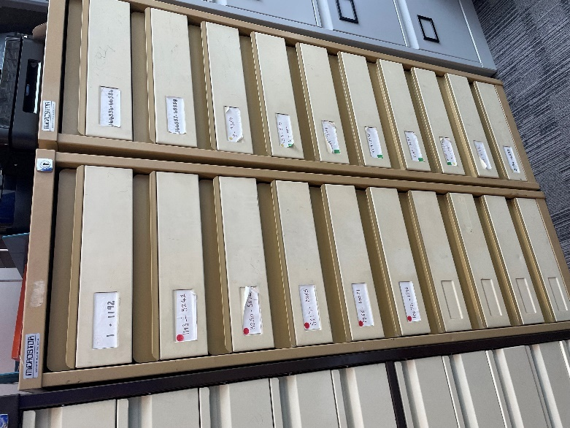 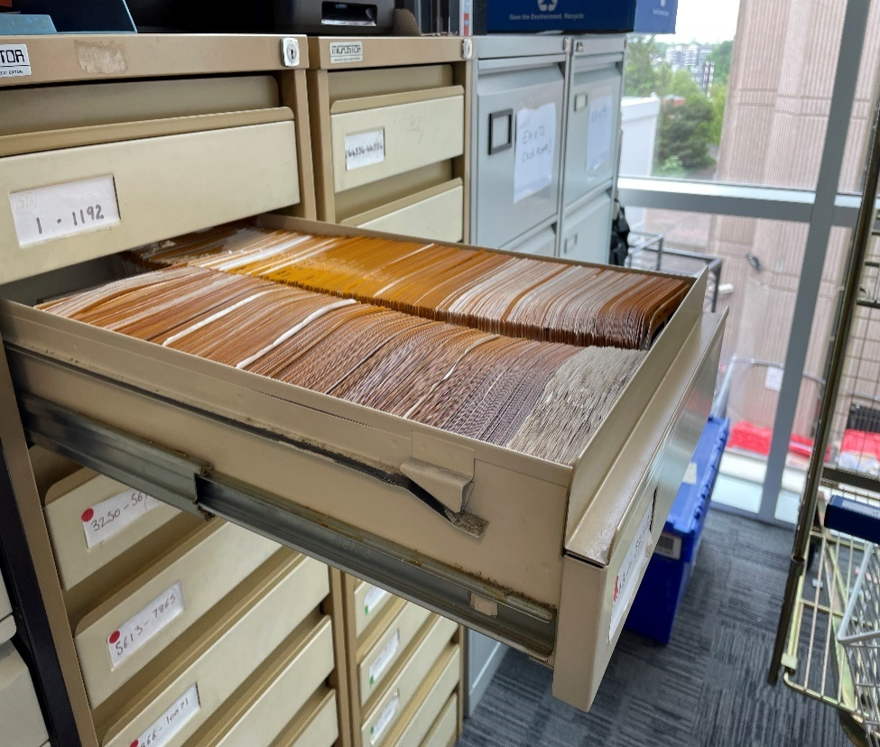

**Human Resources A**

1 x Cabinet: Height 40cm, Width 32cm, Depth 63cm

2 x Full Drawers

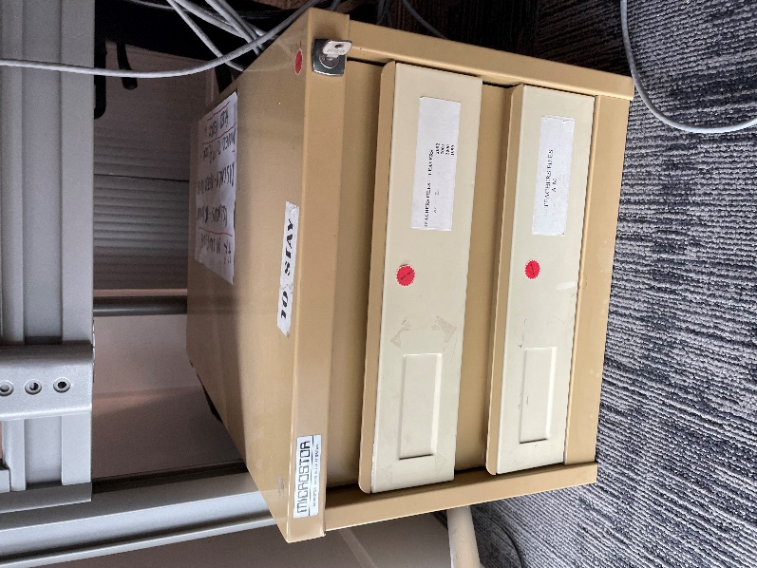

**Human Resources B**

70 x small boxes: Height 13cm, Width 16cm, Depth 10.5cm

