

www.metoffice.gov.uk © Crown Copyright 2022, Met Office

File 2- Radiosonde Background Information

OFFICIAL-SENSITIVE

Contents

Contents 2

1. Introduction 3

2. Our existing network 4

3. Overarching requirements 5

4. Procurement scope 5

5. Required number of radiosondes per annum 6

6. Procurement timeline 6

7. Images of our current automated launchers 7

# Introduction

Radiosondes are amongst the most fundamental and well-established components of the global meteorological observing system; as such, the UK and other World Meteorological Organisation Member States are committed to providing radiosonde data on a free and unrestricted basis to support our shared challenge of observing our global environment.

Radiosondes are unique in their capability, providing very high precision upper air observations and provide essential calibration data that enables the Met Office to exploit satellite and other forms of data.

The Met Office has operated, either directly or through partners, an extensive network of high-quality radiosonde systems for more than 70 years, with a combination of manned and automated sites to measure temperature, humidity and wind profiles across the atmosphere.

The observations from this network provide information used by the Met Office’s Numerical Weather Prediction (NWP) models, forecasters and climatologists. The importance of radiosonde data is unlikely to change for any users or stakeholders in the foreseeable future.

The Met Office’s current contract for the supply and support of operational radiosondes comes to an end in April 2023. This will have been in place since 2016. Furthermore, our Vaisala automatic launchers (AS15 Autosondes) are at end of life and require replacement for business continuity reasons. This contract will therefore cover replacement of the Met Office’s existing automatic launchers as well as the radiosonde supply and support contract.

Several other sites have been identified as desirable locations for increased radiosonde coverage (with automated launching). These locations address coverage gaps in the network and align to specific weather or customer requirements, however, funding is only available to install one new site. The preferred site for a 5th automated launcher is at Larkhill. A feasibility exercise needs to be undertaken to confirm this, so the Met Office may wish to install a 5th automated launcher at a different UK site.

# Our existing network

The below table lists the Met Office supported sites, in the UK and internationally.

|  |  |  |  |
| --- | --- | --- | --- |
| Location | Launch method | Met Office owned site | In scope for this contract |
| Camborne, UK | Manual | Yes | Yes |
| Lerwick, UK | Manual | Yes | Yes |
| Castor Bay, UK | Automated | No | Yes |
| Albemarle, UK | Automated | No | Yes |
| Watnall, UK | Automated | Yes | Yes |
| Herstmonceux, UK | Automated | Yes | Yes |
| Larkhill, UK | Manual/Automated * | No | Yes |
| Cardington, UK | Manual | Yes | Yes |
| Aberporth, UK | Manual | No | Yes |
| South Uist, UK | Manual | No | Yes |
| West Freugh, UK (deployable) | Manual | No | Yes |
| Pendine, UK (deployable) | Manual | No | Yes |
| Mount Pleasant Airport (Falkland Islands) | Manual | No | Yes |
| Halley, Antarctica | Manual | No | Yes |
| Rothera, Antarctica | Manual | No | Yes |
| St Helena, South Atlantic | Manual | No | Yes |
| Seychelles, Indian Ocean | Manual | No | These sites purchase their own radiosondes using Met Office funding |
| Tarawa, Kiribati (Pacific) | Manual | No |
| Funafuti, Tuvalu (Pacific) | Manual | No |

*The intention is to change from a manual site to an automated launch site.

# Overarching requirements

1. The Met Office require a single supplier for radiosondes and automated launchers. This is because the added science driven challenges and management overhead of two separate suppliers across an estate would bring too much complexity (significant burden to assessment and trials, additional spares holding, more inflexibility and little perceptible commercial advantage)
2. The Met Office are looking for a supplier with a proven track record of operational radiosonde systems and automated launchers, of the type offered for this tender.
3. The delivery of social value is of great significance throughout the life of this contract. Early market engagement has shown that some suppliers are aware of and engaging in plans to reduce their environmental impacts, either through their entire operation, and/or through design of more eco-friendly radiosondes. The Met Office has included questions worth a total of 10% in the tender on the following areas ‘Response to Net Zero’ and ‘Delivery of ‘Greener’ radiosonde initiatives with measurable outcomes’.
4. The contract scope covers options for up to 3 additional automated launchers (including Larkhill) should Met Office business need require that.
5. The Met Office expects the market to evolve towards making more use of cloud computing over the contract period. The Met Office will work with the supplier over the course of the contract to ideally enable the Met Office to move away from performing local data processing at every site using desktop computers.
6. The Met Office plans to deploy the manual and Automated systems one site at a time over approximately the first 18 months of the contract. Internal discussions are underway to agree the order and priority of installations.
7. Bidders must set out the key tasks involved in the automated launcher deployment, including equipment lead times and expectations of Met Office staff.
8. All bidders will be expected to provide all hardware and software necessary for the trial flights free of charge. Multi-radiosonde trial flights will take place at the Met Office site at Camborne, UK.

# Procurement scope

Includes: Radiosondes, manned system hardware, automated launch system hardware, software, support, any other necessary consumables, such as unwinders or valves.

Excludes: Balloons and parachutes. However, if these can be provided by the bidder as part of the contract, then please include details and indicative pricing.

# Required number of radiosondes per annum

The Met Office currently launches in the region of 5,900 sondes per year across the network.

In the first year of the contract we anticipate installing and commissioning two new automated launchers and launching in the region of 7,000 sondes across the network.

In year two we hope to install and commission the remaining three new automated launchers and launch approx. 10,200 sondes.

From year three, and for the remainder of the contract, the number of radiosondes we expect to launch per annum is estimated to be in the region of 11,000. We anticipate launching approximately 1330 sondes per year from each automated launch site.

# Procurement timeline

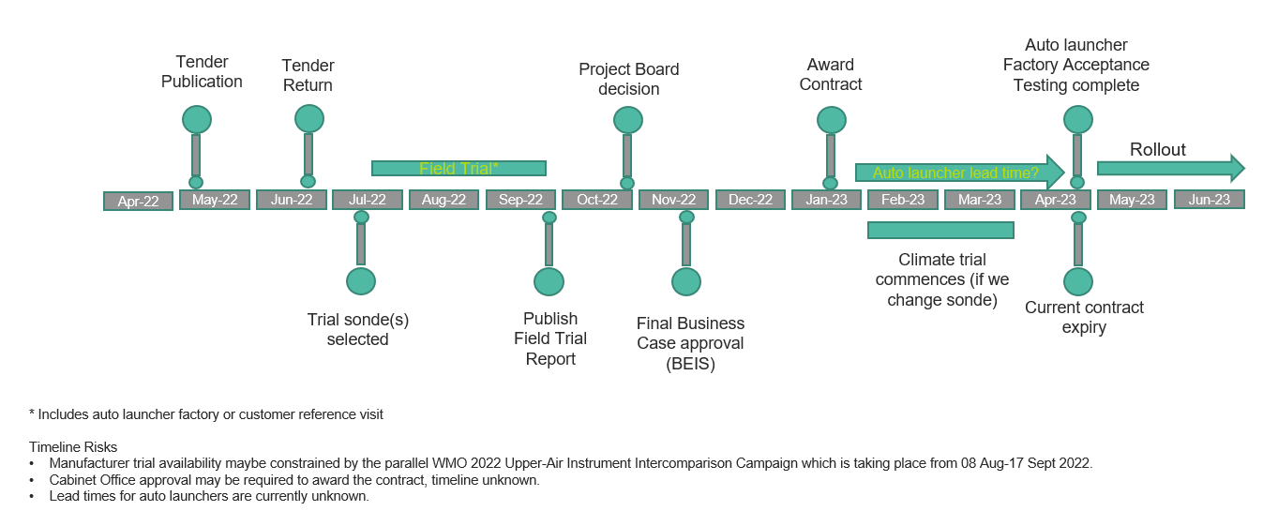

# Images of our current automated launchers

Albemarle Castor Bay

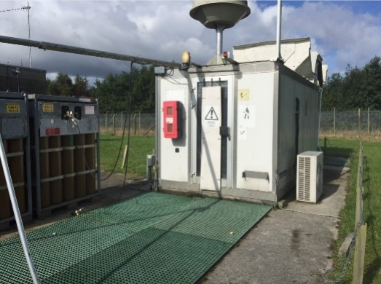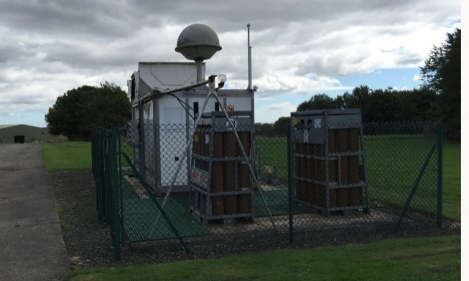

Herstmonceux Watnall

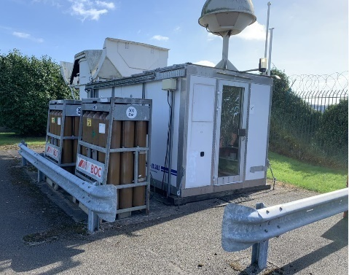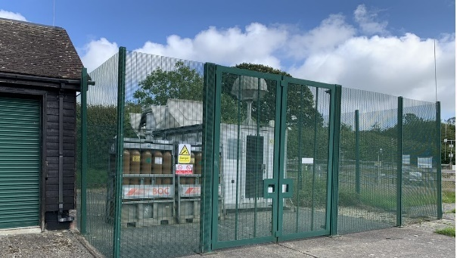

Met Office  
FitzRoy Road  
Exeter  
Devon  
EX1 3PB  
United Kingdom