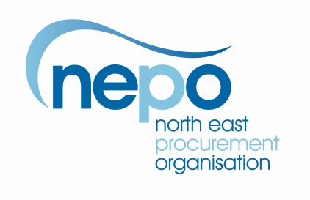

**004898 – NEPO Aggregates and Concrete**

**Market Engagement Event – Tuesday 27th September 2016**

Back in November 2015 we held a Market Engagement event in an effort to shape the way we go out to tender for Aggregates and Concrete. The result of which was that a number of potential bidders advised that they thought the proposed lotting structure was not best suited for the framework we are trying to put in place. They also commented that some of the descriptions of the various materials were not accurate, did not conform to British or European standards and that we had duplicated some.

We took note of the comments and are now holding a second market engagement event to discuss the changes we have made following the recommendations that came out of the comments.

Please will you review the excel spreadsheet posted with this note and let us have your views preferably before the event.

The lotting structure will be further expanded by the inclusion of three geographical areas:

* Durham
* Tees Valley
* Tyne & Wear

When multiplied by the material lots this will bring the total number of lots to 42 we want to know from the Market how they feel about this approach so please post any comments via the portal.

Kind Regards Chris Rush