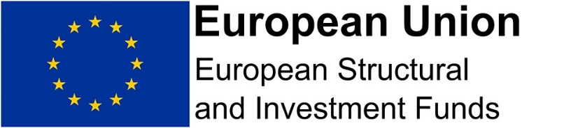

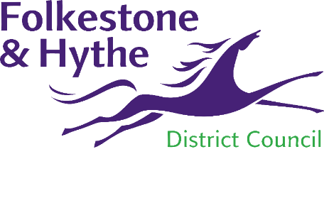

**FOLKESTONE & HYTHE DISTRICT COUNCIL**

**Mid-term Evaluation of the Folkestone Community Works CLLD Programme**

**BRIEF FOR CONSULTANCY SERVICES**

**July 2020**

**Prepared by:-**

**Folkestone & Hythe District Council**

**Civic Centre**

**Castle Hill Avenue**

**Folkestone**

**Kent CT20 2QY**

**INTRODUCTION**

Folkestone & Hythe District Council (“the Council”) wishes to appoint a suitable supplier to conduct a mid-term evaluation of the Folkestone Community Works (FCW) Community Led Local Development (CLLD) Programme 2017-2022. This is an ESIF-funded programme which under the agreement with the Managing Authorities requires a mid-term evaluation to be undertaken in accordance with ESIF guidance and best practise.

**BACKGROUND**

The Folkestone Community Works CLLD programme is one of the three CLLD programmes operating across the South East LEP area and is an ESIF-funded award under the 2014 – 2020 EU structural funds programme. The FCW CLLD programme was awarded in 2017 and will operate to the end of 2022. Folkestone & Hythe District Council is the accountable body and the programme is managed by a programme management team (PMT) within the council’s Economic Development team.

.

The FCW programme comprises £2.49 million of ESIF funding which together with the required 50% match funding is bringing a total investment of £4.9 million into the central Folkestone area.

The FCW CLLD programme is only one of three in the SE LEP area. It arose from the commitment in the South East LEP’s ESIF 2014-20 Programme Strategy to allocate ERDF and ESF funds for Community Led Local Development (CLLD) which is a new way for the UK to deliver local economic, social and environmental development and was included in the programme in support of social inclusion goals. Key features of CLLD programmes are that they are driven by local needs and adopt a ‘bottom up’ approach to delivery through a local action group (LAG).

The programmes bring both ERDF and ESF funding together to support a single integrated CLLD Strategy for a specific area within Folkestone that met key eligibility criteria including a target population of between 10,000 and 150,000 and contains the 20% most deprived areas as identified under the 2010 Indices of Multiple Deprivation.

As part of the programme application process, the Strategy for the defined FCW CLLD area was developed in 2016 and is available on [www.folkestonecommunityworks.com](http://www.folkestonecommunityworks.com). The overall aim of the programme strategy is to improve social and economic community cohesion in the area through three key objectives to:

1. Help residents to access jobs – this is the ESF element of the programme which has a total allocation of £1,950,000 (£975,000 ESF)
2. Help local businesses and start-ups to grow and provide new job opportunities – this is an ERDF element of the programme with a total allocation of £1,950,000 (£975,000 ERDF)
3. Improve communication and knowledge of activities for residents and businesses, such as through an community/employability/enterprise hub – this is an ERDF element of the programme with a total allocation of £500,000 (£250,000 ERDF)

In addition, as allocation of £581,566 was awarded for the programme management costs with 50% of this ERDF funded and 50% by Folkestone & Hythe District Council. Programme rules stipulate that CLLD programme management costs should be no more that 25% of the programme’s total public sector funding.

The FCW CCLD area is shown below and is defined on the basis of Lower Super Output Areas. This includes all or parts of the electoral wards of Broadmead, East Folkestone, Central Folkestone and Folkestone Harbour.



**RESEARCH REQUIREMENT**

The Council is looking to appoint consultants to independently carry out a mid-term evaluation of the Folkestone Community Works CLLD programme. This evaluation should be based on EU evaluation guidance and best practise for programmes funded through the UK’s 2014-20 ESIF structural funds programme.

The purpose of this mid-term evaluation will be to highlight progress towards objectives and identify any actions that need to be taken to ensure that the outputs and results are ultimately achieved. Specifically, this evaluation should include:

* Checking whether the FCW Local Development Strategy Objectives are still relevant and whether the programme is making satisfactory progress towards achieving the original aims and objectives
* Assessing the performance of the programme to date, including the management of the programme, the role of the LAG and project delivery
* Making any suggestions for improving both the programme management and project delivery
* Determining the likelihood of achieving the programme’s spend allocation as the contracted Outputs and Results

TIMESCALES

The Council requires this work to be completed within 3 calendar months from the date of commission.