Community Safety Pilot Evaluation – Invitation to Tender

Context and background
Waltham Forest has the 21st highest crime rate of all London Boroughs and is 9% safer than the London average. However, our Resident Insight Surveys consistently show a discrepancy between crime rates and the fear of crime amongst residents. In 7 of the last 9 surveys crime has been the top concern of residents, with over 40% of residents identifying this as a top concern since 2018.

In April 2022, a Community Safety Review concluded that a new approach to tackling ASB and addressing resident concerns around community safety is required. Recent 15-Minute Neighbourhood research demonstrates that feeling safe can be a key barrier for people to enjoying their neighbourhoods. Despite high-profile specific interventions by the Council such as the Hate Crime Assembly and VAWG partnership, levels of concern have remained high.

The Council is currently embarking on developing a new approach to Community safety. The aim of the authority is to reduce crime, ASB and the fear of crime, support vulnerable victims, and empower residents to make a difference. The new approach will be focused on place, as crime is concentrated in certain areas and residents in some areas reporting significantly lower feeling of safety. By understanding the often hyper-local nature of these challenges, we are focusing on solutions for crime and fear of crime through a place-based approach. To do this, we are embarking on a ‘Safer Streets’ pilot for the new approach to Community Safety by working in two locations: Chingford Mount and South Leytonstone.

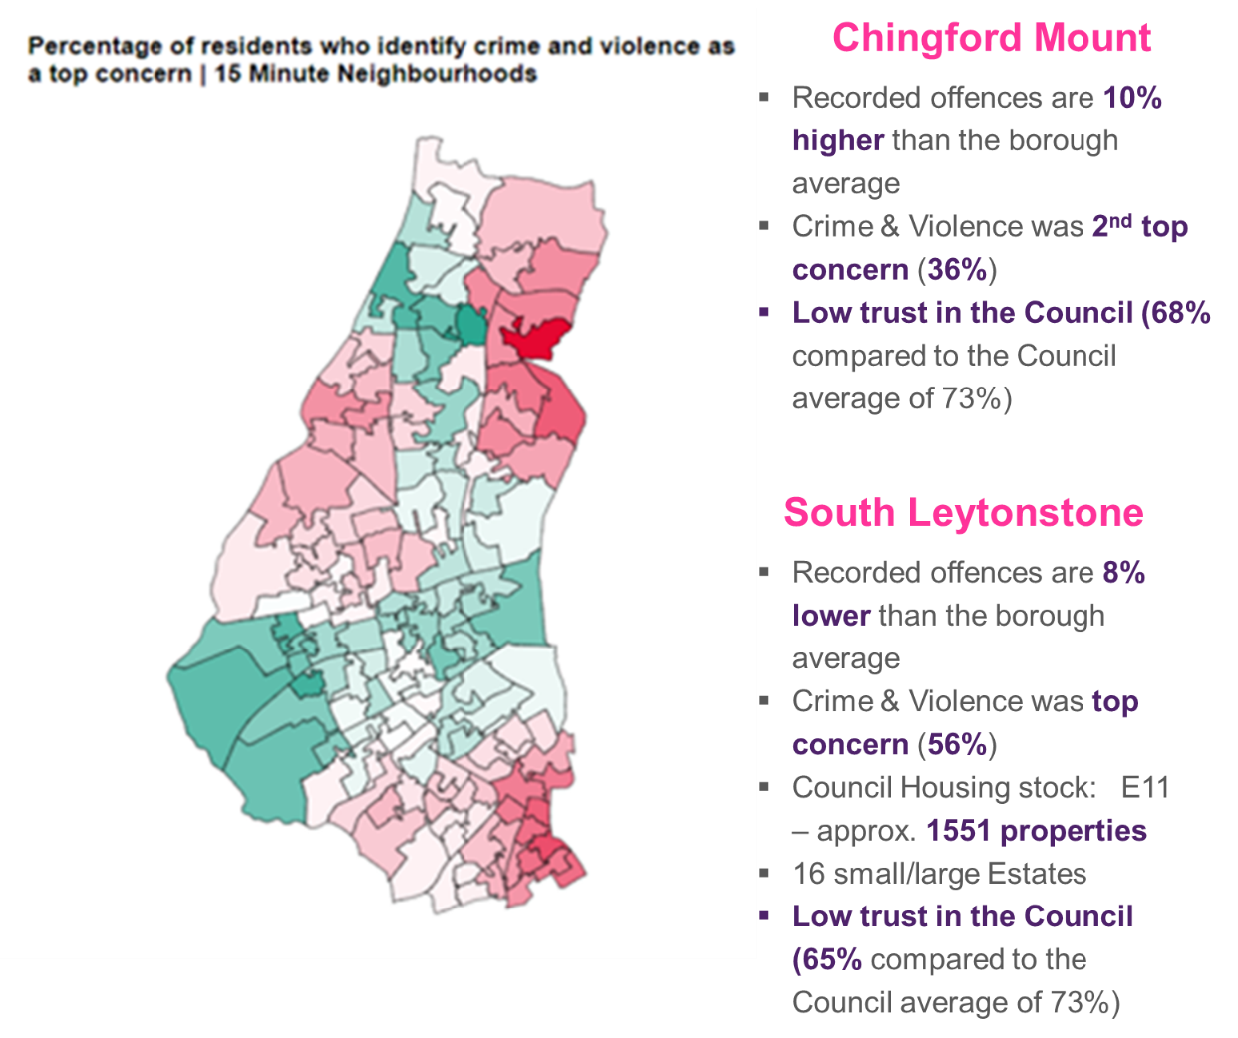
As shown above, these two pilot areas have been picked for their contrasting characteristics and geographical locations, but similar challenges around low trust in the council, and high concern around crime and violence. In both areas, there is a pop up police station, a base to operate from, and high levels of social housing estates.

The Safer Streets Pilot will be a four-month project working in the two areas with a new operating model. The proposal is to bring together a multi-agency team with staff delivering their existing functions with a focus on joint problem solving, tackling safety concerns and an additional resident-focused engagement. The multi-disciplinary team (MDT) will consist of around 40 staff and include teams including ASB, Neighbourhoods, Violence Reduction, CCTV operations and be supported by a further 20 officers from wider teams including Regen, Community Safety, Housing services and Streetbase and the Met Police.

The Safer Streets pilot is aiming to instil new ways of working for the multi-agency team by:
- Acting quickly on easy issues and proactively with high-profile patrols
- Increased joint working with the police and other partners
- Having an enhanced reporting portal to better report and understand residents concerns
- Deeper resident engagement with targeted comms and increased engagement events
- Data-led approaches to tackling crime

We expect that the pilot will enable residents to contact a single team to solve issues and raise concerns more simply, to receive feedback on the concerns they have raised and a follow-up once their concern has been dealt with.

For staff working on the pilot, they should have a stronger sense of ‘one team’ and be empowered to get things done, with enhanced job satisfaction as a result of measurable impact and real-time feedback from residents. Staff should also have a deeper and more sophisticated picture of local issues and what drives resident concerns.

For elected Members, they should feel more confident that issues are logged and responded to, and have an ability to hold officers to account regarding progress and resident satisfaction.

Research approach and objectives
The Council will be monitoring a range of quantitative indicators that we already collect at a local level to measure the successes of the pilots. These include rates of ASB, street cleaning, dog fouling, police performance measures, noise, flytipping and social media interactions. However, we are looking for the successful provider to conduct qualitative research to understand the experience of residents, businesses, partners, elected Members and staff in the pilot areas with a view to assessing the impact of the Safer Streets Pilot and recommend insight-driven improvements to the model before it is rolled out across the whole borough.

Waltham Forest Council is seeking to understand and measure the Safer Streets pilot based on the viewpoints of four key cohorts:
- Residents: How do residents who are reporting concerns experience the response of the MDT? How does this compare with experiences of residents in areas outside of the pilot? What is the experience of residents who are interacting with the MDT because they are causing an issue in the pilot areas (eg street drinkers, ASB complaints) and how does this compare with experiences outside of the pilot areas? What is the experience of residents on housing estates of the new pilot approach? Are there any changes in these experiences throughout the pilot (beginning, middle, end)? Do residents in the pilot areas feel safer as a result of the changes? (Number of residents engaged to be determined by successful provider)
- Staff: How does every member of the new MDT perceive the pilot project at the beginning, during and after the pilot? How does this compare to Officers in other areas? What is their daily experience of the new ways of working? What has worked, and what hasn’t? Has it changed their job satisfaction or sense of empowerment to get things done? Do they have any suggestions for improvements and changes? (Est. 35-40 core staff and 20 wider team)
- Businesses and Partners: What are the experiences of businesses in the two pilot areas of crime and community safety? Have these perceptions changed from the beginning to end of pilot, and what interaction have they had with the MDT? How do partners perceive the new operating model? What are the challenges and their priorities to improve the process? (Housing associations, police, registered providers and a selection of businesses in both areas)
- Elected Members: Have ward councillors experienced any change in feedback from residents around community safety and crime? Is there a change in their interaction with residents, partners and council officers throughout the pilot, and what are the benefits and drawbacks of this? What do they experience and what are the challenges they identify within the pilot areas? Do they feel more equipped and empowered to make change in their areas? (11 ward Councillors, up to 9 Cabinet members)

The objectives for the successful applicant are to:
- Develop a more robust understanding of the issues around Community Safety in Chingford Mount and South Leytonstone
- Assess and measure the impact of the pilot in the 2 areas
- Attain learning from staff, residents, Members and partners to improve and refine the model
- Develop recommendations to improve the model before it is rolled out across the whole borough

Purpose and outputs
The purpose of the evaluation is to understand the benefits and challenges of the Safer Streets pilot from the perspective of residents, staff, partners and members. The evaluation results will inform the approach the Council takes before launching the new operating model of Community Safety later this year.

We will require several main outputs from this project, as detailed below:
- Weekly progress updates to the Council’s contract manager
- Mid-project evaluation report (initial highlights and learning from Community Walks and interviews with residents, staff and partners by April 2023)
- Headline findings presentation in slide format at project end (July 2023)
- A full draft report and a final detailed full report in electronic format of qualitative research findings in July 2023 (Following completion of Safer Streets pilot)

Timetable
The Community Safety pilot is beginning in the last week of February. The pilot will run for four months until June. The evaluation for the pilot would be expected to run concurrently during this four month period, with final interviews taking place with staff in the immediate period after the end of the pilot. We envisage the timetable to approximately follow the below:

Action(s) | Date
Invitation to tender | 3rd – 17th February
Notification of successful bidder | by 24th February
Project kick-off meeting | w/c 27th February
Finalisation of research methods and approach | By 13th March
Begin fieldwork | w/c 13th March (continues until end June)
Interim report on initial findings | By 14th April
Final interviews post-pilot | 19th – 30th June
Submission of draft report and headline results | w/c 10th July
Submission of final report | w/c 24th July

The above timetable is indicative only and subject to variation by the Council. Providers will be informed of any significant changes.
What are we looking for
We are looking for an organisation with extensive evaluation experience, preferably one that has experience working on Community Safety and crime, in a similar context and with knowledge of Waltham Forest.

We welcome submissions that clearly propose and demonstrate a methodology and approach that will achieve the objectives above and help key stakeholders to understand the impact of the pilot. We would welcome proposals which may consist of the following activity:
- Interviews with relevant stakeholders at start, during and at end of pilots
- Focus groups with stakeholders and lessons learned sessions
- Walking ethnographies or the use of other ethnographic methods to research the experience of groups in the pilot areas in comparison with the rest of the borough
- Cases studies and other data collection methods

Evaluation Criteria
Evaluation criteria | Criteria weighting % | Sub-criteria | Sub-criteria weighting
Quality | 70% | Relevant experience of qualitative research methods and engagement on crime and community safety and knowledge of best practice in these areas. | 20%
 |  | Understanding of our objectives, approach to devising appropriate evaluation to respond to the objectives and to ensure the objectives are reached. | 20%
 |  | Analysis, data, reporting and presenting | 15%
 |  | Quality of personnel and difference - what sets your company apart from others and how this will help you to ensure the project is successful? Details of the expertise and experience of all staff working on the project should be provided. | 10%
 |  | Timescales - capacity to adhere to timings, adequate contingencies put in place | 5%
Price | 30% | None
Total | 100%

Quality
Please outline in your proposal your approach to each of the quality criteria above. Bids will be assessed on the above following the below criteria and weighting:
SCORE | DESCRIPTION
5 | Response is of an excellent standard and goes above and beyond the criteria.
4 | Response is of a high standard and meets all the criteria, with no reservations at all.
3 | Good response however there is a minor reservation in one key area.
2 | Acceptable response; however there are reservations in two or more key areas.
1 | Non-compliant – failed to provide a sufficient response/address the question.

Price
30%
The maximum price score for this section is given to the provider who has submitted the proposal with the lowest total cost for the duration of the contract. All other providers are awarded using the following formula:
(Lowest Bidder Price / Bidders Price) x Percentage Score Available
Please note: costs should be inclusive of expenses and any other additional costs that may be incurred.
Please ensure that your submission is no longer than 6 sides of A4, font size no smaller than 11. Please set out your submission based on the sub-criteria headings, providing your response to each quality category and please include a breakdown of costs of your submission.

Budget
Our budget for this project is in the region of £25,000.

Contract conditions
The successful contractor must abide by Waltham Forest Council’s terms and conditions.
We expect all consultants to comply fully with GDPR in the handling and storage of both existing data and new data collected and with the Market Research Society Code of Conduct.
Waltham Forest Council will retain copyright and publication rights for the study results. The consultant must not issue press releases, nor disclose study information to a third party, without prior agreement with Waltham Forest Council.

Submission and appointment
Please submit tenders via the London Tenders website (www.londontenders.org) by 5pm on Friday 17th February 2023.
It is anticipated that the successful bidder will be notified by Friday 24th February at the latest, and that unsuccessful bidders will be notified in writing the week after.

Queries and further information
Please raise any queries relating to this Invitation to Tender through the discussion forum on the London Tenders Portal. All queries relating to the tender documentation should be raised through the portal before midday on Wednesday 15th February 2023.
Thank you for taking the time to tender for this project.

