**Overview:**

To provide greater all-year access to the play and sports facilities in Morden Recreation Ground, and for those using it for general leisure, by improving the pathway from the entrance to the playground/sports area. The current path is difficult to use for people with limited mobility e.g., people with disabilities, with pushchairs, the elderly. In wet weather it cannot be used due to flooding, and the improvements are part of a response to the climate emergency.

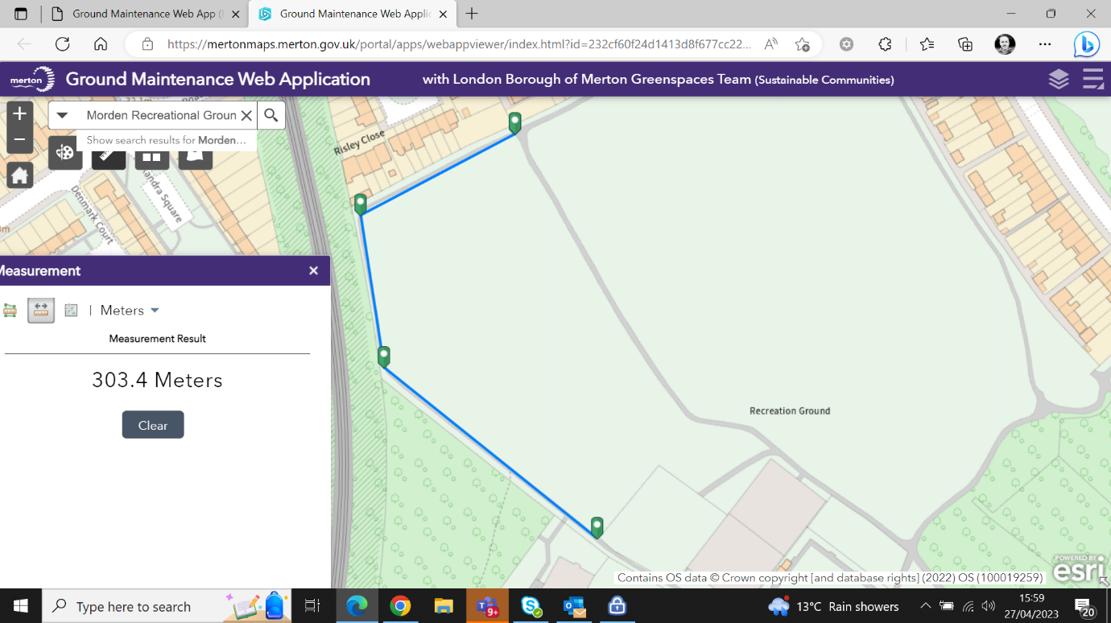

**Specific Works**

Footpath up to end of fence to playground approximately 550m2

Take up footpath. Excavate along one side to make footpath 1.5 wide. Stockpile and remove from site using grab loaders.

Supply, level and compact 100mm average consolidated thickness of type one stone to form new subbase.

Supply, lay and roll 50mm average consolidated thickness of 20mm dense binder course macadam.

Supply, lay and roll 25mm average consolidated thickness of 6mm dense surface course macadam.

To excavate and supply new precast concrete edgings to above footpath.

From fence to playground to where footpath meets the entrance footpath. Approximately 150m2, Same specification as previous footpath.

To excavate and supply new precast concrete edgings to above footpath.