**Nottingham City Council**

**Soft Market Testing Approach for**

**Large / Small Format Digital Screen Advertising**

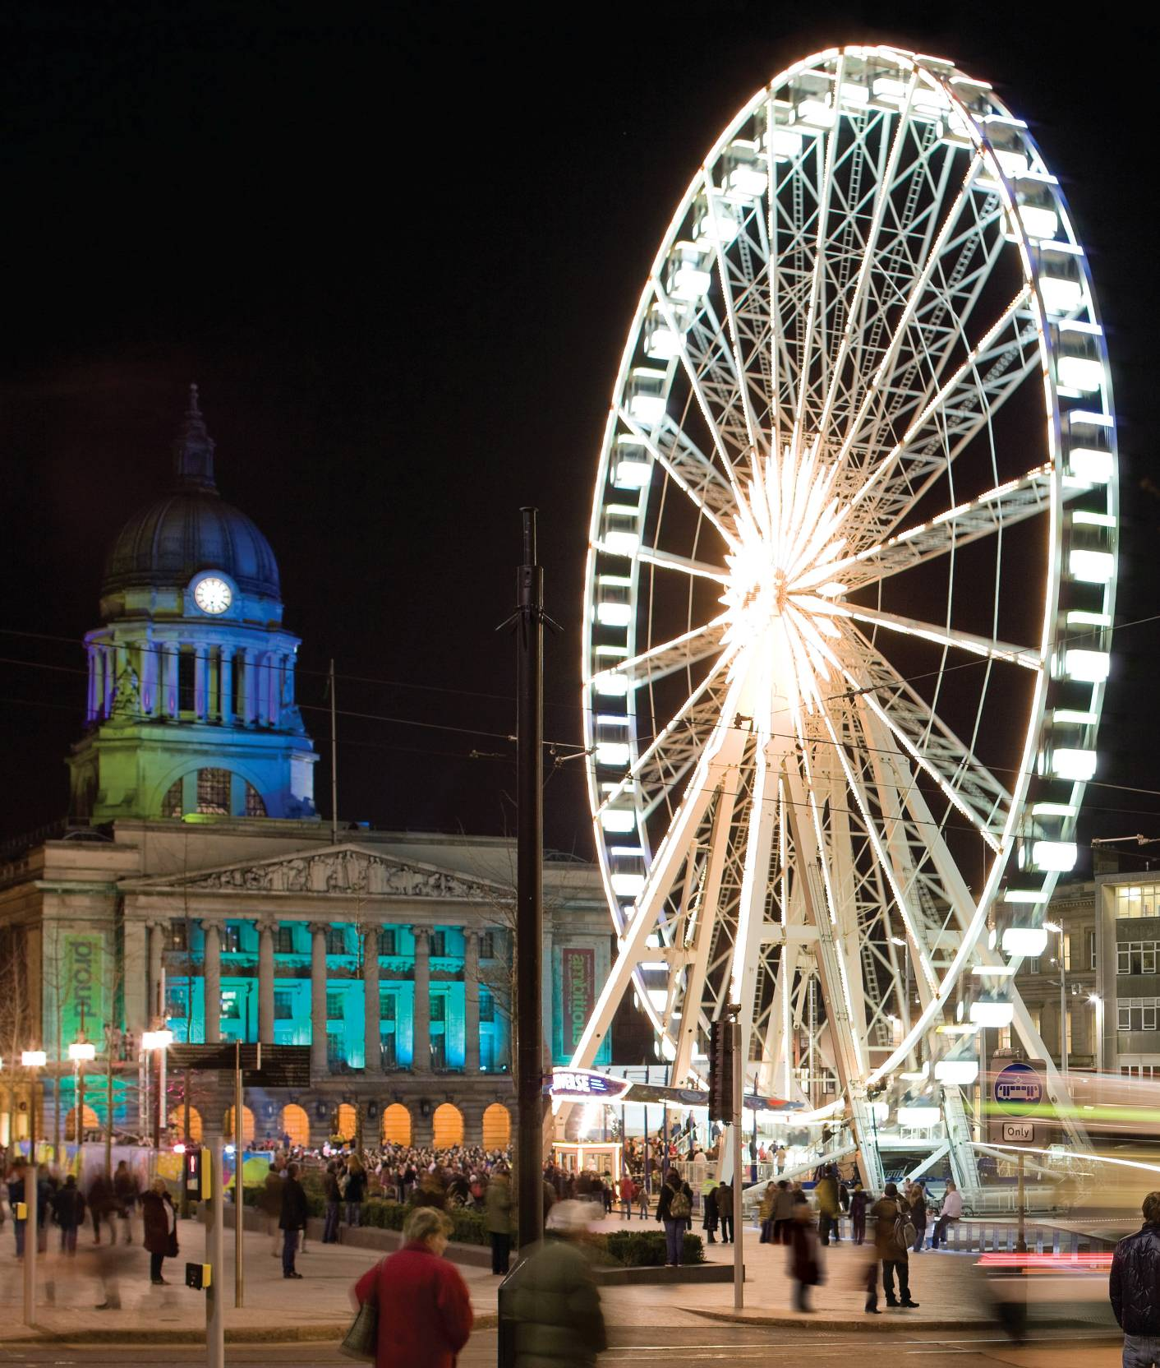

**April 2017**

**1 Why are we doing Soft Market Testing?**

Soft Market Testing is a method of gathering market intelligence on a given subject area by engaging with the providers of the goods / services required. At the same time Nottingham City Council is looking for efficiencies and best value.

**2 Soft Market Testing Process**

The Council is to undertake a soft market testing exercise to canvass external providers of digital screen advertising infrastructure to help us agree the most appropriate procurement route to facilitate a portfolio of large and small format outdoor digital screen advertising on Council owned land, at specified locations across the city centre. This exercise will enable us to finalise the future service specification and conduct an open and transparent tender process later this year.

Nottingham City Councils’ digital screen advertising infrastructure project is expected to be undertaken in two phases. For the first phase, the City Centre Digital Media Interim Planning Statement has identified the following locations for digital screens in Nottingham City Centre.

1. Broadmarsh multi-storey carpark,
2. Maid Marian Way roundabout
3. Replace and digitise the City Centre Wayfinder units located across the city

**Intended outcome of this document**

The main purpose of this exercise is to establish the most appropriate option to procure supplier(s) to facilitate a large and small format digital screen advertising infrastructure across the city centre at locations specified in the City Centre Digital Media Interim Planning Statement.

Potential procurement routes to be considered

Option 1: For the Council to procure a concessionaire to have responsibility for the operation, design, supply, install, maintenance and repair of large and small format digital screens at specified locations across the city centre and to also facilitate the advertising content.

Option2: For the Council to purchase/lease the hardware, to install and operate the equipment, to manage the repairs and maintenance contract and to procure a separate concessionaire to have responsibility for facilitating the advertising content.

This exercise will demonstrate how feasible these procurement options are from both a cost / deliverability perspective as well as ascertaining if there are any other factors or potential benefits or services that the Council should be seeking to secure.

The Council will also be seeking advice on whether to contract with a single supplier to provide this service over the whole portfolio of large and small format digital screens (i.e. Broadmarsh multi-storey carpark, Maid Marian Way roundabout and City Centre Wayfinder Units) or if the Council should enter into contracts for each service as separate lots. Please note: In this instance, the Council may allow potential providers to bid for more than one lot.

The Council is interested in securing a supplier(s) for at least a 5 year period with the option to extend for a further 5 years, although we would like to discuss concession lengths as part of the soft market testing process.

Following the soft market testing the Council will draw up its tender documentation with a view to issuing an OJEU notice mid-August 2017 (although time scales are subject to change).

**Process**

1. The soft market testing will take place from the date of the published PIN (Prior Information Notice) until 28th April 2017.

* Any **questions** regarding the soft market testing approach document should be submitted by **21st April 2017 at 12 noon** to [claire.lambert@nottinghamcity.gov.uk](mailto:claire.lambert@nottinghamcity.gov.uk)
* Any **responses** to the soft marketing testing should also be returned to [claire.lambert@nottinghamcity.gov.uk](mailto:claire.lambert@nottinghamcity.gov.uk) by **28th April 2017 at 12 noon**

1. Neither the intention nor the purposes of this soft market testing exercise is to confer any advantage upon its participants in any future procurement process.
2. **This PIN is NOT a call for tenders and responses.**
3. Please note that we are not asking for commercial details or offers at this stage and we are only seeking your thoughts and comments on how we envisage the concession would work.
4. All information gathered from the Soft Market Testing will be carefully considered and analysed by the Digital Signage Project Board. All providers’ responses will be anonymised and not shared with competitors for these services.
5. An appropriate specification and service model will be designed using the information provided and from wider consultation with stakeholders.

**Methodology for soft market testing**

* The PIN is published inviting all parties interested to register and fill out the questionnaire at the end of this document and return to us via the email address specified above.

**3 Context for the introduction of large format digital advertising in Nottingham.**

**Context**

The purpose of this project is to secure additional revenue for Nottingham City Council whilst increasing the number of channels available to communicate with the public.

This will be achieved through an open, fair and transparent procurement process.

**What we want to commission**

The Council wants to commission either a single supplier or a number of different suppliers to conduct the operation installation and maintenance of large and small format digital screen advertising infrastructure, at specified locations, and to manage the advertising content. The company contracted to manage the advertising content will either pay Nottingham City Council a rent for each prime location unit, a percentage of the advertising revenue or a combination of both (whichever is agreed through the tendering process). The successful supplier(s) will also offer a share of advertising space free of charge to the Council to promote Council and Community messages.

The City Centre Digital Media Interim Planning Statement has identified possible first phase locations for digital screens in the city centre.

Broadmarsh multi-storey carpark

The Broadmarsh area is undergoing a complete regeneration with plans to invest over £250m over the next 4 years. The Council is currently seeking approval to redevelop the existing Broadmarsh carpark and bus station to create a multi-storey carpark and bus station with additional retail and leisure opportunities, it is estimated that this should be completed by January 2019. The proposed new pedestrian environment and redevelopment of the multi- storey car park will greatly increase footfall in the area and offers opportunities for full motion LED screens to be well integrated in this part of the city. Advertising consent has already been granted to install 3 large format outdoor digital screens, 6m by 4m, on the side elevations of the new carpark, 2 screens on the north elevation (Colin Street) and 1 screen on the south elevation (Canal Street).

Maid Marian Way Roundabout

The Council is intending to site a large format outdoor digital screen/s on Maid Marian Way roundabout. This route generates traffic volumes of around 31,000 vehicles per day and is one of the main arterial routes into, and out of, the city centre from the north. This therefore makes this site a prime location for advertising. The Council will have responsibility for securing advertising consent on this site before the tender is issued later this year.

Replace and digitise the City Centre Wayfinder Units

Nottingham City currently has a network of 20 Wayfinder Units at various locations across the city centre. There is an opportunity to replace and digitise these existing units with a small format full motion city centre screen advertising network with Wi-Fi connection whilst retaining the ability to function as a Wayfinder service. The Council will have responsibility for securing advertising consent on these sites before the tender is issued later this year.

**4 Soft Market Testing - to be completed and returned by provider**

|  |  |  |
| --- | --- | --- |
| **Questionnaire:** | | |
| **Organisation Profile** | | **Response** |
| Name of Organisation | |  |
| Name and Job Title of individual completing this questionnaire | |  |
| Contact Details | |  |
| Briefly describe your Organisation in respect of its activities, market sector and relevance to Digital Signage | |  |
| **Option 1 – *For the Council to procure a concessionaire to have responsibility for the operation, design, supply, install, maintenance and repair of large and small format digital screens at specified locations across the city centre and to also facilitate the advertising content.***    The Council wishes to seek your views on this option and to establish your preference. Please outline what you consider to be the strengths and weaknesses of this procurement option and where possible, highlight any benefits / risks and mitigating factors that the Council should take into consideration. (Please note, that we are happy to consider sub-contracting arrangements for all elements with the exception of the facilitation of the advertising content for this option). | | |
| No. | Question | Response |
| 1.1 | Please outline the strengths and benefits of this option |  |
| 1.2. | Please outline the weaknesses and any potential risks of this option. Where possible, can you offer any mitigating factors that would minimise (any) risks? |  |
| 1.3 | Would you be using sub-contractors for any part of this option? If yes, please provide details. |  |
| 1.4 | Contract Length – the Council is currently considering offering a concessionary contract for 5 years with the option to extend for (up to) a further 5 years for Option 1  Do you feel that this term is appropriate for this option? If no, what would you recommend and why? |  |
| **Option 2 – *For the Council to purchase/lease the hardware, to install and operate the equipment, to manage the repairs and maintenance contract and to procure a separate concessionaire to have responsibility for facilitating the advertising content.***  The Council wishes to seek your views on this option and to establish your preference. Please outline what you consider to be the strengths and weaknesses of this procurement option and where possible, highlight any benefits / risks and mitigating factors that the Council should take into consideration. | | |
| No. | Question | Response |
| 2.1 | Please outline the strengths and benefits of this option |  |
| 2.2. | Please outline the weaknesses and any potential risks of this option. Where possible, can you offer any mitigating factors that would minimise (any) risks? |  |
| 2.3 | Contract Length – the Council is currently considering offering a concessionary contract for 5 years with the option to extend for (up to) a further 5 years for Option 2  Do you feel that this term is appropriate for this option? If no, what would you recommend and why? |  |
| **Single Supplier v Multiple Suppliers** | | |
| No. | Question | Response |
| 3.1 (a) | Should the Council offer a contract to a single supplier for the whole portfolio? *(i.e. Broadmarsh Multi Storey Car Park, Maid Marian Way Roundabout and City Centre Wayfarer Sites)* |  |
| 3.1 (b) | What would be the advantages / disadvantages from a supplier perspective and the Council perspective? |  |
| 3.2 (a) | Should the Council offer the portfolio as 3 separate lots? (e.g. Lot 1 Broadmarsh Multi Storey Car Park, Lot 2 Maid Marian Way Roundabout and Lot 3 City Centre Wayfarer Sites?) *Please note: The Council may also consider allowing providers to bid for more than one ‘lot’.* |  |
| 3.1 (b) | What would be the advantages / disadvantages from a supplier perspective and the Council perspective? |  |
| **Your Preference** | | |
| No. | Question | Response |
| 4.1 | From the two Procurement Options, please state your preferred choice? Please provide details to support your response e.g. details of how you have delivered this option in other cities. |  |
| 4.2 | Are there any other procurement options that you think the Council should consider?  Please provide details – we may wish to explore this further |  |
| **Other** | | |
| No. | Question | Response |
| 5.1 | How much of a share of (free) advertising space can you offer the Council for each location? |  |
| 1. Broadmarsh Multi Storey Car Park, |  |
| 1. Maid Marian Way Roundabout and |  |
| 1. City Centre Wayfinder Sites? |  |
|  | For each of the above, please specify whether there are any restrictions e.g. times of days |  |
| 5.2 | Are there any other potential benefits or services that the Council should be seeking to ensure? |  |
| 5.3 | Are there any other factors that the Council should be considering?  Please provide details |  |
| 5.4 | Please outline your expectations with regards to exclusivity rights to display advertising materials for: |  |
| 1. Broadmarsh Multi Storey Car Park |  |
| 1. Maid Marian Way Roundabout and |  |
| 1. City Centre Wayfinder Sites? |  |
| 5.5 | Anything else?  Please provide details of anything else that the Council should be considering or be made aware of. |  |

