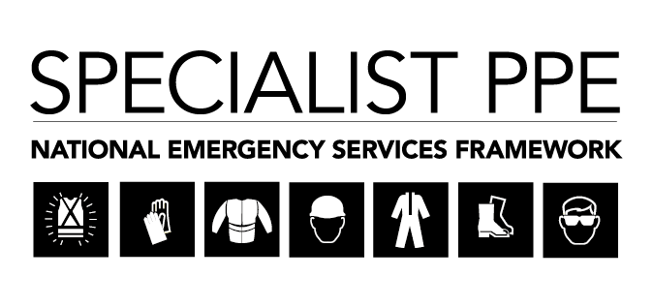

Provision of Specialist Personal Protective Equipment (PPE) Clothing

The Specialist PPE project has been identified as a key deliverable for the Fire Commercial Transformation Programme under the Clothing Category. Kent Fire and Rescue Service (KFRS) is the Lead Authority for this project working collaboratively with subject matter experts from across the Sector to deliver a National multi-supplier Framework Agreement. The aim of this project is to deliver a Framework Arrangement which allows Fire and Rescue Services (FRS), and other blue light agencies, to establish contracts for the supply of Specialist PPE which includes clothing and associated services for use in a variety of environmental scenarios.

Feedback from our last Supplier/Stakeholder engagement events held at West Midlands FRS HQ in March 2019 have helped shape the structures for proposed Lots. Lot 1 now excludes Powered Air Purifying Respirator Suits. The Lot for Marauding Terrorist Attack (MTA) garments has also been removed.

The proposed Lots for the framework are summarised below:

Garment type/Primary Lot | Sub-Lot
- Hazardous Material and CBRN | - Gas Tight Suits  - Chemical Protection  - Chemical gauntlets
2) USAR | - Chainsaw Items  - Hot Gas Cutting Items  - DVI
- Wildlands | - Ensemble – consisting of the following items, also available for individual purchase:  - Helmet  - Flash Hood/Snood  - FR Coveralls  - Gloves  - Boots
- Water Rescue | - Ensemble – consisting of the following items, also available for individual purchase:  - Dry Suits  - Life Jackets – 275 newton  - Life jacket 150 newton  - PFDs  - Water Rescue helmets  - Skull Cap  - Gloves  - Thermal Protection Bear Suit  - Boots
- Generic | - Boots  - Helmets  - Gloves  - Thermal Base Layers  - Hi-Viz Jackets  - Coveralls

Commercial and Technical groups have been established and specifications are being developed. Our next step is to re-engage with Industry and customers to provide an update on progress with the aim of issuing tender documents in January 2020.

We therefore invite you to attend an engagement event, which is open to both suppliers and customers, as detailed below:

Location: Surrey Fire and Rescue HQ,
Croydon Road,
Reigate, RH2 0EJ

Date: Wednesday 27th November 2019

Time: 10.00am for a 10.30am start.

The purpose of this event is to:

- Share full details of revised Lot structures and sourcing strategies.

- Share details of technical specifications and garner feedback from both suppliers and customers for our consideration as we finalise our requirements.

- Have discussion and feedback as to latest industry developments with regards to garment sizing and fitting for communities, groups of people with protected characteristics (Race, gender, sexual orientation, religion and belief, allergies and phobias)

- Share details of proposed timescales for tender activities.

- Question and answer session

This invitation is open to Suppliers, and Authorities’ Procurement representatives, Operations and Technical Managers. Due to limited space, we kindly request that a maximum of 2 representatives attend from each organisation.

Please register your interest in attending this event to SpecialistPPE@kent.fire-uk.org, providing the following details:

- Names of attendees (limited to 2 per Supplier or Authority)
- Supplier or Authority name
- Your role within your organisation
- Registration is required no later than 16.00hrs on Thursday 14th November 2019.

A full agenda will be issued to all participants no later than Friday 15th November 2019.

