**2021-0233 Single Advocacy Service - market survey**

The London Boroughs of Camden and Islington are proposing to re-tender their statutory advocacy services to a single joint contract expected to commence on **1st June 2022 (for Islington)** and **1st October 2022** **(for Camden)**.

Both boroughs also commission non-statutory (generic) advocacy, which enables people who have complex needs and require support to express their views, have their voice heard and make informed choices.

We wish to explore the options for continuing to commission non-statutory advocacy services through this engagement, in order to inform our procurement strategies.

**Current Service Model in Islington**

The existing advocacy provisions in Islington are integrated into a Single Advocacy Service, provided by a lead provider in partnership with a sub-contracted provider.

The lead provider delivers all of the statutory advocacy in the borough, as well as a small portion of non-statutory (generic) advocacy. The sub-contracted provider delivers LD-specific elements of non-statutory (generic) advocacy.

**Current Service Model in Camden**

The existing advocacy provisions in Camden are split into two contracts, with Provider A delivering all the statutory advocacy, with the exception of Independent Health Complaints Advocacy (IHCAS) which is commissioned through Provider B.   Community advocacy for older adults and adults with mental health conditions is also delivered by Provider A.

The following table shows the advocacy elements as they are currently commissioned by each Council:

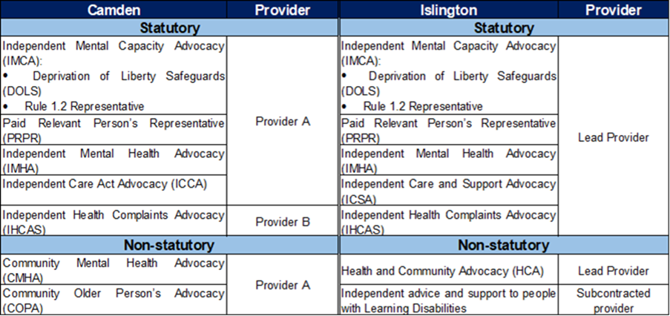

**Proposed procurement for a specialist advocacy pathway**

Camden and Islington are proposing the joint procurement of an integrated advocacy service that will provide all of each borough’s statutory advocacy functions, as well as non-statutory (generic) advocacy provision. This will have multiple benefits, including facilitate integration and joint working with partners in social care and health services.

The proposed service would work with residents from both Camden and Islington, but will retain some areas where the service will be tailored in recognition of both boroughs’ different practices, populations and needs.

Camden and Islington would welcome partnerships, which would allow for greater choice, especially for specialisms such as advocacy for people with learning disabilities, mental health problems, autism (without LD), dementia and sensory impairments, which can be delivered through partnership arrangements from a range of local providers.  The pathway may be managed by a single provider, or a lead contractor with one or more sub-contractors.

This pathway will include all statutory advocacy provisions, with the option to include generic / non-statutory advocacy for all customer groups.

        It is anticipated that the contract will be for an initial period of 4 years with the option to extend for a further 3 years.

**Pricing Model and Demand**

The existing pricing models for both Camden and Islington guarantee an agreed level of funding on the basis of a minimum level of activity, with additional activity funded through tariffs.

This decision was made based on the assumption of an increase in demand for advocacy, given the fluctuating demand for advocacy and the unknown impact of the Care Act (customers going through assessment and support planning have a right to access an advocate from 1st April 2015).

In commissioning a new jointly procured advocacy service across Camden and Islington, there are similar unknown impacts to consider, most pressingly, the introduction of the Liberty Protection Safeguards (LPS) as well as the proposed changes to the Mental Health Act.

Camden and Islington would like to review their pricing models and welcome suggestions that could potentially be developed as part of the procurement strategy. In addition, Camden and Islington would also like to gain an understanding of future levels of demand for advocacy based on local and national trends and upcoming changes to legislation that will directly impact upon advocacy services.

**Next Steps**

Before commencing a procurement process, we wish to engage with the market to help us shape the process for these services.  Below is a ***provisional*** timetable for the procurement of the new advocacy service:

|  |  |
| --- | --- |
| **Key Milestone** | **Timeframe** |
| Tender period | November 2021 to January 2022 |
| Evaluation and award | February 2022 |
| Implementation - Islington | March, April, May 2022 |
| Go Live Islington | 1st June 2022 |
| Implementation – Camden | June, July, August, September 2022 |
| Go Live Camden | 1st October 2022 |

We invite you to take part in this market engagement exercise by completing an online survey, using the following link: <https://forms.office.com/r/r6NAFYNgbY>

Please submit your response by midday on Friday, 25th June 2021.

**We appreciate that this questionnaire might be inaccessible for some, so if you or your organisation requires information and support to complete the questionnaire please provide us with your details.**

Following this initial market testing exercise, Camden and Islington will continue to engage with providers via market engagement and market warming meetings and events as required.

Subsequently, Camden and Islington expect to run a procurement exercise which is indicatively due to take place between November 2021 and January 2022, with contracts awarded in February 2022.

Any such tender will be published via the London Tenders Portal.

**Contacts**

Claudia Gabriel

Commissioning Manager for Adults

Camden Council

Tel: 020 7974 1185

Email: Claudia.Gabriel@camden.gov.uk

Tim Rising

Strategic Commissioner for Adults

Camden Council

Tel: 020 7974 2224

Email: Tim.Rising@camden.gov.uk

Kate Thomson

Contracts Officer –

Quality, Brokerage & Contracts

Islington Council

Tel: 020 7527 7459

Email: Katherine.Thomson@islington.gov.uk

Wil Lewis

Commissioning Manager –

Housing with Care and Support

Islington Council

Tel: 0207 527 7816

Email: Wiliam.Lewis@islington.gov.uk

**Disclaimer**

Interested parties will not be prejudiced by any response or failure to respond to this soft market testing/sounding exercise and a response to this notice does not guarantee any invitation to participate in any future public procurement process that the Councils may conduct.

This notice does not constitute a call for competition to procure any services for the Councils and the Councils are not bound to accept any proposals offered. The Councils are not liable for any costs, fees or expenses incurred by any party participating in the soft market testing/sounding exercise. Any procurement of any services by the Councils in due course will be carried out strictly in accordance with the provisions of the Public Contracts Regulations 2006 and the Public Contracts (Amendment) Regulations 2009 No. 2992.

Any responses provided will not be treated as commercially confidential and may be used by the Councils in the final service specifications used for the contracts but no organisation will be individually identified.