**Volume 2 - The Specification**

Transport for LondonTfLRoundelB&W

**SSQ STAGE DRAFT ONLY**

Invitation to Tender (ITT)

**Construction Logistics and Community Safety (CLOCS) Secretariat and Administration**

Internal Reference Number: tfl_scp_002045

|  |  |
| --- | --- |
| Version: |  |
| Date: | 1st December 2021 |
|  |  |

Transport for London

Palestra Building

197 Blackfriars Road

London SE1 8NJ

*Copyright on the whole and every part of this document is owned by Transport for London. No reproduction of the whole or any part of this document is to be made without the permission of Transport for London.*

**TABLE OF CONTENTS**

1. ORGANISATIONAL OVERVIEW 4

1.1 Transport for London (TfL) 4

1.2 Business Unit 5

1.3 London’s Freight and Servicing Action Plan 5

1.4 Delivering a Road Freight Legacy 6

1.5 Vision Zero and Reducing Road Danger 6

2. INTRODUCTION 8

2.1 Background 8

2.2 Construction Logistics and Community Safety (CLOCS) development 9

2.3 TfL’s application of CLOCS 10

2.4 Supporting the application of CLOCS and WRRR 11

3. requirement OBJECTIVES 12

3.1 Primary objective 12

3.2 Specific objectives 12

4. SCOPE 13

4.1 General requirements 13

4.2 Specific Requirements 14

5. DELIVERABLES 25

5.1 Project outputs and deliverables 25

5.2 Publications, presentations and marketing material 27

5.3 Submission of deliverables 27

5.4 Evaluation of the deliverables 28

5.5 Ownership 28

6. SERVICE LEVEL AGREEMENTS AND KEY PERFORMANCE INDICATORS 29

6.1 Service Level Agreements (SLAs) 29

6.2 Key Performance Indicators (KPIs) 29

7. PROJECT PLAN AND TIMESCALES 31

7.1 Project Plan 31

7.2 Timescales 31

8. PROJECT MANAGEMENT AND STRUCTURE 32

8.1 Project management requirements 32

8.2 Project management structure 32

8.3 Governance 32

9. GENERAL REQUIREMENTS OF THE SUPPLIER 33

9.1 Resourcing 33

9.2 Data protection 33

9.3 Communications 33

9.4 Equality and inclusion 34

9.5 Web accessibility standard 34

APPENDIX A – historic Developments which led to a common national standard 35

APPENDIX B Work Related Road Risk default solutions 40

APPENDIX C CLOCS Working Group MEMBERSHIP organisations 43

APPENDIX D CLOCS BulLetin example 44

APPENDIX E CLOCS incident alerts and update template 45

# ORGANISATIONAL OVERVIEW

## Transport for London (TfL)

### TfL is an executive body of the Greater London Authority, created in 2000 as the integrated body responsible for the Capital’s transport system. Its primary role is to implement the Mayor of London’s Transport Strategy and manage transport services across the Capital. TfL is made up of many predecessor organisations covering almost all transport modes in London, and therefore has the accumulated experience to provide one of the largest integrated transport systems in the world.

### TfL comprises of different modes. The modes are Surface Transport, Corporate, London Underground and Rail. TfL is a partner in Crossrail.

### TfL manages London’s transport network and is responsible for London’s buses, the Underground, the Docklands Light Railway (DLR), London Overground, London River Services, Cycle Hire, electric vehicles and policing. TfL also runs Victoria Coach Station and the London Transport Museum.

### TfL is responsible for 360 miles (580km) of main roads, and all of London’s 4,600 traffic lights. In addition, it manages the London Congestion Charging scheme and regulates the city’s taxi and private hire trade. TfL also promotes a range of walking and cycling initiatives across the Capital.

### Customer Communication and Technology which is letting this contract is an integral part of TfL is responsible for the strategy and planning of the London Bus Network, Public Carriage Office, London River Services, the TfL Road Network, Congestion Charging, traffic management, road safety, walking, cycling and freight.

## Business Unit

### Transport Strategy and Planning is one of the departments within the City Planning Directorate. London’s growth is leading to a significant increase in the freight traffic needed to serve the Capital’s economy. The role of our directorate is to engage with the freight industry, both with the operators and the businesses they serve.

### By supporting the industry, the department looks to maximise the opportunities for changing behaviour, minimising the traffic impact on the road network, reducing the impact of freight on the environment and increasing the levels of compliance and safety.

## London’s Freight and Servicing Action Plan

### The London Freight and Servicing Plan sets out the vision for sustainable freight distribution in London:

*“... the safe, reliable and efficient movement of freight and servicing trips to, from, within and, where appropriate, through London to support London’s economy, in balance with the needs of other transport users, the environment and Londoners’ quality of life...”*

### The vision establishes the following objectives for London:

* 80% of all trips to be made sustainably by 2041
* Reduced congestion on London’s Roads through effective planning to improve road network efficiency
* Increased compliance with standards
* Reducing the social impact of freight on the environment
* Improve air quality through the reduced CO2 and NOx emissions
* Safety – reduced collisions particularly involving construction vehicles and vulnerable road users (pedestrians and cyclists)
* Accommodate the forecast growth, changing demand patterns and intermodal balance.

## Delivering a Road Freight Legacy

### 89% of all London’s goods are delivered by road and 40% of all the morning peak traffic in Central London is made up of construction trips. To re-balance the needs of the City the Mayor of London has committed to Vision Zero by 2041 with 80% of all trips to be by sustainable modes over the same period.

### Based on the above, our approach to freight management needs to continue to enhance safety, increase efficiency and deliver a number of other improvements within the industry. TfL has published a Freight and Servicing Action Plan (<http://content.tfl.gov.uk/freight-servicing-action-plan.pdf>) which aims to build on our legacy of working with the industry to provide a better London.

### The key elements of the Freight and Servicing Action Plan summarised under the following themes:

* Better planning
* Improving road safety
* Re-timing deliveries and collections
* Kerbside access
* Increasing efficiency
* Effective communication
* Journey planning

### The Freight and Servicing Action Plan will assist in coordinating freight related activities and to ensure an integrated approach to managing safe and sustainable freight activity in London.

### 

## Vision Zero and Reducing Road Danger

### TfL is committed to ensuring London reaches Vision Zero by 2041 and City Planning is responsible for leading and coordinating TfL’s engagement with the freight industry on road safety issues, including FORS, Vision Zero Action Plan and new Direct Vision Standards.

### Vision Zero: The Vision Zero Action Plan (<http://content.tfl.gov.uk/vision-zero-action-plan.pdf>) details how TfL will work towards achieving a reduction in the number of people killed and injured on London’s Roads through creating safer roads, safe people and safe vehicles. The programme includes delivering all of the safer actions set out in the Mayor’s Transport Strategy, namely better junctions, Safer Lorries Scheme, 20mph speed limits, training, awareness and enforcement.

### As part of the Vision Zero Action Plan TfL has published as suite of documents aimed at further reducing collisions as part

* Direct Vision Standards: Reducing risk posed by the most dangerous vehicles by introducing a world-leading Safety Standard for HGV’s across London <https://tfl.gov.uk/info-for/deliveries-in-london/delivering-safely/direct-vision-in-heavy-goods-vehicles>
* Safe behaviours:Reducing the likelihood of road users making mistakes or behaving in a way that is risky for themselves and other people through targeted enforcement, marketing campaigns education programmes (<https://stars.tfl.gov.uk/>) and safety training for cyclists and motorcyclists (<https://tfl.gov.uk/modes/cycling/cycle-skills> <https://tfl.gov.uk/travel-information/safety/road-safety-advice/motorcycling-in-london>)

# INTRODUCTION

### The following sections are intended to provide prospective bidders with an overview of associated work which has informed, and is complimentary to, the requirement being tendered. This section sets out the background to CLOCS and why it was developed. The specific requirements of the opportunity being tendered can be found in sections 3 onwards of this Volume.

## Background

### The Mayor of London has repeatedly pledged that he and TfL must continue to do everything we can to reduce the risk for all vulnerable road users. This will remain a priority any new Mayor from May 2020. TfL has set a target of zero killed or seriously injured collisions on the TfL network by 2041. There are still particular concerns over the over representation of heavy goods vehicles (HGVs) in fatal and serious collisions with cyclists and pedestrians.

### A vulnerable road user is 78 times more likely to be killed or seriously injured in a collision involving a HGV than one involving a car and with 57% of all cyclist fatalities involving a HGV TfL is committed to brining these types of collisions down.

### TfL has been working collaboratively with the freight industry, other public sector organisations and businesses to improve roads safety and a number of TfL initiatives are gaining support and recognition across the UK. Vehicle operators and the businesses that employ them are beginning to realise the value and necessity of taking ownership for work-related road safety.

### Public sector organisations such as TfL, Crossrail and the London boroughs which commission large infrastructure projects, are ideally placed to lead the way in addressing the imbalance between road safety and workplace health and safety. Other major projects, clients and principal contractors that procure logistics services can also have a large scale influence on raising the standards of vehicle operations and road safety using their buying power.

## Construction Logistics and Community Safety (CLOCS) development

### In response to the over involvement of construction vehicles in cyclist fatalities and to understand why, TfL commissioned the independent Construction Logistics and Cyclist (now Community) Safety (CLOCS) report[1]. The research, published in 2013, found that blind spots on these vehicles could be greater than general haulage vehicles, that the management of road safety lagged behind the management of workplace health and safety and that there was no common standard for the construction logistics industry to adhere to.

### The CLOCS programme was developed in 2013 to take forward the recommendations of the above research and revolutionise the management of work related road safety within the sector. Whilst the original research was commissioned to look at issues relating to particular cycling incidents, it was quickly recognised that the safety of all vulnerable road users and wider improvements to safe HGV and other commercial vehicle operations was in scope. CLOCS aims to achieve a visionary change in the way the construction and other industries manage work related road risk.

### This has been implemented through two industry led workstreams and training, each addressing the original CLOCS report findings:

### Workstream 1 (WS1): Improving vehicle safety through design and manufacture of safer new vehicles and fitment of appropriate safety equipment to existing vehicles and Addressing the safety imbalance in the construction industry through ensuring road safety is considered as important as health and safety on site

### Workstream 2 (WS2): Encouraging wider adoption of best practice across the construction logistics industry through taking best in class examples, developing a common national CLOCS Standard for managing work related road risk (WRRR) and embedding a new cultural norm

* CLP Training: Three one day courses, Foundation Level, Practionioner and Advanced. These training courses are offered to anyone interested in learning how to develop a CLP by the

### Over 60 representatives from different organisations – vehicle manufacturers, construction logistics clients, operators, regulatory and enforcement bodies are actively engaged with the working groups that oversee the delivery of the CLOCS programme and its outputs. The working groups are instrumental in ensuring the programme meets its objectives in a way that can be practically and effectively applied by the construction industry.

### The first, and key output from CLOCS was the *CLOCS Standard for construction logistics: managing work related road risk (*WRRR), or the ‘CLOCS Standard’. Developed by the CLOCS working group, it contains specific requirements for either the operator, vehicle, driver and client (employing the fleet operators) all aimed at reducing the risk of a collision between a heavy goods vehicle and vulnerable road user.

### The structured workstream approach has achieved significant success. However, the outputs from WS1, now the ‘Safer Trucks Programme’ and WS2 now ‘CLOCS Manager and Addressing the Safety Imbalance Programme’ will be complementary to the success of the *CLOCS Secretariat and administration* requirement objectives and functions.

### Further historic information on the past development of the CLOCS Standard and examples of CLOCS achievements since inception can be found in Appendix A. A successful bidder will note these achievements and seek to build upon them developing new programmes which have a similar impact to these historic schemes.

## TfL’s application of CLOCS

### Since February 2012, TfL has included the WRRR safety requirements (within the CLOCS Standard) in its own procurement contracts. All suppliers contracted to TfL must ensure that vehicles used in the delivery of goods and services to TfL meet the highest, and latest, safety standards. TfL uses its procurement contracts to ensure that these standards, such as DVS rated vehicles or FORS accreditation for fleets, are undertaken via the procurement process.

### In 2016, TfL established a dedicate WRRR team to monitor and enforce the contractual clauses, including carrying out compliance checks on the gate and work with suppliers and others to raise levels of compliance. This team also works with other organisations mandating the CLOCS WRRR standard to assist them in developing monitoring and enforcement processes and provide guidance.

### For more information on the WRRR requirements visit: <https://www.fors-online.org.uk/cms/clocs-and-wrrr/>

## Supporting the application of CLOCS and WRRR

### TfL has developed a range of default solutions including guidance and tools which can provide organisations with everything needed to implement and adhere to the requirements in the CLOCS Standard. This include, but are not limited to, FORS, Safe Urban Driver (SUD) training and e-learning. Any supplier must keep abreast of any new or emerging policy developments which may impact upon the delivery of CLOCS. An example of further information pertaining to existing supporting solutions can be found in Appendix B

# requirement OBJECTIVES

## Primary objective

### The primary objective of this contract is to deliver CLOCS as a nationwide programme which seeks to improve whole journey safety of construction traffic.

## Specific objectives

### Provide overarching, credible governance and a voice for CLOCS. This will involve positively positioning the CLOCS community across the UK with collaborative industry-led initiatives that is addressing one of the most emotive issues facing the construction sector.

### Position the CLOCS Standard as the leading, appropriate and obvious solution for improving vulnerable road user safety for other logistic sectors to follow. CLCOS must be embedded in relevant city, regional and nationwide policies which could aid the growth of the programme.

### Grow and maintain engagement and existing relationships with construction industry stakeholders and CLOCS Champions through ongoing communications, PR and maintenance of the CLOCS working groups. This will help to stimulate interest in CLOCS and will increase the number of CLOCS Champion sign ups.

### Ensure CLOCS is meaningful and unbiased through consistent and effective application and review of the CLOCS Standard and ensure the CLOCS standard remains aligned to FORS standard silver requirements.

### Monitor the extent to which CLOCS Champions have implemented and enforced the standard.

### Normalise the management of Work Related Road Risk in construction supply chains through the specification of the CLOCS Standard in contracts, planning consent and alignment to other schemes and initiatives.

### Aid the reduction in road traffic collisions and casualties involving vehicles in construction supply chains in London and beyond by embedding CLOCS Standards industry wide.

### Deliver and expand Construction Logistics Plan training days one, two and three ensuring positive collaboration with training delivery partners

### Ensure CLOCS remains construction focused, but makes environmentally sustainable construction logistics the ‘business as usual’ goal for all UK construction projects focusing on all trips and modes to site.

### Ensure CLOCS becomes a self sustaining programme exploring new ways in which funds can gained to reinvest into the overall programme.

# SCOPE

## General requirements

### The bidder should demonstrate how they will provide credible, professionally administered governance and secretariat function demonstrating industry ownership of CLOCS. This will both maintain and further build momentum of the CLOCS initiative. This will require a ranging skill set to deliver the specific requirements of this specification detailed in section 4.2. Proven ability and track record of providing training, gaining funding from a variety of organisation, stakeholder engagement, marketing and communication skills are needed to embed this industry-led change initiative across construction and other applicable industries.

### Specific requirements are detailed below; however the bidder’s proposal will detail how they will manage the overall requirement to meet the objectives of this specification. This may include suggested improvements to the current governance model, a suitable project team and structure, how communications will be managed, details of how to make the scheme financially self sustaining and a high level project delivery plan, including milestones.

### The bidder will demonstrate the key personnel involved in the delivery of the requirement and their capacity to deliver these requirements.

### The supplier is required to provide the functions to meet the objectives stated in section 3.

## Specific Requirements

### Stakeholder engagement

### The supplier will act as secretariat for the quarterly CLOCS Board, working group and sub-group meetings, conducting all administrative requirements including communications, invitations, agendas, compiling presentation slides, papers, facilitation (as required), notes and minutes. Administrative arrangements will include the sourcing of a venue, or arranging relevant online facilities, refreshments and catering. A suitable representative will be appointed chair of the working groups through a fair selection process agreed with the working group.

### The industry-led working group is comprised of a range of construction, logistics and safety organisations. It has been established to provide a clear understanding of current and upcoming industry good practice. Good practice includes vehicle design and technology, operational constraints and capabilities, driver training and development, construction logistics plans and site standards..

### The supplier will ensure the working group continues to include the required range of representatives. A balance of organisations in scope of, and implementing, the CLOCS Standard and wider programme objectives shall be invited, including TfL, local authorities, public sector bodies, major projects, construction clients and principal contractors, vehicle operators, industry bodies and associations, regulatory and enforcement bodies and road safety organisations. A full list of the current organisations represented on the CLOCS working group is provided in Appendix C.

### The supplier will ensure that working groups, and the Board, maintain effective governance to define, consult and make decisions that seek to form actions and assess programme performance to:

* Provide consultation and advice on CLOCS and other related programme objectives and deliverables
* Review and maintain the CLOCS Standard and supplementary guidance documentations (subject to TfL final approval)
* Ensure industry and other relevant public and private sector bodies are kept up to date with developments in the CLOCS programme

### The supplier will identify and exploit opportunities for aligning and embedding CLOCS within other relevant industry initiatives and groups.

### The supplier will identify and exploit opportunities to attend appropriate industry events to promote the programme to wider audiences and will provide or coordinate with TfL a suitable resource to attend approximately eight events per year. A calendar of industry events should be maintained, updated and reported to the CLOCS board on a quarterly basis.

### Maintenance of the CLOCS Standard

### The supplier will review and maintain the CLOCS Standard in line with UKAS ([United Kingdom Accreditation Service](http://www.ukas.com/)) rules stating standards must be reviewed every two years. The CLOCS Standard was first published in December 2013 and is updated every two years. Any supplier must ensure the standard is continually updated, remains aligned to FORS standard silver requirements, and that consultations

* Remain owned and developed by the CLOCS Board and working groups
* Becomes progressively challenging for both client and operator, reflecting both industry ‘good’ and ‘best’ practice
* Remains in line with any legislative change(s) and takes into account changes to industry best practice
* Considers and includes (where relevant) links to relevant guidance from government bodies or agencies e.g. Health & Safety Executive and Department for Transport
* Remains aligned with the FORS scheme and any other recognised equivalent fleet operator quality management and accreditation schemes that seek to support implementation of the CLOCS Standard
* Meets the objective and continues to be positioned as a common, single national work related road risk standard for the construction and other applicable industries to adhere to

### The supplier will review and revise all existing CLOCS supplementary guidance documents annually as a minimum with input from the CLOCS working and/or sub-groups. All relevant documentation can be found in the CLOCS Library found at <http://www.clocs.org.uk/standard-for-clocs> and <http://www.clocs.org.uk/clocs-guides>

**CLOCS Champion communications**

### The supplier will respond to information requests submitted via the website, and from TfL as required and will maintain a series of briefing notes and presentation packs. These will be routinely updated to ensure currency and impact throughout the lifecycle of the contract.

### Good communication of the programme, within the CLOCS Community and externally to maintain the reputation of the scheme and ensure its growth is absolutely essential to the success of CLOCS. It will be important to engage senior and influential individuals and organisations that can help drive industry-wide change.

### The supplier will maintain the content of the Memorandum of Understanding (MOU) agreement with CLOCS Champions (and associated Terms of Reference), reviewing and updating it as necessary to ensure it is fit for purpose. CLOCS Champions state their intent to implement the CLOCS Standard through the MOU. Completed MOUs will be processed, counter-signed and electronically stored. CLOCS Champion certificates will then be issued with the associated CLOCS welcome pack suite of documents, branding elements and guidelines for use. New champions will be added to the CLOCS website. The MOU and Terms of Reference can be found at <https://www.clocs.org.uk/resources/mou_and_tor.pdf>

### The supplier will maintain and regularly update a log of CLOCS Champions with relevant contact details. The up to date list of Champions will be displayed on the CLOCS website.

### The supplier will be expected to update and revise the MOU (and Terms of Reference) and the associated process of recording CLOCS Champions, within the first two months of the contract. This will align with their wider proposals for the governance and administration of the programme. This will include a process for monitoring organisations’ implementation of CLOCS and removing organisations from the Champions list if they fail to meet the implementation timescales.

### The supplier will maintain and routinely cleanse a mailing list comprised of working group members, CLOCS Champions, those signed up to the CLOCS bulletin and those expressing an interest.

### The supplier will publish the relevant CLOCS bulletin stories to the website and distribute to the CLOCS distribution list. Its content will be consistent with the current monthly bulletin and will evolve based on feedback from CLOCS Champions. The CLOCS bulletin is published monthly and includes, but is not limited to, progress of the CLOCS workstreams, updates from CLOCS Champions, relevant industry events, summary of incident alerts, updates from the CLOCS manager collision management tool and other data sources. An example of the CLOCS Bulletin is provided in Appendix D.

### The supplier will be responsible for communicating serious and fatal incidents to the CLOCS distribution list. TfL will be responsible for notifying the supplier of incidents in London as they occur, but the successful bidder must take steps to ensure partner city regions also notify CLOCS of such incidents. Whilst we will obviously not know the specific number, bidders should allow for an average of creating three incident alerts per month (based on 2019 alerts). An example of the current alert template is provided in Appendix E.

### The supplier will maintain an incident log for alerts and a record of updates to incidents e.g. Where there are findings from a court case or other investigation relating to the incident. Where these are identified and could be of use to the CLOCS subscribers for lessons learned or to take action, the supplier will provide an update on previous alerts. The supplier must propose a possible means of identifying and notifying the CLOCS distribution list of serious or fatal incidents occurring outside of London.

### The supplier will maintain the strong support that CLOCS has already stimulated through engagement with senior level representatives of construction and logistics organisations. The bidder will consider how they will maintain these types of campaigns throughout the lifecycle of the contract. Letters, campaigns, lobbying activity and meetings will be targeted for maximum impact and addressed from a credible industry signatory. There will be a compelling call for action to get involved with CLOCS and specify its requirements in contracts. Correspondence or other high level campaigns will be carried out at least annually. Follow up correspondence and meetings will be conducted to secure commitment and action from construction clients and stakeholders.

### Management, hosting and maintenance of CLOCS website and email address

### The supplier will host, maintain and back up the CLOCS website ensuring it is routinely security tested, maintained and makes reasonable adjustments to ensure an accessible service as per the Equality Act 2010 including all further amendments and updates to the Act. The CLOCS website is a standard site hosted by The Unknown Creative in partnership with Vidahost and is designed using a Wordpress platform. Its URL is [www.clocs.org.uk](http://www.clocs.org.uk).

### The supplier will be tasked with reviewing, revising and developing an updated versions of the website.

### The supplier will ensure the website technically supports the CLOCS programme, documents, all information and sub-pages.

### The supplier will review and update the website content at least monthly. New publications, press releases, e-bulletins, events and details of CLOCS Champions will be updated within 24 hours of the information becoming available.

### Development of the website will take place as required

### The supplier will host, manage and maintain the dedicated CLOCS email account ([enquiries@clocs.org.uk](mailto:enquiries@clocs.org.uk)) used to handle CLOCS related queries.

### The supplier will ensure all correspondence, complaints and enquiries are processed and resolved to a satisfactory conclusion. This is defined as responded to, with the information requested, a course of action agreed or no further enquiries after having received a response from CLOCS.

### The supplier will ensure responses are confirmed in writing by letter or email and should be in the same format in which any written correspondence is received. A copy of all incoming and outgoing responses shall be kept for the period of the contract, and provided to TfL at the end of the contract or as requested.

### The supplier will send an acknowledgment or full response within 48 hours of receipt of written communication whether by letter or email. The number of enquiries will be reported to TfL quarterly. Email responses will range from simple information provision and clarifications to processing of signed MOUs.

### The supplier will be available to respond to and clarify email enquiries over the phone (or in face to face meetings) where required. Calls should be entered in a call monitoring log so that they can be reported to TfL or other partners quarterly.

### The supplier will ensure the CLOCS brand and logo is used consistently by CLOCS Champions in accordance with the CLOCS brand guidelines and logo usage standard. TfL, the CLOCS Board, or other relevant partners shall be informed of any breach of the use of the CLOCS brand and logo. The CLOCS brand and associated materials will remain the property of TfL.

### Annual CLOCS progress event

### The supplier will deliver of an annual CLOCS progress event for each year of the contract. This will include working with relevant partners to identify conference speakers and preparing the programme agenda alongside specifying the scope of the overall event. The CLOCS progress event is a showcase of the outputs of the initiative and a demonstration of the construction industry’s commitment to improve road safety in its supply chains. It also aims to raise further awareness and encourage wider uptake. The supplier will use its judgement on how best to host this, and any event, in light of COVID, or other yet to emerge, pandemics or extraordinary events which may inhibit face to face gatherings.

**Deliver, expand and ensure Construction Logistics Plan (CLP) training is of the highest quality reaching the widest audience**

### The supplier will provide all CLP training courses (Foundation, Practioner and Advanced) including maintaining all training materials, databases and course content updating them as necessary and ensuring the highest quality of trainers.CLP training materials must be reviewed annually to ensure all case studies and guidance are relevant and takes account of any changes in the construction, public policy or other arena which is relevant to the training being provided.

### Once training has been undertaken it should be considered active for five years before expiring. The supplier will consult with the CLOCS Board on the details of this issue and provide detail in this bid as to how and when re-newed training should be undertaken and at what level.

### The supplier will accept that all the CLP training materials are the intellectual property of TfL and that no changes to existing materials or guidance can be made without the permission of TfL. The CLOCS Board will be notified of any changes or updates annually, or when relevant. Any new training material will be the intellectual property of the supplier, but will be developed in consultation with the CLOCS Board and CLOCS stakeholders.

### The supplier must work collaboratively with industry experts to provide CLP training ensuring fair and reasonable co-operation between all parties. The supplier will take into account the reasonable needs, advice and suggestions of training providers and experts to ensure a fair and cooperative working relationship. Regular liaison and consultation will be required between all parties. The supplier will also ensure the training register is updated once training dates are complete and that CLOCS is embedded into any additional qualifications to enhance its significance

### TfL has been supported by HS2 Ltd for a number of years in providing day one and day two of the CLP training. HS2 has also expressed a desire to support the full three days of training throughout this new contract, as a Training Delivery Partner, in both online and direct delivery formats. There are currently four members of staff available to support the CLP training programme.  In return for their time and effort TfL license them to deliver the course to the HS2 supply chain (only), independently of TfL or the supplier. This is done at at their own expense.

### Each of the Training Delivery Partner’s staff members will be available for one day per calendar month, on average. When delivering direct (face to face) training, the team can only support within approximately 30 miles of the HS2 Phase 1 & 2a routes, between London and Crewe. Any supplier providing face to face training must ensure the trainer is in the classroom with the participants to deliver the training. Any guidance notes or other training materials which are updated must be shared with all training partners.

### The HS2 Training Delivery Partner’s team have provided input at the outset of each course, when making major changes and in an annual review and improvement workshop. HS2 Ltd can offer up to 2 days per year per person to support such workshops. TfL requires any new supplier to consult HS2 when making changes to the CLP training.

### For courses that HS2 Ltd deliver to their supply chain, the supplier will support the contractor in providing the appropriate certification to each successful participant, as well as update trainee details to the appropriate training register.

### The Training Delivery Partner(s) will neither prepare, nor pay for any training material costs in support of the supplier to deliver courses. (HS2 staff time and travel expenses are provided at the expense of HS2 Ltd).  All preparation and organization of courses or workshops remain the sole responsibility of the Supplier.

### Proposed dates should be shared with the Training Delivery Partner(s) at least two months out and must be confirmed through electronic diary bookings one calendar month from training days or workshops.

### An annual MOU between the supplier and any third party industry experts involved in delivering training must be signed between the supplier and any third party industry experts.

### At each CLP training course TfL must be offered two places on each course at no charge. TfL will notify the supplier of its intention to take up these places no later than 10 working days before the course is due to begin. If TfL cannot take up one or both of those places they can be sold on.

**Ensure CLOCS becomes a finically self sustaining model**

### In order to run the scheme the supplier will provide an outline business plan setting out how CLOCS will become financially self sustaining. No TfL funding will be allocated to CLOCS from the start of the new contract and therefore, the supplier must show how the programme can be achieved without this. The supplier will demonstrate realistic and considered approaches to gaining greater numbers of champions and co-investment from other partners, outline ideas on how to manage costs and possible future funding sources

### The main revenue raising avenues open to a supplier are:

* Grant funding gained from public, or other, bodies
* Charging for CLOCS champions fee
* Revenue raised from CLP training
* Charging for course accreditations
* Other sources, as yet unidentified in this document, which the supplier may bring forward

The aim of CLOCS is to ensure as wide as possible compliance and improve safety overall. It is not designed as a revenue generation scheme and should not be viewed as such. Any supplier will need to examine carefully it can carefully balance running costs and revenue generation activity and this will need to be explained in any bid

### Expand CLOCS as a standard to also incorporate clean and efficient construction practices within the supply chain journey

### CLOCS’ focus must be on safety. However, a successful bidder will provide achievable ways in which CLOCS can incorporate cleaner and more efficient journeys across the whole supply chain into CLOCS initiatives. A successful bidder will also focus on modes and all trips to sites across the supply chain. A supplier will provide ways in which CLOCS can grow and expand its core aims in order to adapt to changing policy landscapes.

### Additional requirements

### The supplier will ensure all documentation and communication produced relating to CLOCS must be written in plain English and presented in such a way as to be accessible and clear to all.

### The supplier will provide annual data reports covering:

* Number of enquiries (web, letter, phone) by period
* Number of CLOCS Champions, broken down by category (client, operator, communicator, other) by period
* Timeline for CLOCS Champion implementation as per MOU and monitoring of CLOCS Champions progress to implementation
* Number of CLOCS bulletin recipients
* Number of attendees at working groups and sub-groups broken down by type of organisation (client, operator, regulator etc.)
* Highlight report including risks, issues and opportunities
* Outline finances showing profit and loss, any reinvestment and additional revenue sources secured
* Number of places at CLP courses take up by TfL
* Number or places at CLP courses filled as a percentage each year
* Number and details of any policy documents into which CLOCS has been added

### Quantities and current service levels

### The table below offers indicative quantification of the key requirements and current levels of service/input that should be considered when scoping the scale of work against the evaluation criteria.

### In line with the programme objective to grow and expand CLOCS UK wide, these figures should be used as an indicative baseline. Growth of the scheme will obviously impact on these figures and this should be taken into consideration when scoping the scale of work

|  |  |  |
| --- | --- | --- |
| **Task** | **Description** | **Indicative quantities** |
| Working group meetings | Industry-led meeting attended by representatives from construction, logistics and safety organisations. Includes organisation, presentation preparation, attendance, communications and producing and distributing notes and actions | 4 per year (Quarterly) |
| Sub-group meetings | Sub-groups are smaller meetings attended by a sub-set of the working group. The sub-groups will have a more specific and specialist objective | Up to 8 per year |
| 10 attendees per meeting |
| Review of CLOCS Standard | In line with UKAS rules, the CLOCS Standard is reviewed every two years (in collaboration with the working groups and board) to ensure it is up to date, progressive, consistent and aligned with other schemes | 1 per 2 years  (using CLOCS working group and board) |
| Review of supplementary guidance documents | The full suite of supplementary guidance documents (supporting the CLOCS Standard) will be reviewed annually to ensure it is up to date and consistent | 1 per year  (using CLOCS working group + sub-groups) |
| Industry event attendance | Attendance (shell stand / table-top presence or video calls) and potential speakers at industry events to ensure the programme is promoted and reaching new and appropriate audiences | Approx. 8 per year |
| Responding to email enquiries | Processing of all email correspondence, complaints and enquiries. All emails will be responded to or acknowledged within 48 hours of receipt (two working days) | Approx. 30 per week |
| Updating the website | Ensuring the website is up to date. This includes updating current content, adding new content / guides or ensuring suitable news stories are added | Minimum 1 per month |
| Processing MOUs | CLOCS Champions are subject to the terms of the Memorandum of Understanding. All submitted forms must be counter-signed, logged, electronic certificate sent, welcome pack (CLOCS Standard, supplementary guidance documents, branding elements and hard copy certificate) compiled and posted, name added to the website and email confirmation sent | Approx. 12 per month |
| Currently 356 champions   * Clients (27) * Operators (234) * Communicators (21) * Regulator (7) * Principal contractor (67) |
| CLOCS bulletins | The monthly bulletin is emailed out at the end of each month. Content includes programme updates, Champion stories/contributions, relevant news articles, incidents and updates | 1 per month |
| Current subscribers to be handed over at inception |
| Incident alerts | Serious or fatal incidents are communicated to subscribers via a CLOCS incident alert. This is dependent on notification via TfL. The alert contains information on nature of the incident, date/time, location, vehicle, other useful information and relevant media links. Where possible, update alerts are also sent as new information emerges. | Approx. 3 per month, plus occasional updates (approx. 1 per month) |
| Currently 725 subscribers |
| CLP training courses | To advertise, promote and provide high quality CLP training in classrooms or via teams/ zoom with partners to interested parties. The supplier will keep relevant and up to date any training material, ensure TfL has two free places offered to it and keep an up to date database of all those who complete each course | Three one day courses, typically attended by between 12-18 people monthly |
| Course accreditations | CLOCS can accredit some externally provided courses if they meet a high standard of delivery and training | CLOCS has accredited some courses e.g. Site Access Management |
| Widen the scope of CLOCS to identify new ways of embedding the scheme into new policy areas | Identify new and emerging policy themes to embed CLOCS into. CLOCS must also be mandated into various procurement contracts across the UK | Typically five new procurement contracts a year |
| Annual progress event | CLCOS should have a showcase event highlighting the outputs of CLOCS and a demonstration of the industry’s commitment to road safety. Bidders should provide Bidders should cost for ‘information only’ two options – large scale and smaller scale in the pricing template (Volume 4). | 1 per year |
| Large Scale:   * 500 delegates + exhibition space   Small Scale:   * 200 delegates conference only |

# DELIVERABLES

## Project outputs and deliverables

### The main outputs and deliverables for this project include, but are not limited to:

| **Milestone Date** | **Output and Deliverable** |
| --- | --- |
| From 1st December 2021 | **CLOCS** Take over existing CLOCS assets from TfL and current service provider and communicate the CLOCS scheme as a new industry-led model |
| Monthly | **E-bulletin published** 12 monthly releases per year. To include relevant news, progress, alerts and events |
| Monthly (average) | **Press release published** 12 releases per year, frequency is dependent on alignment to CLOCS successes |
| Quarterly | **Working group meetings** four per year promoted, facilitated, written up and actions implemented |
| Annually | **Principal client correspondence or meeting campaign** targeting executive or managing director level representatives in client and contracting organisations not yet signed up |
|  | **Revised Memorandum of Understanding** to ensure accountability of champions |
|  | **Annual website review and revision** and agreed milestones |
|  | **Supplementary guides revised and published** after review and discussion at working and sub groups |
|  | **Annual progress event** demonstrating the successes outlined in year 1 review report and positioning the next year |
|  | **Revised CLOCS Standard edition**  consulted on, published and launched |
|  | **Supplementary guides revised and published** after review and discussion at working groups and sub groups |
|  | **Annual progress event** demonstrating the successes |
|  | **Provide CLP training** three, one day, courses to be undertaken as often as possible |
|  | **Embed CLOCS into procurement contracts** seek out new opportunities to embed CLOCS as procurement requirement |
|  | **Seek out new opportunities to grow the CLOCS brand** through lobbying and campaigning activity |
|  | **Financially self sustaining programme** by ensuring the programme can support itself |

### 

### The bidder should provide a cost for delivery of years one and two of the contract in their response to Volume 4 (pricing schedule). There may be a possibility for minor cost increases for years three and four, where the there have been significant increases in CLOCS activity e.g. the number of CLOCS enquiries.

## Publications, presentations and marketing material

### Quality and design is important and this should be reflected in the project outputs including all written documentation, presentation, and marketing and communication material.

### All information must be communicated in a succinct, well presented and visually impactful way.

### All documentation must be written in plain English without technical jargon and presented in such a way as to be accessible and clear to all. Any diagrams/figures and illustrations included in the interim and final reports should be fully comprehensible when viewed in black and white or greyscale. The supplier shall adhere to the CLOCS brand guidelines.

### Electronic copies of all documentation must be provided to TfL in electronic format in Microsoft Office Word, Excel and PowerPoint and Adobe pdf format as appropriate. Any PDF file should contain document information and meta data in accordance with TfL’s web media requirements. Any raw numerical data used must be provided in Excel format.

### TfL will retain ownership of all outputs and deliverables including all information collected and data/documentation presented in relation to this requirement.

## Submission of deliverables

### CLOCS deliverables as specified in this requirement will be provided as a draft copy in electronic format at the date agreed with TfL.

### CLOCS deliverables for publication will be expected to be agreed through the following staged process:

* First draft submitted to TfL and the CLOCS board
* Comments submitted to Supplier
* 2nd draft submitted to TfL and the CLCOS board for final approval
* Final draft submitted and signed off

### Timescales for submission of each deliverable, including time for drafting, comment and final submission will be agreed in advance between TfL, the CLCOS board and the supplier depending on the scope of the deliverable. TfL and the CLOCS board shall provide feedback, comments or any revisions to be made within an agreed number of days to the supplier. The supplier shall make any changes within the agreed timescale before re-submitting the documentation for approval.

### The supplier should allow for quarterly review meetings with TfL (not including the inception meeting, close out meeting and annual review meeting) throughout the duration of the requirement to discuss the programme progress, including amendments to project deliverables. Update meetings may be undertaken in person or via teleconference. Review meetings will be in person and if hosted by TfL will be held at TfL Palestra in Southwark (197 Blackfriars Road, SE1 8NJ).

## Evaluation of the deliverables

### TfL will carry out evaluation of the deliverables using the following criteria:

* **Time:** Time control, project management, reporting on contract progress, identifying current/future risks. Timely communication of windows of opportunity in regulations, events or developments in policy, industry or practice that impacts on the programme identified.
* **Cost:** Cost control, accurate invoice schedules, timely invoicing, cost cutting initiatives, delivery within budget, identifying joint ventures and funding opportunities, exploring opportunities to work with other organisations and possibility of sharing costs beyond London due to the national benefits of the project.
* **Quality:**. All deliverables must be accurate and submitted to the highest quality, suitable for dissemination across the industry to different levels and sectors. TfL and CLOCS must maintain its credibility and reputation in order to coordinate this programme and the deliverables must be of a quality that reinforces and reflects this position.
* **Relationship:** Feedback from the project team and lead supplier providing reports & project communications as agreed. Feedback from project stakeholders including clients, contractors, operators, industry associations, manufacturers, regulatory bodies road safety groups.
* **Overall:** Good value for money, project management controls and overall performance rating.

## Ownership

### TfL will retain ownership and the intellectual property of CLOCS, its outputs and deliverables including all information collected and data and documentation produced in relation to CLOCS. Any materials produced after the 1st December 2021 will be the property of the supplier during the length of the contract and will be reviewed if/ when the contract is terminated

# SERVICE LEVEL AGREEMENTS AND KEY PERFORMANCE INDICATORS

## Service Level Agreements (SLAs)

### In addition to delivery of the requirement in section 4, specific SLAs applying to the full requirement include:

* Respond to emails and messages from TfL within one working day
* CLOCS email enquiries – to be acknowledged within two working days and dealt with within three working days
* Website updates – content to be updated within one working day of information becoming available
* Meeting notes, minutes and actions – to be provided to TfL for review within four working days of the meeting. Externally distributed notes will be sent within one working day of TfL sign off
* CLOCS Champions – all CLOCS Champion requests are to be processed through to completion within five working days (acknowledgement, timescale for implementation updated, welcome pack sent, website updated)
* CLOCS alerts – to be sent within 24 hours of the incident occurrence or notification of an incident from TfL
* CLOCS Bulletin – to be sent once a month
* Provide TfL with highlight, quarterly and annual reports on the date agreed where TfL will review and provide comments within three weeks. Final annual reports due four weeks after TfL comments have been provided
* CLP training to be advertised as widely as possible and through all relevant media

## Key Performance Indicators (KPIs)

### Based on the bidder’s proposal and as agreed at the inception meeting, all outputs will be delivered to TfL on time, to cost and the quality and subject to TfL quality sign off to ensure they are fit for purpose. Specific KPIs include:

* Adherence to all SLAs at a minimum of 90 per cent
* Maintaining existing CLOCS Champions levels, currently at 243
* Increase the number of CLOCS Champions by a minimum of 10 per cent year on year
* Increase construction clients (those employing fleet operators) specifying the CLOCS Standard by 20 per cent year on year
* Maintaining CLOCS working group levels at a minimum of 40 attendees.
* Ensure a minimum of 25 per cent of operators at the CLOCS working group
* Ensure 90% attendance at all CLP training courses
* 2 free places at each CLP training course to be offered to TfL
* The price at which attending the CLP training courses is no more than + or – 25% its current level, unless specifically agreed by TfL
* The price of CLOCS champion membership is no more than + or – 30% its current level unless agreed by TfL
* Ensure a minimum of 25 per cent of clients (those employing fleet operators) at the CLOCS working group

### The continuation of this contract will be reviewed after two years and six months. This will be known as the break clause and will be dependent on the project review and reference to the SLAs and KPIs being achieved, with the option to extend for a further two years and six months. TfL will retain the right to terminate the contract after the initial two years and six months contract term.

# PROJECT PLAN AND TIMESCALES

## Project Plan

### Bidders are expected to submit a detailed project plan with allocated resources.

## Timescales

### Key dates for the bidding process are outlined below and in the ITT:

|  |  |
| --- | --- |
| **Activity** | **Date Complete** |
| SSQ Issued | 01/06/2020 |
| Draft ITT Issued | 01/06/2021 |
| SSQ Evaluations | 01/07/21 |
| SSQ Consensus | 08/07/2021 |
| ITT Issued Date | 19/07/2021 |
| ITT Final Clarification Close Date | 09/08/21 |
| ITT Return Date | 16/08/2021 |
| ITT Evaluation | 06/09/21 |
| Final Consensus meeting | 15/09/2021 |
| Contract Award recommendation | 20/09/2021 |
| Stand Still Period Commencement Date | 27/08/2021 |
| Stand Still Period End Date | 30/09/2021 |
| Contract Award | 01/10/2021 |
| Project handover commences | 02/10/21 |
| CLOCS official takeover | 01/12/21 |

### 

# PROJECT MANAGEMENT AND STRUCTURE

## Project management requirements

### The outputs for this project should be completed and delivered to specification and within an agreed budget and timeframe. Suitable project governance, management processes and tools should be proposed by the supplier and will be agreed at the start of the project. These should then be applied throughout the duration of the contract.

### Internal project management processes will be robust and the supplier will keep TfL fully informed of ongoing progress of work – particularly document change control, risk/issues and lessons learned.

## Project management structure

### The supplier will detail in their bid the full project management structure outlining the roles and responsibilities of the individuals with relevant skills, knowledge and experience in the field of project management, construction logistics technical expertise, creative marketing and communications tools and techniques.

### The supplier will submit a project plan, available resources, risk, issues and mitigating measures.

## Governance

### CLOCS will be steered by the CLOCS working group and Board. However, governance is restricted to the scope of this ITT unless additional resource is identified for mutually agreed developments. The CLOCS secretariat will work together with the working group and Board to ensure effective governance. The CLOCS initiative, intellectual property and brand will be retained by TfL. The supplier must drive the day to day CLOCS programme forward for the next five years using their skill and experience to expand and promote this project and identify new and emerging opportunities for commercial expansion for CLOCS and its associated training.

# GENERAL REQUIREMENTS OF THE SUPPLIER

## Resourcing

### The supplier will have individuals assigned to the project with the relevant knowledge and expertise to deliver on all requirements of the specification. The supplier will be able to draw upon these individuals as required throughout the duration of the project to deliver the outputs to TfL’s quality expectations.

## Data protection

### Under the Data Protection Act 1998, TfL is obliged to take appropriate technical and organisational measures against unauthorised or unlawful processing of personal data and against accidental loss or destruction of, or damage to, personal data. To comply with this requirement, TfL must choose a service provider who can provide sufficient guarantees in respect of the technical and organisational security measures governing the data processing to be carried out; and ensure that the data process complies with those measures.

### The supplier must not share any personal data with any sub-contractor unless TfL has given written consent.

### To promote evidence-based policy and practice across London, TfL aims to publish all research reports on TfL’s website. However, all reports need to gain approval for publication from within TfL (TfL senior managers, TfL Press Office) and from the Greater London Authority (Mayor’s office, Transport Team). The supplier must not release or publish the project report (including on their website) without the clear approval of TfL, and not before the report is published by TfL. The supplier must not charge for downloading project reports (but can charge to cover the cost of paper copies). All press work regarding the publication of the project report will be coordinated through TfL’s press office (this includes the trade press).

## Communications

### To ensure the programme meets the needs of its intended audiences over the next five years, the outputs should be presented in a way that is accessible and clear to policy makers, construction clients, logistic operators and the business community more generally.

### To ensure CLOCS is relevant and useful for all stakeholders and external audiences; it must be communicated and presented in a succinct and well presented pack of communications materials. The following already exist but will need to be updated as required by the supplier and at the direction and in consultation with TfL. The CLOCS branded toolkit will include but is not limited to:

### A comprehensive series of Powerpoint presentations used for training days one, two and three. The slide packs may differ according to the needs of the targeted stakeholders. They will be used to present the CLOCS aims and objectives, progress and developments to different stakeholder groups and audiences

### A series of briefing notes to support TfL in responding to questions from the GLA, Mayor, MPs, industry and general public

### Marketing and communication material including leaflets, posters, display banners, and web based information.

* + - Any other communication or marketing material for campaigns, lobbying or which is public facing.
    - All CLP training material and CLP guidance material

## Equality and inclusion

### TfL is committed to removing barriers to accessing transport services wherever possible and in the way it employs and develops its workforce. In particular, the supplier should clearly demonstrate how equality and inclusion issues are addressed through this project.

## Web accessibility standard

### TfL’s Web Accessibility standard can be found at <http://content.tfl.gov.uk/onl-std-010-web-accessibility-standard.pdf>

**9.6 Partners and sub-contractors**

Any partner or subcontractor which does not form a signatory to this, or other TfL documents relevant to this contract used by the supplier, must adhere to the same standards as set by TfL within the overarching contract. It is the sole responsibility of the supplier to ensure the working practices, standard of work and any other legal or other sundry requirements of external partners or subcontractors meet these standards.

# APPENDIX A – historic Developments which led to a common national standard

### In 2013 CLOCS identified eleven different standards for managing work related road risk (WRRR) all trying to achieve the same thing, but in slightly different ways. The vast majority of operators will be working for multiple clients. Differing standards makes it very difficult for the logistics industry to understand and adhere to the requirements in a consistent or effective way. It is also increasingly difficult, particularly for smaller operators, to make the case for investment in multiple requirements. Research carried out in October 2015 found that over 85% of the logistics industry wanted a single common standard[2].

### The first output from CLOCS was the CLOCS Standard for construction logistics: Managing work related road risk, a common, consistent standard developed by the CLOCS working group, for use by the construction logistics industry.

### Implemented by planning authorities, major projects, developers and principle contractors and other clients through contracts, it includes sixteen requirements for fleet operators and construction clients all aimed at reducing the risk of a collision between commercial vehicles and vulnerable, or other road users. It provides a framework that enables management road risk in a way that can be adhered to in a consistent way by fleet operators.

### Over 240 organisations, including 35 major project and construction clients are now committed to implementing this consistent standard across their supply chains. Furthermore, other local authorities are in the process of implementing within their own supply chains or through the planning process.

### Organisations that express an interest and wish to commit to implementing the CLOCS Standard do so by stating their intent via a Memorandum of Understanding (MOU) and are known as ‘CLOCS Champions’ and are recognised as such on the website and given access to CLOCS branding materials.

### It is however, becoming increasingly important that the implementation of the CLOCS Standard by those signing up to the scheme is communicated effectively and that organisations are actively monitored. This is so that those who are doing so effectively can be championed and effective practice captured; communications be effectively targeted; provide further assistance to those that may require it and also to protect the reputation of CLOCS.

### Key CLOCS achievements to since its inception include:

* Development of the CLOCS Standard for construction logistics: Managing work related road risk, a common standard for use by the construction logistics industry. Implementation of the CLOCS Standard by over 240 organisations, including 35 construction clients, many of whom are doing so on a national basis
* Inclusion of the CLOCS Standard within planning conditions via Section 106
* Publication of six supporting supplementary CLOCS Guides and Toolkits, including:
  + - CLOCS Guide: Managing WRRR in contracts
    - CLOCS Guide: Managing supplier compliance
    - CLOCS Compliance Toolkit
    - CLOCS Guide: Vehicle safety equipment
    - CLOCS Guide: Managing driver training and licensing
    - CLOCS Toolkit: Managing collision reporting and analysis
* Alignment of the Fleet Operator Recognition Scheme (FORS) to the CLOCS Standard to assist operators in meeting the requirements in a consistent way
* Development of FORS collision manager - a consistent collision reporting and management tool for drivers and operators, in the absence of the HSE extending RIDDOR to traffic collisions and injuries. It is fully aligned with insurance reporting requirements
* Progressive engagement with principal insurers, brokers and claims handlers
* Commissioned independent research including:
  + - Understanding driver distraction
    - The development of a consistent methodology to evaluate the effectiveness of, and test vehicle blind-spot technology.
    - Blind-spot analysis of different models of truck to determine the best in class for driver vision
    - Research into the operational capability of vehicles to inform the development of site and tip ground condition standards
    - Evaluation of new specification vehicles to better understand how to increase the uptake of safer vehicles by operators and to be specified by major projects, clients and others employing fleet operators
* Success in Europe resulting in Members of the European Parliament voting to improve road safety through HGV cab designs
* Awarded the Premier Prince Michael International Road Safety Award in recognition for its collaborative approach with the private sector to catalyse improvements to vulnerable road user safety

### The CLOCS programme represents a united response to road safety across the industry and greater social responsibility which will save lives. Visit [www.clocs.org.uk](http://www.clocs.org.uk) for further information.

### The CLOCS programme has developed a number of ‘default solutions’ to help fleet operators and clients meet the requirements of the CLOCS Standard. A full list of the requirements and guidance documents produced to support the implementation of the standard is provided in the below table:

**CLOCS requirements assistance and default solutions provided to meet requirements**

|  |  |  |
| --- | --- | --- |
| **CLOCS Standard reference** | **Requirement** | **Default solution** |
| **Operators** | | |
| 3.1.1 Quality operation | Fleet operators shall ensure the transport operation meets the standard of an approved independent fleet management audit - certification from FORS (or equivalent ) | FORS  [www.fors-online.org.uk](http://www.fors-online.org.uk) |
| 3.1.2 Collision reporting | Fleet operators shall capture, investigate and analyse road traffic collision information that results in injury of damage to vehicles and property (and report them to client through a log) | FORS Collision Manager  <https://www.fors-collision-manager.org.uk/> |
| 3.1.3 Traffic routing | Fleet operators shall ensure that any vehicle routes to sites or premises specified by clients are adhered to | Construction Logistics Plan guidance |
| **Vehicles** | | |
| 3.2.1 Warning signage | Fleet operators shall ensure that prominent signage is fitted to vehicles over 3.5 tonnes that visually warns other road users not to get too close to the vehicle | CLOCS Guide: Vehicle safety equipment  Blind spot take care stickers available from FORS |
| 3.2.2 Side underrun protection | Fleet operators shall comply with the Safer Lorry Scheme | CLOCS Guide: Vehicle safety equipment  List of discounts available on FORS website  Vehicle manufacturers no provide at point of sale for new vehicles |
| 3.2.3 Blindspot minimisation | Fleet operators shall ensure all vehicles over 3.5 tonnes have front, side and rear blindspots completely elimination or minimised as far as practical and possible through a combination of fully operational direct and indirect vision aids and driver audible alerts |
| 3.2.4 Vehicle manoeuvring warnings | Fleet operators shall ensure that all vehicles over 3.5 tonnes are equipped with enhanced means to warn other road users of a vehicles left turn manoeuvre (recommended for reversing) |
| **Drivers** | | |
| 3.3.1 Training and development | Fleet operators shall ensure that all drivers undergo approved progressive training and continued professional development specifically covering the safety of vulnerable road users | Safe Urban Driver training available on line  Approval process and list of approved training provided on FORS website |
| 3.3.2 Driver licensing | Fleet operators shall ensure that a system is in place to ensure all drivers hold a valid license for the category of vehicle they are tasked to drive and any risks associated with endorsements or restriction codes are effectively managed - must be checked through DVLA | DVLA license checking available for free online |
| **Clients** | | |
| 3.4.1 Construction Logistics Plan | Clients shall ensure a CLP is in place and is fully complied with | Construction Logistics Plan guidance |
| 3.4.2 Suitability of site for vehicles fitted with safety features | Clients shall ensure that the condition of sites is suitable for vehicles fitted with safety features and underrun protection |
| 3.4.3 Site access and egress | Clients shall ensure that access to and egress from the site is appropriately managed, clearly marked, understood and clear of obstacles |
| 3.4.4 vehicle loading and unloading | Clients shall ensure that vehicles are loaded and unloaded as far as is practicable |
| 3.4.5 traffic routing | Clients shall ensure that a suitable risk assessed route to the site is specified and communicated |
| 3.4.6 Control of site traffic particularly at peak hours | Clients shall consider other options to plan and control vehicles and reduces peak hour deliveries |
| 3.4.7 Supply chain compliance | Clients shall ensure contractor and sub-contractor compliance with requirements 3.1.1 - 3.3.2 | CLOCS Compliance Toolkit  CLOCS Guide: Managing supplier compliance |

# APPENDIX B Work Related Road Risk default solutions

The following default solutions have been developed by Transport for London to assist organisations to implement and adhere to work related road risk requirements:

### Fleet Operator Recognition Scheme (FORS)

### FORS is an accreditation scheme for businesses operating van, lorry, minibus, coach and bus fleets of all sizes. It offers impartial, independent advice and guidance to help improve lawfulness, environmental, social and economic performance. Unlike many other membership and recognition schemes, it requires evidence of performance against the many regulatory and environmental requirements facing the industry.

### The FORS scheme is a voluntary accreditation which helps improve operators’ performance in all aspects of safety, fuel efficiency, economical operations and vehicle emissions.

### Accreditation provides vehicle operators with peace of mind that they are meeting their legislative requirements, as well as helping to increase efficiency, reduce costs and win work.

### FORS is now recognised as the industry-wide, national accreditation scheme for fleet operators, giving assurance to existing and potential clients that an operator is high performing and adheres to high quality standards. The FORS Standard enables clients to take ownership of road risk within their supply chain by specifying FORS accreditation in the procurement process.

### Currently around 3,500 operators are FORS accredited nationally.

### FORS is a default solution to meet the Quality Operation requirement of TfL WRRR and CLOCS contractual conditions. For more information on FORS visit [www.fors-online.org.uk](http://www.fors-online.org.uk)

### Approved progressive driver training

### TfL has developed a suite of approved training and e-learning products for drivers and managers which aim to increase skills and knowledge and promote best practice within the industry. These products offer a default solution to the need to ensure drivers and managers have received appropriate progressive training on safety topics including protecting vulnerable road users.

### Safe Urban Driving (SUD)

### SUD is essential training for all commercial drivers operating HGVs and Public Service Vehicles (PSVs) regularly in the urban environment and where there are high volumes of vulnerable road users, such as cyclists and pedestrians.

### The course consists of two 3.5 hour modules, one classroom based and one practical module where drivers can get on bikes and get a cyclists view of the road. The two modules are taught on the same day with up to twenty drivers participating in two groups of ten.

### Theory content:

### The changing streetscape and the urban environment

### Vulnerable road users and sharing the road safely

### Defensive driving techniques and actions in the event of an emergency incident

### Practical content:

### Exchanging places, driver attitude and perception

### Introduction to active travel, driver fitness and health

### Hazard recognition: understanding the issues faced by vulnerable road users

### SUD Training is Driver Certificate of Professional Competence approved and fully aligned to meet the Driver training requirement of TfL and CLOCS contractual conditions and FORS Silver accreditation.

### FORS accredited operators may be able to benefit from funded places provided by TfL for their suppliers, or operators who work within London

### Van Smart

### TfL has developed Van Smart as a default solution to improving van safety and stimulating behaviour change within the van sector. Van Smart is a cohesive and exemplary suite of products and a ‘must have’ for quality operators of vans.

### E-learning

### Three e-learning modules are available on the FORS website to train drivers in road safety, van safety and cycle safety..

### FORS Collision Manager– Collision management tool

### There are clear benefits to the routine recording, investigation and analysis of collisions and near misses to focus on prevention and safe ways of working. This is standard practice within workplace health and safety, but has so far not been routinely required for work related road risk.

### FORS Collision Manager is an online collision and near miss reporting tool that helps operators to comply with the WRRR requirement to log incidents and collisions. FORS Collision Manager is a single resource to log, report, investigate and analyse incidents and collisions. This consists of a website and spreadsheet tool to edit and report incidents. It allows users to log in and view trends and benchmark performance against similar companies. Anonymity is maintained through all areas of the site and sensitive data is encrypted.

### Through this site, operators can thoroughly report, investigate and analyse incidents allowing operators to identify contributory factors, incident hotspots and trends. This will enable a focus on learning and prevention.

### For more information visit <https://www.fors-collision-manager.org.uk/>

# APPENDIX C example of CLOCS Working Group MEMBERSHIP organisations



# **APPENDIX D CLOCS BulLetin example**

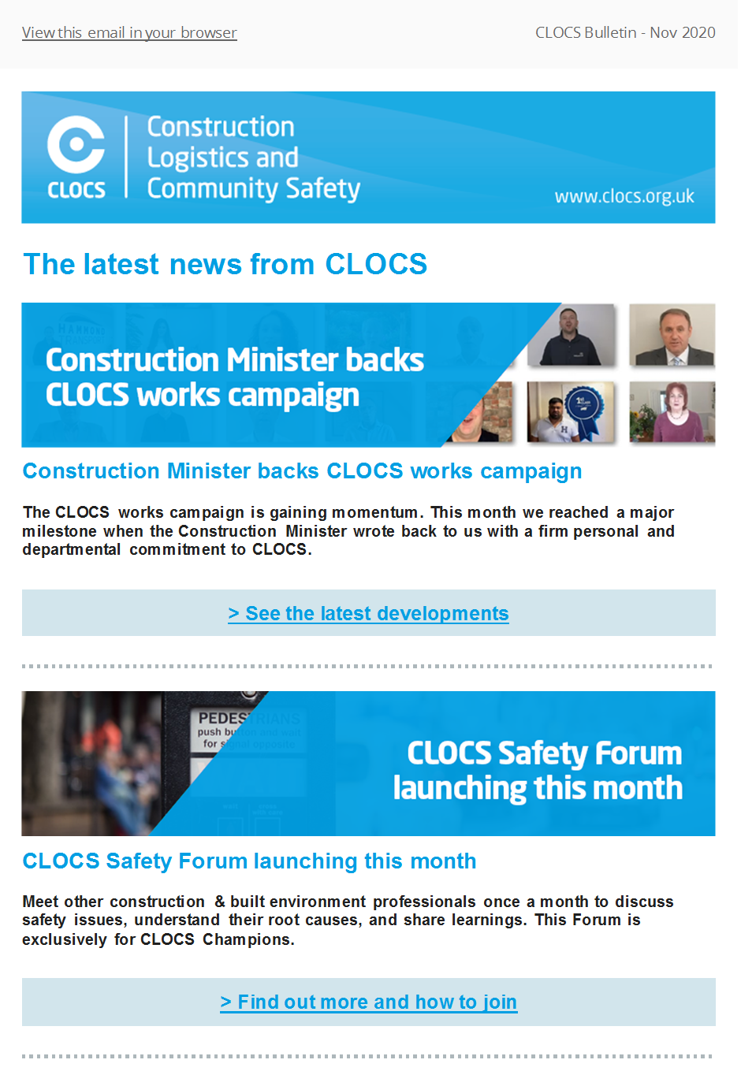

# A**PPENDIX E CLOCS incident alerts and update template**

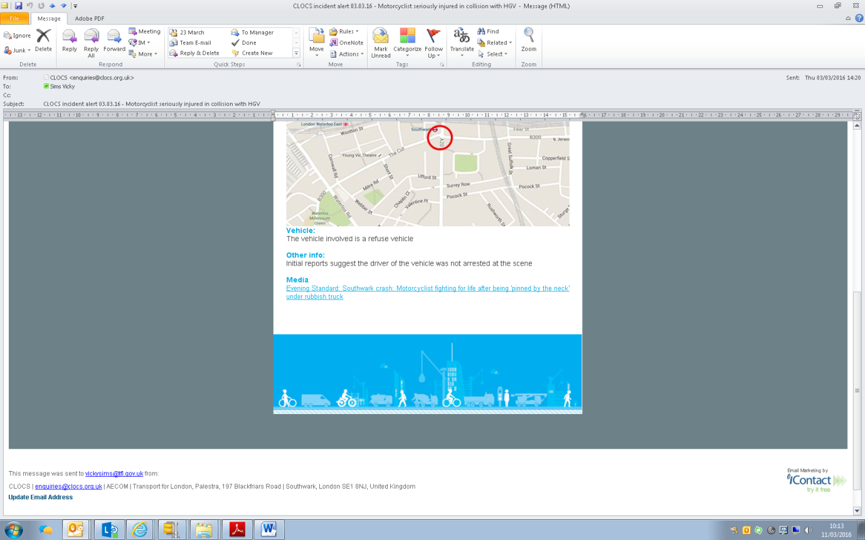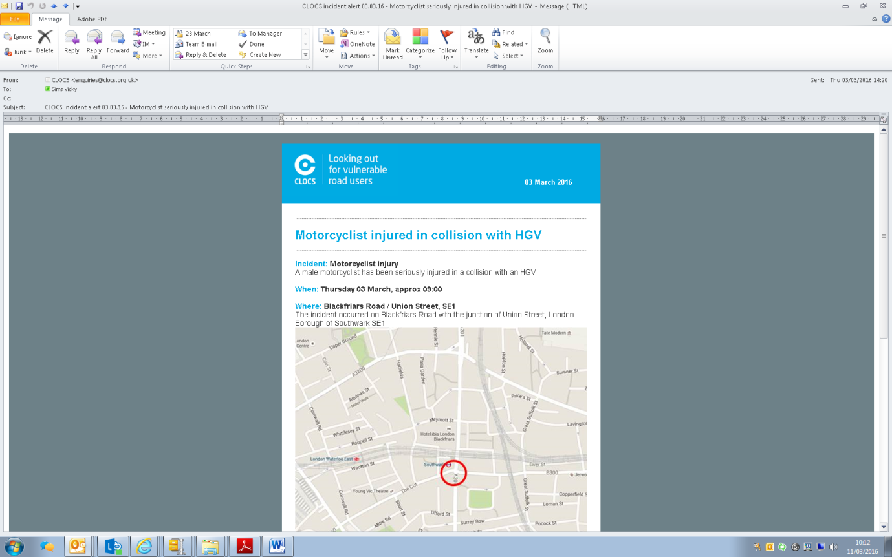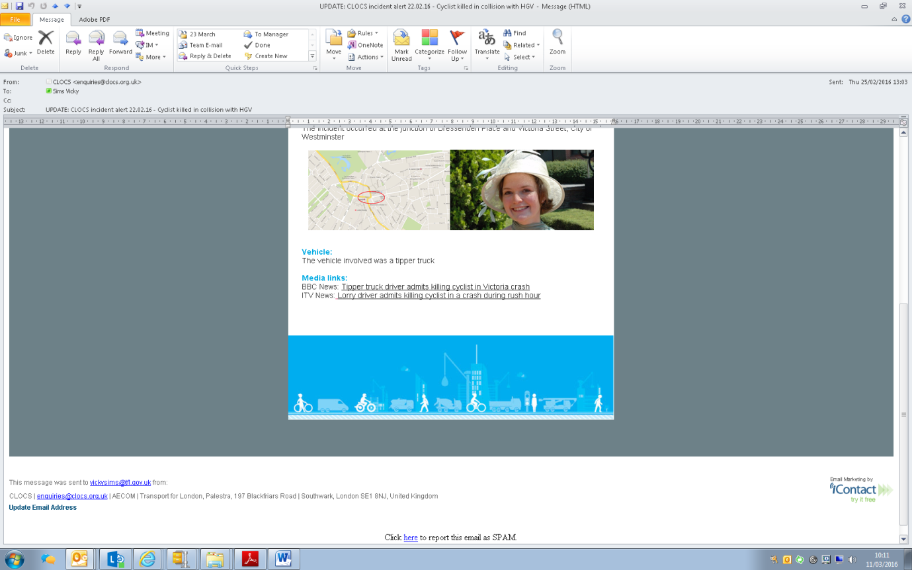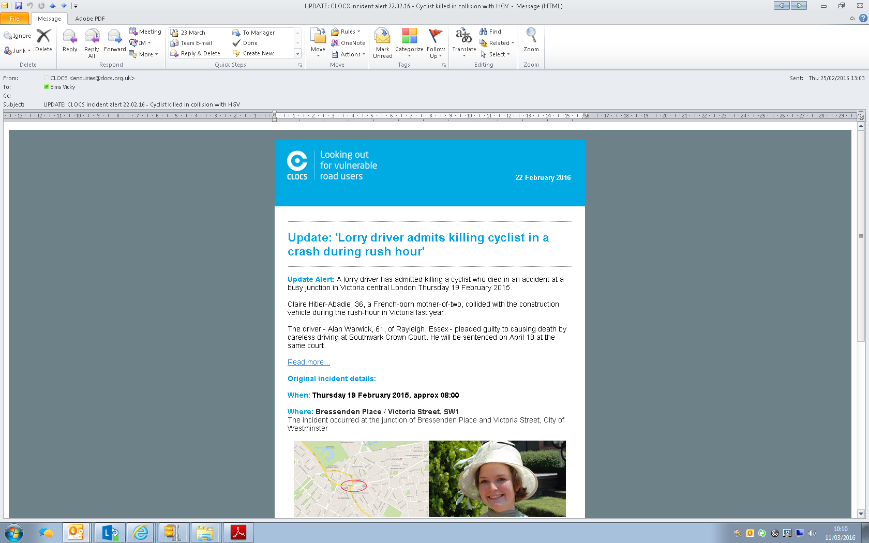

1. Helman S, Delmonte E, Stannard J et al Construction *Logistics and Cyclist Safety* (CLOCS), TRL report commissioned by TfL, published Feb 2013.
2. Freight in the City – Poll carried out by Road Transport Media. <http://freightinthecity.com/2015/11/freight-operators-call-for-uk-wide-compliance-standards-for-fleets/>