SPECIFICATION
FOR
DEMAND RESPONSIVE TRANSPORT (DRT)

Introduction

The West of England Combined Authority (CA) Bus Service Improvement Plan (BSIP) which included a proposal to pilot Demand Responsive Transport (DRT) to serve the region. The project is a key deliverable in the Governments ambition to grow bus usage and to deliver better bus services.

The project will also contribute towards National and Local Decarbonising Plans to achieve zero emissions fleet vehicles. The main aim of the DRT service is to support the local bus network by offering more service flexibility to parts of the region not directly served by the high frequency services available on the main corridors.

Another key aim will be to offer seamless journey opportunities linking to Transport interchange points connecting into the existing bus network and major destinations (eg hospital, major employers) with areas that are currently not directly accessible or require a number of connections. The ambition of this service is to strengthen the existing bus network and increasing its overall viability through increasing patronage on existing commercial services and attractiveness.

Our vision is for bus services people can depend on, are quick, on time and reliable, combine to form a simple to understand and easy to use network, are accessible for everyone, are safe and comfortable, and offer value for money to passengers and to the public purse.

We aim to create a connected region, fit for the future, which will promote active and sustainable travel, improve community health and reduce private vehicle journeys.

Success in delivering this vision will mean more travel by bus, less reliance on car travel, which is essential to achieving the West of England’s economic, environmental and quality of life ambitions.

Summary of Requirements

The CA wishes to contract with an Operator who will be responsible for operating and delivering a Demand Responsive Bus Service for an initial two (2) year period (with options to extend for up to a further four (4) years) period in accordance with the requirements set out in the Services Agreement.

The Operator is directly responsible for delivering on this service include providing, operating, monitoring and maintaining the following service aspects in accordance with standards in this document, with sign off from the CA:
- The safety of the operation
- The vehicles
- The drivers and their training
- Route and stop planning
- Integration with the booking/planning software (provided by the CA)

DRT Scheme
The DRT scheme is a flexible service that provides shared transport to users who specify their desired location and time of pick-up and drop-off via an app or call centre. DRT offers travel to any location within each individual zone and interchange with fixed route public transport services at specific points. The DRT service allows the user to make advance bookings and on demand trips with a guaranteed pick-up time of 60 minutes from the time of booking.

Each of the identified DRT regions will be operated by a single operator, and that Operator will have operational control within that region. An Operator can/may operate multiple regions.

Using existing bus stop infrastructure with an additional network of ‘virtual’ stops developed by the Operator, with assistance from CA. Any registered user can book a journey

DRT Regions
The DRT service will operate in these regions, (zone maps and descriptions detailed in Schedule E).

- DRT 1 East of Region – drop off points outside zone allowed: Emersons Green; Kingswood; Royal United Hospital Bath; Lansdown Park and Ride
- DRT 2 Keynsham Town
- DRT 3 Midsomer Norton/Radstock Town
- DRT 4 North of Region – drop off points outside zone allowed: Cribbs Causeway; Southmead Hospital; Bristol Parkway Station
- DRT 5 SE NSC – drop off points outside zone allowed Hengrove Park
- DRT 6 SE of Region – drop off points outside zone allowed Brislington Park and Ride; Keynsham; Pensford; Odd Down Park and Ride
- DRT 7 SW of Region/SE NSC inc Axbridge – drop off points outside zone allowed: Hengrove Park
- DRT 8 SW of Region/SE NSC ex Axbridge – drop off points outside zone allowed: Hengrove Park
- DRT 9 Thornbury Town
- DRT 10 Yate Town
- DRT 11 Clevedon/Portishead – drop off points outside zone allowed: Portway Park and Ride; Avonmouth
- DRT 12 Weston
- DRT 13 Windmill Hill & Knowle
- DRT 14 Brislington & St Annes

Contract Duration
The contract is intended to start on 2nd April 2023 and run until Sunday 5th April 2025 unless previously terminated under clauses 23 or 24 of the conditions with an option to extend for a further period of up to 48 months. The extensions can be in any length as decided by the CA and multiple extensions may be given up to the maximum additional 48 months.

Contract Lots

(Details of each regions Operator to be added on award)

Operational Information
Set out in Schedule D.

Technology and customer support?
DRT service technology layer is split into three areas, the customer app, driver app and MaaS, API functionality. The software/app and any equipment will be free issued by the CA and the CA will assist with the set-up and integration. If the operator has its own compatible service technology, then the operator will be able to continue to use their system, requires confirmation and approval by CA.
Customer App & website (Developed by others)
The customer app & website will be the public facing application that customers will use to make journeys on the DRT service. Customers will use these to book, pay for and manage their journeys.

Driver App (Developed by others)
The driver app has the ability to use technology to automatically handle bookings and dynamically assign vehicles in real-time based on demand information from the back-office system and reporting location to the back office. It also allows drivers to understand accessibility needs and validate tickets during journeys or link to other ticket validation equipment such as on bus Electronic Ticket Machines.

MaaS & API Integration (Developed by others)
Alongside DRT, the Combined Authority is deploying a MaaS (Mobility as a Solution) across the region.

DRT provider will:
• Integrate the DRT customer-facing element into the MaaS platform, allowing users to plan, book and pay for DRT journeys within the MaaS platform without needing to download the native DRT app.
• Work with the Combined Authority and the selected MaaS supplier to integrate into the MaaS platform.

Customer Call Centre (Run by Others)
The call centre will provide users the ability to book trips (for those individuals not able to book via the app) and raise issues and concerns. The customer call centre will book trips directly through the app for the user.

Transport Data Hub (Run by the CA)
The Transport Data Hub will allow for data to be collected, shared and used for a number of mobility and wider use cases. The Transport Data Hub is still in development and expected end of 2023.

The DRT service provider should be prepared to share and upload appropriate data onto the data hub as part of this project or prepare an API feed of the data.

Vehicles

This is a guide and Contractors must review this Specification and each region/area and consider the optimum number and type of vehicles that will best suit and ensure the regions objectives are met.

The Combined Authority is considering two separate options regarding the provision of vehicles, as follows:

The Contractor sources its own vehicles that meet the minimum vehicle specification set out in Schedule G, in which the Combined Authority may pump prime this with an upfront (capital) payment; or

The Combined Authority funds the vehicles (although Operator will still procure/obtain) and provides these to the Contractor through the initial contract period Free of Charge (FOC). Operator will be liable for maintenance and industry standard fair wear and tear standards.

In either scenario the Combined Authority will own title to the vehicle. At the end of the initial Contract Period (2 years) the Combined Authority may elect to continue to own the vehicles, lease them to the Contractor, or agree an alternative mechanism in which the Contractor purchases the vehicles from the Combined Authority at a valuation agreed by both parties.

Hours of Operation
The DRT service will be operational for the hours (Core Service) set out in the table below. The Contractor is required to provide additional priced options for changes to the Core Service. Please see Schedule D for specific services related to the Christmas Period for each year of the Contract.
Days | Core Service
Mon – Fri | 07:00 – 19:00
Sat | 07:00 – 19:00

Parameters of Operations

The DRT services cannot compete with commercial services. This is not competing with or a replacement for a door-to-door dial-a-ride service or patient transfer or other community transport service and will not offer those services. Any revenue/fares received by the Operator will be given to the CA

The Operator is responsible for the DRT service within the region and, in accordance with the Specification and the service agreement, will make all operational decisions to run the service.

SCHEDULE A: FARES AND TICKETING

- The fares charged on the service will not exceed those detailed in this schedule.

- Children under 5 years of age when accompanied by a fare paying passenger and not occupying a seat to the exclusion of a fare paying passenger will be carried free.

- Any unaccompanied children aged 5 - 15 will be carried at the child ticket rate.

- Contractors will be equipped with preloaded handheld ticket machines to take contactless payment, scan QR codes and mobile tickets EMV ticketing, m-ticketing, contactless cEMV tap on tap off, and will be available for passengers to purchase tickets
- An operator may be expected to be a participant in the development of smart payment systems as they are developed in the city and sub-region.

- Passengers holding an All-English National Concessionary Travel Scheme will be permitted to travel for free after 0900 Monday – Friday and at any time on weekends and Public Holidays.

- All Rider tickets, PlusBus and Freedom Travelpass will be accepted. Any other scheme introduced.

- Dogs will be carried free at the driver’s discretion and at the owner's risk, and unless held on the owner's lap must be kept on the floor of the vehicle.

- Accompanied luggage, parcels, folding pushchairs and shopping baskets on wheels will be carried free where space allows.

- No additional fare shall be charged for the carriage of wheelchairs used by passengers.

FOR INFORMATION ONLY

MAXIMUM FARES ON West of England Combined Authority CONTRACTED BUS SERVICES

Supported Bus Service | Adult Single | Adult Return | Child Single
Bristol Zone | £2.00 | £3.50 | £1.00
Bath Zone | £2.00 | £3.50 | £1.00
Weston Zone | £2.00 | £3.20 | £1.00
West of England Zone | £3.70 | £5.00 | £1.00

TICKET | PERIOD | TYPE | PRICE
AvonRider | Day | Adult | £7.00
 |  | Student / Child | £5.30
 |  | Group | £14.00
 | Week | Adult | £30.00
 |  | Student / Child | £22.50
BathRider | Day | Adult | £5.60
 |  | Student / Child | £4.20
 |  | Group | £11.20
 | Week | Adult | £22.00
 |  | Student / Child | £16.50
BristolRider | Day | Adult | £6.00
 |  | Student / Child | £4.50
 |  | Group | £12.00
 | Week | Adult | £23.50
 |  | Student / Child | £17.70
WestonRider | Day | Adult | £3.30
 |  | Student / Child | £2.50
 |  | Group | £6.60
 | Week | Adult | £12.50
 |  | Student / Child | £9.40

Fare Zone map

Bristol Fare Zone
Bath Fare Zone
Weston-Super-Mare Zone
West of England Fare Zone

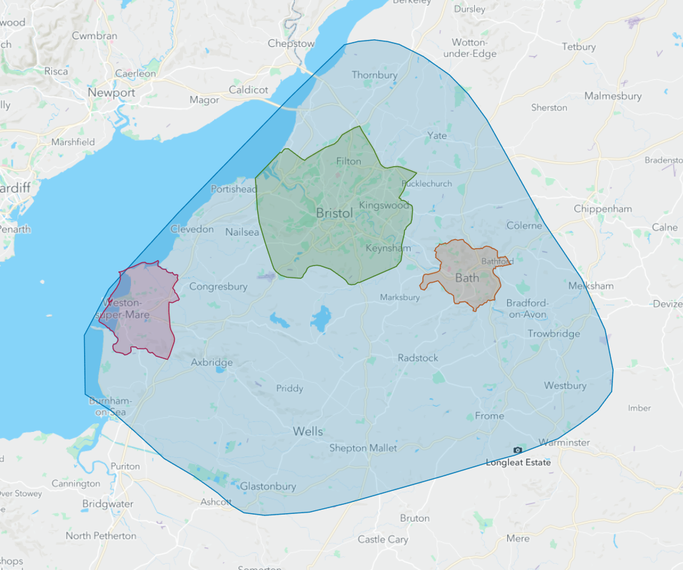

SCHEDULE B: DEDUCTIONS

(Effective from 1st April 2023)

Scale of Deductions - Failure to provide the Contracted Service in accordance with Clause 5 of the Services Agreement will result in deductions being made as set out in the clauses below.

- Failure to operate any journey or part thereof specified in Schedules D/E to the Contract, a deduction of £100.00 for each instance.

- Late operation in excess of 60 minutes from the arrival time specified on the passenger app a deduction of £200.00 for each instance

- Should the vehicles used in the operation of this contract fail to display any marking or notice required under the vehicles schedule, deductions will be made as follows:

(a) Correct operational zone: a deduction of £50.00 for each instance.

(b) Designated seats for the use of the elderly or disabled: a deduction of £150.00 for each instance.

(c) No Smoking notice: a deduction of £25.00 for each instance.

(d) Internal and/or external West of England Combined Authority notice: a deduction of £25.00 for each instance.

- Operation of a vehicle other than specified in Schedule I (or subsequently agreed with the Director), a deduction of £250.00 per day of operation.

- Failure to operate a low floor vehicle: a deduction of £200.00 for each instance.

- Failure to comply with vehicle cleanliness specifications as set out in Clause 10 of the Conditions of Contract:

(a) a deduction of £100.00 for failure to clean vehicle (inside and outside) prior to commencement of a day’s operation;

(b) a deduction of £100.00 for failure to remove graffiti within specified time limit.

- Failure to collect a booked passenger from the reserved spot, whether a recognised or virtual stop, a deduction of £200.00 for each instance.

- Failure to notify West of England Combined Authority of any vehicle involved in a collision within 24 hours of the incident. £100.00 per incident.

- Failure of driver to wear specified uniform: a deduction £100.00 per driver per day.

- Driver smoking or vaping whilst in the vehicle providing the Contracted Service or when in contact with the public travelling on the Contracted Service, a deduction of £300.00 for each instance observed by the Director.

- Drivers failing to abide by prevailing legislation regarding the use of mobile phones whilst driving, £300.00 for each instance.

- Driver failing to have ticket machine or handheld ticket machine and mobile phone/tablet operational on the contracted service: £200.00 for each instance.

- Failure to provide any ticket or other fare facility as specified in Schedule A to the Contract, a deduction of £150.00 for each instance.

- Failure to record tickets or passes correctly through the ticket machine, £200.00 for each instance.

- Failure to ensure a member of staff is available during the hours of operation of the contracted service, to monitor and restore the service if it becomes disrupted: £200.00 for each instance.

- Failure for a journey to track and provide real time predictions due to driver not logged into driver app/ticketer machine, £150.00 for each instance.

- Failure to operate service using a branded vehicle £200.00 per vehicle per day. (unless agreed in advance)

- The issue of any publicity material in any form without acknowledgement of West of England Combined Authority support a deduction of £100.00 for each publication observed by the Director.

- Sub-contracting without prior written permission of the Director, except in emergency in accordance with the Conditions of Contract, a deduction of £500.00 for each day.

The deduction figures listed above will be in place for the life of the contract.

SCHEDULE B (Continued)

SYSTEM OF OPERATION OF DEDUCTIONS

1. The Director is authorised to waive any deduction if he/she is satisfied that the failure to operate or irregular operation arose as a result of severe weather conditions, particular cases of traffic delay or other unforeseen circumstances outside the Contractor's control. The onus is on the Contractor to advise the Director of any difficulties arising from any such cause. In the event of no such advice being received, deductions indicated above will be made.

2. The Contractor will find it appropriate to furnish a statement of early and late running giving explanations where possible. The Director will then be in a position to take account of such circumstances when considering whether to make any deduction.

3. If the Contractor considers that the running time given in the calculated by the driver app is the cause of unreliable operation he must inform the Director in writing within one month from the commencement of the contract. The Director will then examine the case for revising the driver app to eliminate the problem in conjunction with the Contractor. In such circumstances deductions which might be reasonably attributable to the identified problem will normally be waived for such time as is necessary to resolve the difficulty affecting the journey(s) in question.

4. In the event of the Contractor being dissatisfied with the decision of the Director in any instance, the dispute resolution procedure outlined in section 15 of the services agreement will apply.

SCHEDULE C: CONTRACT PRICE REVISIONS

PRICE REVISIONS FORMULA

- Contract prices will be reviewed annually and any changes will take effect on 1st April 2024 and then the 1st April of each subsequent year of the contract.

- The price revision will be based on the changes to the Consumer price Index (CPI) as published in the November edition of the Monthly Digest of Statistics. Please note that this could result in contract prices going down.

- The percentage change in price will be based on the movement of prices between October of the previous year and October of the current year. (E.g. for the first review it will be the price change % between October 2022 and October 2023).

- The Percentage change in price will also be capped at + or – 2%. Please note this may be subject to review.

SCHEDULE D: PUBLIC HOLIDAYS (CHRISTMAS PERIOD)
The contract is intended to operate on the days shown in point 5: Timetable (Christmas and New Year arrangements are detailed below) The contractor will be notified in advance of the requirements to operate any additional services detailed in the timetable.

 | 2023/24 | Service level
Christmas Eve | Sun 24th | Normal service
Christmas Day | Mon 25th | No service
Boxing Day | Tues 26th | No service
 | Wed 27th | Saturday service (Monday to Friday service will operate where there is no Saturday service provision)
 | Thurs 28th | Saturday service (Monday to Friday service will operate where there is no Saturday service provision)
 | Fri 29th | Saturday service (Monday to Friday service will operate where there is no Saturday service provision)
 | Sat 30th | Normal service
New Year’s Eve | Sun 31st | Normal service
New Year’s Day | Mon 1st | No service
 | Tues 2nd | Normal service

 | 2024/25 | Service level
Christmas Eve | Tues 24th | Normal service
Christmas Day | Wed 25th | No service
Boxing Day | Thurs 26th | No service
 | Fri 27th | Saturday service (Monday to Friday service will operate where there is no Saturday service provision)
 | Sat 28th | Normal service
 | Sun 29th | Normal service
 | Mon 30th | Saturday service (Monday to Friday service will operate where there is no Saturday service provision)
New Year’s Eve | Tues 31st | Saturday service (Monday to Friday service will operate where there is no Saturday service provision)
New Year’s Day | Wed 1st | No service
 | Thurs 2nd | Normal service

 | 2025/26 | Service level
Christmas Eve | Wed 24th | Normal service
Christmas Day | Thurs 25th | No service
Boxing Day | Fri 26th | No service
 | Sat 27th | Normal service
 | Sun 28th | Normal service
 | Mon 29th | Saturday service (Monday to Friday service will operate where there is no Saturday service provision)
 | Tues 30th | Saturday service (Monday to Friday service will operate where there is no Saturday service provision)
New Year’s Eve | Wed 31st | Normal service
New Year’s Day | Thurs 1st | No service
 | Fri 2nd | Normal service

 | 2026/27 | Service level
Christmas Eve | Thurs 24th | Normal service
Christmas Day | Fri 25th | No service
Boxing Day | Sat 26th | No service
 | Sun 27th | Normal service
 | Mon 28th | Public Holiday service
 | Tues 29th | Saturday service (Monday to Friday service will operate where there is no Saturday service provision)
 | Wed 30th | Saturday service (Monday to Friday service will operate where there is no Saturday service provision)
New Year’s Eve | Thurs 31st | Saturday service (Monday to Friday service will operate where there is no Saturday service provision)
New Year’s Day | Fri 1st | No service
 | Sat 2nd | Normal service

 | 2027/28 | Service level
Christmas Eve | Fri 24th | Normal service
Christmas Day | Sat 25th | No service
Boxing Day | Sun 26th | No service
 | Mon 27th | Public Holiday service
 | Tues 28th | Public Holiday service
 | Wed 29th | Saturday service (Monday to Friday service will operate where there is no Saturday service provision)
 | Thurs 30th | Saturday service (Monday to Friday service will operate where there is no Saturday service provision)
New Year’s Eve | Fri 31st | Normal service
New Year’s Day | Sat 1st | No service
 | Sun 2nd | Normal service

 | 2028/29 | Service level
Christmas Eve | Sun 24th | Normal service
Christmas Day | Mon 25th | No service
Boxing Day | Tues 26th | No service
 | Wed 27th | Saturday service (Monday to Friday service will operate where there is no Saturday service provision)
 | Thurs 28th | Saturday service (Monday to Friday service will operate where there is no Saturday service provision)
 | Fri 29th | Saturday service (Monday to Friday service will operate where there is no Saturday service provision)
 | Sat 30th | Normal service
New Year’s Eve | Sun 31st | Normal service
New Year’s Day | Mon 1st | No service
Christmas Eve | Sun 24th | Normal service

 | 2029/30 | Service level
Christmas Eve | Mon 24th | Normal service
Christmas Day | Tues 25th | No service
Boxing Day | Wed 26th | No service
 | Thurs 27th | Saturday service (Monday to Friday service will operate where there is no Saturday service provision)
 | Fri 28th | Saturday service (Monday to Friday service will operate where there is no Saturday service provision)
 | Sat 29th | Normal service
 | Sun 30th | Normal service
New Year’s Eve | Mon 31st | Saturday service (Monday to Friday service will operate where there is no Saturday service provision)
New Year’s Day | Tues 1st | No service
 | Wed 2nd | Normal service

 | 2030/31 | Service level
Christmas Eve | Tues 24th | Normal service
Christmas Day | Weds 25th | No service
Boxing Day | Thurs 26th | No service
 | Fri 27th | Saturday service (Monday to Friday service will operate where there is no Saturday service provision)
 | Sat 28th | Normal service
 | Sun 29th | Normal service
 | Mon 30th | Saturday service (Monday to Friday service will operate where there is no Saturday service provision)
New Year’s Eve | Tues 31st | Normal service
New Year’s Day | Weds 1st | No service
 | Thurs 2nd | Normal service

SCHEDULE E: DRT SERVICES BY ZONES/REGIONS

- Regions
DRT 1 East of Region – drop off points outside zone allowed: Emersons Green; Kingswood; Royal United Hospital Bath; Lansdown Park and Ride

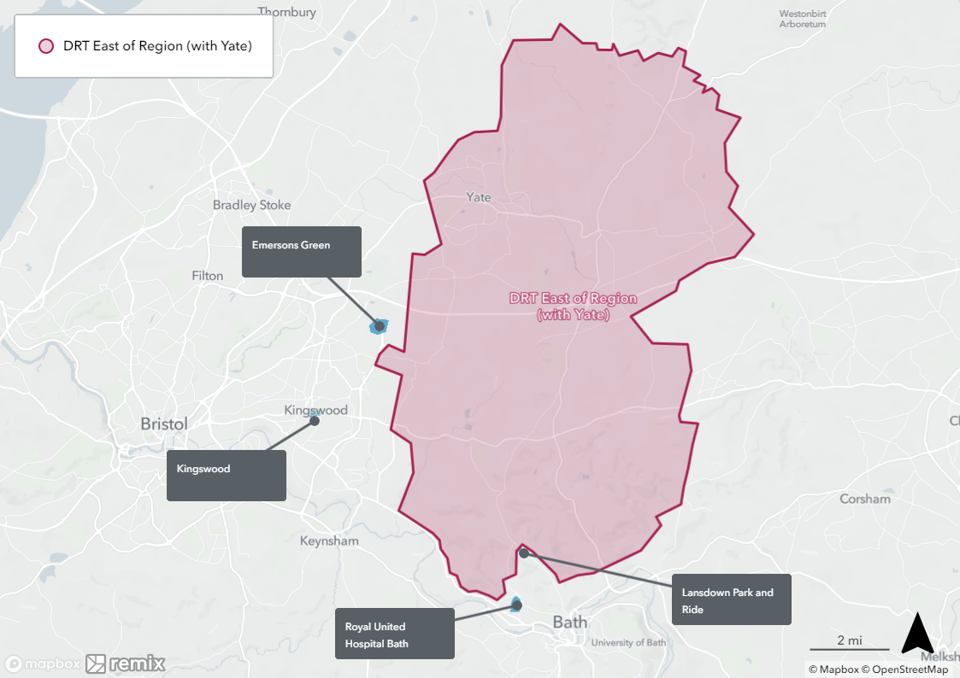

DRT 2 Keynsham Town

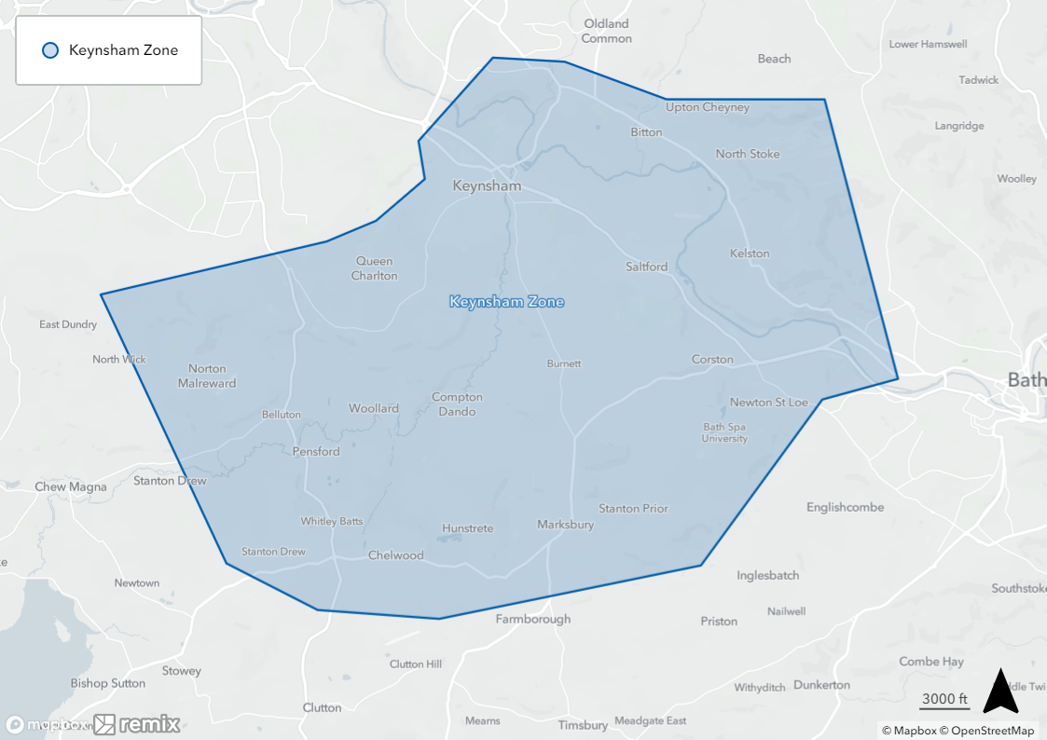

DRT 3 Midsomer Norton/Radstock Town

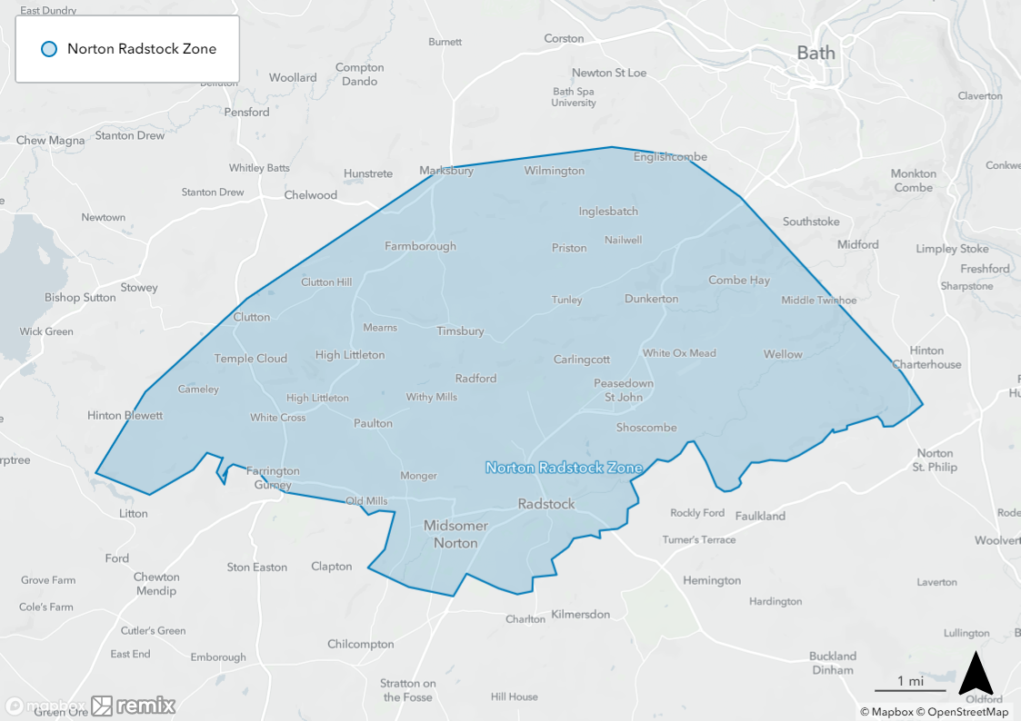

DRT 4 North of Region – drop off points outside zone allowed: Cribbs Causeway; Southmead Hospital; Bristol Parkway Station

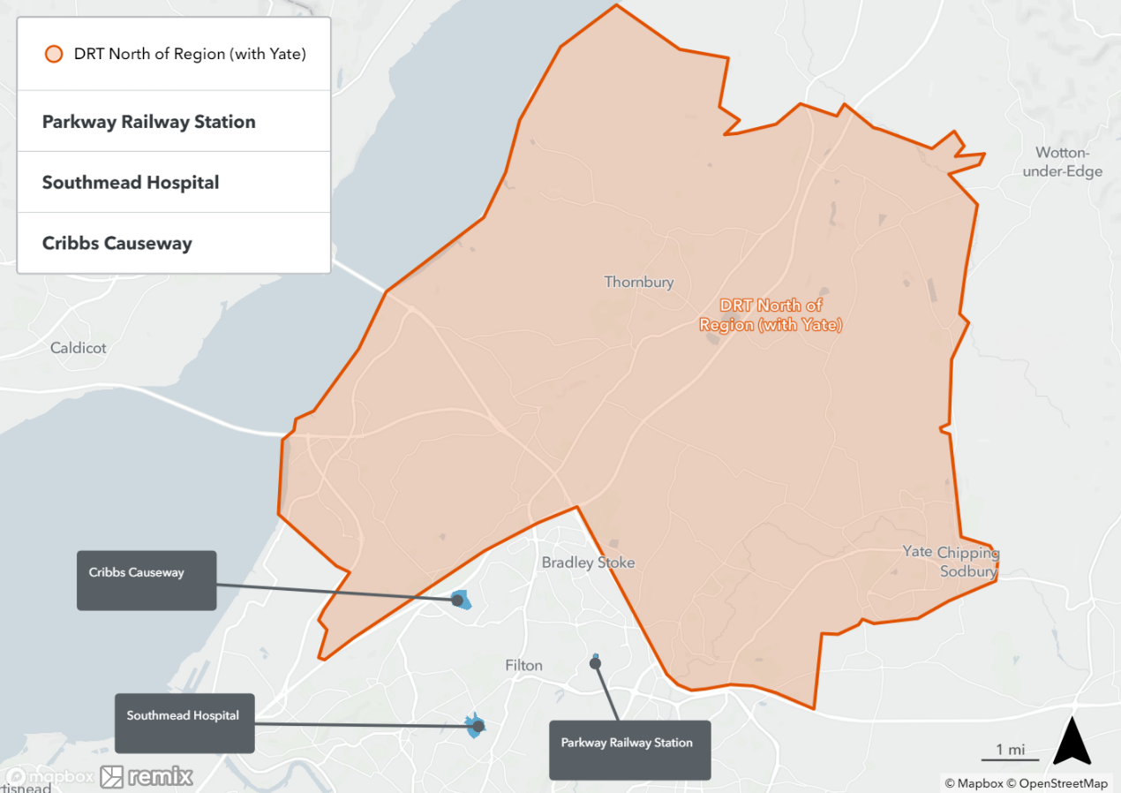

DRT 5 SE NSC – drop off points outside zone allowed Hengrove Park

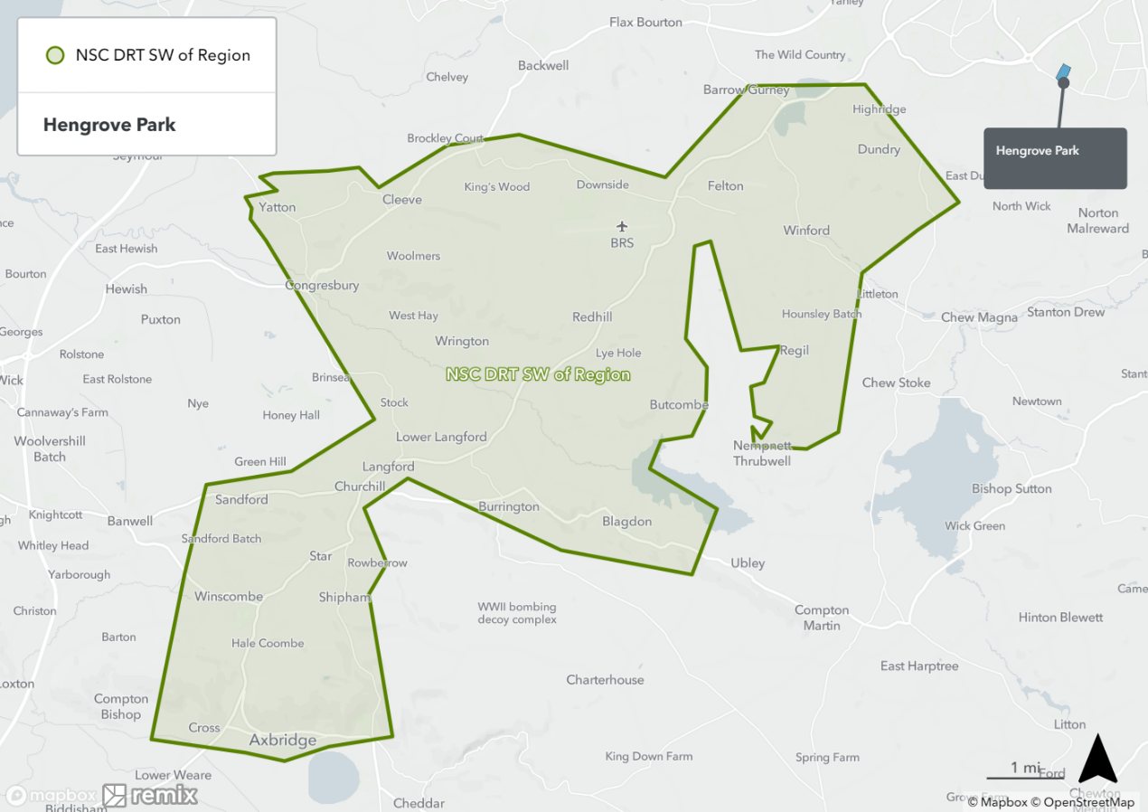

DRT 6 SE of Region – drop off points outside zone allowed Brislington Park and Ride; Keynsham; Pensford; Odd Down Park and Ride

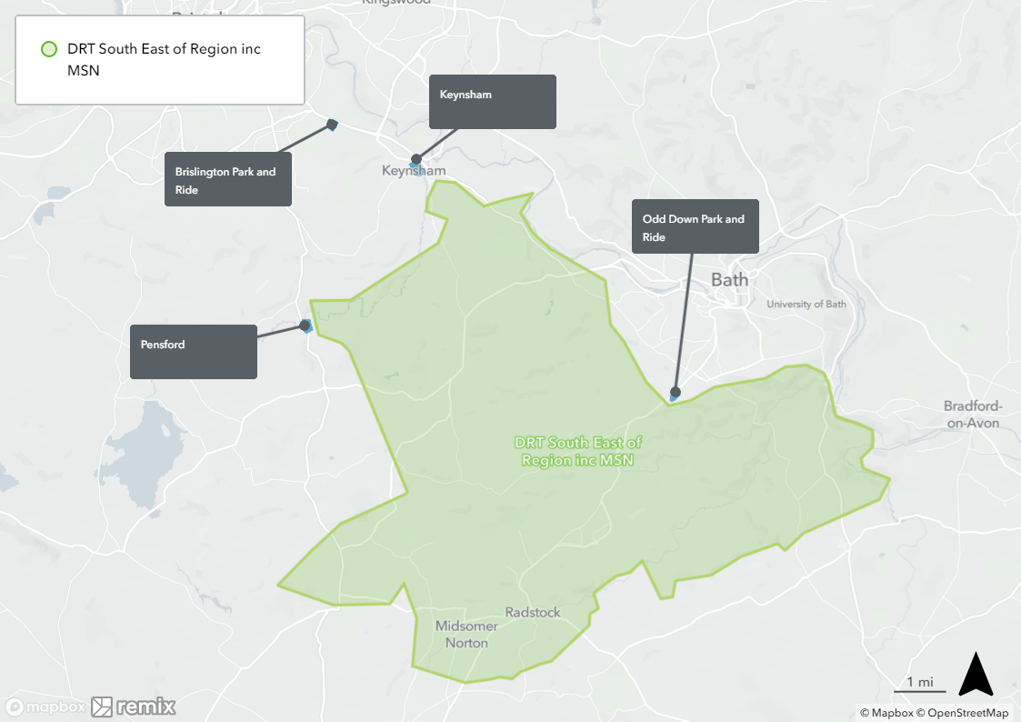

DRT 7 SW of Region/SE NSC inc Axbridge – drop off points outside zone allowed: Hengrove Park

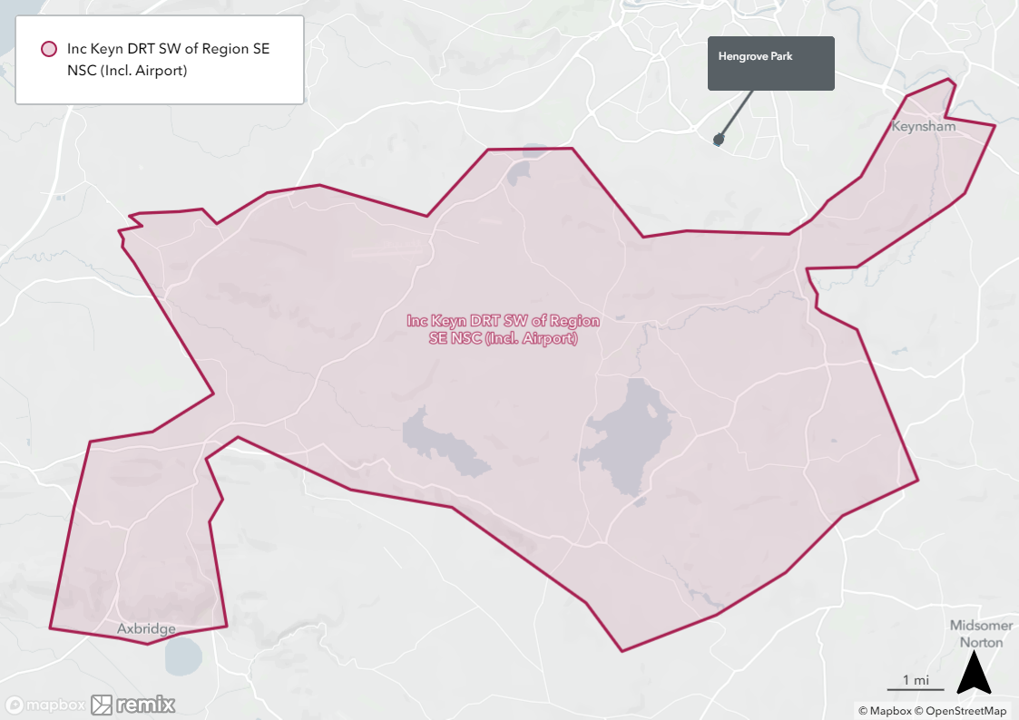

DRT 8 SW of Region/SE NSC ex Axbridge – drop off points outside zone allowed: Hengrove Park

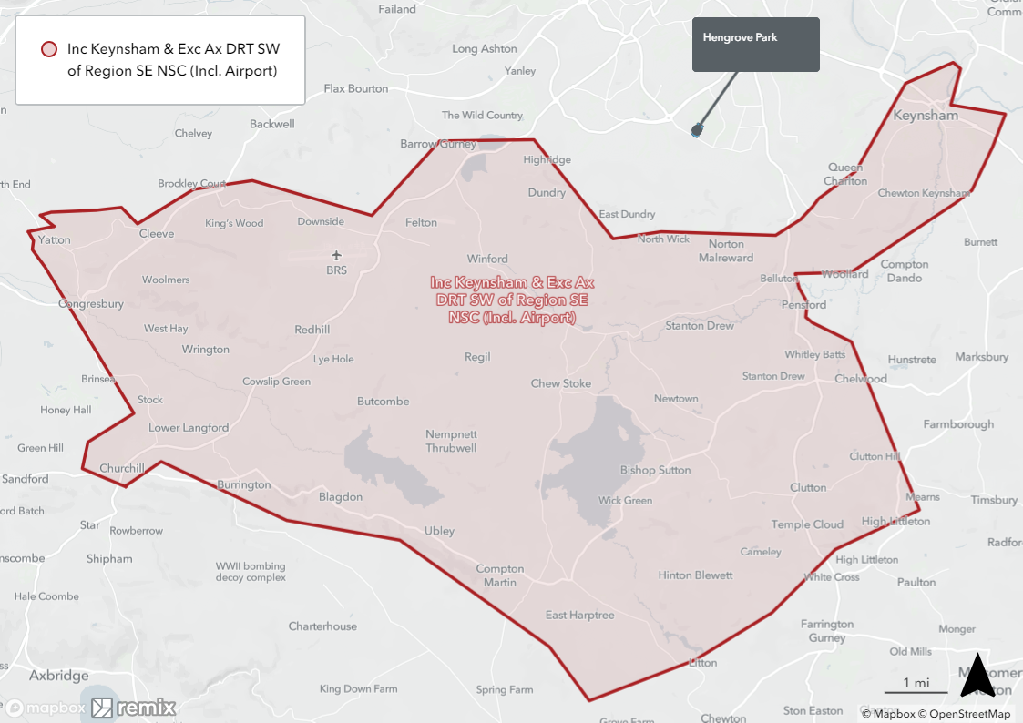

DRT 9 Thornbury Town

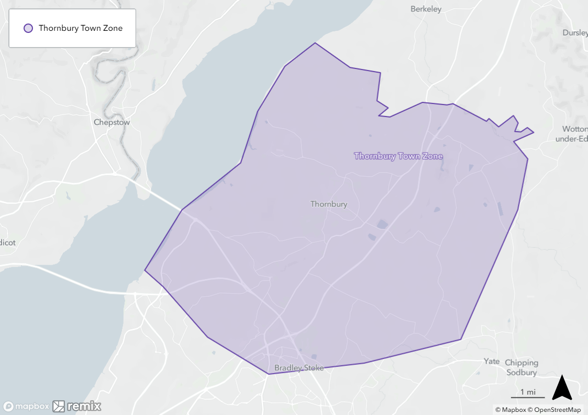

DRT 10 Yate Town

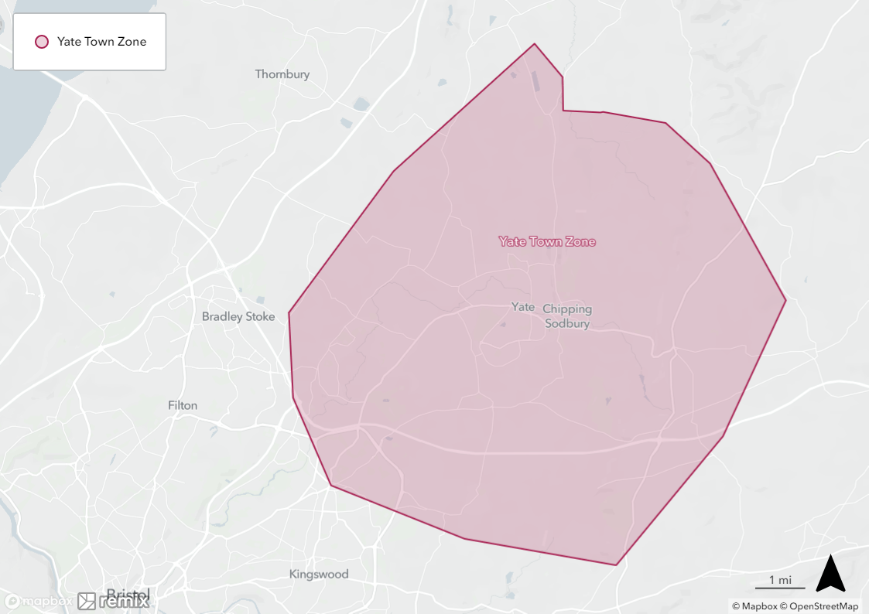

DRT 11 Clevedon/Portishead – drop off points outside zone allowed: Portway Park and Ride; Avonmouth

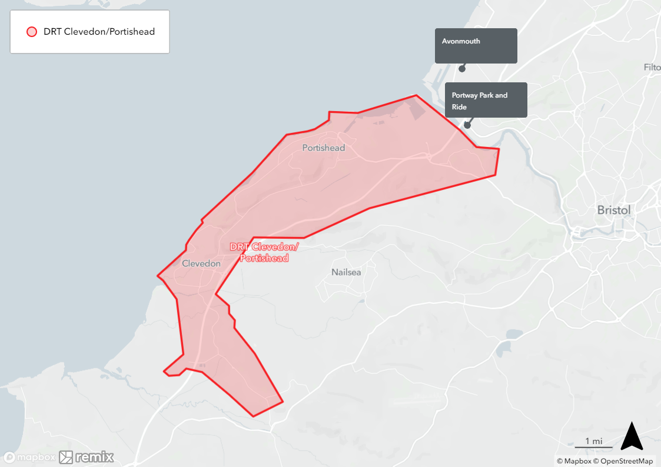

DRT 12 Weston

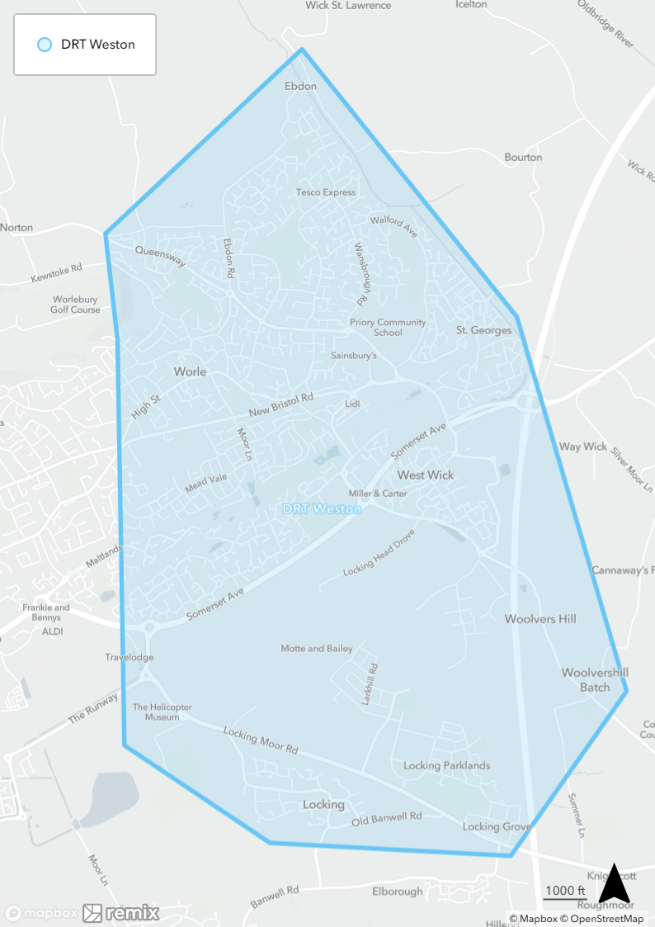

DRT 13 Windmill Hill & Knowle

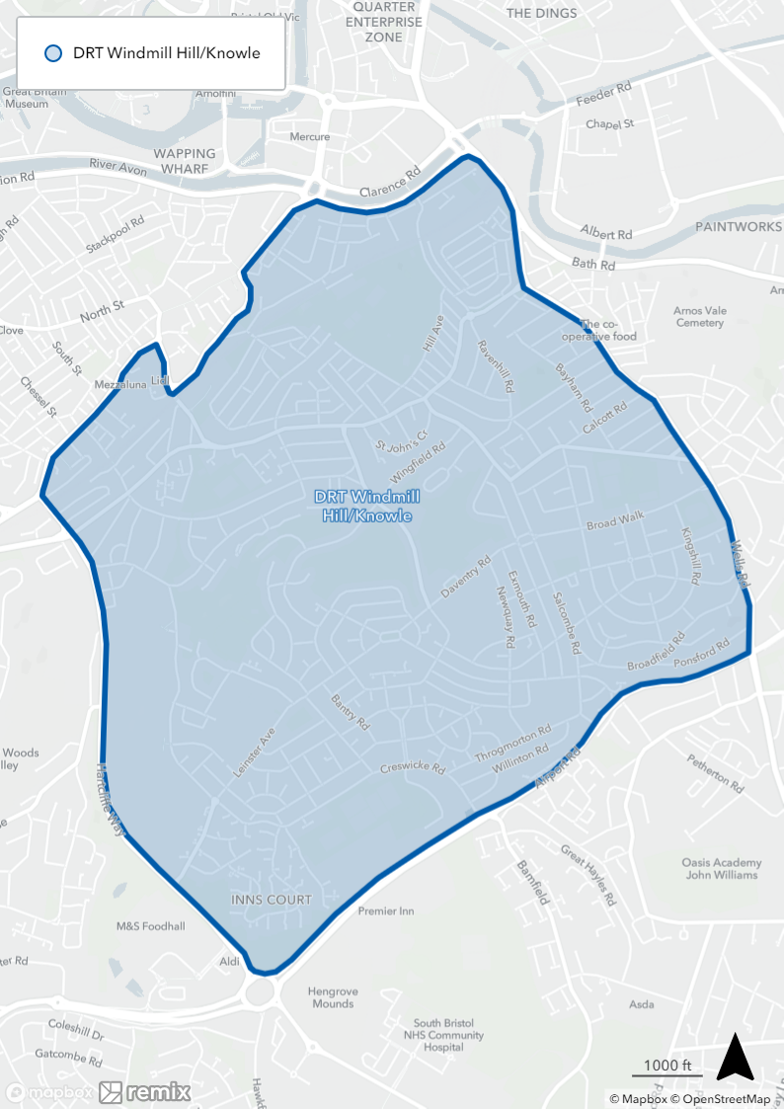

DRT 14 Brislington & St Annes

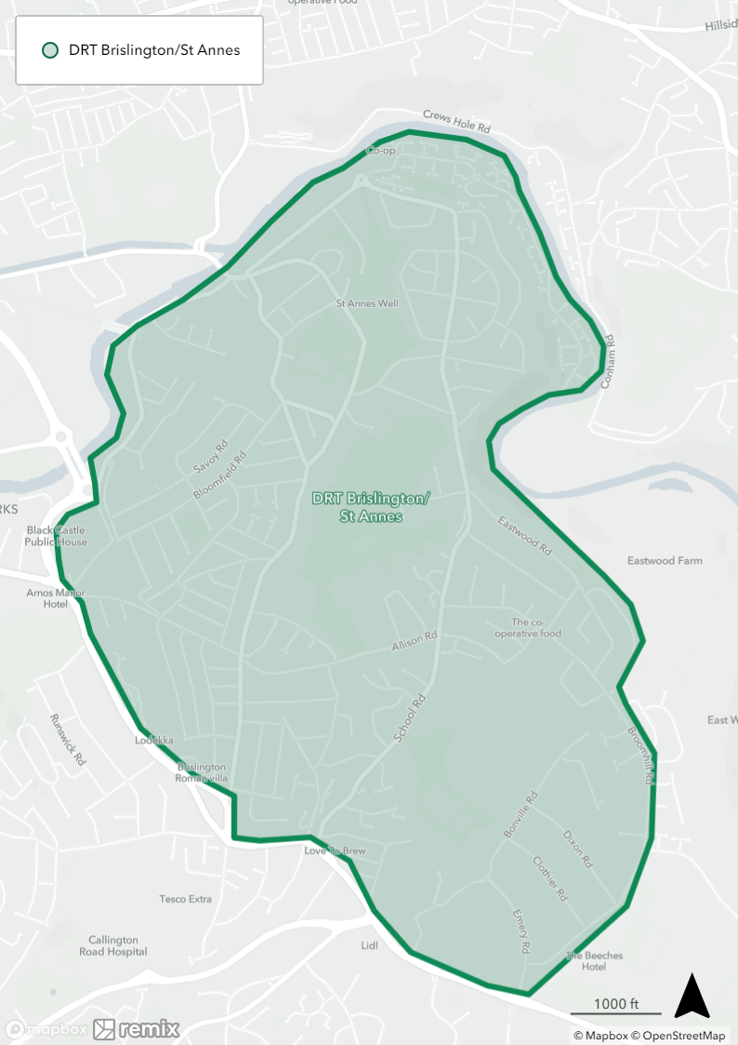

E: CONTRACTORS’ OBLIGATIONS

- The contractor shall operate the contracted service in compliance with the contract conditions.

- The contractor shall at all times provide the contracted service with skill, care and diligence, with the utmost good faith and to the contract standards.

- The contractor will be subject to the conditions in the West of England Enhanced Partnership Plan and Schemes. This applies to services that would otherwise be classed as exempted services in the Enhanced Partnership Schemes.

- The contractor shall inform West of England Combined Authority representative as soon as they become aware (and confirm in writing) if the contractor is unable or fails to provide the service or any part of it. The provision of information under this shall not in any way release or excuse the contractor from any of its obligations under the contract.

- The contractor shall notify West of England Combined Authority in writing with details of any collision involving a vehicle in the operation of a contracted service and any incident that results in injury to passengers within 24 hours of the incident.

- In the event of service disruption, the contractor will be required to liaise with West of England Combined Authority to facilitate the updating of the Travelwest website and/or real time information system within 60 minutes. The contractor will be required to communicate with West of England Combined Authority designated officer to ensure information on the service is collated and relayed to the public through the appropriate media channels.

- The contractor will be required to maintain and update its own website to provide information on service operation, including updates on service disruption. This will include regular updates of operation in the event of a major disruption due to adverse weather conditions or other circumstances.

- The contractor will be required to co-operate, liaise and co-ordinate its activities with those of any consultant employed directly or indirectly by West of England Combined Authority.

- The contractor shall have and keep in force at all times during the life of this contract a Public Service Vehicle Operator’s Licence of the relevant classification as required by ection 12 of the Public Passenger Vehicles Act 1981 or a Section 22 Community Bus Permit or any subsequent enactments which allows the operation of the services in the manner proposed and shall produce the licence or permit at any time for inspection by an authorised officer of West of England Combined Authority.

- If the contractor does not have the correct licence or if any licence previously granted has been suspended or withdrawn for any reason or has had conditions attached to it which prohibit the operation of the contracted service. The contractor must notify West of England Combined Authority immediately and West of England Combined Authority reserves the right to immediately terminate the contract without notice.

- The contractor shall, if required by West of England Combined Authority, at any time produce for inspection by an authorised officer, the current policy/policies of insurance in respect of the vehicles being used on the contracted service. Along with any licences or other requirements necessary for the operation of the vehicles, and any certificate appertaining to the fitness of the vehicle for operating under the licence or with regard to the current legislation appertaining to the road-worthiness of the vehicle. This does not negate the contractor’s responsibility for ensuring that such documents are sufficient to comply with ongoing requirements.

- The contractor is responsible, both administratively and financially, for ensuring that the appropriate registration to enable the contracted service to commence or to vary it has been lodged with and approved by the Traffic Commissioner. West of England Combined Authority will reimburse the cost of any registration fee incurred by the contractor for variations to the registration made at the request of West of England Combined Authority, but the contractor shall take responsibility for any variations agreed at the contractor’s initiative.

- The contractor shall deal with lost property in accordance with the Public Service Vehicles (Lost Property) Regulations 1978 as amended by the Public Service vehicles (Lost Property) Regulations (Amendment) 1995.

- The contractor will be required to have a robust business continuity plan in place within 3 months of the start of any contract.

- The contractor must notify West of England Combined Authority in writing of any public inquiry to be held by the Traffic Commissioner into the operation of the contractor’s services, including those that are not operated under contract to West of England Combined Authority.

- If the contractor fails to observe any of the contractor’s obligations listed in this schedule, West of England Combined Authority may withhold monies as set out in Schedule B.

SCHEDULE F: VEHICLE/S TO BE USED IN PERFORMANCE OF THE CONTRACT (to be completed at contract award)

The number of vehicles specified for each zone includes one additional spare vehicle, however if an operator wins multiple zones, it may be possible to use the same spare vehicle for multiple zones.

DRT zones and number of vehicles proposed

West of England Combined Authority has a duty under the Transport Act 1985 to have regard to the transport needs of members of the public who are elderly or disabled.

Particulars of vehicles to be used normally on the services listed above:-

Make and Model Type of Body

........................... ......................

........................... ......................

........................... ......................

Maximum Age Number of Wheelchair Spaces

........................... ................................................

........................... ................................................

........................... ................................................

NOTES:
This form must be returned with the tender. The Contractor must advise West of England Combined Authority of any changes to the vehicle details given during the period of the Contract. If vehicles are used on the Contract awarded as part of this Schedule, details of which have not been notified to West of England Combined Authority, the Contractor will be liable to deductions as set out in Schedule B.

SCHEDULE G: VEHICLES

- All vehicles used on the contracted service will be low floor and have adequate capacity to meet demand. All vehicles operated on the DRT routes regardless of size or type must comply with this Schedule G.

- No Large single (25+seats above) or double decker vehicles can operate on DRT routes. All in cases need to be appropriate to the services and location.

- All vehicles used on the contracted service will at a minimum comply with Euro VI emission standards. These vehicles must be in place by 31st December 2023. This only applies to services not travelling into a Clean Air Zone.

- All vehicles to be used on this contracted service must comply with all the requirements of the Public Service Vehicles Accessibility Regulations 2000.

- At least one vehicle in operation in a region must be wheelchair accessible with a side ramp and not a rear tail lift.

- Certain seats within the vehicle, close to entrance or exit doors shall be designated for the use of persons who are elderly or disabled and a notice should be displayed close to the seats to that effect.

- Entrance/exit steps and grab-rails shall be clearly marked to assist visually disabled persons.

- All vehicles will be fitted with winter tyres as appropriate from November until April, to ensure continued operation throughout the year.

- All vehicles operating on the contracted service will be painted in the livery specified by West of England Combined Authority, at the contractor’s expense (livery TBC).

- All vehicles operating on the contracted service will be equipped with a fully operational handheld ticket machine to be supplied by the West of England Combined Authority.

- All vehicles operating on the contracted service will be equipped with a means of communication with the base/depot, whether that be by radio or mobile phone.

- Any vehicle being used on this contract shall be licenced, equipped, and maintained as required by statute and shall not be parked overnight on any public highway.

- The contractor shall if required by West of England Combined Authority allow the vehicle(s) to be submitted for a spot check without prior notice, to ensure that the legal requirements in force are met. This spot check may be carried out by an authorised officer or agent of West of England Combined Authority, either on site or at a place nominated by the authorised officer.

- The contractor shall, always, keep proper records of all routine services, repairs and work carried out on the vehicle(s) and all such records shall be produced whenever required for the inspection of any officer authorised by the director.

- The contractor shall take reasonable steps to ensure the safety of passengers not only whilst they are on board the vehicle but also whilst they are entering or leaving or boarding or alighting.

- Any vehicle provided must be capable of one person operation unless a conductor is present, and the doors are always under his/her control.

- The contractor shall ensure that all vehicles involved in the execution of the contracted service must always be clean, tidy and in a hygienic condition both internally and externally.

- Vehicles must always when operating the contracted service have climate control and be adequately heated and ventilated or air conditioned and must comply at all times with all statutes, orders and regulations.

- Vehicles must carry suitable first aid and fire extinguishing equipment.

- The contracted is required to operate with CCTV equipment fitted to all vehicles. When operating a CCTV system it must be maintained to ensure it is fully functional throughout the life of the contract. The contractor must ensure that, when required, footage from the system is made available in line with CCTV codes of practice. Available within 5 days of request.

- The contractor is required to have access to 10% or more of spare vehicles to cover breakdowns and/or incidents.

- In the event of an unscheduled breakdown and/or incident, the Contractor is required to have a replacement vehicle in operation within 2 hours , or the next booking.

- The contractor must ensure the Real Time Information (RTI) system is actively monitored throughout operational hours contracted.

- The contractor will ensure that RTI/Ticket Machines are fully operational at all times. In the event a RTI/ticket machine is out of operation a replacement RTI/Ticket Machine will be in operation within 2 hours of notice of the fault. During this period the Contractor will be able to provide emergency tickets to passengers (and must record passenger numbers) manually and report to the Combined Authority.

SCHEDULE H: ADVERTISING / NOTICES

- The contractor shall provide an A3 display case for notices relating to public transport as West of England Combined Authority may from time to time require.

- Passengers are not permitted to smoke or vape when travelling on contracted services and a notice to this effect should be clearly displayed on the vehicle.

- External advertising shall be allowed at the discretion of the Director. All proposed advertising shall be sent to West of England Combined Authority to approve before placing on the vehicle.

- The contractor shall not display any advertising on vehicles to be used on the contracted service that contains any of the following:

4.1 party political advertising
4.2 religious advertising
4.3 tobacco advertising including e-cigarettes
4.4 alcohol advertising
4.5 pay-day loan advertising (being short-term consumer borrowing where an individual borrows small amounts of money at a very high rate of interest e.g Wonga.com and Quick Quid)

- The Contractor will make available 100% of interior advertising space for the free use of West of England Combined Authority, as required. The vehicles will be fitted to accept advertising on the coving panels.

SCHEDULE I: STAFF

Supervisors/Managers

- The contractor must always have at least one allocated suitable manager on duty in the West of England area when the contracted service is in operation.

- The contractor is required to supply a monthly staff rota to West of England Combined Authority which is to include contact details for the on-duty supervisor/manager. One week before the 1st of each Month.

Drivers

- All vehicles supplied for the carriage of passengers must be in the charge of a competent and reliable driver. The driver must be licensed in accordance with the provisions of the relevant legislation. The contractor shall produce the relevant copy licence of any driver on reasonable notice for inspection by the Council.

- The contractor must supply a dedicated pool of drivers for the contracted service, and should notify West of England Combined Authority of any changes to this.

- The contractor must have at least one spare driver on duty in the West of England area at all times when the contracted service is in operation.

- The driver shall be of clean and smart appearance and courteous towards passengers at all times. Drivers shall wear a standard uniform either that of the contractor or a uniform specific to the contracted service and approved by West of England Combined Authority, to make them easily recognisable to passengers.

- Uniforms shall be worn at all times whilst employed on the contracted service.

- The contractor must be able to communicate with drivers of vehicles operating the contracted service by mobile phone, radio or via the ticket machine.

- Any mobile phone communication must only be carried out when the vehicle is parked at a safe location and in compliance with the relevant legislation regarding mobile phone in vehicles.

- Driver shall not smoke or vape at any time when in charge of the vehicle on a contracted service. In the event of failure to observe this requirement, the Council may without monies due, as set out in Schedule B.

- Where any other employee of the contractor is in the vehicle in the course of any contracted service, they shall comply with the requirements set out in this schedule.

- The contractor is required to have access to 10% or more of additional drivers to cover breakdowns, incidents and/or sickness.

- All drivers must receive all mandatory training and in-house training to cover but not be limited to, customer service, driver behaviour, disability awareness and managing difficult situations prior to operating a vehicle and providing a DRT service. Failure to meet this requirement will result in a breach of contract.

- The contractor at all times must comply with the Equality Act 2010 and must actively promote equality and diversity in employment of staff and through service delivery.

SCHEDULE J: COMMENTS AND COMPLAINTS

- The Contractor is required to have a Customer Charter in place prior to operations commencing. The Customer Charter may be the Contractors own Charter and/or the Contractor may use the Combined Authorities. In any event the Customer Charter must be consistent with that of the Combined Authorities.

- West of England Combined Authority shall send to the Contractor, within 7 days of receipt, all complaints received about the Contracted Service or its performance.

- The Contractor shall send to West of England Combined Authority, within 7 days of receipt, all comments or complaints received about the Contracted Service or its performance. A copy of the written reply to a complaint must be forwarded to West of England Combined Authority within 21 days of the receipt of the original complaint.

- When West of England Combined Authority seeks written comments following a complaint, the Contractor shall send a detailed response in writing to West of England Combined Authority within 14 days of the receipt of notification of the complaint. If the Contractor does not respond within 14 days he shall be deemed to accept the validity of the complaint which thereafter West of England Combined Authority shall be entitled to uphold and in consequence the Contractor shall be liable to all relevant deductions as set out at Schedule B.

SCHEDULE K: SUPPORTING DATA

- The contractor shall supply each month to West of England Combined Authority full details of total passengers carried.

- This information should be supplied to West of England Combined Authority within 14 days of the beginning of the following month.

- Where the contractor collects this in an electronic format, it shall be supplied to West of England Combined Authority in this format.

- If the contractor fails to submit the data they will be liable to all deductions set out in Schedule B.

- The contractor shall when requested by West of England Combined Authority submit for each day of operation details of the number of passengers carried on each individual journey. West of England Combined Authority will require this for one complete week in each quarter, per annum. West of England Combined Authority will advise the contractor of the required weeks.

- The contractor shall provide each month to West of England Combined Authority full details of any journeys or part journeys not operated, during the previous month’s operation.

- West of England Combined Authority shall be entitled to call for such additional evidence as it may think fit to substantiate any account submitted by the contractor and shall be entitles to so even if there is no reason to suspect that an account might be incorrect.

SCHEDULE L: DRT SCHEME AND PUBLICITY
- The DRT service will be promoted by West of England Combined Authority and North Somerset Council within its publicity programme which includes roadside displays and timetable leaflets. This does not preclude the contractor from issuing publicity material provided an acknowledgement of West of England Combined Authority support for any contracted services is included and a draft copy of the material is sent in advance to West of England Combined Authority for approval of the Director. West of England Combined Authority reserves the right to withdrawal any such material deemed by West of England Combined Authority not to be suitable. If the contractor fails to include an acknowledge in any material, West of England Combined Authority reserves the right to withhold certain monies as set out in Schedule B.

- The contractor will be expected to co-operate wherever possible to publicise contracted services operated on behalf of West of England Combined Authority.

- All registrations relating to the services will be submitted in a timely manner.

- Copies of all registrations sent to the Traffic Commissioner relating to the contracted service will also be sent to West of England Combined Authority, North Somerset and Somerset County Council where applicable at the same time.

