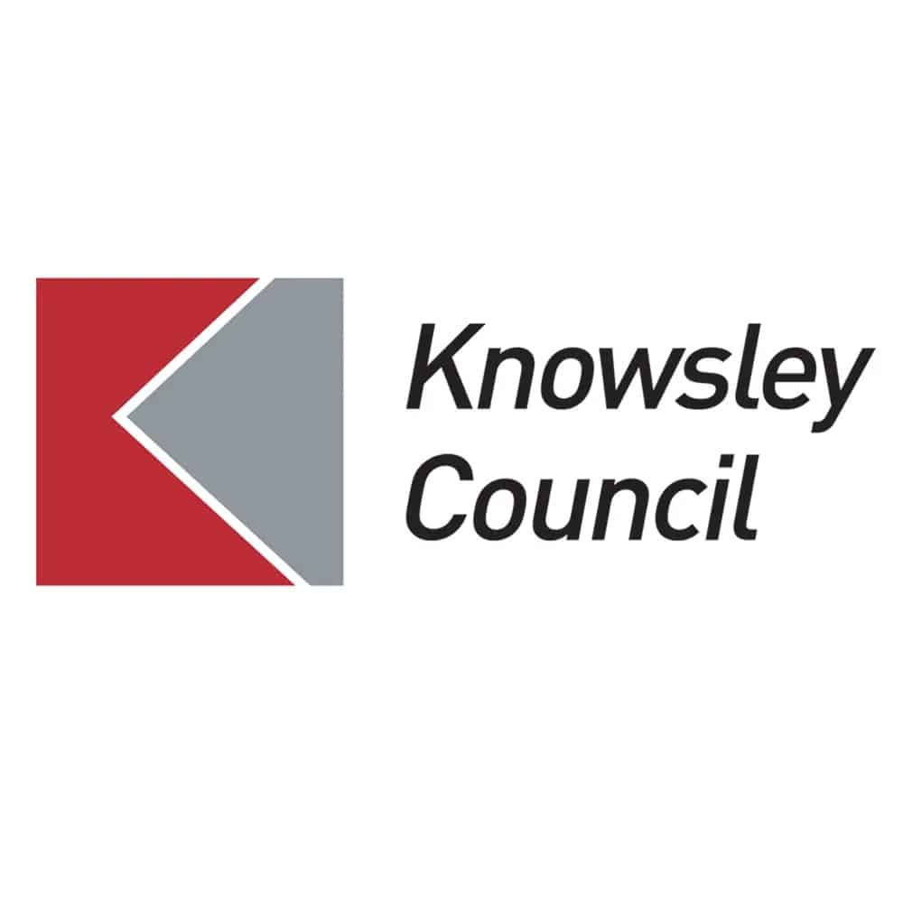****

Knowsley Council

**Soft Market testing**

Shakespeare North Substation Roof

Contract Period:

**August/September 2024**

1. **Background**

We would like to take the opportunity to do some `soft market testing’ as outlined below, to determine current interest levels in the market for the provision of fencing and gates to prevent unauthorised access at an external substation roof area of the Shakespeare North Playhouse.

1. **Key Aims**

The key aims/requirements are:

* The gate and fencing panels are to be flush with the brickwork so as to not create any foot/grip holds.
* The gate and fencing panels are to be perforated (one of the front panels is to also contain artwork created with perforated holes – this is currently being developed) and to be non-climbable and vandal resistant.
* The gate and fencing panels are to be wind resistant, the Contractor will need to provide an assessment of wind resistance.
* The gate and fencing panels are to be powder coated in RAL 7022
* We will need proposals from the Contractor will be requested to provide the methodology and options for fixing the back of the fence and gate posts to the existing brickwork walls.
* The design which has been submitted for Planning Permission is attached.

**Project Timescales**

|  |  |
| --- | --- |
| **Stage of the project** | **Anticipated deadline** |
| Contract Start Date | August/September 2024 |

1. **Soft Market Testing**

**THIS IS NOT A CALL FOR COMPETITION**

The Soft Market Test is intended to allow interested organisations with relevant experience to outline their views and provide information with no commitment to themselves or the Council.

The Council is looking to award a contract commencing in May/June 2024 tentatively. It is further envisaged that the initial contract would be for a period of 6 months, extension of the contract period may be considered before the issue of the tender. During the Soft Market Test we would like to gauge the level of interest.

Knowsley Council are seeking expressions of interest and information from **providers based within the borough of Knowsley** for the this project.

**Stage 1 -** Interested suppliers are required to complete the following company information form and a short questionnaire (at appendix 1). Suppliers who complete and return the questionnaire ***may*** be invited to meet with Council representatives to discuss its requirements.

The questionnaire should be returned via The Chest - <https://www.the-chest.org.uk/> by **24/07/2024 at 12p.m.**

If Suppliers have any questions about this soft market test, such questions should be submitted to the Council using the ‘Question and Answer’ facility within the opportunity advertised on The Chest. A copy of the question and a copy of the written reply may be circulated to all Suppliers, with anonymity of the Supplier preserved. Suppliers must not raise questions through any other channels, including emails direct to the Council or to STAR Procurement. No questions will be responded to, other than those raised through The Chest as described above

**We encourage your participation in this soft market testing exercise, but must emphasise that your involvement in this exercise will not carry any commercial advantage in any ensuing procurement process.**

**No information provided in response to this soft market testing exercise will be used in any evaluation of any subsequent response to a procurement exercise.**

| **1. Company Information** | |
| --- | --- |
| Full name of your organisation: |  |
| Contact Details Name: |  |
| Job Title: |  |
| Registered Office Address: |  |
| Telephone no: |  |
| Mobile No: |  |
| Email Address: |  |
| Web Address (if any): |  |
| Company Reg. Number |  |

| **2. Questions (for completion)** | | |
| --- | --- | --- |
| 2a. | Would you be interested in bidding for this opportunity? | *Please Complete* |
| YES/NO |
| 2b. | Please detail the experience your organisation has in delivering these types of Works? | |
| Response: | | |
| 2c. | Please confirm that you can meet the requirements as laid out in the Key Aims and scope of works provided? | *Please Complete* |
| YES/NO |
| 2d. | Please confirm that your business is based within the borough of Knowsley or within the Liverpool City Region. | *Please Complete* |
| YES/NO |

| **3. Declaration** | |
| --- | --- |
| **Name:** |  |
| **Signed:** | Duly authorised on behalf of the Supplier  (Electronic signature required here) |
| **Position:** |  |
| **Date:** |  |