QUOTATION REQUEST FOR DECOMMISSIONING AND COMMISSIONING THE SPLASH PARK AT LEE ON THE SOLENT.

Gosport Borough Council invites quotations to decommission the Splash Park at Lee on the Solent for the 2021 season after the 7th October 2021 and recommission the splash park in the first week of April 2022 as provisionally opening before the 16th of April.
GENERAL CONSIDERATIONS
The contractor must take the physical constraints of the works locations into account when submitting their quotation.
Materials
All materials are to be supplied by the contractor and should conform to relevant BS EN standards or equivalent.
The contractor shall be responsible for calculating required quantities.
The contractor will specify the materials to be used within their returned quotation. The specified materials will be installed as specified by the manufacturer or industry good practice to produce the required outcomes.
Site Safety
Please include site risk assessment for the works detailing how public and employee safety will be maintained during the works and including relevant PPE.
Note - the Risk assessment should also include covid-19 social distancing guidance.
Documents
The contractor shall provide evidence of Public Liability Insurance with minimum cover of £5 million along with employers’ liability insurance, appropriate industry accreditation for these works along with a valid waste carriers licence with details for the disposal of the waste generated by these works or a valid trade waste agreement.

DETAIL OF REQUIRED WORKS
Site information
Lee on the Solent Splash Park, Beach Road Car Park, Marine Parade East, Gosport PO13 9LA
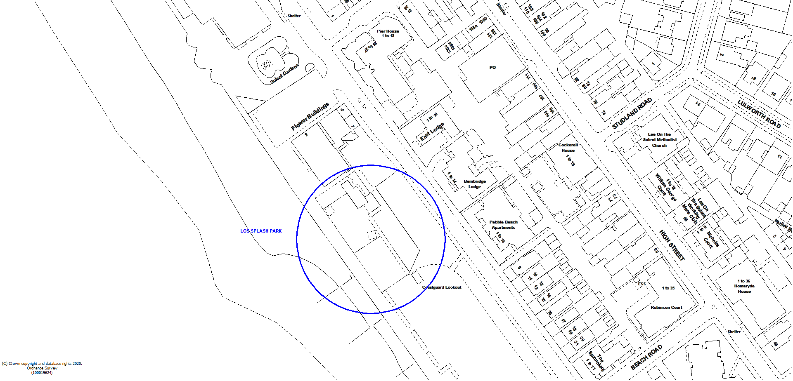

Requirements
The Splash Park at Lee on the Solent is due to reopen late April 2022 Gosport Borough Council therefore wishes to commission the park by 16th April 2022.

Decommissioning includes the following:
Full Service to check typically:
- Pump Sets - Check strainers and clean, empty pipe work of water.
- Level Equipment: - Switch down manual and auto operation of top-up system. Isolate supply.
- Drain: Check drain/overflows and clear as required and sump pump set to winter mode and operational.
- Set drain to waste.
- Check for pipe condition and leaks.
- Check plant room drains and leave tidy.
- Play items - Check units are secure. Winter blanks to be fitted on ground jets, jet put into plant room.
Commissioning includes the following;
- Sterilise and refill water reservoir tank.
- Shock treat and flush system.
- Replace Granudos pressure switch.
- Install exterior splash pad features and remove silicon sealant.
- Run system – repair any leaks and check sequencing.
- Test water quality including a bacterial test.
- Provide a written report and submit via email to client on works and include test results Streetscene@gosport.gov.uk

QUOTATION PROCESS
If required you may attend a site visit, a time can be arranged by email enquiry through the Proactis South East Business Portal. The site visit date is 30/09/2021 please contact 8000 198 598 and ask for Caroline Smith.
Please return quotes through the South East Business Portal, also known as Proactis, and break the quote down to show cost of materials and labour, this must be your full and final price, for both the decommissioning an the commissioning.
Quotes are to be returned by 7th October 2021.
Evaluation
These works will be awarded on best value price, provided the quotation covers all of the requirements in the specification above and the detailed documentation required.

