**Victoria Park, Ashford**

**PUMP TRACK DESIGN AND BUILD SPECIFICATION**

**Description of works**

Management, design, community engagement, supply and installation of a new pump track at Victoria Park, Ashford, Kent. The total budget is £65,000 which includes for all fees, expenses, time and capital expenditure to deliver the complete project from inception to completion.



**Overview**

Victoria Park is Ashford’s oldest and largest urban park, and is managed and maintained collaboratively by Ashford Borough Council’s in house grounds maintenance team and corporate property team. It services the whole of the town and is at the start of a £4.5m transformation project to help it meet the growing needs and aspirations of the expanding community.

A consultation was carried out with the local community at the start of the Victoria Park Project that identified a strong desire for a new cycling facilities in the park, especially the creation of a pump track as no similar facilities exist locally.

We are seeking a contractor to deliver both the design and the build of a new pump track in Victoria Park, adjacent to the new cycling learning zone and the planned new wetland. There are a number of key local stakeholders who we are keen to be involved in the creation of the pump track as they have been strong supporters of our funding bids and are likely to contribute heavily core user groups. It is proposed that the track be free to access and to use.

The pump track is jointly funded by the National Lottery Heritage Fund, British Cycling, Kent County Council and Ashford Borough Council.

**Site**

The site of the proposed pump track is roughly in the centre of the park (what3words digit.orange.trace), covering a space approximately 50m by 30m at its widest points. The space is currently grassed with bush and tree borders surrounding a majority of the perimeter. There are two access points, one on the North-West of the site leading from a mixed-use path which follows the course of the river Stour, and the other on the South-West of the site leading onto a “wheels learning” stretch of wide path.

The site sits within flood zone 3 for the river Stour to the North ([Flood map for planning - GOV.UK (flood-map-for-planning.service.gov.uk)](https://flood-map-for-planning.service.gov.uk/confirm-location?easting=600706&northing=141861&placeOrPostcode=Tn23%207XE), and will have a newly created (potentially seasonal) wetland to the East once the larger Victoria Park Project is complete.

Drawing GA08 – Adventure Play Area provides the indicative location, and the new wetland to the east of the Pump Track.

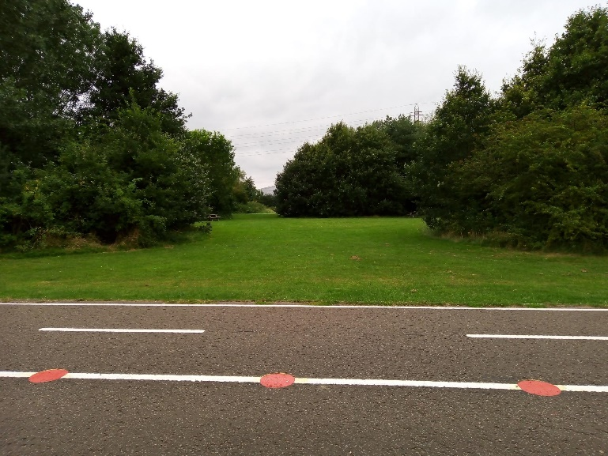 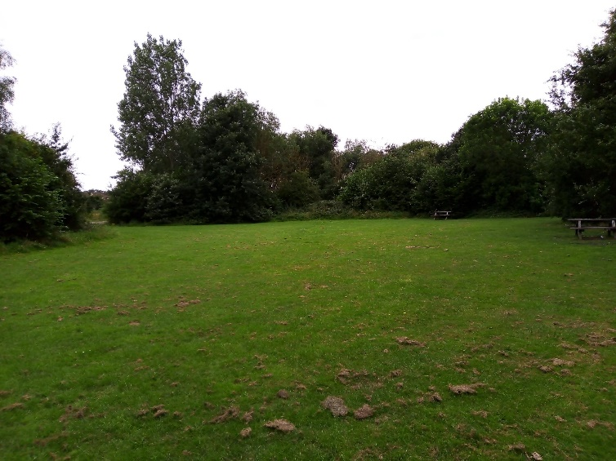

View on to site from South-West access point. View across to the Eastern side of the site.

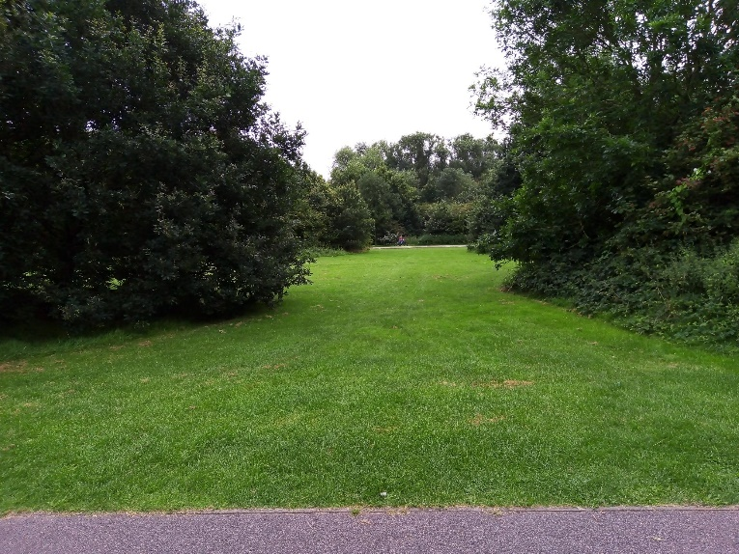 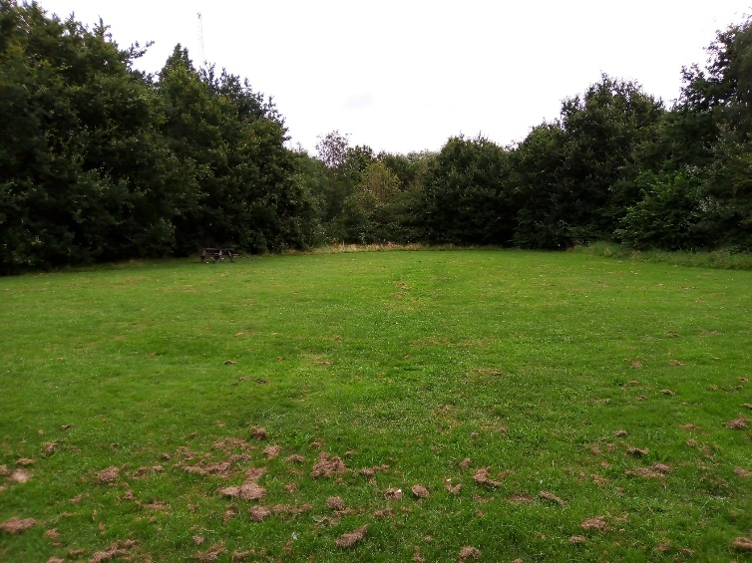

View on to site from North-West access point. View across to the Western side of the site.

**End Users**

It is intended for the proposed pump track to be for use by Mountain bikes, BMX bikes, Skateboards, scooters and rollerblades.

There are a number of local clubs and groups who have shown a keen interest in the development of a pump track in the park, including a local youth club (Sk8side). ABC expects the pump track to be as accessible to novice riders as it would to experienced, especially as the track will sit adjacent to Victoria Park’s “wheels learning” zone.

As a condition of the British Cycling funding, ABC have drawn up a cycling development programme. This includes irregular use of the track for competitive events.

**Consultation and Design Notes**

ABC would like any bid to include plans for formal engagement and consultation with key stakeholders and future users. This engagement is likely to present specific needs and desires about the track from the local community, and as a foundation, ABC would like to see any design also include as much as possible of the following:

* Rest and start area(s) offering a safe, elevated space with good sightlines.
* One surfaced access path from the South-West egress to the site leading to the track.
* Features suitable for races and freestyle riding, with a variety of straights and corners, and jumps and obstacles (such as pump bumps, doubles, triples, quads, tabletops, step ups, step downs, tank jumps and angled rollers).
* Track width able to accommodate all levels of users in a safe, progressive and fun manner.
* Markings on the track for logos, safety and race use.
* Design to allow a sufficiently challenging length of track for races, or in use as a continuous loop, or in sections in a more informal manner if users require it.
* Layout and design which will accommodate coaching and community engagement events.

Furthermore, as can be seen from Drawing GA08 – Adventure Play Area, there are plans to move the current graffiti wall in the park to the space around the track, and install a seating area. There is also a new path which is proposed to cross through the boundary of the site. Any design should make allowance for these.

**Planning and all required approvals**

The successful bidder will be responsible for producing and submitting a full planning application for the proposed design, which includes management of any sub-consultants to produce required reports and drawings. In addition to the required site plans and construction details, the application will likely include, but not be limited to: a Design and Access Assessment, Flood Risk Assessment, details on cut and fill, and Construction Traffic Management Plan.

The successful bidder will be required to act as agent for Ashford Borough Council (the client), and manage the entire planning application process including swift discharge of conditions and any necessary permits e.g. Environment Agency.

The local planning authority have previously offered pre-application advice which was supportive of the indicative proposal of the construction of a pump track in Victoria Park. The application process should allow at least eight weeks.

**Timetable**

To meet the conditions attached to British Cycling funding, the track must be completed and handed over by no later than 31st March 2022.

**Track Specification**

Preliminary works will include the organising, planning and scheduling of the pump track build, along with all CDM and H&S requirements which are to be met and documented prior to commencement.

The final design for the track must be signed off and agreed by both ABC and British Cycling prior to any works starting.

The winning contractor will be responsible for erecting all relevant site and pedestrian signage, installing ground protection Matting to minimise site impact and minimise any disruption to existing ecology to the point of work, and protecting mature trees within the area likely to be impacted by the works.

Formation of the track is to be based on the use of soil from within the site and the adjacent proposed wetland to construct and shape the contours of the track. All material is to be compacted and stabilised to necessary and safe standards.

Level changes between the end of the track and the start of the surrounding grassed area is to be landscaped to present more organic and natural-looking curves, to the approval of the Client.

Sub base & Surfacing to include suitable materials and approach for the proposed use of the facility, to allow water permeation, and to limit standing water and regrowth of plants.

Track surfacing will be in tarmac to present the highest possible durability and lowest possible maintenance burden. Track surface should be laid with a minimum level 100mm above ground level.

Attention is drawn to the location of the site within flood zone 3, and the impact of importing material into a flood zone. The successful bidder will be responsible for calculating all necessary cut and fill, and any necessary disposal of spoil off site to a licensed site, ensuring required licences are in place, all to Environment Agency guidance regarding both development within a flood zone, and guidance on disposal of waste.

Management and maintenance guidance should also be included in any final handover materials. This should as a minimum include a ROSPA audit, describe the frequency and suggested actions of an inspection routine, management prescriptions for routine maintenance issues, and estimated costs of maintenance for a 5-10 year period.

**Security**

The winning contractor will be responsible for keeping the site secure at all times from the start date of installation to agreed handover to the ABC. The Council will not be held responsible for any damage caused to the contractor’s (or sub-contractors) property (owned or hired) while onsite.

**Post Installation Inspection**

ABC will arrange an independent post installation inspection before handover takes place. The winning contractor will be directly responsible for resolving any issues or medium/high risk items highlighted by the inspector and in agreement with ABC and British Cycling before the handover can take place.

**Health & Safety**

The contractor shall comply with any Health and Safety at Work Act and Regulations and shall ensure that all their instructions concerning safety measures are continuously observed by their employees.

**Landscaping**

The existing grassed areas adjacent to proposed surfaces shall be landscaped a minimum of 1m wide to provide a finished level to facilitate the ease of mowing, and to provide an organic and natural-looking aesthetic with the surrounding space. The finished landscaping shall be free from depression where water might collect.

The landscaped areas shall be brought to condition where they can be turfed or seeded. All vegetation, debris, stones of a greater than 10mm size and foreign matter shall be removed and the top 50mm of soil reduced to a fine tilth.

The Contractor shall take into account future grounds maintenance requirements and ensure that grass areas within and around their designed layouts can be well maintained.

Landscaping shall be carried out using the excavated topsoil from within the site.

Landscaped areas will be agreed as acceptable by ABC and British Cycling handover.

**Grass Seeding**

Landscaped areas shall have the top 50mm of soil reduced to a fine tilth prior to grass seeding.

Landscaped areas shall be seeded with the following grass mixture conforming with BS 4428 : 1989 Code of practice for general landscape operations (excluding hard surfaces) Section 5.1 regarding purity and germination:

Quantity/Ratio Description

40% Dwarf Perennial Ryegrass

20% Chewings Fescue

20% Smooth Stalked Meadow Grass

15% Creeping Red Fescue

5% Bent (Highland)

**Turfing**

Large areas of bare earth shall be turfed with quality turves to BS3969:1998+A1:2013 – Recommendations for turf for general purposes and approved by ABC and British Cycling

All turf shall be laid to BS4428:1989 – Code of practice for general landscape operations.

Turves shall not be laid when there is ground frost. The turves shall be laid upon prepared ground and laid in a stretcher bond with butt joints. Whole turves shall be laid around the perimeter of the area and immediately adjacent to the footpath. Small slivers of turf shall be avoided where possible.

The turves shall be cut into the existing grassed areas with straight cut lines and fine sifted topsoil shall be worked well into all the joints.

The turf shall be watered as necessary by the Contractor following being laid to stop the turf from drying out. The Contractor shall ensure that all subcontractors adhere to the relevant clauses

**Access Restrictions & Site Set Up**

The contractor shall propose their preferred access points to the site, including how they plan to manage any inherent risks to, and minimise the impact on, other park users.

The contractor shall ensure that any footpaths internal or external to the open space are not damaged during the works. Any damage caused to existing hard surfaces/ footpaths during the course of the works shall be rectified to the satisfaction of ABC at the contractor’s expense.

As the open space will be open to the public during the Works the contractor shall provide a banksman for all plant movements across the open space. Vehicle movements must observe a strict 5mph speed limit and use hazard warning lights when moving.

The contractor shall take all precautions when tracking across grass to avoid damaging the grass, any damage to the grass shall be reinstated by the contractor.

Victoria Park hosts a Parkrun event every Saturday morning which often attracts in the region of 250 runners. The route for this run uses both paths immediately next to the site of the pump track, and ABC is very keen to avoid any disruption to this event.

**Vacate Site**

On completion of the works, the sites shall be vacated, and all materials, equipment and debris will be removed from the site.

Storage areas, compounds, welfare facilities and access routes shall be cleaned, tidied and returned to their original condition at the contractor’s expense and to the satisfaction of ABC.

Constraints on how the contractor provides the works

**Pre-tender site visit**

The *contractor* shall be deemed to have inspected and examined the site and its surroundings and to have satisfied themselves before submitting their tender as to the nature of the ground, the form and nature of the work and materials necessary for the completion of the works. The means of communication with and access to the site and in general to have obtained for themselves all necessary information as to risks, contingencies and all other circumstances influencing or affecting their tender.

Working hours

Working hours are restricted to between 08:00hrs and 17:30hrs Monday to Friday, and weekend working will only be permitted where pre-agreed with ABC*.*

Nuisance and obstruction

The contractor shall take all necessary precautions to prevent nuisance to the owners or occupiers of land or properties in the area adjacent to the site, and shall at all times avoid obstruction of the public highway.

The contractor shall comply with the general recommendations for noise control set out in BS 5228 parts 1 to 3.

ABC may have other contractors carrying out maintenance works on the site during the contract period. The contractor shall not intentionally inhibit the working practices of other contractors on the site.

The contractor shall ensure that at all times throughout the course of the works a suitable, safe and sufficient way for pedestrians shall be maintained on all footpaths in the vicinity of the works.

Burning on site

The contractor shall not burn any material on site or on any land owned by ABC.