

**Brierton Lane, Hartlepool, TS25 4BY**

**Telephone (01429) 28 4366**

* Train tables can be accessed via the below web link:-

<http://www.connectteesvalley.com/traintimetables.asp>

* A cycle route planner can be accessed via the below web link and cycle storage is available at the Centre:- <http://routes.bikehub.co.uk/>
* A bus route is attached.  The number 6 and 36 buses stop near to the Centre.  Bus times can be accessed via the below web link:-<http://www.stagecoachbus.com/>

**Road directions from the NORTH to TS25 4AF**

* From the **North** take **A19 South**

|  |  |
| --- | --- |
|  |  |

* Take the exit ramp to **Hartlepool** and merge onto the **A179** turning left
* At the first roundabout, take the **3rd** exit,
* Go through next roundabout (2nd exit) & continue onto **Hart Lane**
* Go straight through set of Traffic Lights on **Hart Lane**
* Go through next roundabout (1st exit) and stay on **Hart Lane**
* At next set of Traffic Lights turn right onto **Serpentine Rd**
* **Serpentine Rd** then merges into **Wooler Rd** continue along **Wooler Rd**
* Go through next roundabout (2nd exit) & continue along **Wooler Rd** (White House on the right)
* Go straight through next set of Traffic Lights and continue along **Catcote Rd**
* Continue along Catcote Rd and go through next set of Traffic Lights (shops on the right)
* Continue along Catcote Rd for approx 1 mile and then take right turn onto **Brierton Lane** (CETL is on the corner of Catcote & Brierton Lane – **Farm Foods** is on the opposite corner)
* Take the **first entrance** on your right and follow the signs to **CETL** car park

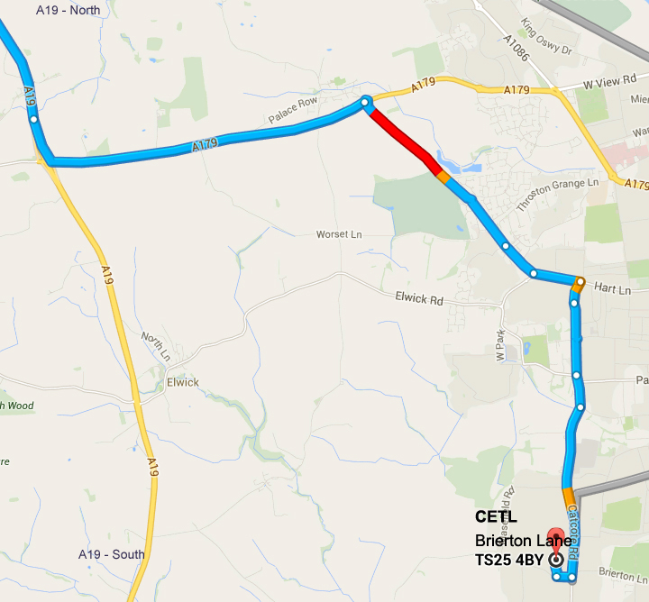



**Directions from the NORTH**

**CETL**

Brierton Lane

Hartlepool

TS25 4AF

**Road directions from the SOUTH to TS25 4AF**

* From the **South** take the **A19 North**
* Take the **A689** ramp to **Bishop Auckland/​Durham/​Hartlepool/​A1(M)**
* At the top of the ramp, keep right at the fork, follow signs for **Wolviston/​Seal Sands/​A689**
* At the roundabout, take the **3rd**  exit onto **A689** towards **Hartlepool/Billingham/Seal Sands**
* At the next roundabout go straight (**2nd** exit) carry on the **A689**
* At the roundabout, take the **2nd**  exit **​A689 / Hartlepool** onto **Stockton Rd**
* Carry on along Stockton Rd for approx 3.8 miles through all the traffic lights until you get to a roundabout
* At the roundabout, take the **1st**  exit onto **Owton Manor Lane** and carry onuntil you reach the **T Junction**
* At the **T Junction** turn right onto **Catcote Rd** and carry on along Catcote Rd for approx 0.5 miles until you see **Farm Foods** on the left. CETL is on the corner of Catcote Rd and Brierton lane
* Turn left into **Brierton Lane** and take the **first entrance** on your right into the **CETL** car park.

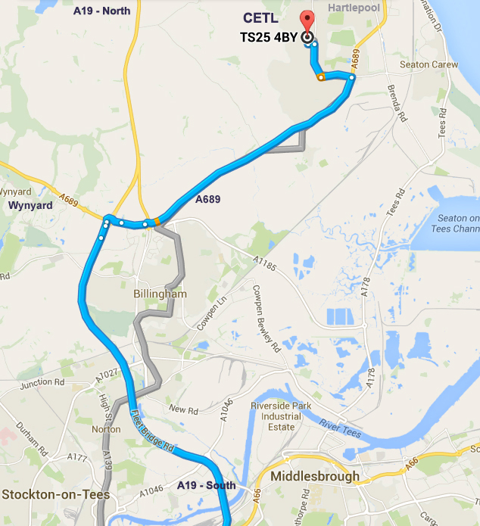

**Directions from the SOUTH**

**CETL**

Brierton Lane

Hartlepool

TS25 4AF