**MARKET ENGAGEMENT SURVEY  
Cheshire East All Age Substance Misuse Service**

**Introduction**

Cheshire East Council is conducting a soft market testing survey to understand interest from providers in the delivery of an All-Age Substance Misuse Service. We also want to use feedback to help inform our future commissioning intentions including the service model. The closing date for this survey is **6th September 2024**

In addition to this, we are intending to hold one to one conversations with interested providers using Microsoft Teams. If you would like to attend one of these please indicate your interest at the end of the questionnaire.

**About the Service**

The current substance misuse service in Cheshire East delivers a number of recovery orientated, integrated, community substance misuse services to adults and young people across Cheshire East including:

• Needle exchange

• Outreach

• Rehabilitation & support

• Medication-assisted treatment

• One to one and group sessions

• Counselling

• Benefits and housing advice

• Employment and Training advice

• Children and Young Persons Service

• Family Support

• Brief and structured interventions

As part of the recommission, the Council has undertaken a review of the service which has included engaging with stakeholders and residents to co-produce the delivery model.

**Guidance**

The purpose of the soft market testing survey is to help inform the design of the service and the tendering process, thereby ensuring it takes account of the views and needs of providers. Any responses submitted will be used by Commissioners in commercial confidence.

Please note: you are not obliged to answer all or any of the questions asked within the questionnaire.  Your responses will not be scored in any way.   This is an information gathering exercise and is not a pre-qualification process.  This soft market testing exercise does not form any part of any subsequent formal procurement process.  Completion of this questionnaire does not create any formal relationship between the responder and commissioners.

You must carefully consider the use of phrases such as ‘in confidence’ or ‘commercially sensitive’ when responding since they will not necessarily protect your organisations information from disclosure under the Freedom of Information Act 2000.  In respect of any information submitted by your organisation which is considered commercially sensitive, you should clearly identify such information as ‘commercially sensitive’.

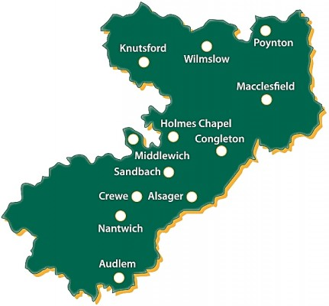**About Cheshire East**

The borough of Cheshire East is home to  **398,800**residents and around 175,000 households. It contains the major towns of Crewe, Macclesfield, Congleton and Wilmslow (with populations above 20,000). There are also a number of other significant centres of population (over 10,000) in Sandbach, Poynton, Nantwich, Middlewich, Knutsford and Alsager.

Whilst most residents enjoy a good standard of living, there are pockets of deprivation, which impact on the quality of life and opportunities for some people. Average life expectancy varies from 74 years in the most deprived areas to 83.3 years in the most affluent.

The Council’s identifies three aims and priorities in its Corporate Plan: these are to be ‘open’, ‘fair’ and ‘green’; as well as to be ‘An open and enabling organisation’; ‘A Council which empowers and cares for people’ and ‘A thriving and sustainable place’

Further information on the area and service delivery is contained in our [Market Position Statement](https://www.cheshireeast.gov.uk/livewell/care-and-support-for-adults/working-in-partnership/market-position-statement-for-adults-social-care.aspx) and our [Corporate Plan](https://www.cheshireeast.gov.uk/council_and_democracy/your_council/council_finance_and_governance/corporate-plan.aspx).

**Organisational Details**

Organisation

|  |
| --- |
|  |

Organisation address

|  |
| --- |
|  |

Contact details (including name, email address and telephone number)

|  |
| --- |
|  |

**Questions**

|  |  |  |  |  |  |
| --- | --- | --- | --- | --- | --- |
| 1. Please describe your organisation’s experience, skills and knowledge relevant to delivering an All-Age Substance Misuse service. This includes any contracts delivered relevant to this commission. | | | | | |
|  | | | | | |
| 2. Please give a brief description of how your organisation currently delivers this type of service elsewhere or your basic approach if you don’t currently hold a contract for this? | | | | | |
|  | | | | | |
| 3. Please suggest methods that could be used to reduce the current unmet need across Cheshire East. | | | | | |
|  | | | | | |
| 4. Please give examples of how lived experience could be utilised to enhance treatment and recovery services for people across Cheshire East. | | | | | |
|  | | | | | |
| 5. What would you see as the key challenges relevant to the delivery of this service? | | | | | |
|  | | | | | |
| 6. Please add any additional comments you have about the service: | | | | | |
|  | | | | | |
| 7. Would your organisation be interested in being part of a procurement for this service in the future? (please put a cross below) | | | | | |
|  | Yes |  | No |  | Unsure |
| If no / unsure, please can you tell us why? | | | | | |
|  | | | | | |
| 10. Would your organisation be interested in taking part in a market engagement session? This is expected to be a one-to-one conversation via Teams on the **23rd September 2024** [please put a cross below] | | | | | |
|  | Yes |  | No |  | Unsure |

**Thank you for taking the time to complete this survey.**

**Please email completed surveys to** [**commissioning@cheshireeast.gov.uk**](mailto:commissioning@cheshireeast.gov.uk)

If you any questions about this process, please use ‘The Chest’ to direct these to the Council’s Procurement Team.