Changing Futures Programme: Delivery Plan Template

Version 6

1.1 Area | Lancashire, Blackburn with Darwen & Blackpool
1.2 Named contact  - name  - main role | (a) Mark Aspin | (b) Head of Community  Protection, Safeguarding &  Housing Services
1.3 Address | Blackburn with Darwen Council, Town Hall, King William St, Blackburn. BB17DY
1.4 Telephone number  - organisation  - contact | (a) 01254 585100 | (b) 01254 585512
1.5 Email address of named contact | Mark.Aspin@Blackburn.gov.uk

Guidance notes

- The purpose of this delivery plan is to build on your initial expression of interest, and to set out a theory of change and costed proposals for how you intend to improve outcomes for adults experiencing multiple disadvantage in your area through the Changing Futures programme.

- This delivery plan will be a live document, with flexibility to develop over the course of the three-year delivery period and designated review points. However, we want to have a clear sense of your proposals for involvement in the programme at this stage to inform a robust assurance and final selection process, while acknowledging that implementation and delivery will be an iterative and evolving process.

- Please refer to the Changing Futures prospectus when completing this delivery plan form, including section 2.1 on the aims of the programme; 2.2 on defining the cohort; 2.3. on core delivery principles; and 2.4 on core partnership requirements. Further guidance on each section is also available in the attached guidance document.

- We may share information in your delivery plan, including contact details, with other government colleagues and The National Lottery Community Fund for assessment and for the purpose of developing our understanding and informing wider policy development and best practice.

- Please use black type, Arial font 11. Where additional supporting materials such as the theory of change template are requested, further information is provided in the questions and guidance below. The deadline for submission is 23:55, Thursday 6 May.
- Cohort identification: Who will the programme support?
Please provide information on the cohort you intend to work with over the course of the programme.

Max: 600 words

The purpose of this section is to help us understand the level of need locally, and how you will identify and engage a local cohort of adults experiencing multiple disadvantage who will directly benefit from the programme in order to deliver the individual-level outcomes set out in the prospectus and in your theory of change (see below). Your response should set out:

- Your understanding of the cohort you expect to benefit from the programme, alongside rationale for any particular focus on priority groups within the cohort definition set out in the prospectus
- How you will identify and engage individuals to directly benefit from the programme, and their routes into support – including outreach for those not currently connected with support services.
- Anticipated number of direct beneficiaries supported through the programme, with a breakdown of the cumulative total in each year of delivery, taking account of the long-term intervention required for individuals experiencing multiple disadvantages.
- How you will take account of diversity and equality considerations, and the need to tailor support to the needs of different groups with protected characteristics.

Please include reference to eligibility criteria, referral criteria and assessment tools you expect to use and whether you currently operate or anticipate operating a waiting list for joining a specific cohort. This will help inform evaluation design considerations.
The Changing Futures - Lancashire (CFL) proposal covers 14 local authority areas, across four Integrated Care Partnership (ICP) footprints. Each ICP has a detailed understanding of their local ‘multiple disadvantage’ needs, through existing programmes and research, including Fulfilling Lives and Operation ADDER in Blackpool, Transforming Lives in East Lancashire, and the Blackburn and Darwen Homelessness Review. This learning, along with feedback from our Lived-Experience Team, has underpinned our approach to cohort identification.
Our target cohort includes Lancashire adults, experiencing 3 or more multiple disadvantage characteristics, who are not benefiting from existing multiple disadvantage schemes:

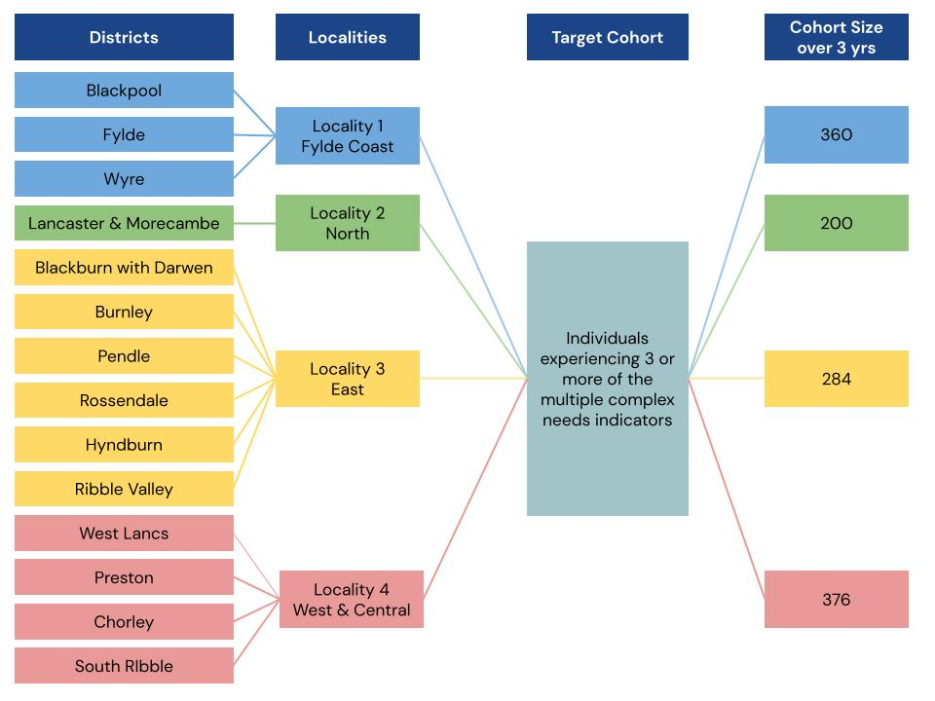
We’ve purposely kept our criteria broad, to avoid excluding important groups:
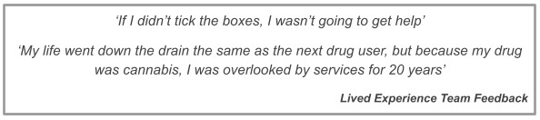
Using an extrapolation of data from both local authorities and partners, we project approximately 1,220 beneficiaries over the life of the programme, as follows:
 | Area | 2021/22 | 2022/23 | 2023/24
 |  | (4 months delivery) | (12 months delivery) | (9 months delivery)
 | North | 30 | 103 | 67
 | East | 50 | 140 (reduced – less navigators) | 94
 | West and Central | 46 | 205 (reduced less navigators) | 125
 | Fylde Coast | 40 | 200 (reduced less peer mentors) | 120
 | Total | 166 | 648 | 406
 | Cohort members will be identified through every public service front door, achieved through a programme of awareness training to public sector and third sector staff and commissioned providers with support in engaging vulnerable groups in a trauma-informed way. We’ll work proactively with community partners, such as soup kitchens and outreach organisations, and with temporary accommodation providers who offer over 5000 placements across Lancashire. We’ll develop a communications strategy and large
scale communications programme jointly with our Lived-Experience Team, to raise awareness of CFL amongst partners and service users, through marketing material, events and attendance at strategic meetings.
A simple screening tool will enable partners to quickly identify potential cohort members, with onward referral to a multidisciplinary team, which includes people with livedexperience (Navigators). We intend to develop information-sharing systems that enable assessment of eligibility without having to ask the individual to repeat their story, or requiring only minimal additional information. Eligibility includes a score of 30 or more using the New Directions Team Assessment however, scoring criteria will be flexible, allowing staff to exercise professional judgement. Those who don’t meet the threshold will receive proactive signposting, brief intervention and advice.
Navigators will use their lived-experience to build trust and confidence in the system, connecting cohort members to Enhanced Service Hubs and advocating on their behalf. The hubs will respond to the diverse needs of the individual by providing integrated and holistic care.
Through our experience, and feedback from our Lived-Experience Team, we understand that those experiencing multiple disadvantage also experience multiple barriers to engagement:
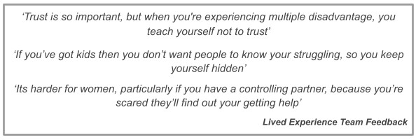
The cornerstone of our approach to overcoming barriers to engagement is our Navigators, who’ll build rapport quickly. Taking an outreach-based approach, Navigators will support services to build trusting relationships with individuals, working in an environment that is familiar to them and on their terms. A personalisation budget will facilitate creativity in our approach. For example, where individuals have no means of contact we’ll buy low-cost mobile phones to enable communication. Navigators will carry a caseload of approximately 10 people at any one time and will support individuals for up to 15 months - based on Fulfilling Lives learning which suggests 12 months yields the best individual outcome. We’ll be sensitive towards different protected characteristics, by employing a wide range of Navigators and peer workers, which are representative of the local population. This will include individuals with a range of experiences (homelessness, substance misuse, domestic abuse etc) and a mix of ages, genders, abilities and ethnic backgrounds. This will enable us to ‘match’ Navigators to individual based on who they are most likely to connect with and trust.
- Outline theory of change: How will the programme achieve improved outcomes at individual, service and system level?
Please set out your outline theory of change at system, service and individual level

using the templates provided (annex A). Use the section below to provide a brief overall narrative explaining how you developed the theory of change and how the different levels connect.

Max 2,500 words (templates & summary)

Using the tables at annex A, outline your theory of change with specific activity and outcomes identified at an individual, service and system level. Please also provide a brief narrative in this section covering:
- How you have developed this theory of change, and how a range of partners – including lived experience expertise – have been involved in shaping the activity set out.
- How the different levels (system, service and individual) interact
The Theory of Change (TOC) has been developed through a collaborative, iterative process with key stakeholders including a Changing Futures Lancashire (CFL) team of service providers, managers, system change leaders, academics and improvement specialists; and a team of people with lived experience of multiple disadvantage (MD) and of the needs and outcomes that CFL expects to support (Lived Experience Team, [LET]). We applied established methods of building programme theories, using evidence reviews, consultations, in-depth interviews and discussions to:
- Establish shared goals for a systems approach to improving support for adults experiencing MD;
- Identify and refine the key components that should make up such an approach at individual, service, and system levels; and
- Agree what implementation might look like in each of the 4 CFL localities and how best to adapt components (like activities) to the needs and context of adults and localities, while maintaining consistency in components (like change mechanisms) that are directly linked by evidence to achieving the desired outcomes and impacts.
Importantly, we were led by the LET to reflect on lived experience expertise throughout our theorising, and to consider the different models and metaphors needed in the theory and overall initiative based on the target population. Their unique contributions include:
  - Advice to incorporate crucial themes and mechanisms related to choice, trust,
‘whole-person’ principles and helping adults envision their future success;
  - Revisions to statements in the TOC to avoid placing the onus to engage in support solely on adults experiencing MD, and to include innovative best practices as new activities, such as the Multiple Disadvantage Accreditation.
Lessons from previous support of the target population, including during COVID-19, also informed the components of the TOC. Further learning, from data and evidence, gathered during implementation and evaluation of CFL will be used to continuously validate and refine the TOC.
Annex A includes the TOC, articulated at system, service and individual levels. It explains how the needlessly complicated and fragmented nature of the current system of support in Lancashire negatively influences collaboration, evidence-based decision making and meaningful, person-centred support of adults experiencing MD. Proposed system-level strategies and activities will deliver change mechanisms that lead to more coordinated, communicative governance and operations in the immediate and long term. This prioritisation and collaboration facilitates the impetus and means to reform how
services are designed and delivered. Changes include supporting providers to improve their knowledge, attitudes and practices to deliver more sensitive, personalised, flexible, trauma-informed care; and physical re-designs to provide a single point of contact to help adults connect and engage with support.
These cultural shifts (leadership, governance and staff) and service improvements will enhance the individual interactions and experiences that adults experiencing MD have within the support system in Lancashire; and increase the likelihood that they will feel encouraged to remain connected to support and more empowered, informed and able to manage their recovery in ways that work for them.

- Delivery plan: What will you deliver as part of the programme?
Please set out your plan to deliver the activity in your outline theory of change over the three-year delivery phase.

Max 1,250 words

The purpose of this section is set out your plan to deliver the activity in your outline theory of change over the three-year delivery phase. Building on the initial delivery proposals set out in your EoI, your response should:
- Provide a brief summary of your delivery approach and wider partnership strategy, based on your theory of change and taking account of the delivery principles set out in the prospectus
- Set out key milestones and timeline for delivering the activities set out in your theory of change, covering the individual, service and system levels.
- Identify key risks to successful, timely implementation of the delivery plan, and how these will be mitigated

Further guidance on the kind of activity in scope for grant funding is available in section 4 of the guidance attached.

Across Lancashire, we have several projects tackling multiple disadvantage however, these are focused on specific cohorts or localities or are themed around an area of service delivery, resulting in inequitable provision. Our aim, through Changing Futures Lancashire (CFL), is to provide integrated and targeted care to those who fall through the gaps of current provision and to bring all Lancashire-wide multiple disadvantage work together through integrated governance arrangements. Our proposal is costed at £6,499,065. However, given our scope cuts across 14 local authority areas which experience some of the highest levels of deprivation across the UK, we believe we offer an exciting and ambitious opportunity to bring about fundamental system change in the delivery of multiple disadvantage provision.
Delivery Model
Our delivery model (illustrated below) is based around an integrated model of Enhanced Service Hubs with lived-experience Navigators supporting engagement and delivery:

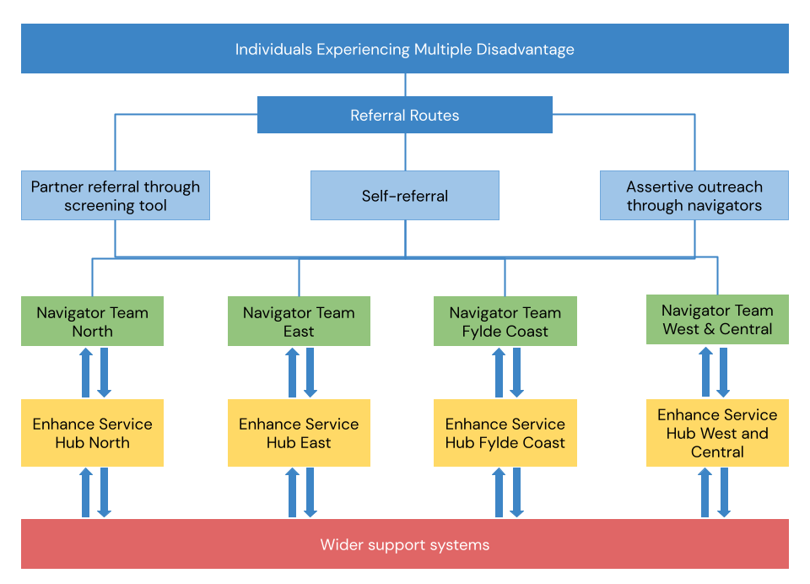

Using learning from
Bl
ackpool Fulfilling Lives,
our Navigators will be
people with lived
-
experience who can
advocate on behalf of
individuals experiencing multiple disadvantage

and connect

t
hem

with service hub provision.
With lived experience,
Navigators
will
have
the unique ability to build trust quickly.
We’ll offer three levels of Navigator role

:

Navigator
s:
Paid staff who can demonstrate previous experience and skills in w
orking
with vulnerable people
-

caseload size of 10

Associate Navigators:

Paid staf
f who are trained to NVQ Level 3

in Health and Soci
al
Care (or working towards)
-

caseload size of 7

Peer Mentors:
Volunteers who unde
rtake peer mentoring training
-

caseloads are
capped at

4
depending on the individual’s ability

The
stepped
roles offer a progression route

into paid work
.
We’ve
purposely
capped
caseload sizes
because we know that
navigat
ors
will need time to
build
relationships,
deliver outreach
,
liaise with partners and carry out admin
istration
.
We
’ve

also included
costs for Psycho
logy services within our budget,
to support staff wellbeing.

The Enhanced Hub Structure involves
both
physical
and virtual
hubs in

each ICP

footprint.

Hubs will
integrate
existing provision

with CF funded provision to

support those
experiencing multiple disadvantage.
Existing provision includes:

•

Social Care

•

Primary/Secondary Health Care Provision

•

Substance Misuse Provision

•

Mental Health Provision

•

Criminal Justice Agencies

•

Housing and Homelessness Provision

•

Domestic Abuse

Services

•
Community and VCFSE partners
We’ll

use
CF funding to
supplement existing provision where significant needs and gaps
have been identifie
d within each of the ICP areas, which are reflected in the
illustration
below:
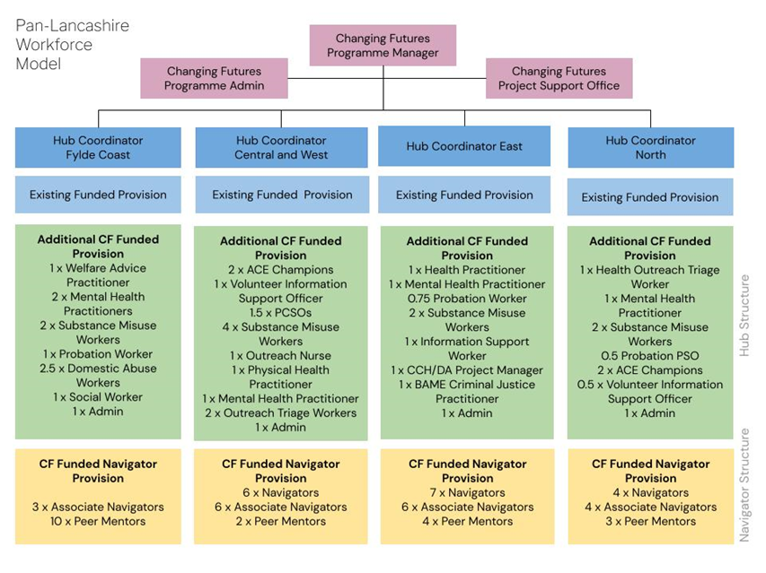
Hubs

will provide a ‘one
-
stop shop’ of multi
-
disciplinary and multi
-
agency support.
Services will be tailored around the needs of the individual, with an integrated health and
social care assessment. Cohort members will have a comprehensive
plan of interventions
including:

• psycho
-
social interventions
• adult learning and other
inclusion activities
• access to
a
full range of health services
• holistic wellbeing support
• long
-
term supported accommodation and housing
• domestic abuse services, including refuges
• access and pathways to statutory services
• community services
• be
nefits advice
• DWP support
It will be the role of
Navigator
s
, to help connect individuals to their plan of support and
advocate on
the individual’s
behalf when the plan
(
or system)
is not

meeting the
individual’s needs
. Navigators will also help individuals to
recognise their
own as
sets and
build their resilience

s
o that over time they
can

become

independent of their navigator
.

Hub
Coordinators
will be responsible for overseeing CFL delivery

within each of their ICP
areas,
and for ensuring that services a
re working effectively together.
At a service level,

Hub Coordinators will attend monthly ICP meetings to feedback learning and highlight barriers, whereupon ICP members can facilitate multi-agency service developments.
At a system level, a Programme Manager will feed into strategic groups and boards, including a new Changing Futures Partnership Board. We have strategic backing to develop a new Multiple Disadvantage Board across Lancashire through CHL delivery, ensuring all multiple disadvantage work streams are connected and governed within a single structure, helping shape and sustain system change, and influence service design and recommissioning of complimentary areas.
Key Milestones
The key milestones we will achieve include:
 | Sept – Dec 2021  Project  Mobilisation | Individual Level | Commence first intake of peers for peer mentoring training
 |  | Service Level | Mobilise service with staff, premises and integrated working arrangements in place ready for delivery ,  Recruit ICP Team Managers from localities including the LET
 |  | System Level | Recruit programme manager and finalise governance arrangements  Recruit Core Programme Team
 | Dec 21 – Apr 22  First 4 months of ‘live’ delivery | Individual Level | Work with 166 individuals experiencing multiple disadvantage with a reduction or improvement in wellbeing, offending, substance misuse, physical and mental health, secure housing, financial security, and education training and employment, as measured by the outcome star tool
 |  |  | Commence second phase of peer mentoring training
 |  | Service Level | Commence ‘live’ delivery 1st December 2021
 |  |  | Assess intake levels against eligibility and adjust where required
 |  |  | Review performance to ensure the project is meeting aims and objectives with adjustments where required
 |  | System  Level | Review performance, progress and feedback through governance structure
 |  |  | Invite wider multiple complex needs delivery to align with the programme governance board
 | Apr 22 – Mar 23  Year 2 of delivery | Individual Level | Work with 648 individuals experiencing multiple disadvantage, with a reduction or improvement in wellbeing, offending, substance misuse, physical and mental health, secure housing, financial security, and education training and employment, as measured by the outcome star tool
 |  |  | Continue a rolling programme of peer mentoring training
 |  | Service Level | Complete end of year evaluation making adjustments to delivery where required
 |  | System Level | Review evaluation, taking learning and sharing across strategic structures
 |  |  | Finalise arrangements for Lancashire-wide Multiple Disadvantage Programme Board
 |  |  | As a merged group, review equity of multiple

 |  |  | disadvantage provision, duplication and opportunities for streamlined integrated provision
 | Apr 23 – Mar 24 | Individual Level | Work with 406 individuals experiencing multiple disadvantage with a reduction or improvement in wellbeing, offending, substance misuse, physical and mental health, secure housing, financial security, and education training and employment, as measured by the outcome star tool
 |  |  | Facilitate handovers to wider provision for those requiring ongoing support
 |  | Service Level | Complete end of programme evaluation making recommendations for system change
 |  | System Level | Multiple Disadvantage Board to continue after the programme ends and to consider the further system change/commissioning required
Delivery Risks

We’ll maintain a risk log throughout mobilisation and delivery, which outlines identified risks that can impact successful delivery. To date, these include:

 | Area | Risk |  | Mitigation
 | ICT and Data Management | System access, training and data sharing |  | Aiming to mirror Fulfilling  Lives approach using InForm system. Engaging with ‘at scale’ MHCLG Led Database discussions
 | Retention and Recruitment | Scale and requirements on diversity, local knowledge and lived experience reduce the pool of  people available |  | Using existing local peer mentor structures to identify suitable candidates and scale over time
 | Commissioning and  Procurement | Limited timeframes for commissioning new providers and  complex requirements across ICP  areas |  | Where possible, make use of existing structures through contract extensions. Delay project start till 1st Dec 2021
 | Programme  Duplication | A variety of services are available to the cohort from multiple partners.  Preventing duplication and mitigating the risk of causing confusion is critical. |  | To be managed within CF governance arrangements  that have already been put in place and will continue  throughout mobilisation and  delivery
 | Staff Welfare | Working with people experiencing multiple disadvantage is  challenging, particularly for those  with their own lived-experience.  Keeping staff well and feeling supported is key, as is a risk  sensible approach to engagement and relationship building. |  | We’ll have strong supervision arrangements in place with a budget for Psychological  Services for staff
 | Covid | Providing face-to-face services and a physical multi-partner covid safe  space for the hubs to work from will be an ongoing challenge. |  | Provision of PPE and implementing social  distancing. Virtual hubs and digital delivery options will  facilitate ongoing delivery in the event of lockdown

Funding requirement
Please set out costed proposals for how you intend to use Changing Futures grant funding to support the activity set out in your theory of change and delivery plan, using the spreadsheet attached at annex B.

Using the attached excel spreadsheet at annex B, your response should:

- Set out how much grant you are requesting in total.
- Provide a costed list of activities in priority order, setting out expected cost for that activity across the whole three-year delivery period.
- For each costed activity, set out whether this is scalable - by scalable, we mean whether it is a fixed cost or whether you could scale the level of activity up or down with more or less funding (e.g. service delivery reaching more of fewer individuals if a different level of grant is provided).

There is no minimum or maximum grant amount. It is envisioned that the average grant size over the three years will be in the region of £2.5-£3.5m, and that grant amounts may vary significantly between areas.

Partnership and governance arrangements
Please set out your partnership and governance arrangements for the programme.

Max: 750 words, not including table and any supporting diagrams
Set out your governance arrangements, showing how all of the core statutory and voluntary sector partners required in the prospectus (section 2.4) are meaningfully bought in to and providing oversight of the programme, and how partnership working is embedded at strategic and operational level. This should include:

- Relevant strategic priorities or objectives that are shared between key partners
- Your strategic arrangements for governance and oversight of delivery
- Your operational partnership arrangements that will support delivery of the programme

You may provide a diagram if helpful to support the information provided in this section. Further guidance on partnership requirement is in section 2.4 of the prospectus and the guidance document attached.

Please also set out the named leads required in the partnership in the table below.

Role | Named Lead | Organisation | Email address
Political lead | Mohammed  Khan | Blackburn with  Darwen  Council | Mohammed.Khan@Blackurn.gov.uk
Senior  Responsible  Officer | Arif Rajpura | Blackpool Council | Arif.Rajpura@Blackpool.gov.uk
Partnership | Mark Aspin | Blackburn with | Mark.Aspin@Blackburn.gov.uk

Lead |  | Darwen Council
System change lead | Andrew Bennet | Lancashire and Cumbria  ICS | Andrew.Bennet5@NHS.Net
Data and  digital lead | Lee  Harrington | Lancashire  County  Council | Lee.Harrington@Lancashire.gov.uk
Lived experience lead | Ian  Treasure | We are With You | Ian.treasure@WeAreWithYou.org.uk
CFL brings together a number of strategic and delivery partners, who share the common objective of improving outcomes for those experiencing multiple disadvantage. As a partnership, our strategic priorities include:

- Improving outcomes for individuals experiencing multiple disadvantage across Lancashire (individual level)
- Developing more effective partnerships and collaborative systems when tackling the issues which create and compound multiple disadvantage (service level)
- Developing structures that oversee all multiple disadvantage delivery, ensuring learning leads to lasting system change (system level)
- Have those with lived-experience influence system delivery and design, at all
levels

We’ve developed a robust governance framework that ensures that across the 14 Lancashire authorities, and four ICP footprints, delivery is joined-up, consistent and learning is shared across ICP areas and through strategic channels. Furthermore, we intend to extend our governance arrangements to include all locally delivered multiple disadvantage work streams, bringing all delivering together under a single partnership board:

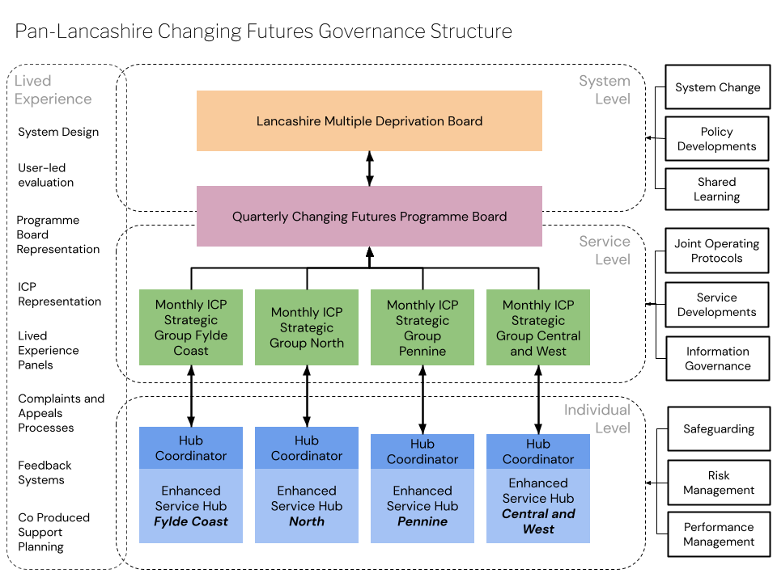
At an individual level, Hub Coordinators will be responsible for ensuring each local Enhanced Service Hub works effectively, delivering on the outcomes anticipated by the programme. This will include ensuring the right partners and providers are engaged in hub delivery, meeting the diverse needs of the cohort, and that the right infrastructure is in place to facilitate effective collaboration. Hub Coordinators will coordinate collaborative oversight of cohort identification, referral processes, case conference approaches and the coordination of support. Weekly hub multi-disciplinary meetings will bring navigators and delivery partners together, to resolve day-to-day operational challenges and barriers, to manage risk and review progress.

At a service level, Hubs will feed local issues into their respective ICP Strategic Groups. These groups will be attended by senior managers from delivery partner organisations who will maintain oversight of local system-change ambitions and help unblock system challenges that have not been resolved at hub level. The group will oversee the joint operational protocols necessary to facilitate effective delivery of the programme, such as information sharing agreements, safeguarding protocols and collaborative risk assessments. The group will also review performance and use learning to facilitate organisation service developments.

At a system level, the Changing Futures Programme Manager will feed into a range of strategic groups and forums, including Health and Well-being boards and Safeguarding boards. This will provide an opportunity to share learning and progress, influencing policy, system design and future commissioning.

Through the development of our proposal, we have identified that across Lancashire, no one board maintains oversight of all multiple disadvantage delivery work streams. Instead, multiple disadvantage work cuts across a number of project areas and therefore feeds into a range of strategic groups. Through Changing Futures, we intend to resolve this. We have strategic backing to develop a new Multiple Disadvantage Board, overseeing all locally delivered multiple disadvantage work streams. This will create a far greater understanding of multiple disadvantage provision across Lancashire and enable future delivery to be consistent, collaborative with learning shared more effectively throughout the system.

Cutting across each layer of our governance structure is service user involvement. Those with lived-experience will be at the centre of service and system design, by contributing their views in various ways and at all levels. Our Pan-Lancashire LivedExperience Team has been involved in the development of this proposal throughout the programme design, and will continue to be involved through ICP Forum and Partnership Board representation. Members of the team will represent the views of the wider cohort, obtained through a comprehensive range of formal and informal feedback mechanisms.

Interaction with other projects and programmes
Please set out how the planned activity in your delivery plan will complement and enhance other programmes and interventions underway or planned that impact on adults experiencing multiple disadvantage, while avoiding duplication.

Max: 750 words, not including any supporting diagrams
Your response should set out:
- Any wider contributions from local partners to your approach, demonstrating how Changing Futures is part of a wider local strategy on multiple disadvantage and how changes will be sustained beyond the life of the programme
- How activity supported through the Changing Futures programme is complementary and additional to other funding, projects and programmes working with adults experiencing multiple disadvantage, while avoiding duplication.
You may provide a diagram or visual representation of other relevant programmes and funding as a supporting document to help illustrate this answer. Further examples of the type of government and local programmes you should take in to account are set out in the guidance document.

We’ve built our proposal for Changing Futures Lancashire using learning from existing multiple disadvantage initiatives, including Blackpool Fulfilling Lives, Transforming Lives in East Lancashire and MEAM in Preston and Blackburn. Our proposal further builds on the positive work achieved, by forging partnership collaboration structures and ensuring the right strategic framework is in place to facilitate effective oversight of all multiple disadvantage work streams.

Across Lancashire, there are a number of multiple disadvantage work streams already in progress. This includes:

- Project ADDER: a home office and Public Health England collaborative programme aiming to disrupt drug supplies and find new ways to engage and maintain drug users facing multiple disadvantage in treatment. This is a multidisciplinary team approach with Lived Experience at its core
- The Accelerator Programme: a health and social care programme looking at integrated working around CCG footprints at primary care network level - currently working in four localities in East Lancs
- Integrated Neighbourhood Teams: a multi-agency case conferencing approach
with an escalation process from the Accelerator Programme. Currently in the four neighbourhoods of BwD with plans to roll out across Pennine.
- Transforming Lives: a multi-agency approach to multiple disadvantage through a panel approach. Panels are focussed on different cohorts in different areas driven from referrals from communities, community safety and housing.
- Fulfilling Lives: Supported people with multiple disadvantage specifically in Blackpool.
- Others: a range of thematic and geographical pathways and approaches including resilience hubs, dual diagnosis panels and integrated offender management approaches
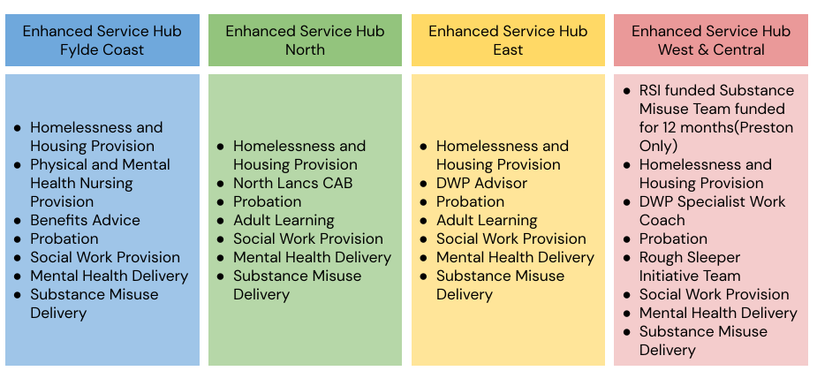
We have started the process of mapping all multiple disadvantage work streams across the region. Through this process, we have identified the inequity of multiple disadvantage provision when considering Lancashire as a whole. Much of the current provision works in specific localities and with a focus on specific themes or groups. This allows for people to ‘fall through the gaps’. Furthermore, governance arrangements for multiple disadvantage work streams are equally fragmented, with reporting lines into various locality-based and thematic strategic groups, meaning that no one group has full oversight of all multiple disadvantage delivery.
We propose that CFL will resolve both these issues. At an individual level, our target cohort will be those individuals experiencing multiple disadvantage who fail to benefit from existing delivery. At a system level, we propose to establish a partnership board, which over time, brings together oversight of all multiple disadvantage work streams into a single group. This will ensure effective collaboration across and between the different projects, and ensures learning is systematically shared across the system.
We have commitment from both local providers and strategic partners to ensure our vision becomes reality. Each of the 4 ICP areas have secured commitment from partners to deliver from the Enhanced Service Hubs which includes:
Variations between hub provision is a result of differing needs and gaps between localities. At a strategic level, we have secured commitment from a range of strategic roles to establish a Lancashire-wide strategic Multiple Disadvantage Partnership Board.

Data
Please set out how you intend to develop the collection, sharing, analysis and use of data to drive service improvement and measure outcomes set out in your theory of change.
Max: 600 words
Your response should set out:
- A) A brief summary of: what data you already hold on the cohort, what data sharing agreements you have in place locally, and how you intend to develop the collection, sharing, analysis and use of data to drive service improvement and achieve better outcomes for adults experiencing multiple disadvantage
- B) Using the tables below, the data available to measure improvement in outcomes set out in your theory of change (even if you don't currently hold it), where there are key gaps and how you might go about filling those (this might involve a variety of options, not limited to existing administrative data).
In identifying the cohort, principle services for each MD type analysed their client databases to identify service users with multiple deprivation. This has identified nearly 1,400 individuals with MD who are known to services.
Data sharing agreement – across the ICP areas service user data sharing will be guided by the Local Safeguarding Adult Board (LSAB) Information Sharing Protocol. At ICP level, each hub will be required to agree a data sharing agreement so that each service provider is clear on the sharing and processing of data about their services, and service users are clear how their information will be collated, stored, shared and analysed.
Data Analysis will also be central to driving improvement; data on outputs, outcomes and impact will be collated by the ICP Coordinators and analysed across ICP areas to measure progress and aid discussion on learning/improvement. The data will also be shared with other areas nationally to learn from their models of operation and areas of innovation.
We intend to procure the In-Form case management system, which we know works effectively with the multiple disadvantage cohort, having been the primary system used within Fulfilling Lives.
Table 1: short-term outcomes
Level | Short-term Outcomes | Proposed measurement  metric | Current availability (data held/data collected but not held/new data required)
System | Strategic partners are  committed to plans to address  MD | Number of partner agencies who agree plans | Data held
 | Use of mechanisms of communication to share information | Agreed data sharing protocols for ICP areas | New data
 | Core components of the TOC remain consistent | ToC components agreed by partners and governance | New data

 |  |  | arrangements
Service | Availability of co-produced training, guidance and tools |  | Number of training courses, operating protocols and practice tools that co-produced with services and service users |  | New data
 | Staff in the ESH are supported |  | Number and  percentage of staff that have completed training, receive support and participate in reflective practice opportunities (including with LE team) |  | New data
 | Adults experiencing MD have access to Navigators |  | ICP level number of service users with access to navigators |  | New data
Individual | Individuals can choose what support they access and trust support providers |  | Exit survey of service users on their experience |  | New data
 | Appropriate services are available that people can access and want to use |  | Annual survey of service users on their views and suggestions |  | New data
 | People can find and access support until they feel ready to  move on |  | Exit survey of service users on their experience |  | New data
Table 2: long-term outcomes
Level |  | Longer-term Outcomes |  | Proposed measurement  metric |  | Current availability (data held/data collected but not held/new data required)
System |  | Strategic partner plans influence, contribute to improvements and consistency in service provision |  | Number of ICP areas with agreed partner plans whose golden thread on MD also evident in partner plans |  | New data
 |  | Increased understanding and monitoring of information on the nature and prevalence of MD |  | Numbers of appropriate referrals by services and through outreach that cannot be provided a service |  | New data
 |  | Joint evidence-based, decision- |  | Number of cases |  | New data

 | making to ensure quality assurance | with co-produced recovery/safety plans
Service | Improved knowledge, understanding, skills and confidence in delivering traumainformed, person-centred, flexible and coordinated support | Annual survey of service providers and Navigators on their perception of support | New data
 | Use of appropriate strategies to respond to individual needs and experiences | Annual survey of service providers and Navigators on their perception of support | New data
 | Appropriateness and benefits of the service | Exit survey of service users on their experience | New data
Individual | Support providers improve involvement with people experiencing MD | MD service users remained engaged with services | New data
 | Recognition of own needs and ability to seek out further support | Outcome Star tool use with MD service users | New data
 | Reduction or improvement in the following areas: wellbeing, offending, substance misuse, physical and mental health, secure housing, financial security, and education training and employment | Outcome Star tool use with MD service users | New data
Filling gaps in measurements (new data required) will be a function of the ICP Coordinators to report to the Programme Board and to key partnership boards.

Annex A: Theory of Change Templates
 | System level
Context/ problem | - Systems change is greatly needed as the current landscape of support services for adults experiencing MD is overly complex and fragmented.  - Many services remain siloed, with provision mostly divided, rather than being coordinated across areas of MD (i.e. mental health or substance misuse) and designed around the needs of adults experiencing MD.  - This is due, in part, to different leadership, governance arrangements and operational structures within the services.  - Such lack of joint working, communication and information sharing impact negatively on access to and transitions between provisions for adults experiencing MD.  - Consequences of this are multifaceted and severe:  - The needs of adults experiencing MD are more likely to go unrecognised, and the support they receive is less likely to be person-centred, flexible, trauma-informed and have adequate follow up;  - The true scale of MD locally is more likely to remain hidden, reducing the likelihood of evidence-informed, equitable commissioning, funding and resource allocation.  System-level strategy: Foster and maintain multi-sectoral collaboration between strategic partners to develop, implement and sustain a coordinated response to MD at governance and operational levels.
Inputs | Key inputs:  - Lived experience expertise;  - Consensus on main issues and priorities related to MD;  - Shared vision and motivation for systems change and social justice; • Demonstrable commitment to collaborative working: o Adequate funding;  o Investment in infrastructure (e.g. venues, data systems, communication channels); o Existing data sharing agreements and procedures; o Forum for regular convening of strategic partners to plan coordinated service provision to address MD.
Activities | Activities will be tailored/flexed to the context and needs of each CFL site. All activities aim to deliver core change mechanisms to support the common outcomes and impact:

- Whole-system prioritisation of MD and commitment to CFL principles (lived experience, co-production, personcentred, coordinated, flexible, trauma-informed);
- Secure, appropriate and timely information sharing;
- Integrated oversight, quality assurance and governance.
Examples of tailored activities:
- Influence strategic partners to prioritise MD and the CLF principles, with agreed strategies and action plans that are jointly produced with the Lived Experience Team
- Identify information-sharing barriers and facilitators, and create mechanisms for secure, appropriate and timely information sharing;
- Facilitate adaptation of TOC by CFL partnership through guidance and manuals.

Outputs | • Signed commitment to prioritise addressing MD and CLF principles; • Clear plans for coordinated service provision for MD; • Guidance to adapt TOC.
Short-term outcomes | - Partners and networks provide oversight as coordinated plans are implemented through activities at the service  level;  - Information-sharing mechanisms are used by most services within the support system; • TOC is consistently adapted across entire CFL partnership.
Longer-term outcomes | - Improved, consistent sharing of information and evidence across all MD areas and from individual, service and system levels;  - Strategic partners and networks facilitate consistent implementation of coordinated service provisions by using information and evidence to jointly review, make decisions and refine the TOC and strategic plans.
Impacts | • System-level changes facilitate transformation of the local system of support for MD to one that: o Is less fragmented and more collaborative at system and service levels;  - Has more information sharing and communication, better understanding of the scale of MD, and more evidence-based, equitable decision-making;  - Collaborates with people with lived experience of MD, to improve service design and delivery that is person-centred, flexible and trauma-informed, with adequate follow-up.
Key assumptions | • | CFL principles will contribute to improved outcomes;
 | • | Partners and networks, including people with lived experience, will commit to CFL;
 | • | Sufficient resources and time to develop and implement plans will be available;
 | • | Information and evidence sharing will be supported by existing data protection legislation;
 | • | Service- and individual-level strategies and activities will be successful to provide data to evidence system-level outcomes.
External factors | • | Different operations and performance measures and targets in the services addressing MD might hinder progress;
 | • | COVID-19 might worsen vulnerabilities, symptoms and inequalities related to MD, while impeding successful implementation of CFL;
 | • | Precarious and fragile funding conditions might limit the ability to sustain implementation and demonstrate longterm outcomes and impact.
Unintended consequences | •  • | Potential of increased workload (e.g. more meetings, oversight, information sharing and evidence reviews);  Increased joint monitoring, communication and information, and evidence sharing might increase the visibility of the scale of MD, leading to the appearance of a higher/increasing prevalence of MD in the short-term.
 | Service level
Context/ problem | - System-level leadership and collaboration that prioritises coordinated, person-centred care has the potential to improve the way services addressing MD are designed and delivered.  - Evidence suggests that many services supporting adults experiencing MD are not designed to respond  holistically/to a ‘whole-person’. Instead, service design tends to centre on common issues or presenting problems.  - This creates practical barriers for adults experiencing MD when navigating the support system; creating a culture of attitudes and practices that are more likely to exclude them and assess their needs as being too complex/challenging.  - This is manifested in service delivery that shows limited understanding of adults’ specific needs and lack of trauma-informed care principles and empathy.

- Delivery also fails to recognise the intersectionality between adults’ gender, race, ethnicity and culture, and how this affects their support needs and service experience.
- Ultimately, some adults experiencing MD are discouraged from engaging with poorly designed and inappropriately delivered services.
Service-level strategy: Improve service design and delivery so that support for adults experiencing MD is more person-centred, coordinated, flexible and trauma-informed.
Inputs | Key inputs:  - Lived experience expertise;  - Funding and physical infrastructure;  - Training, supervision and regular reflective practice for service providers;  - Guidance and resources about person-centred and trauma-informed care principles; • Practice wisdom;  - Practical support for service providers (e.g. information/data access; knowledge of local pathways and entitlements; collaborative working culture; manageable caseloads; wellbeing support).
Activities | Change mechanisms:  - Single point of contact, ‘service-neutral’ person or team to connect directly with adults experiencing MD, build trusted relationships and help them engage with a range of support services;  - Awareness and understanding that adults experiencing MD are also likely to be experiencing other varied, interrelated and compounding needs;  - Knowledge, skills and confidence to practice person-centred, flexible, trauma-informed care.  Examples of tailored activities:  - Implement Enhanced Service Hubs, navigator roles and peer mentor roles;  - Co-produce training, guidance and resources with people with Lived Experience (e.g. Lancashire Space Programme; Multiple Disadvantage Accreditation);  - Establish professional relationships and peer networks to support shared learning.
Outputs | - Single point of contact, ‘service-neutral’ support roles and facilities implemented;  - Guidance, resources, training, supervision and opportunities for reflective practice, co-produced and offered to service providers;

 | • Professional relationships and peer networks established.
Short-term outcomes | - Increasing percentage of staff within the support system:  - Access and engage in adequate training, supervision and opportunities for reflective practice; o Report and demonstrate knowledge of person-centred, trauma-informed principles, and awareness of available guidance and resources;  - Report having adequate support to practice person-centred, coordinated care.  - Increasing the percentage of adults experiencing MD connected to single point of contact, ‘service-neutral’ person or team.
Longer-term outcomes | - 100% of staff report: o Having access to additional guidance and resources (including practice wisdom) through established professional relationships and peer networks;  o Demonstrate competence and confidence in applying person-centred, trauma-informed principles and tools in practice;  - 100 % new and existing cohort of adults experiencing MD are receiving direct support from a single point of contact, ‘service-neutral’ person or team to engage with a range of services; • Most adults find the new service/delivery appropriate and beneficial.
Impacts | • All services within system of support for MD in Lancashire deliver person-centred, coordinated, flexible and trauma-informed support to adults experiencing MD.
Key assumptions | - Sufficient staff, funding and time will be available to implement and maintain activities;  - Staff will engage in adequate training, supervision, opportunities for reflective practice and shared learning;  - Adults experiencing MD will find new service designs/delivery appropriate and beneficial, and want to engage with them;  - Individual-level strategies and activities will be successful to provide data to evidence service-level outcomes.
External factors | In addition to those stated previously:  • Services (leadership/staff) might find it difficult to make cultural shifts needed to start delivering person-centred, trauma-informed support.
Unintended consequences | • New coordinated direct support roles can be demanding and intensive, increasing risk of staff burnout and poor wellbeing (e.g. vicarious trauma);
 | • | Potential for service providers to feel overwhelmed by greater understanding of the interrelated nature and complexity of issues experienced by people who face MD.

 | Individual level
Context/ problem | - The proposed service-level changes make it easier to adopt person-centred, coordinated, flexible and traumainformed care as ‘business as usual’.  - When services are designed to deliver such care, they are better able to work collaboratively with adults experiencing MD to find what works for them.  - Support creates a safe and trusted relationship, is tailored to individual needs and expectations of adults and empowers adults to understand, manage and make informed decisions about their care.  Individual-level strategy: Collaborate with adults experiencing MD to establish a safe, trusted relationship, and design and deliver tailored, trauma-informed support.
Inputs | Key inputs:  - Lived experience expertise;  - Staff knowledge, skills and confidence to deliver person-centred, flexible, trauma-informed care;  - Co-produced guidance and resources to help staff implement and tailor CFL strategies and activities (while maintaining core change mechanisms);  - Co-produced supporting materials for adults experiencing MD to be involved in their own care.
Activities | Change mechanisms:  - Safe and mutually trusting relationships;  - Interactions between support providers and adults experiencing MD show sensitivity to and recognition of adults’ varied, interrelated needs;  - Adults experiencing MD are included in decisions about what care they receive, how and when;  - Adults gain knowledge, skills and confidence to better understand their circumstances related to MD and make informed decisions about how to respond and self-manage more effectively.  Examples of tailored activities:  • Provide trauma-informed care for people experiencing MD (e.g. offer opportunities for people to talk about their

 |  | life histories, current situations and hopes for the future; listen and respond in an empathic, non-judgemental and anti-oppressive manner, avoiding any potentially stigmatising, blaming or shaming responses);
 | • | Ensure that adults experiencing MD can choose to access a variety of evidence-informed interventions to suit their individual needs (e.g. Solution Focused Therapy, Motivational Interviewing, Cognitive Behavioural  Therapy), enabling clients to set goals, move in a future-orientated direction, improve knowledge and skills, and elicit behaviour change; by addressing difficulties (e.g. substance misuse, emotional dysregulation, low selfesteem) and aiding their own recovery;
 | • | Involve adults experiencing MD in recognising their needs, planning to address them (e.g. co-produce, personalised support plans) and collaborating to track progress (e.g. use of the Outcomes Star).
Outputs | • | 100% of adults experiencing MD report:  - Interactions with providers that show sensitivity and recognition of their varied, interrelated needs;  - Being asked for their opinions and offered choices;  - Being given practical support, resources and materials to aid in their decision-making.
Short-term outcomes | • | Increasing number of adults report:  o Having a safe, mutually trusting relationship with their support provider; o Feeling involved in making decisions about their care; o Feeling knowledgeable and informed about their circumstances related to MD; o Demonstratable skills and confidence to recognise their needs.
Longer-term outcomes | • | 100% of adults:  - Show positive changes in their specific circumstances related to MD (e.g. employment or a training outcome; suitable housing; reduced offending behaviour or substance misuse);  - Demonstrate skills and confidence to find ways to effectively maintain progress;  - Remain connected (following initial contact) to single point of contact, ‘service-neutral’ person or team and engaged with support services until they feel ready to move on.
Impacts | • | Increase in collaboration between service providers and adults experiencing MD to develop and deliver tailored, coordinated, trauma-informed support;
 | • | Increase in contact and engagement of support services with adults experiencing MD;
 | • | Reduction in local prevalence of vulnerabilities and symptoms associated with experiences of MD among adults.
Key assumptions | In addition to those stated previously:  - Support services to refer adults to will be available, appropriate and beneficial;  - Improved system- and service-level strategies and activities will facilitate individual-level success.
External factors | • Other human, social and operational factors within the context surrounding adults, staff and CFL might influence whether, how and for whom strategies and activities work.
Unintended consequences | • By providing a single point of contact or team who are more ‘generalists’, some adults might feel concerned that the provider who knows and supports them most is not expertly skilled or knowledge about their particular areas of need.

