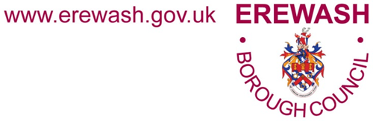

Soft Market Testing Exercise

Operator for
Long Eaton cultural hub

EBCT 295a

SECTION 1 – GENERAL
  - Soft Market test Process

    - Erewash Borough Council is undertaking a soft market testing exercise to seek the views of external operators for Cultural Hub services. The Council wishes to gain insight into the operating models available in the market place to assist with the development of a detailed specification and to help consider the most appropriate procurement process.

    - Please note, this is NOT an invitation to tender.

    - All information gathered from the Soft Market Testing will be carefully considered and analysed by the council for this procurement process. All providers’ responses will be anonymised and not shared with competitors for these services.

    - The soft market test will take place from Thursday 15th July until Friday 13th August 2021.

    - Neither the intention nor the purposes of this soft market testing exercise is to confer any advantage upon its participants in any future procurement process.

  - Responding to the soft market test

    - Interested parties are invited to complete the questionnaire provided at the end of this document. This should be completed and returned to procurement@erewash.gov.uk no later than 14:00 on Friday 13th August 2021.

    - Any queries should be submitted to procurement@erewash.gov.uk.

SECTION 2 – BACKGROUND TO PROJECT

  - General

2.1.1. This is a unique opportunity to help shape a new cultural offer in Long Eaton.

2.1.2. Following Erewash Borough Council’s successful Towns Fund bid, the council is seeking to potentially go to the marketplace and explore services and solutions for the operation for the proposed new Long Eaton Cultural Hub. The Cultural Hub will be developed from the former Box Office cinema building on the Market Place. The opportunity is for the proposed operator to advise on the fit out of the redeveloped building and act as the operator once complete.

  - What the council would like to commission

2.2.1. The council would like to commission an Operator to help develop the proposed Cultural Hub concept and act as Operator once the Hub is complete. The Council expects to award a contract for a suitable period of years post commissioning. The aim is to develop an appropriate cultural offer for the Town of Long Eaton in the vacant Box Office building on the Market Place. The cultural hub should add to the vitality of the town and improve the leisure offer in the area today and in the future. The aim is to have an operator who will advise the Council during the redevelopment of the old Box Office building to help form a new operation which can best serve the needs of the community, local artists and creative practitioners. This organisation would then operate the new Box Office Cultural Hub.

2.2.2. A key consideration for the council is to understand how the system could work considering the various options and methodologies available in the marketplace. The council is keen to explore the strengths, weaknesses, risks, costs and implications around a range of solutions. The council wishes to develop a plan to ensure the long-term sustainability of a cultural hub and is interested in different financial approaches to allow the Operation to be self-financing.

  - Requirement of the Cultural Hub

2.3.1. The Council would like to work with an established operator during the redevelopment of the old Box Office building to produce the most appropriate Cultural Hub for Long Eaton within the Town’s Fund capital budget of £5.59m. It would like the new Box Office to act as a new cultural hub for Long Eaton and achieve the following outcomes:

- Greater vitality of the town centre
- Improved cultural and leisure offer for the people of Long Eaton and Erewash
- On completion of the redevelopment, The Box Office will be in a position to become self-financing

  - Background

2.4.1 On 6 September 2019, the government invited 100 places to develop proposals for a Town Deal, as part of the £3.6 billion Towns Fund project. Long Eaton was selected as one of the hundred places. The Long Eaton bid was accepted on 8 June 2021. This project forms part of Long Eaton’s programme of improvements for the town. Other projects include High Street and highway improvements and mixed-use building developments. Please see the bid, on the Long Eaton Town Investment Plan page for more details of this and the other projects.

    - Long Eaton is a town on the edge of the Nottingham conurbation with a population of 39,000 located in the Borough of Erewash. The town centre covers approximately 13 hectares and includes around 250 commercial units. Within the conservation area is the historical core with commercial buildings from the Victorian and Edwardian period alongside a number of mid to late 20th century buildings.

    - The town is situated between the cities of Derby and Nottingham, and so the residents of Long Eaton are not far from those cities’ cultural resources. In Long Eaton, the Duchess Theatre heads the local cultural offer, and ahead of the COVID-19 situation it had a packed programme stretching out for over two years. There is also the Long Eaton Arts Room, which is a studio base for artists and offers art and craft classes and the Caterpillar Café which offers children’s art and crafts activities and parties.

    - The Box Office originally opened as the New Place Theatre in July 1913 as an 830 seat live theatre. In the 1930s, it was developed into a cinema and was renovated again in 1936 to plans that gave the building a streamlined façade. In the years that followed the building operated as a shop and pub, then lastly as The Box Office nightclub and bar. The doors closed in the last decade. Details of the Box Office site are in Sections 2.5 and 2.6.

    - The Council would like to develop the cultural offer available to the residents of Long Eaton and the Borough. As the former Box Office is a long-standing leisure venue sited on the Market Place in the heart of the town, it is expected to provide a suitable cultural home once redeveloped.

    - The Council is not seeking to run such a facility or finance its future running costs. The preferred model is for a successfully self-supporting organisation with a suitable cultural offer to operate the facility. This should include local and community arts development. Options for redevelopment suggested in the feasibility study could include art café and gallery space and a digital creative workspace, an auditorium for film screenings, lectures and spoken word performance. There could also be flexible studio/ performance spaces for music, dance and other cultural and social events. The Council would like the operator to advise on the best uses for the Hub.

    - In preparation for its Towns Fund bid, the Council had plans of the current building drawn up and condition surveys conducted. A business feasibility study was commissioned to ascertain the likely levels of demand, whether such an operation was feasible and what outline form it could take. The feasibility report is available on the Long Eaton Towns Fund website under Projects.

    - The following additional documentation will be made available during the procurement process

- Current site plans and elevations
- Structural Survey and Asbestos Survey

  - The Box Office profile

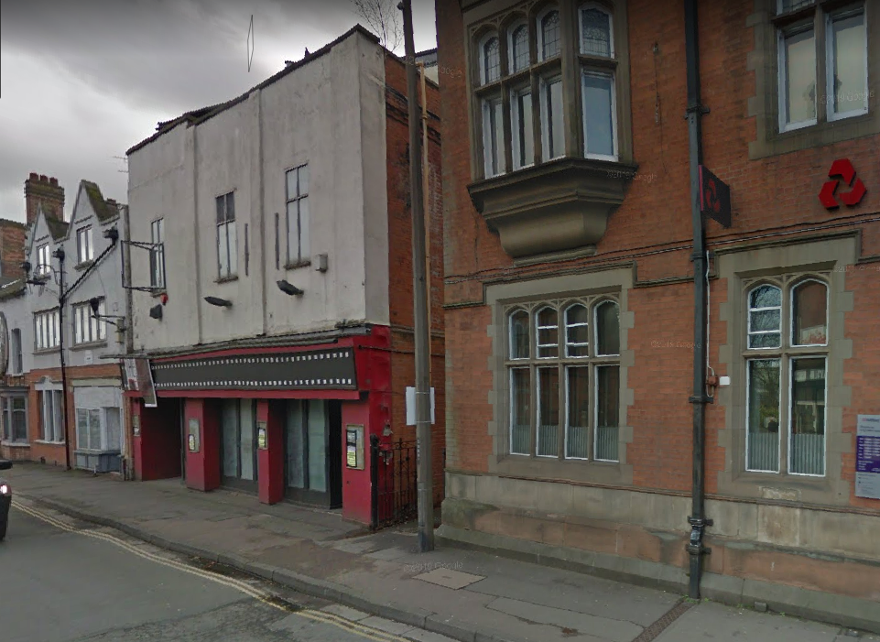

Address: 47 Market Place, Long Eaton, Derbyshire, NG10 1JL
Size: Site approx. 760msq. Building footprint approx. 410msq. The plans of the existing floor space are available on request.
Position: Building forms part of a terrace facing the Market Place. Access to the site is via a side road to a yard area at the rear.
Description of site: Art deco fronted former cinema, pub and nightclub. Accommodation is currently over two and a half floors.
Site condition: The building is in a poor state of repair. Surveys of the site are available on request. Former art deco style nightclub. The building has been empty for some years. Previous owners have removed most of the original fittings including staircases and lift. There are a number of ground floor rooms. The first floor auditorium has a raked stairway rising either side of the old seating positions. The seating and flooring has been removed just leaving the superstructure with a void to the floor below.

History: The site was built in Victorian times as The New Palace Theatre. In the 1930s it was developed into a cinema and was Long Eaton’s last cinema to close in in the mid-1990s. In the years that followed the building operated as a shop and then as a nightclub and bar. It closed in the last decade.

  - The Box Office location and site

Location in Long Eaton town centre
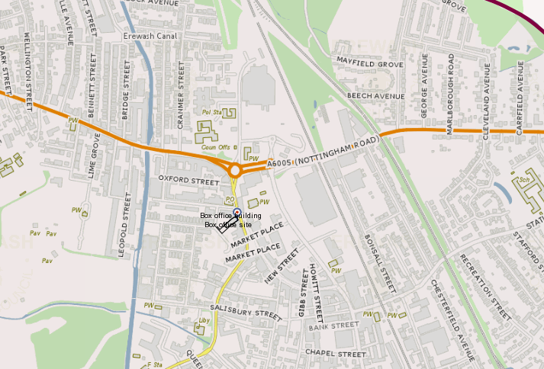

Site on the Market Place
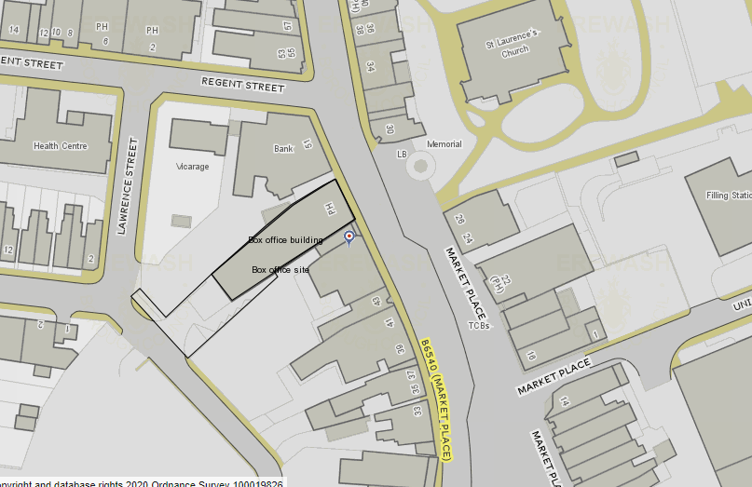

SECTION 3 – QUESTIONNAIRE
Questionnaire instructions
This questionnaire is designed to provide Erewash Borough Council with your comments and ideas to support and shape the new Cultural Hub in Long Eaton.
Please note there is no word limit for each response.
Any information submitted in response to this questionnaire must only relate to your business/ organisation. All responses will be anonymised and will not be shared with competitors for these services.
Responses should be retuned to procurement@erewash.gov.uk by Friday 13th August 2021, 14:00.
Name of person completing questionnaire
Organisation
Email address
Telephone number

1 Interest in project
What brings you to have an interest in this opportunity?

Contractor response:

2 Company background
Please provide a brief summary of your organisation and the sectors in which it operates in relation to our requirements for an operator of the new Cultural Hub.

Contractor response:

3 Audience
Based on the information provided in the Feasibility study around potential audiences, who do you think is the target market? How could you align the Cultural Hub offering to meet the needs and interests of local audiences?

Contractor response:

4 Challenges and benefits
What do you see as the main challenges and benefits to operating a cultural hub in Long Eaton?

Contractor response:

5 Promotion
How could you promote and advertise the Hub?

Contractor response:

6 Engagement
Outline how you could engage with local artists and creative practitioners?

Contractor response:

7 Financial
The Council wishes to work with the future operator during the Hub’s development to design an Operation which will be sustainable in the long term and is interested in different financial approaches to allow the Operation to be self-financing. How could you see this as working over the long term? Please also indicate how you could investigate potential operating grant funding sources

Contractor response:

8 Social value
How else could you maximise the economic, environmental and social benefits within the Borough?

Contractor response:

Thank you for your interest in our project and for your participation

