

building:solutions

**Tender Document**

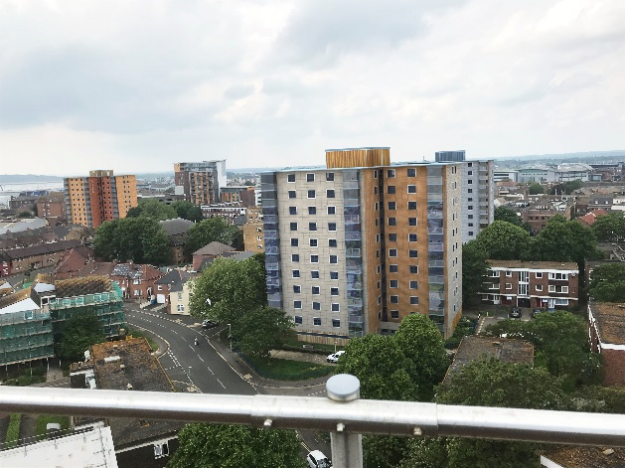

**SECTION 1 - GENERAL CONDITIONS & CONTRACT PRELIMINARIES**

**Appendix 1A -** Drawing Schedule

**Appendix 1B -** Specific Contract Conditions and Particulars

**Appendix 1C -** Working Practices & Specific

Requirements of the Client

**SECTION 2 – PREAMBLES**

**SECTION 3 - SCHEDULE OF WORKS**

**SECTION 4 – PRICING DOCUMENT**

**SECTION 5** – PRE CONSTRUCTION INFORMATION

**For**

**Project Admiral**

**Poole Housing Partnership Ltd (PHP)**

**at**

**NELSON COURT, DRAKE COURT,**

**GRENVILLE COURT AND RODNEY COURT**

**Ref: 4796**