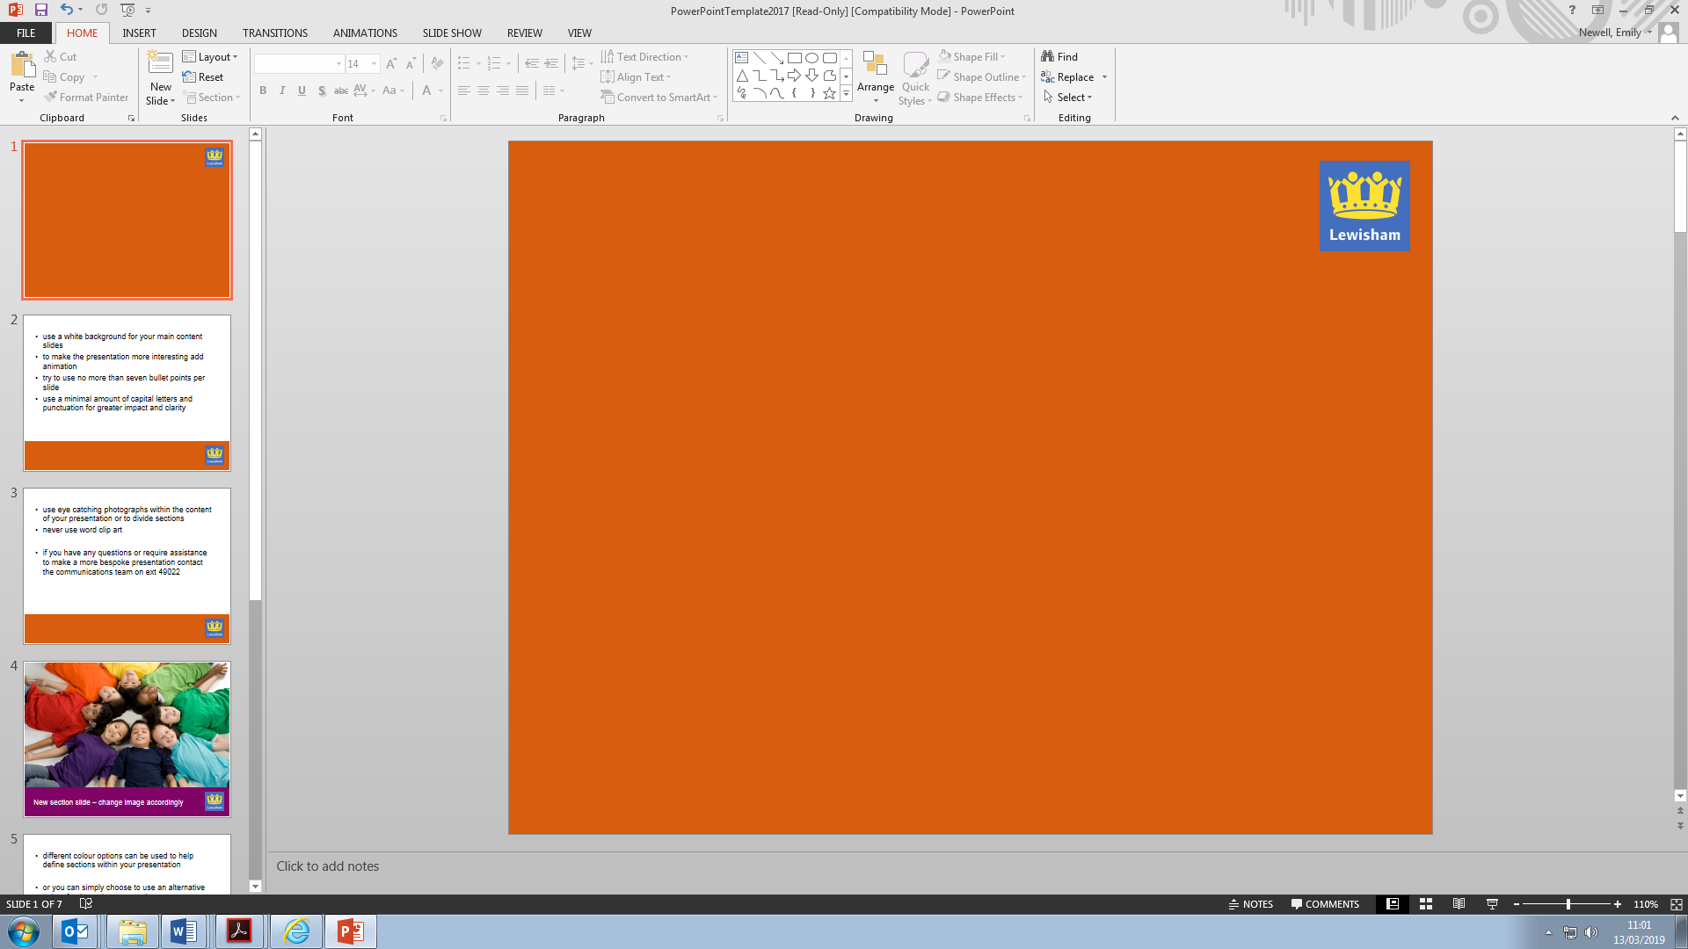

The London Borough of Lewisham invites suitable expressions of interest to a

Market Engagement Event for a Young People’s Substance Misuse and Sexual Health Service

Date: 14:30 – 16:00 Thursday 15th July 2021

Venue: Microsoft Teams

The London Borough of Lewisham is holding a Market Engagement Event to engage with current and potential providers of **an integrated substance misuse and sexual health service for young people aged 10-25.**

LBL are keen to work with providers to deliver a modern, flexible and outcome-focused service, aimed at intervening early in order to prevent and reduce the harm caused by substance misuse and risky sexual behaviour. The anticipated contract start date will be April 2022.

This event will enable LBL to have a discussion with providers which will help to inform the upcoming tendering of these services.

The event will include a discussion with providers on:

* Local needs
* Service requirements and outcomes
* Provisional tender plans

To register your attendance at this event please e-mail [Emily.Newell@lewisham.gov.uk](mailto:Emily.Newell@lewisham.gov.uk) with the name of your company and the names of the delegates you wish to attend.

The deadline for registering your attendance is **12pm on Monday 5th July.**

*Please note that this event does not constitute a call for competition to procure any services, supplies or works for the Council and the Council is not bound to accept any proposals offered. Any procurement of any services, supplies or works by the Council in due course will be carried out strictly in accordance with the provisions in the UK and EU Procurement Regulations.*

