**Parks Flooding Areas – 11th December 2019**

1. **First / southern copse / group of trees**

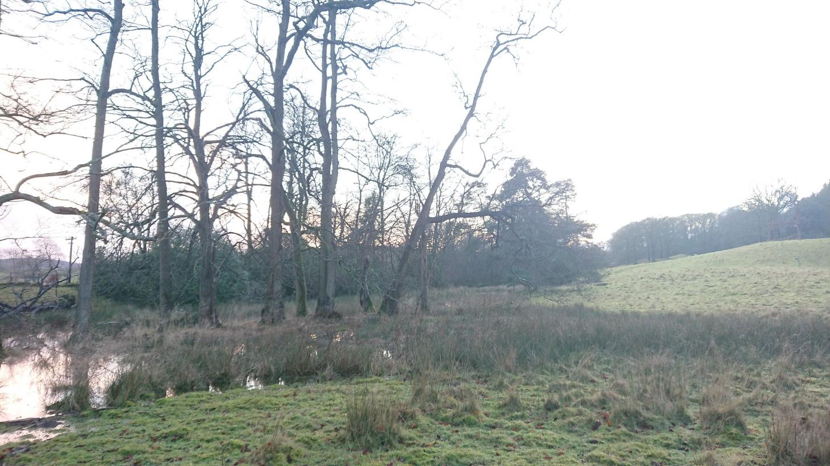

1. **Second / northern copse / group of trees**

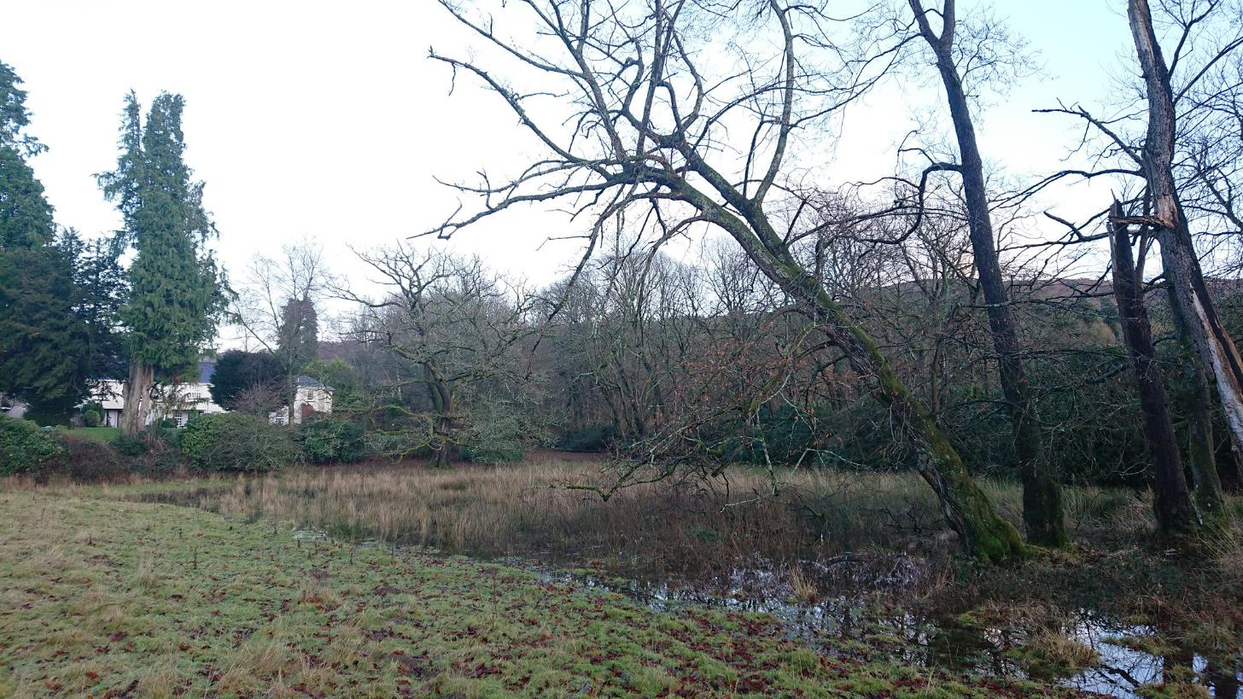

1. **View from Landing How**

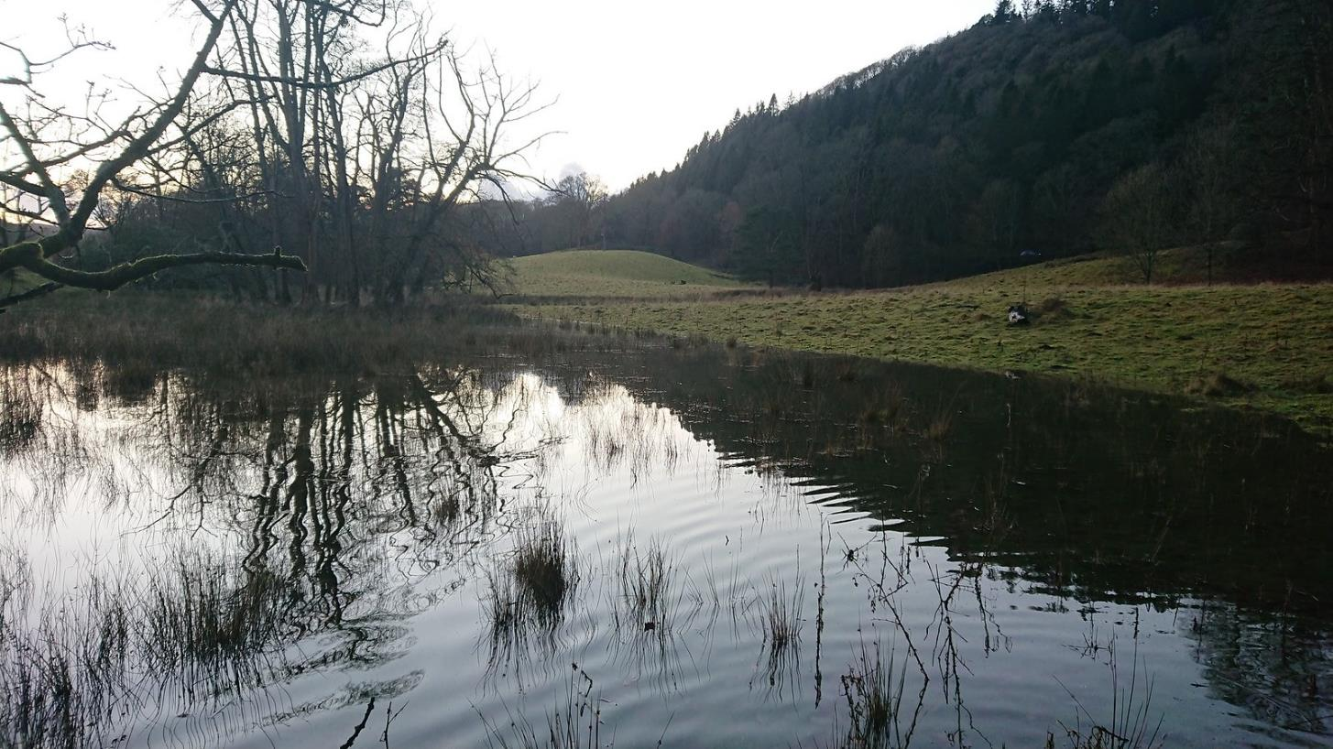

1. **View to Oak Tree**

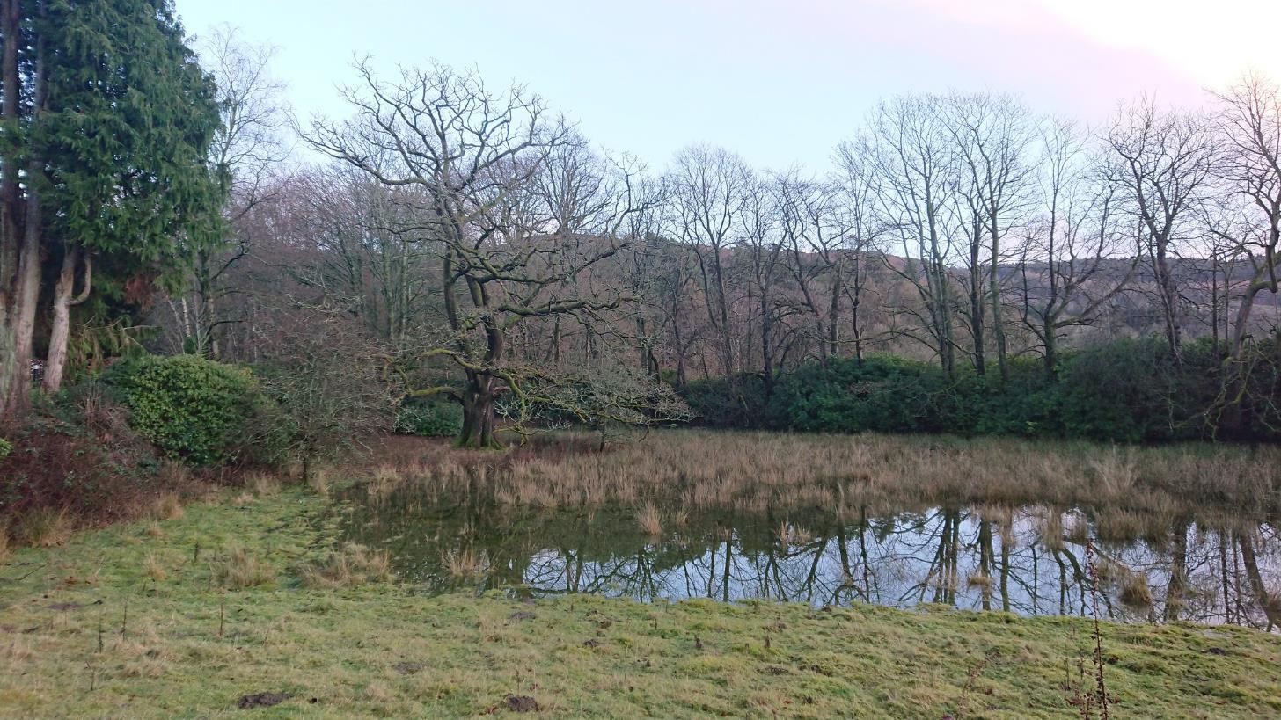

1. **View SW from top of Parks by Landing How**

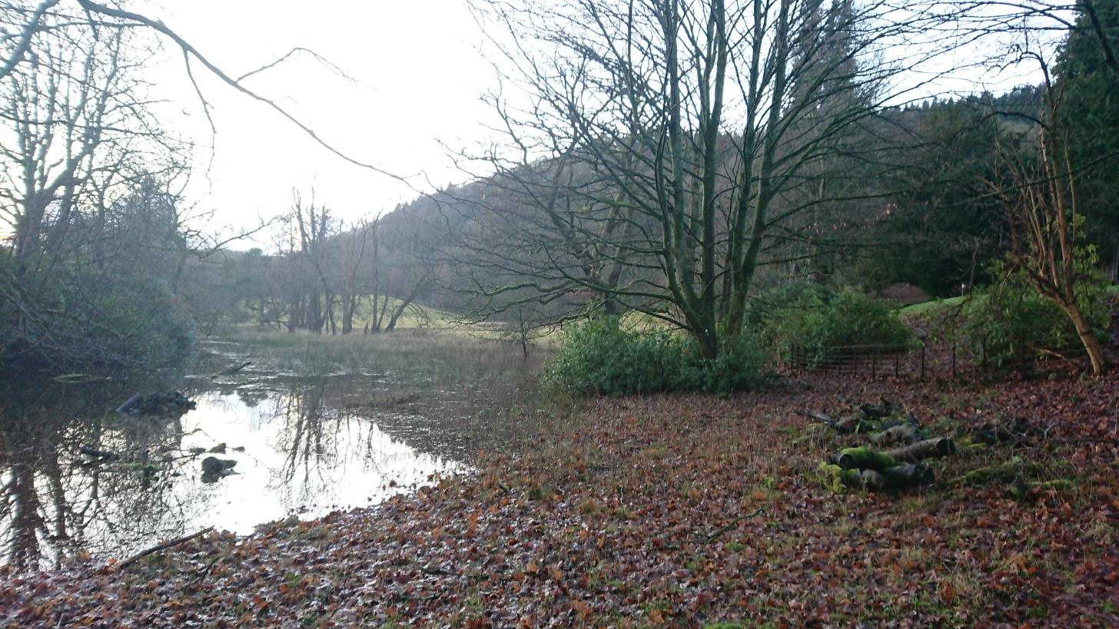

1. **View NE under large Oak Tree**

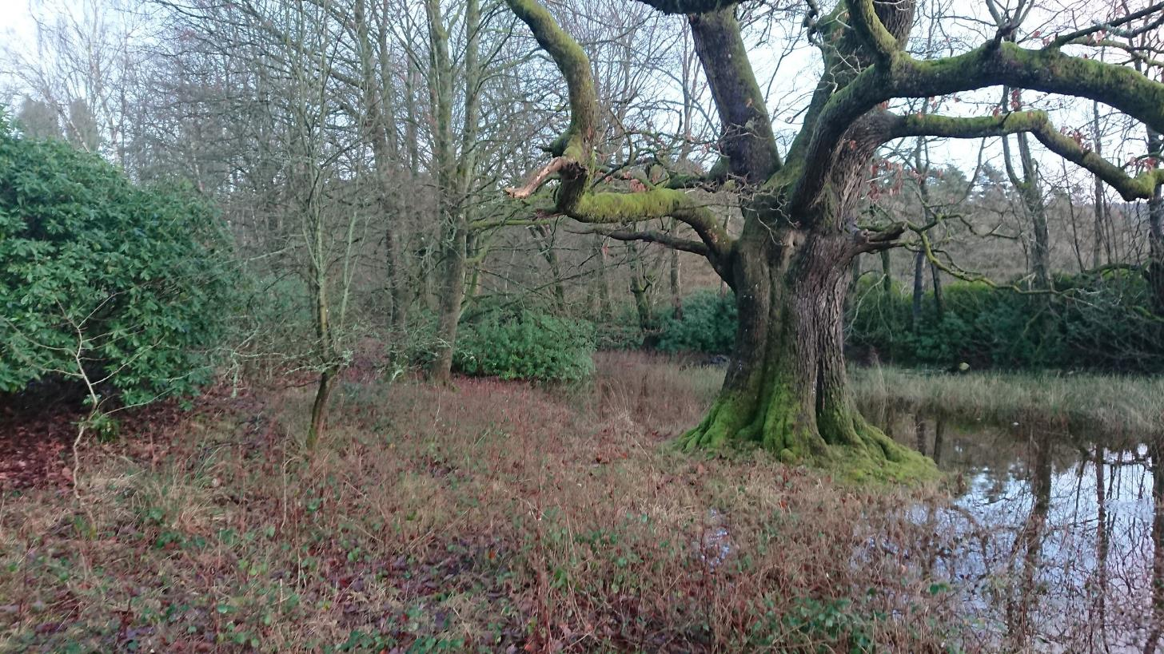

**25th February 2020**

1. **View N from top of knoll**

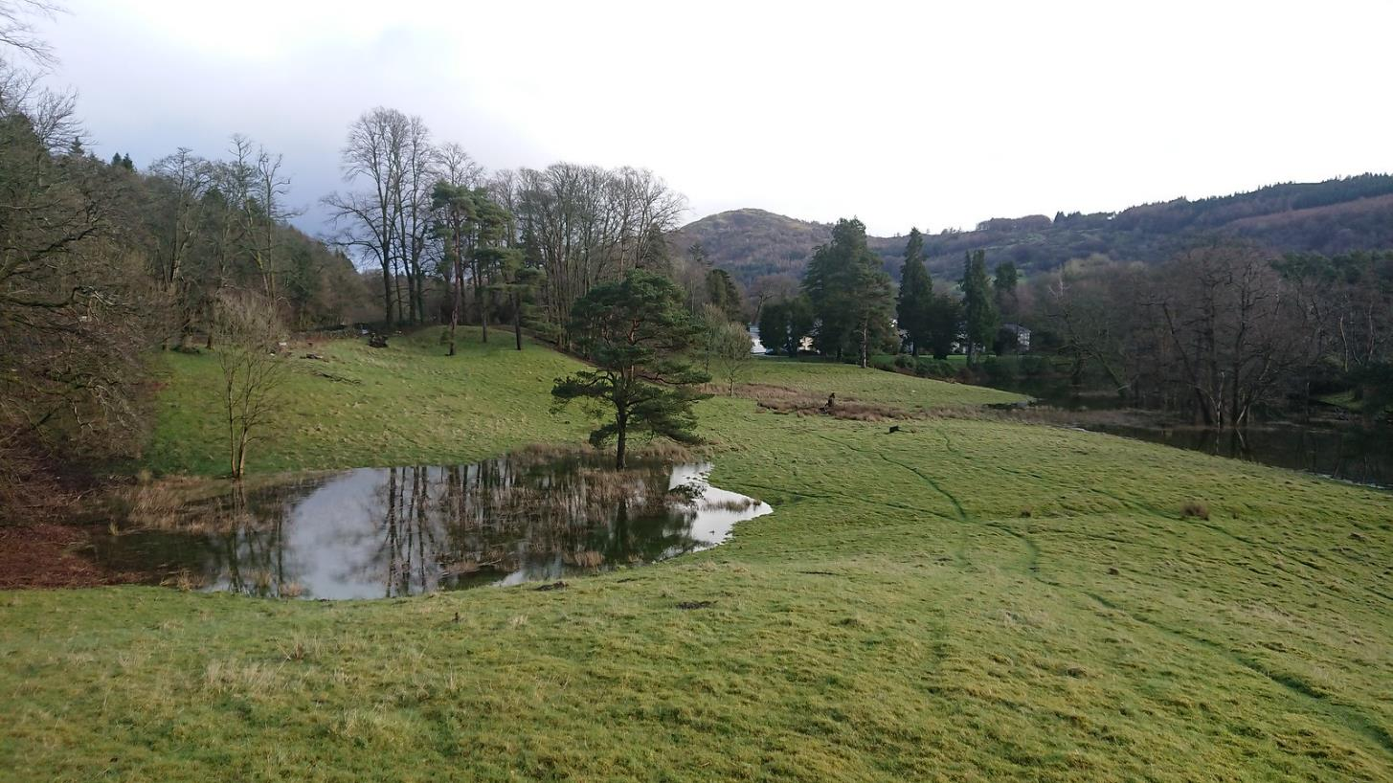

1. **View N from top of knoll**

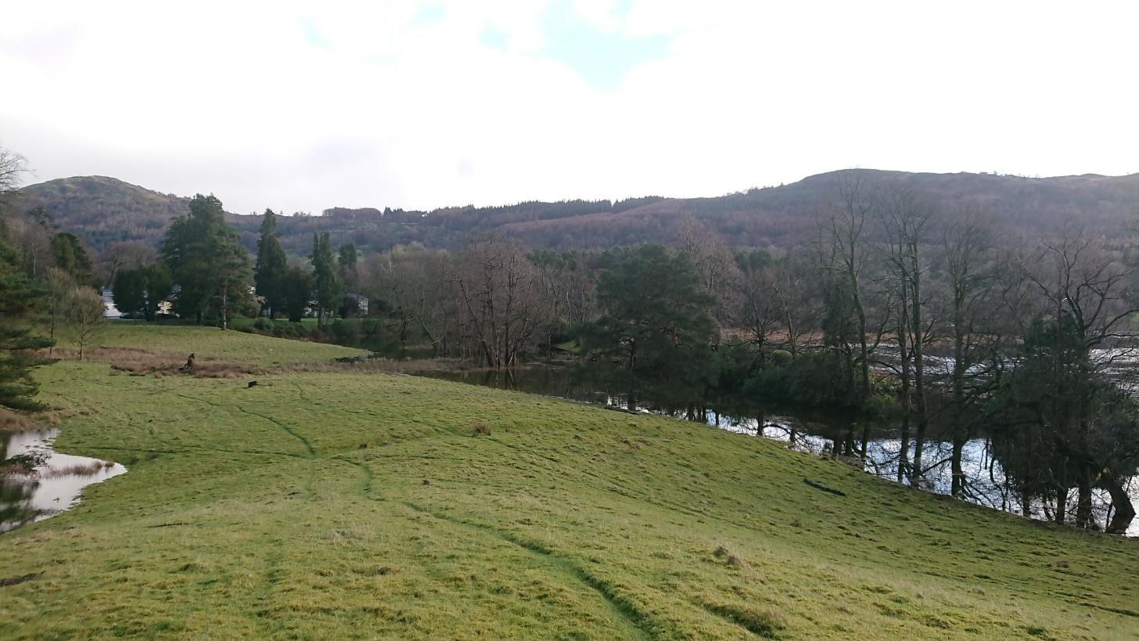

1. **View N along edge of flooding towards LH**

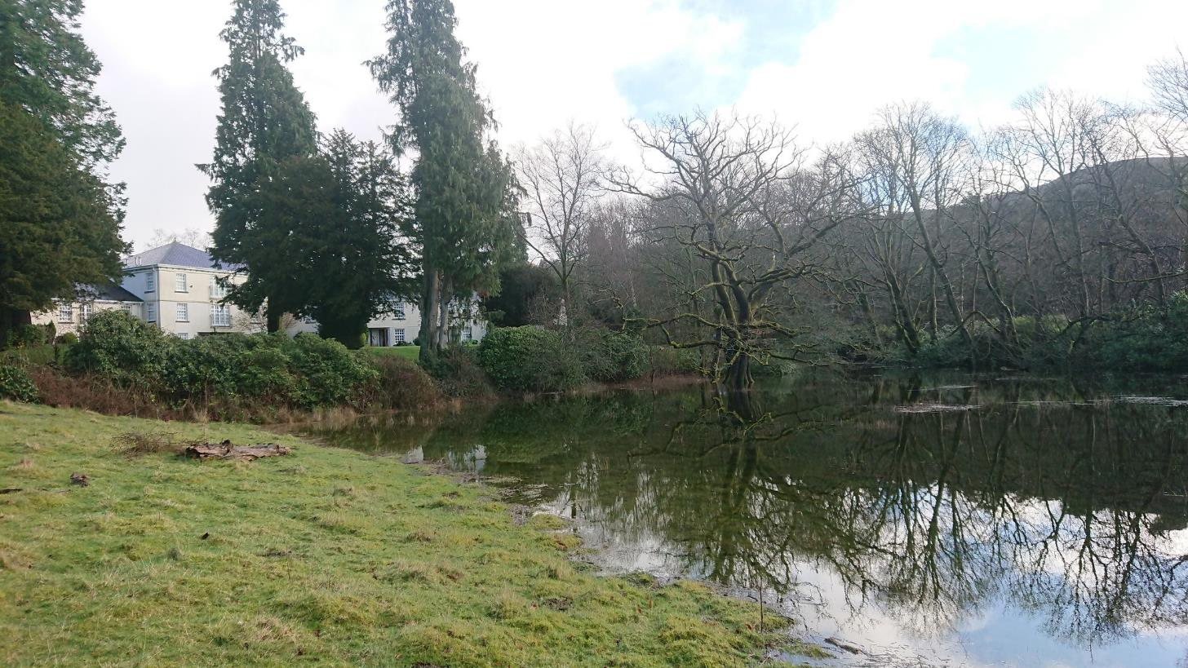

1. **View S – Second and First copse (closes / furthest.)**

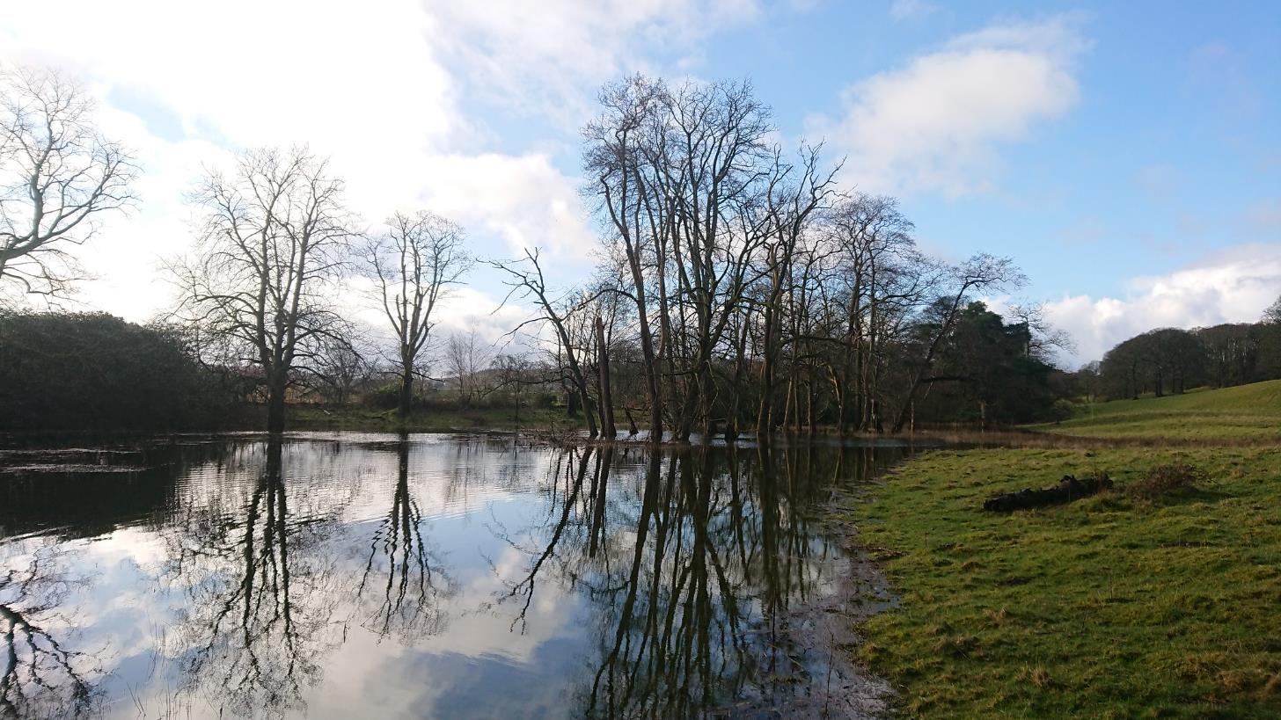

1. **Along LH Boundary**

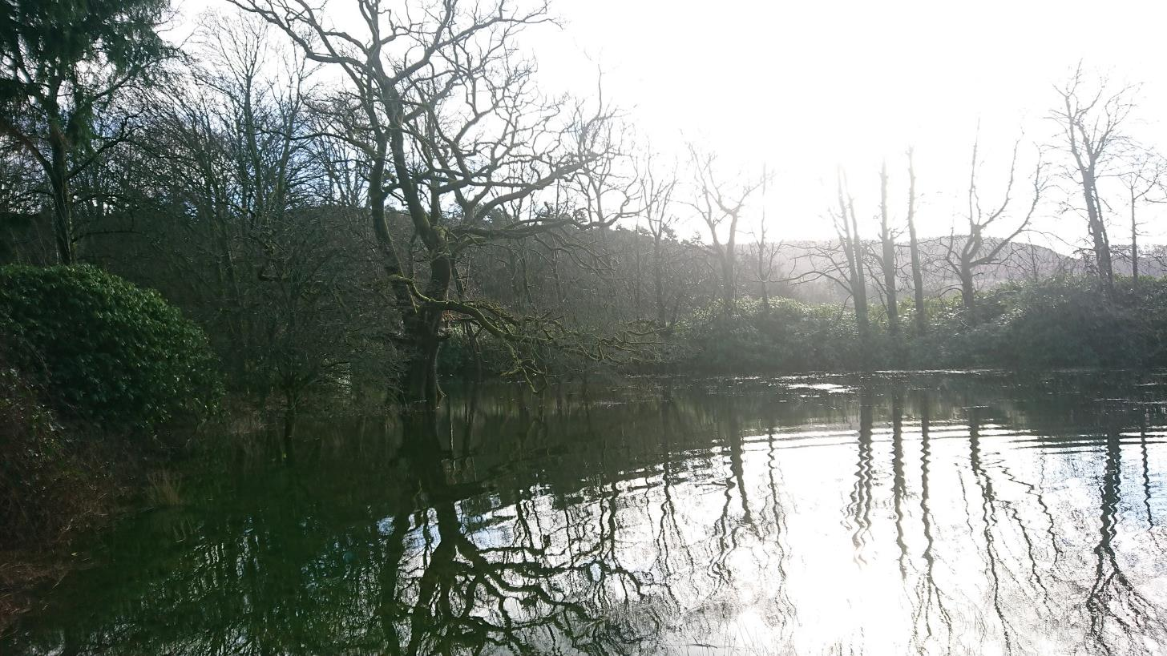

1. **View to road**

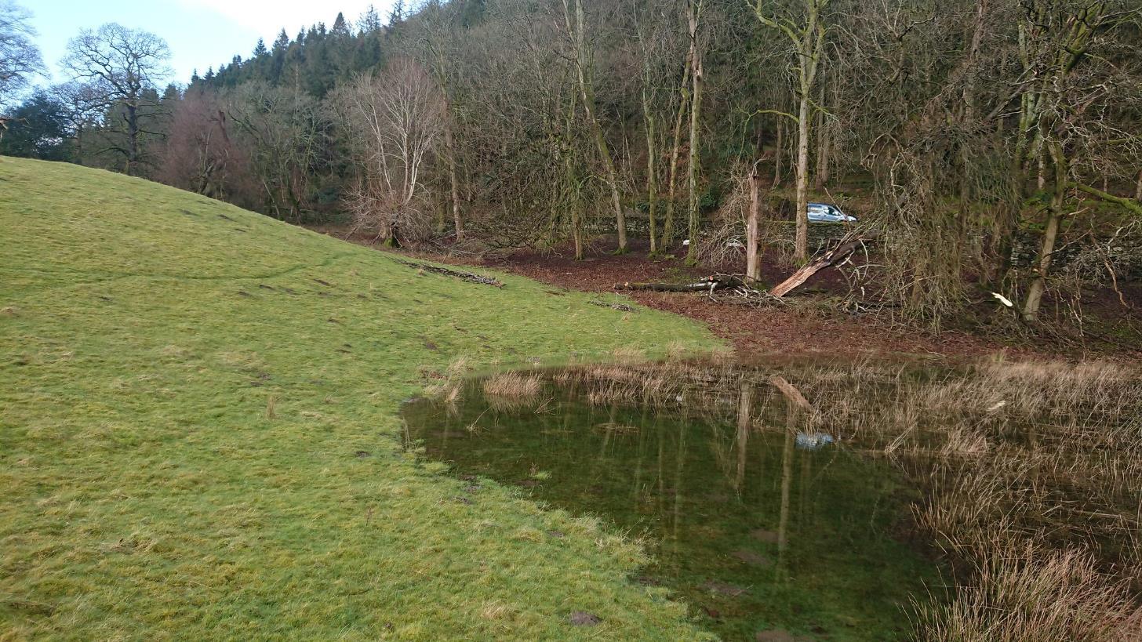

1. **View NE**

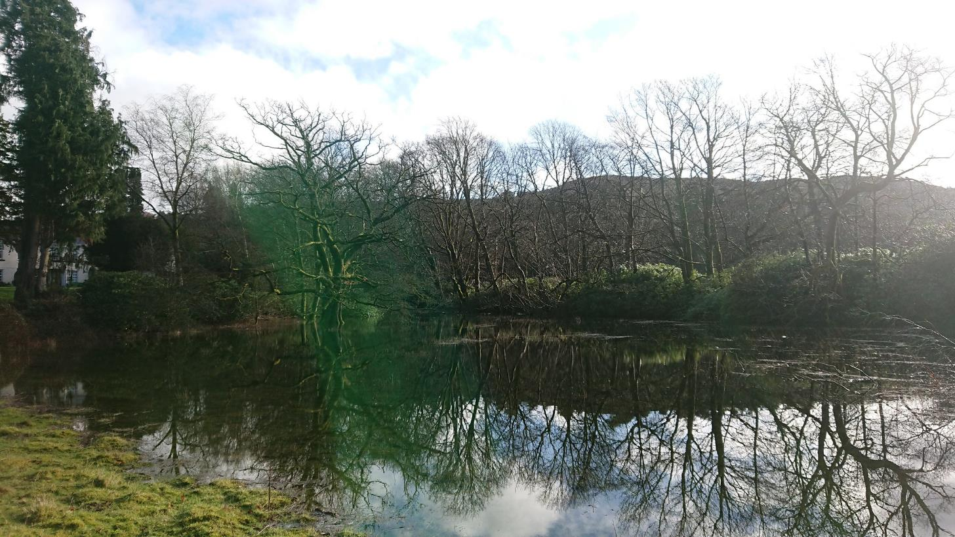

1. **Panorama**

