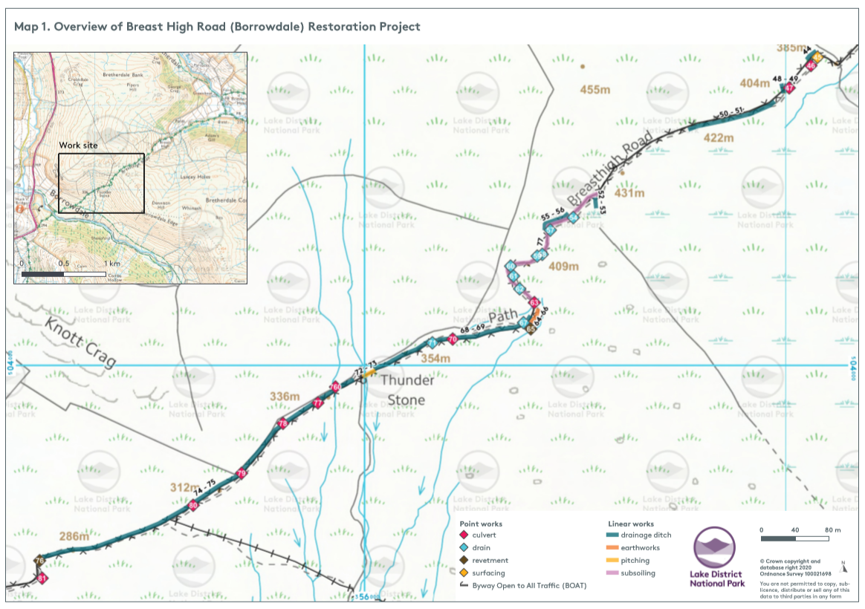

Breast High Road Borrowdale Restoration Project - Images
Map Reference Point | Current feature/condition | Proposed Access Improvement | Image
42-43 | 9 inch culvert pipe no longer working | Replace 9inch culvert - 4 lengths, 3 joints | 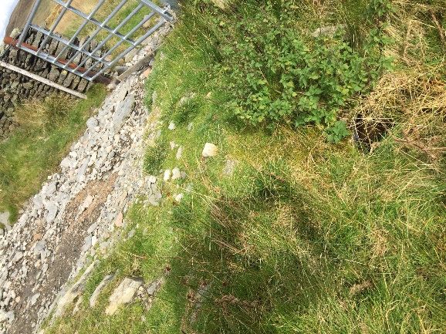
44 | Side drain into culvert, currently eroded | Replace drain and ensure protected edge. 10m | 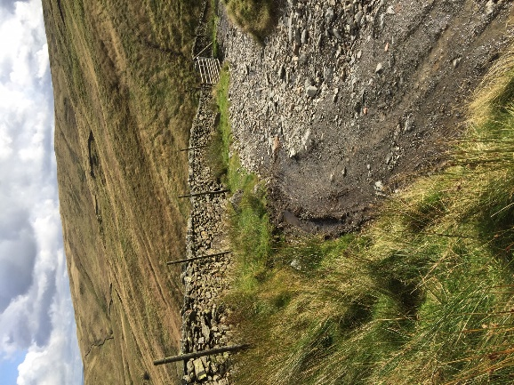
45 | Bend in track unsustainable with loose rocks on steep surface | Create an aggregate surface around bend. | 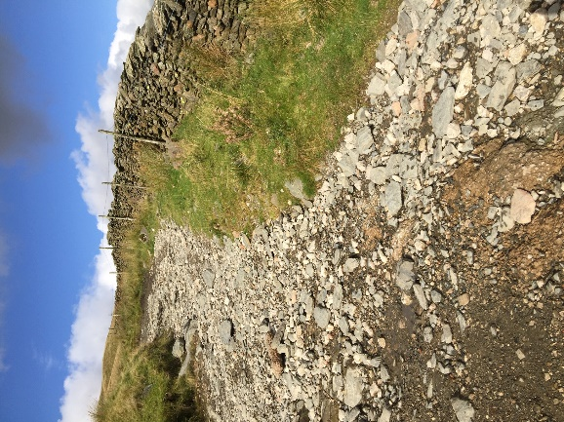  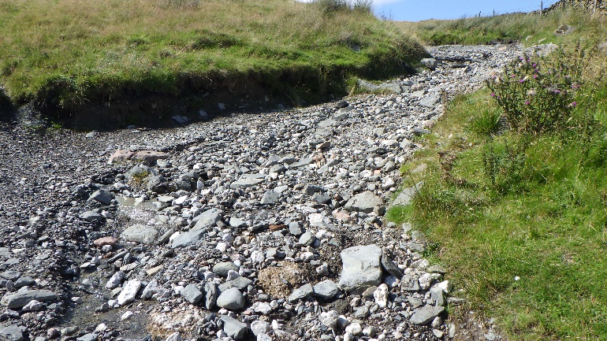
46 | 9 inch culvert pipe broken | Replace 9 inch culvert pipe at a gentler angle | 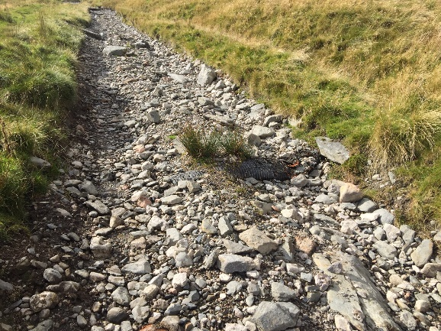
47 | 9 inch culvert pipe broken | Replace 9 inch culvert pipe | 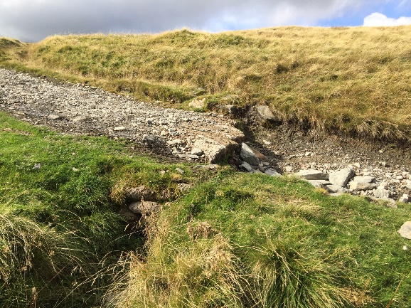
48-49 | Drain | Clear out drain leaving track so functions properly.  8m | 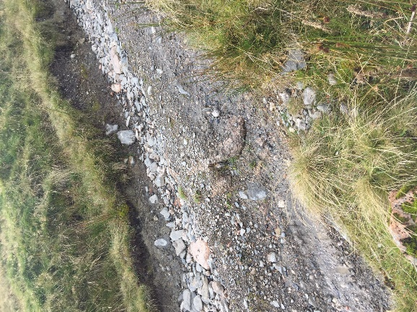
50-51 | Side drains on both sides to clear | Clear out drain so functions correctly and use material to raise road surface.  105m | 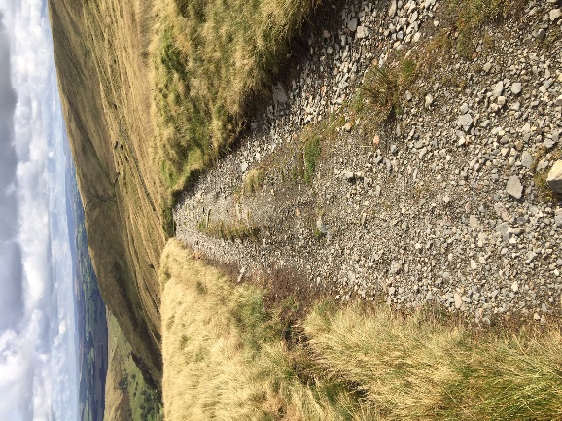
52-53 | Drainage ditch and borrow pit for materials for surfacing |  | 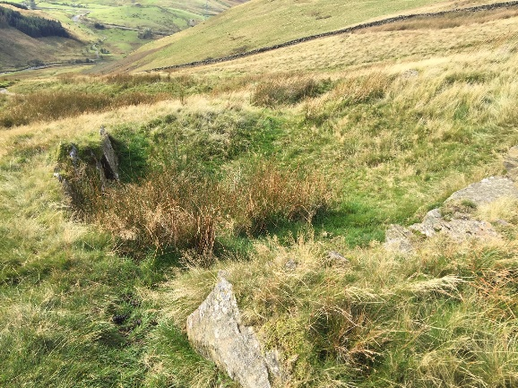
54 | No drainage on track | Install cross drain | 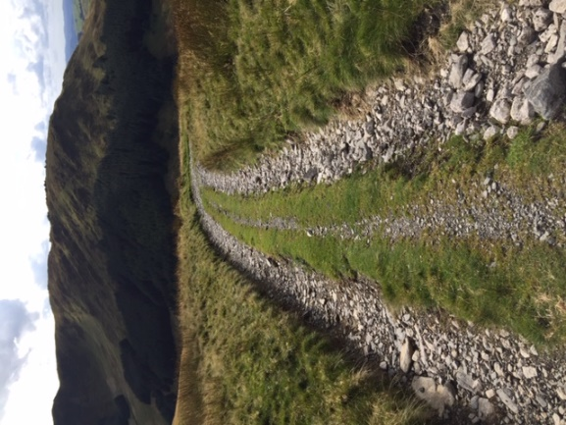
55-56 | Side drain | Clear out drain so functions correctly. Use material on track 30m
57 | no drainage on track | Install cross drain | 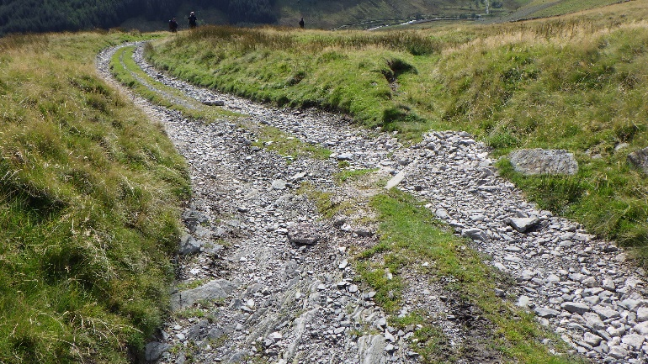
58 | no drainage on track | Install cross drain
59 | Reinstate side drain that is blocked to corner | Clear out drain so functions correctly. Use material on track 35m | 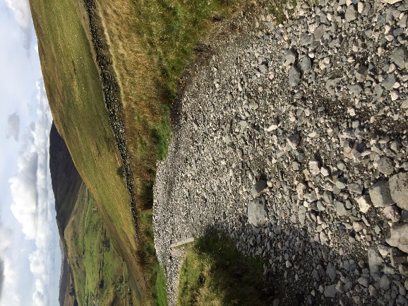
60 | Cross drain not working | Remove cross drain | 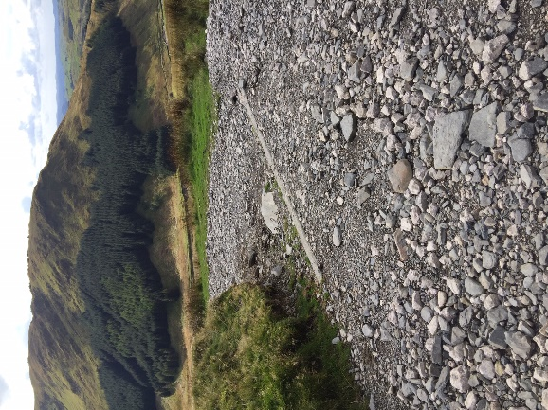
61 & 62 | Existing cross drain not working | Remove and replace with two cross drains. | 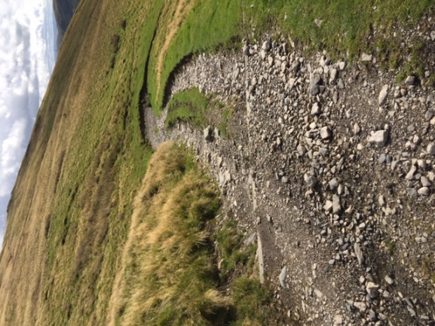  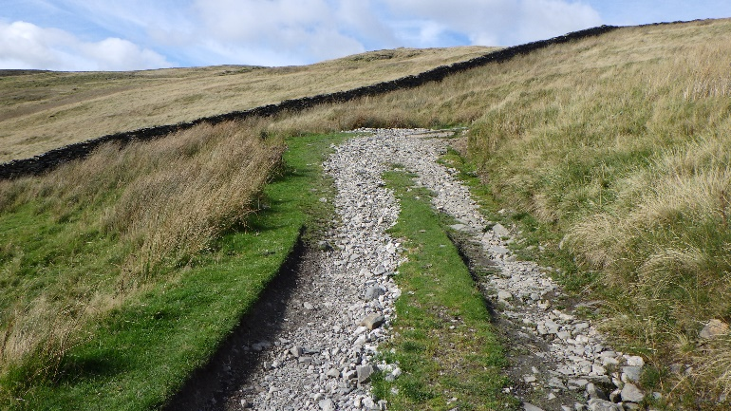
63 | 12 inch culvert working | Culvert ok - leave as is | 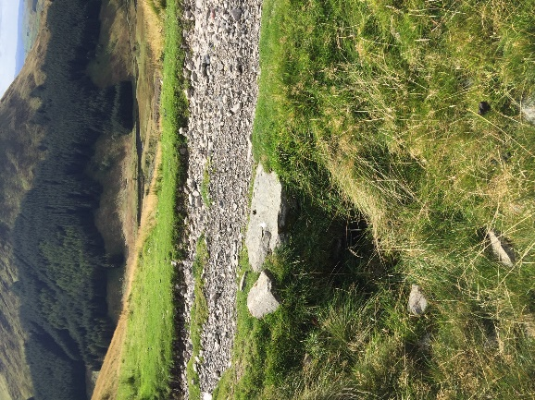
64-66 | Start of Deep erosion of track and loss of material | Earthworks - fill and reprofile track  40mx12m | 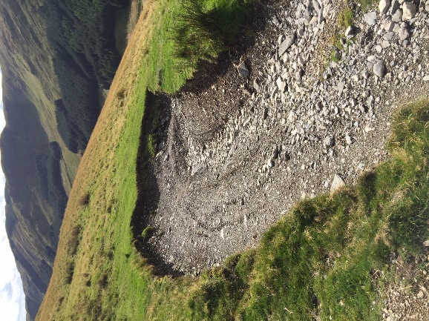  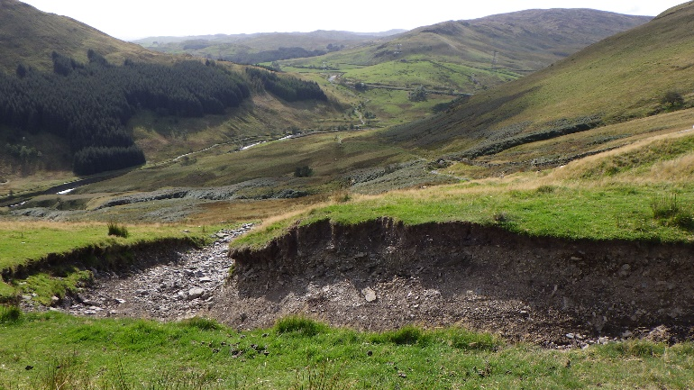  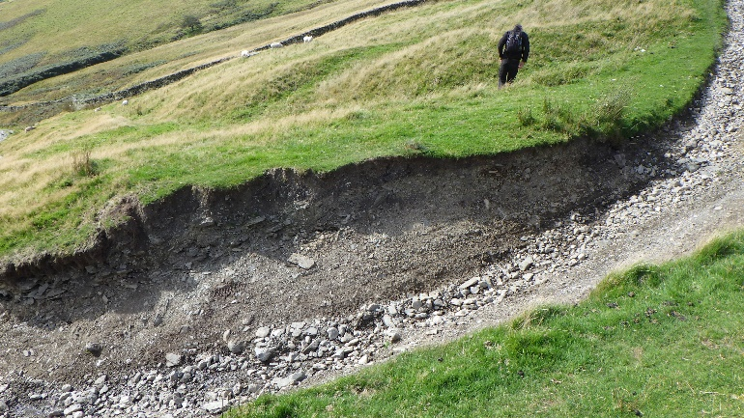
65 | Deep erosion of ditch to side of route | Earthworks - reprofile ditch 20m
67 | Cross drain required | Install cross drain | 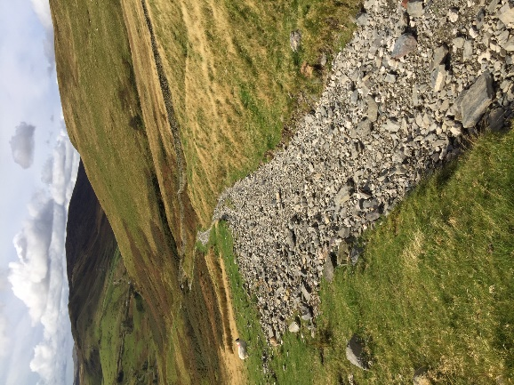
68-69 | Side drain not functioning | Install side drain along northern side. Use material on track to raise camber. 200m | 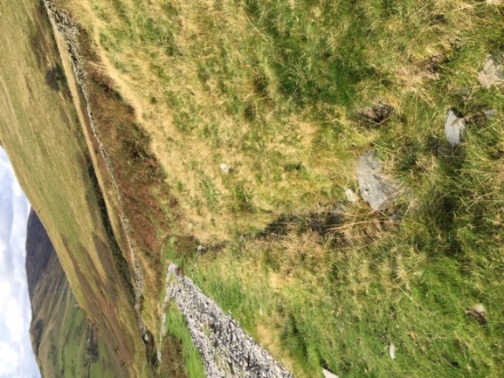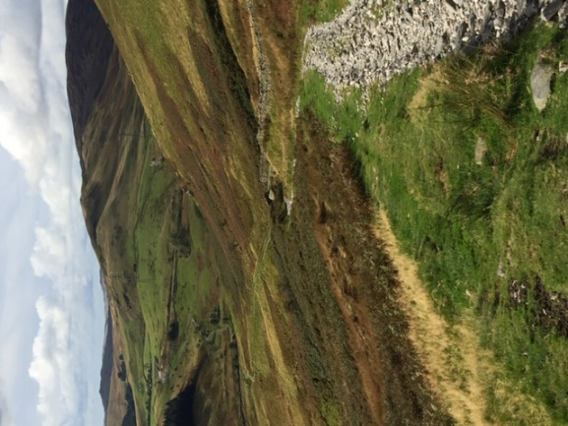
70 | 12 inch culvert ok | Culvert ok - leave as is | 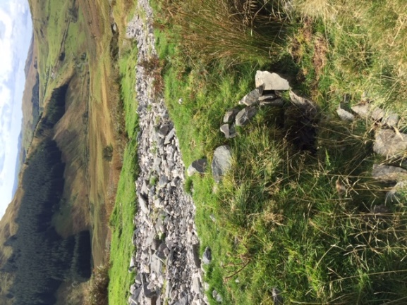
71 | Cross drain not working | Remove cross drain | 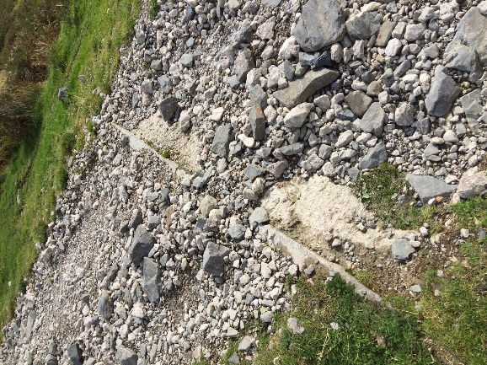
72-73 | Existing culverts blocked and water eroding track. | Remove 4m wall and create 3mx3m sediment trap 1.5m deep. Flag bottom and wall up. 20mx3m pitched area including 2 fords. Revetment 2m on lower side.  Est. 60t stone required | 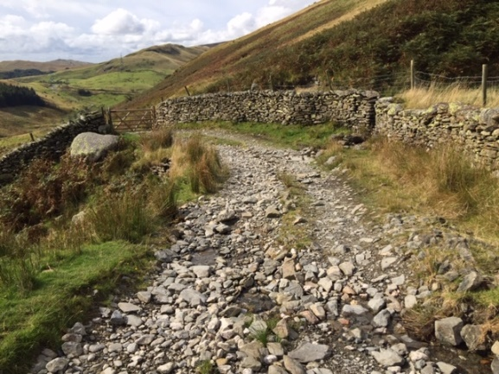  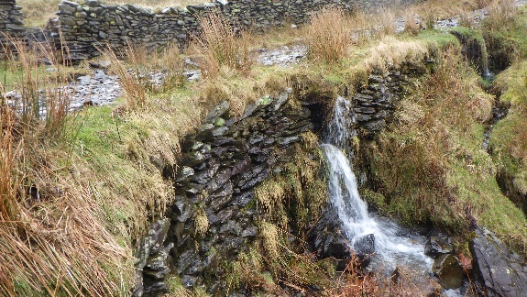  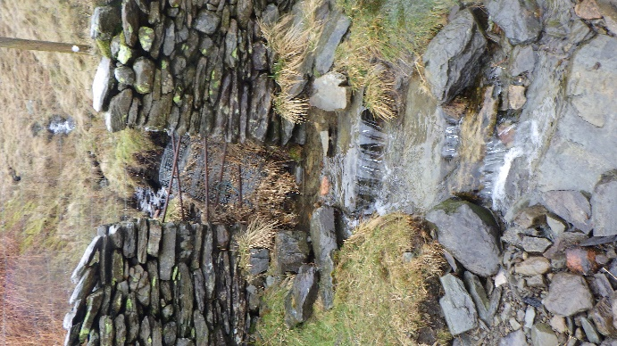  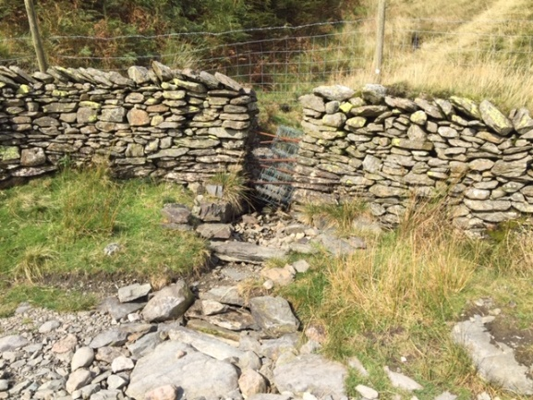  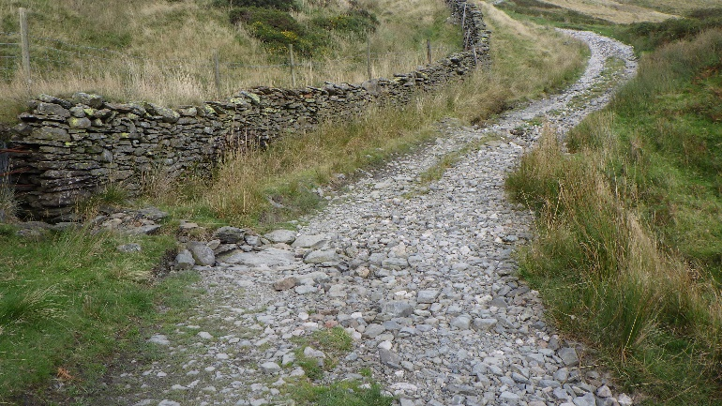
74-75 | Side drain blocked | Reinstate side drain. Use material on track 450m. | 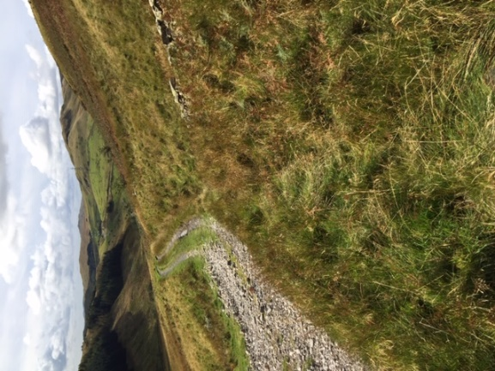  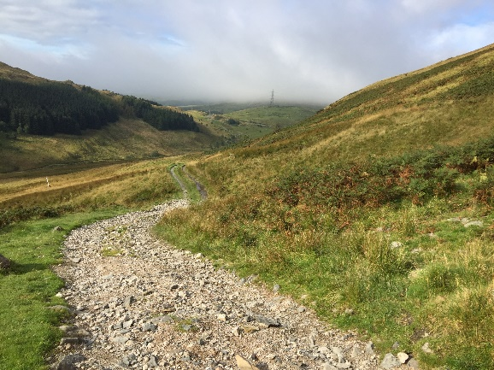
76 | Bank eroded | Earthworks - realign ditch and build embankment to support track 20mx4m | 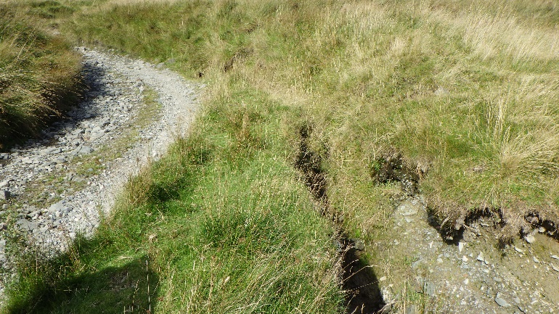

Pitching Stone:
It is estimated ‘Borrowdale’ will require 63 tonnes of stone for the pitching, and culvert headwalls.
Subsoiling:
We will also require subsoiling and surfacing of 500 metres (x 3 metre width) of track within the ‘Borrowdale’ section. See below for map.
We have identified potential sources of substrate which could also be used during the subsoiling process – subject to agreement with the site supervisor and landowner.
The subsoiling will also require a 6inch (15cm) capping of aggregate material in addition to the subsoiling (Est. Total for ‘Borrowdale’ of 225 tonnes of aggregate)

