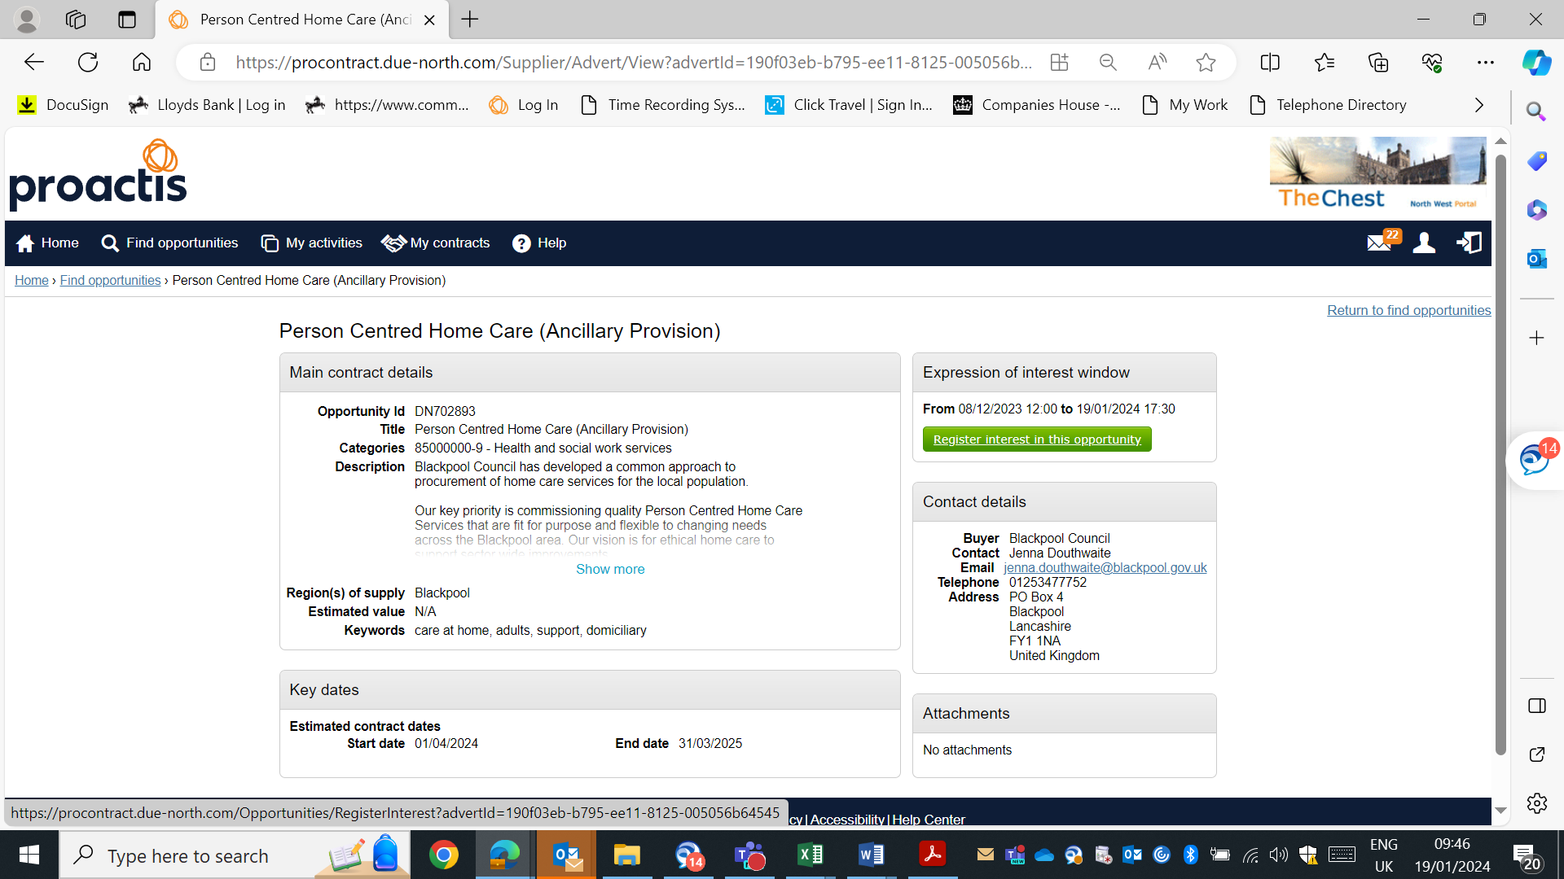
Once you follow the link for the advert you will land on this page. You need to click the green button and “register interest in this opportunity”.
On this page, you can also find other opportunities that are being advertised on this portal, by clicking here.
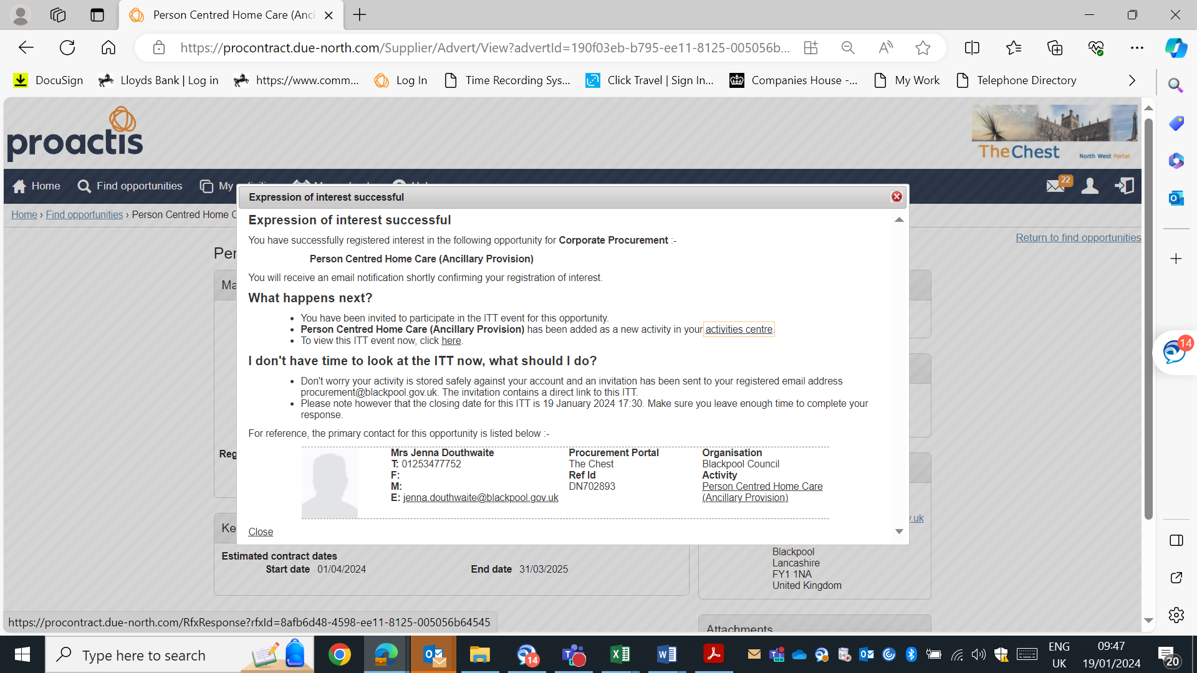
This box will now pop up and under the ‘What happens next?’ section is where you can click ‘to view this ITT event now, click here’ to view the opportunity and all the documents.
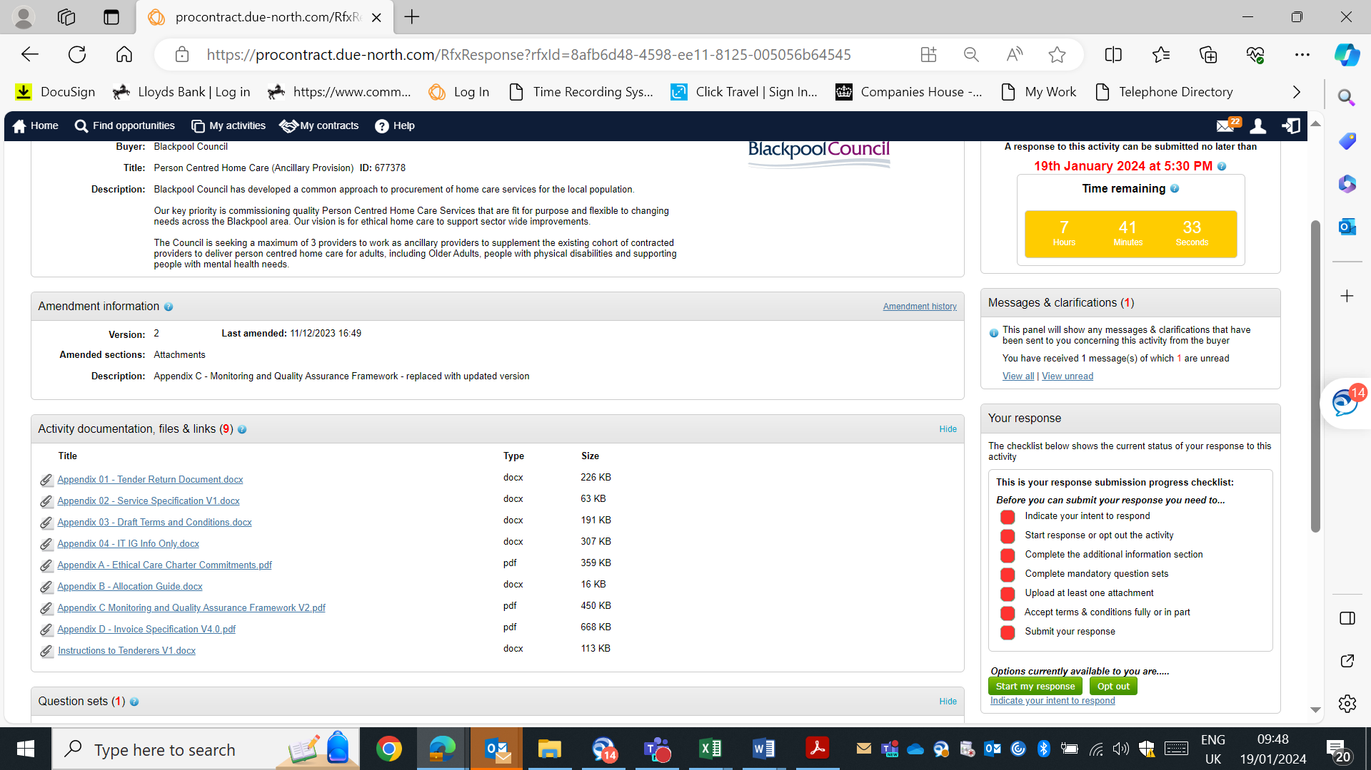
Once you come through to the opportunity you will need to click ‘start my response’
All the documents relating to the opportunity will appear in the ‘Activity documentation, files and links’, it is important you read all the information provided
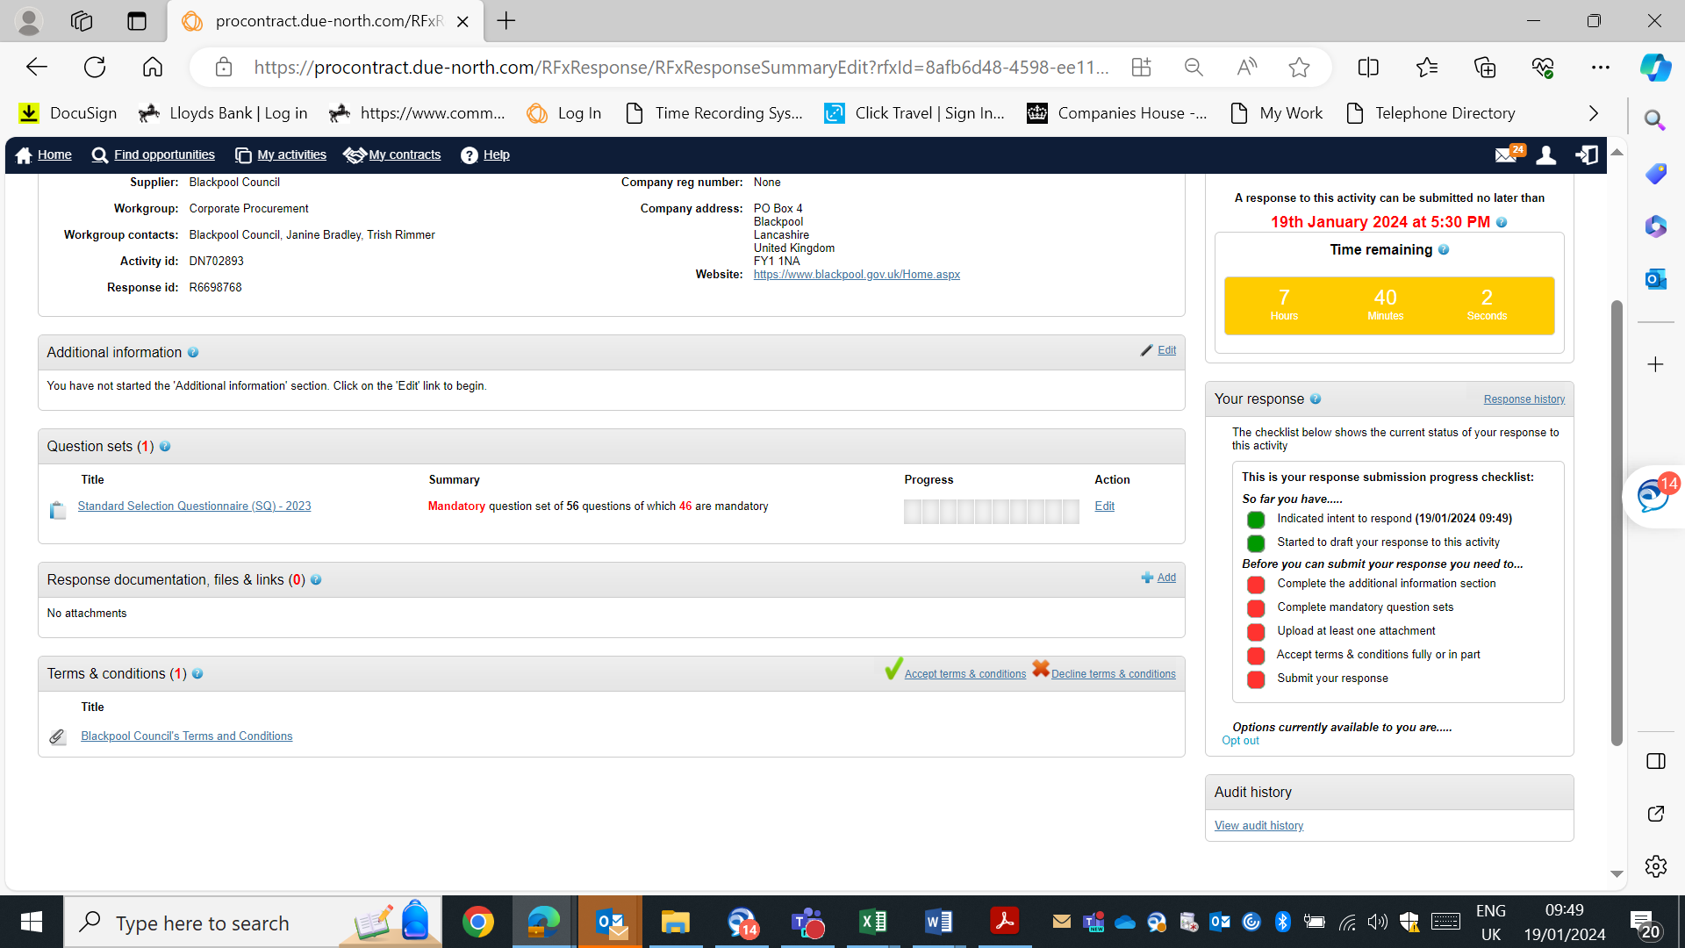

If there is a section titled ‘Question Sets’ you will need to complete this before you can submit your response. You can do this by clicking ‘Edit’.

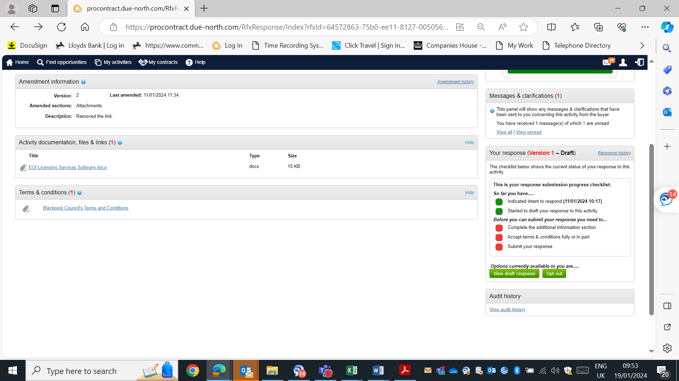
If you do not have a ‘Question Set’ section you will need to click ‘view draft response. If you need to raise a clarification regarding this project you can send a message to the project team by clicking here.

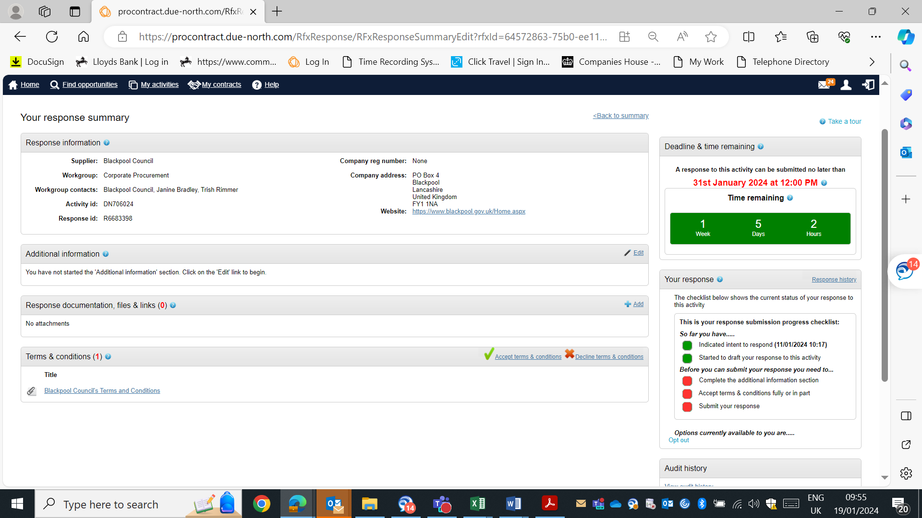
This is the section in where you can ‘add ‘your submission and supporting documentation ‘response documentation, files & links’. You cannot submit your response until you have completed this checklist and all the list is green.
If you need to leave ProActis/The Chest at any point, you can return to the opportunity by clicking ‘My activities’ and then selecting ‘Last viewed activities’.
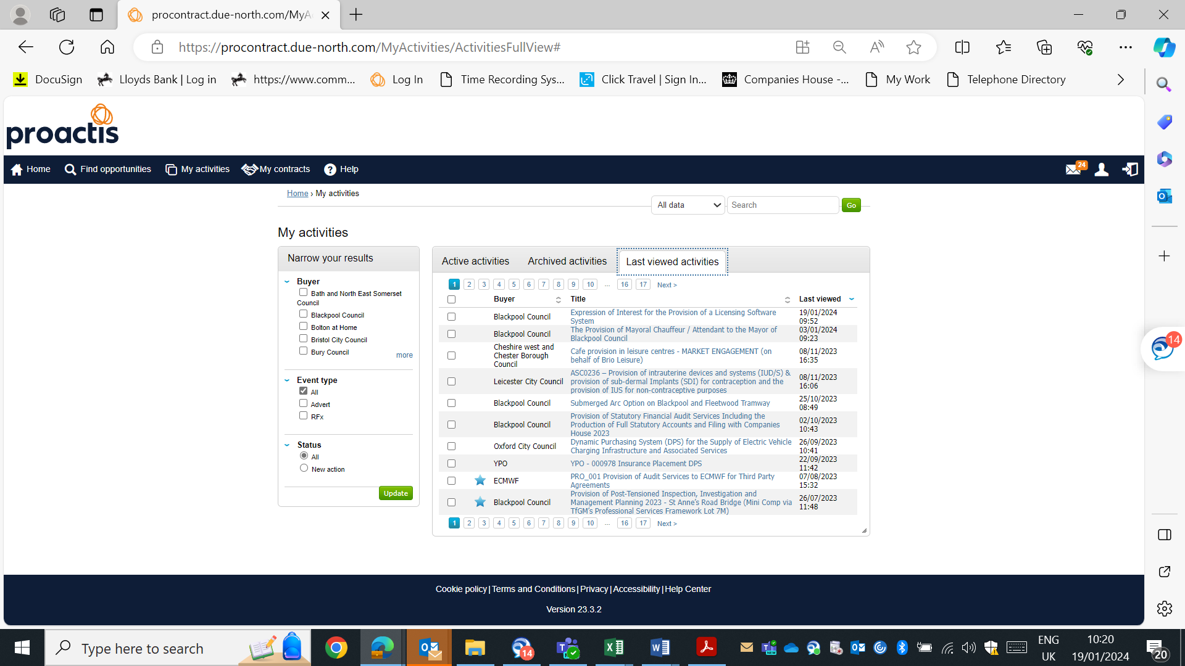
There are also multiple ‘how to guides’ in the help section that provide you with more in-depth guides. You can find these under the ‘Frequently asked questions, Videos & Guides’

