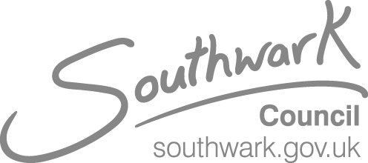

Alternative Provision in Southwark- Market Warming

Please respond by 8 April 2021

Local Authorities have a statutory responsibility for arranging suitable education for all compulsory school aged pupils.

London Borough of Southwark (LBS) is committed to ensuring that all Southwark children receive high-quality education in a safe environment that is fit for learning

Alternative Provision (AP), is available for children of compulsory school age, where mainstream or special schools do not meet full educational requirements for a wide range of reasons which can include:

- Behaviour which results in a permanent or fixed-period exclusion;
- Health reasons – including physical or mental health needs, or a disabled child;
- Where a child is awaiting placement in a mainstream school; and
- Interim or supplementary education for a Looked after Child (LAC)

Southwark Council intends to establish contracting arrangements with high-quality providers via an AP framework. The aim is for an AP framework to generate increased personalised support and choice with the view of improving, educational and developmental outcomes that reflect the needs of the user. In addition, the framework will allow the Council to respond efficiently and effectively to the needs of Southwark children and young people, whilst providing a level of market stability through its bank of pre-qualified providers.

N.B Subject to internal approvals, the procurement a process will commence in April 2021.

Southwark Council will be hosting a virtual market warming event, to inform interested providers of the opportunity and of any updates since the last market engagement event took place.

Please confirm your attendance by completing the form below and submit via the messaging service in the ProContract portal. If you have any clarification questions regarding the event please notify the Project Team via the ProContract portal.

The event will take place virtually on Microsoft Teams:
Tuesday 13th April 2021, 11-12:30pm

A link to the event will be sent to all providers who have submitted an attendance form 48 hours before the event.
Interested parties will not be prejudiced by any responses or failure to respond to this market warming event. A response to this Notice does not guarantee any invitation to participate in any future public procurement process that Southwark Council may conduct, nor a contract as a result.

Please note this notice does not constitute a call for competition to procure any services for the Council and the Council is not bound to accept any proposals offered. The Council is not liable for any costs, fees or expenses incurred by any party participating in this event. Any procurement of any services by the Council in due course will be carried out strictly in accordance with the provisions of the Public Contracts Regulations 2015.

The Council’s tenders will be advertised on the following websites:

https://procontract.due-north.com
https://www.gov.uk/contracts-finder
https://www.find-tender.service.gov.uk

Attendance Form

Your details
1st Attendee | 2nd Attendee
Name: | Name:
Job Title: | Job Title:
Email address: | Email address:
Phone Number | Phone Number
Organisation Name:

Organisation Address:

