Multidisciplinary Panel
Further Competition Invitation to Tender (Stage 3)
Marchmont Farm- Multi-Disciplinary Team

Date: 8th June 2021
ProContract Identification Number: DN 542145

- Introduction

The purpose of this Further Competition Invitation to Tender (ITT) is to award the call-off contract for the Homes England - Multidisciplinary – Marchmont Farm project, Hertfordshire. We ask you to respond to the questions in the Evaluation Section using the Response form and to submit your pricing using the Resource/Pricing schedule provided.

Expressions of Interest and Sifting Brief stages have already been issued by Homes England as the first and second stages of the tender process. As a member of the Homes England Multidisciplinary Consultancy Framework Panel, by returning the Sifting Brief you have already confirmed your interest, capacity and resource to bid in a mini competition to undertake the above project/commission. This Invitation to Tender is the third stage of the tender process for the selection of a consultant team for the project.

This Further Competition ITT provides the following:

Commission Requirements
- Details the requirements and additional terms and conditions for the Further Competition. The successful Supplier will be subject to both the terms and conditions of this Further Competition and the Framework Contract. Unless otherwise defined in these instructions, terms used shall have the meaning given to them in the Framework Contract.

Instructions for Submitting a Response
- Contains important information and instructions on preparing and submitting a tender response. Outlines the evaluation criteria which will be used for assessment. It is important that Suppliers familiarise themselves with the criteria and ensure they are considered when compiling their tender response.

Standard Forms
- Contains standard forms to be completed and returned by the Supplier when submitting a tender response.

Please note all communications during the tender period will be via the ProContract website. All bidders that have registered their interest for the Procurement will receive a direct email notification from ProContract on any updates via the suppliers registered email address. It is the Suppliers’ responsibility to check the ProContract website for any updates to the Procurement process. No claim on the grounds of lack of knowledge of the above mentioned item will be entertained.

This Further Competition ITT and associated information is confidential and shall not be disclosed to any third party without the prior written consent of Homes England. Please do not contact Dacorum Borough Council, Hertfordshire County Council or any other stakeholders in relation to this tender.

ITT Response Deadline via ProContract: 22nd June 2021 17.00 Hrs.

- Background

  - The site

Marchmont Farm is an 18.2 ha strategic greenfield site located on the north-west edge of Hemel Hempstead in Hertfordshire. The site comprising parcels 37084 and 851 is shown edged orange below. The site is located on the north-west edge of Hemel Hempstead in Hertfordshire, approximately 2.5km from the town centre. The A4147 Link Road runs parallel to the site’s southern boundary, and Piccotts End Lane (Footpath and Restricted Byway) runs through the middle of the site connecting Grovehill and Piccotts End.

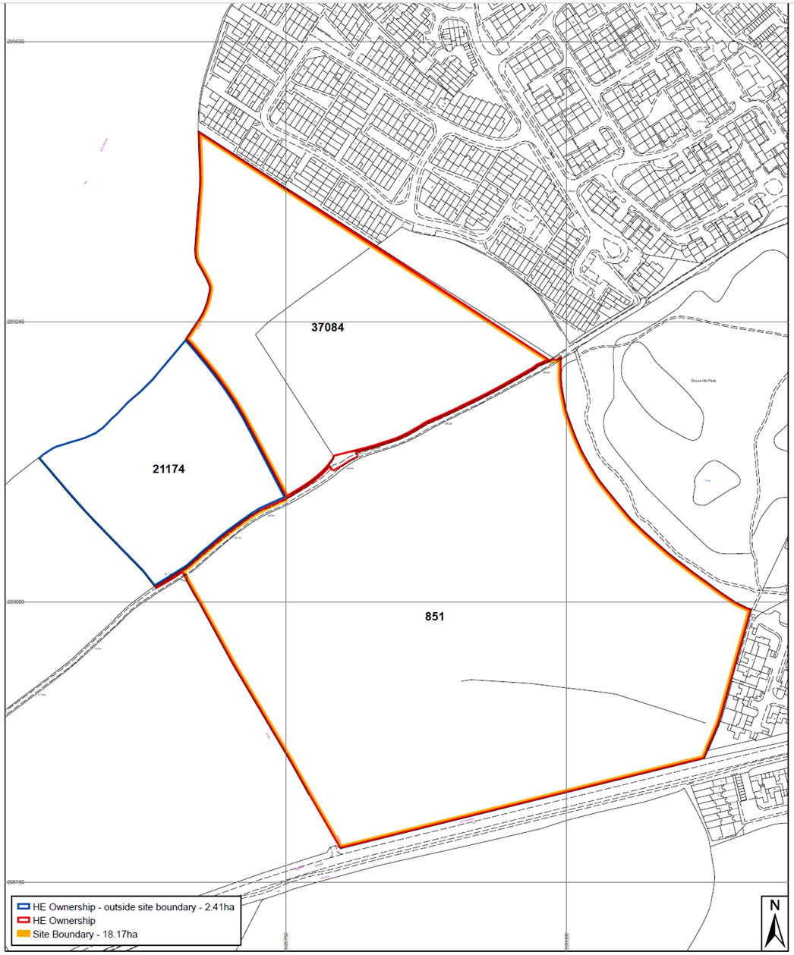

The site is located within Dacorum Borough Council, Hertfordshire. It was allocated as a strategic housing site LA1 and removed from the Greenbelt in 2017. It abuts the North and East of Hemel Hempstead Growth Area proposed in the Dacorum Local Plan 2020-2038 and the remaining parcel 21174, edged blue, forms part of that wider Growth Area but is not part of this commission.

The area within the Marchmont Farm LA1 allocation was previously in the ownership of three landowners; Homes England (14.90 ha), The Crown Estate (3 ha) and Dacorum Borough Council (0.7 ha). Homes England acquired The Crown Estate’s land in March 2019 (shown coloured yellow in the plan below), because it acted as a ransom to Homes England’s land-holding to the north (shown coloured orange).

The Crown Estate retained development land to the north, and under the terms of the Sale and Purchase Agreement, Homes England is obliged to deliver the access, spine road and services through the site up to the northern boundary by March 2024.

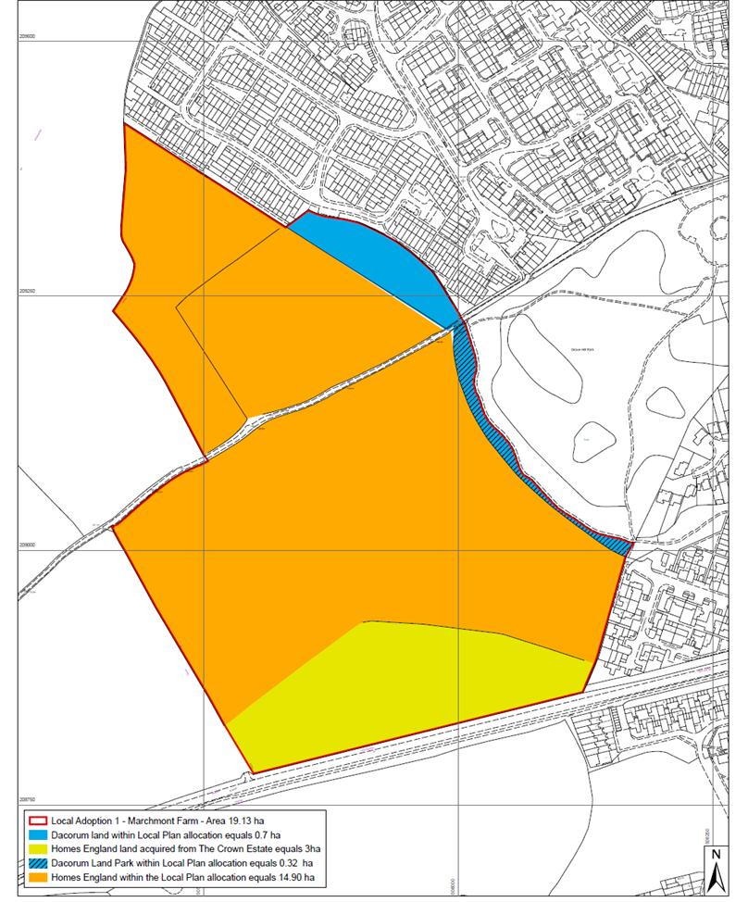

Homes England promoted the removal of the Site from the Greenbelt and worked with the Local Planning Authority, to develop a Masterplan for the LA1 allocation. The allocation comprises the following:

• Up to 350 new dwellings (Use Class C3), including 40% affordable homes
and for 5 Gypsy and Travellers pitches
• Extensive formal and informal open space, including play areas and natural open space
• Extension to Margaret Lloyd Park
• Ecological mitigation
• New footpaths and cycleways connecting adjoining networks
• Vehicular routes and parking
• Provision of new services/utilities and drainage infrastructure works (including sustainable surface water attenuation and control)
• Main site access from Link Road

The application site does not cover the whole of the LA1 allocation. Homes England approached Dacorum Borough Council to acquire their land however, Homes England was unable to secure the whole allocation. The Council has been developing a proposal for up to 35 homes (houses and flats) for this site in isolation (not serviced by Homes England’s land) for inclusion within their own development programme. The site will be linked to the Homes England site by footpaths and an emergency vehicular access which is part of this commission.

  - The proposed Marchmont Farm development

DBC resolved to grant outline planning consent, subject to agreeing the S106, on 29 April 2021 for 19/02749/MOA comprising: up to 350 dwellings, land for 5 gypsy & traveller pitches. Vehicular access from A4147, public open space including extension to Margaret Lloyd Park and associated landscaping, infrastructure and drainage. Detailed approval for access arrangements (Revised Scheme: Emergency Access Link to Laidon Square) Land at Marchmont Farm Piccotts End Lane Hemel Hempstead Hertfordshire HP2 6JH. See parameter plan below.

Further information regarding the site constraints is provided within the Environmental Statement and Design and Access Statement approved as part of outline planning permission. The draft conditions and S106 are appended.

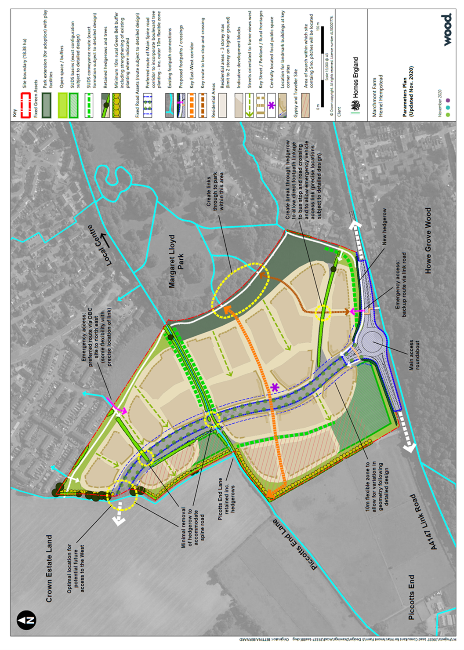

Homes England’s disposal strategy is to provide the strategic infrastructure upfront and sell on serviced land parcels to the market. The current intention is that the site would be brought forward in two phases of delivery comprising Phase 1 on the south side and Phase 2 on the north side of Piccotts End Lane, but that within these there would be different sized development parcels to facilitate the potential for SMEs to compete for a role in its delivery. It is currently envisaged that Homes England, acting as master developer, will appoint and work with the selected partner(s) responsible for satisfying relevant planning conditions/obligations in S.106 and obtaining Reserved Matters approvals for their development parcel.

- Purpose and scope of the Appointment

The purpose of this commission is to appoint a multidisciplinary technical consultant to deliver the upfront infrastructure design in order to de-risk the scheme, but also set the quality threshold for the whole development. The commission requires the appointment of a professional services team to provide a full range of planning, technical and engineering services to deliver the project scope and liaise with development partners including, in brief:

1. Town Planning and Sustainability Strategy, Socio, Environmental and Economic Impact

2. Consultation, stakeholder and community engagement

3. Masterplanning and urban design, architecture, CDM services

4. Establish a site wide global Civil 3D model that will form the base for all technical designs, including earthworks strategy, drainage and highway design.

5. Earthworks Strategy – to minimise and balance cut / fill across the site and avoid / minimise any retaining structures and significant earth movement.

6. Detailed drainage design of both foul and surface water, including SuDS and obtaining technical approvals

7. Detailed highways design including obtaining technical approvals.

8. Detailed utilities and services design including obtaining any necessary approvals and liaison with providers regarding off-site reinforcement, points of connection and on-site networks, plus diversions and/or protection of existing assets.

9. Detailed landscape design including public realm, open space, planting and play strategies, aligned to the biodiversity and ecology strategy and wider infrastructure coordination.

10. Technical and site investigations and reporting, including design advice for surveys, enhancements and mitigation to support the delivery of the access points and spine roads, associated earthworks, drainage, utilities and services.

11. Project, cost and risk management and governance, with cost plan preparation Management and delivery strategies and plans – including the Construction Environmental Management Plan and other Management Plans and Strategies.

12. Infrastructure works procurement and contract management.

13. Additional services as may be required to support delivery of the project for Homes England, including but not limited to additional planning, technical, engineering, delivery management and further surveys and studies.

A more comprehensive list of minimum service requirements is presented in Appendix C.
One consultancy may not have all the expertise needed to fulfil this brief and Homes England encourages consultants to collaborate to ensure the highest level of advice in each area. Sub-contractor appointments will need to be approved by Homes England.

Homes England previously appointed Wood as our lead consultant to masterplan the site and secure outline planning consent with detailed approval for access arrangements and this was granted on 29 April 2021. The alignment of the Spine Road has been agreed in consultation with The Crown Estate. This work sets the parameters for the detailed technical design to support the delivery of the infrastructure as well as providing a significant body of information upon which to develop detailed designs capable of securing planning consent and any other necessary approvals and agreements. We encourage all bidders to review the planning submission documents and drawings Ref 19/02749/MOA.

The most significant item of infrastructure is the Spine Road and Access to the A4147 Link Road which will serve Marchmont Farm and land to the north and which Homes England is contractually obliged to provide to an adoptable standard by March 2024. In addition to providing an exemplary access the Spine Road will have a significant placemaking role and set the standard for the public realm which will need be demonstrated through the planning submission.

Similarly, the attendant Sustainable Urban Drainage system will not only provide the strategic drainage network for the site but will set the standard for landscaping and habitat creation. It will also make a substantial contribution toBiodiversity net gain on the site.

The timetable for the provision of a Gypsy and Traveller site, emergency vehicular access and improvements to Piccotts End Lane are yet to be determined through the planning conditions and s 106. However, it is anticipated that both the Gypsy and Traveller site and Piccotts End Lane improvements will be required before the occupation of the first dwelling.

Together these measures combine with a proposed 3D earthworks model to de-risk the development and accelerate delivery. The current projected delivery timetable for the development is set out below:

Milestone | Phase 1 | Phase 2
Outline planning issued | 30/06/2021 | 30/06/2021
On market | 30/09/2021 | 31/07/2022
G4 - Approval to Dispose | 31/05/2022 | 31/12/2022
Reserved matters submitted for infrastructure | 31/12/2021 | 31/12/2021
Conditional contract | 31/08/2022 | 29/04/2023
Reserved matters approved for infrastructure | 30/04/2022 | 30/04/2022
Reserved matters submitted | 31/05/2022 | 31/05/2023
Infrastructure works commenced | 30/09/2022 | 30/09/2022
Reserved matters approved | 30/09/2022 | 30/09/2023
Unconditional contract | 30/04/2023 | 31/10/2023
Start on Site | 31/05/2023 | 31/01/2024
Infrastructure works completed (physical works) | 30/06/2023 | 30/06/2023
Commencement of first home | 31/07/2023 | 31/03/2024
Practical completion | 30/06/2028 | 30/09/2025
Development end date | 31/12/2028 | 31/12/2028

The 3D earthworks model is particularly important to the delivery of Marchmont Farm. The model will demonstrate cost efficient delivery of attractive development platforms capable of sustaining high quality schemes and ensure these are well linked to the Spine Road future footpaths, open space and landscaped areas.

The infrastructure must embody high quality placemaking and sustainability principles to maximise the site’s attractiveness and deliverability to the market. The infrastructure design will be informed by Building for (Healthy) Life 12 assessments, local design guidance and emerging work on the Manual for Streets (3), the National Design Guide and the National Model Design Code. It will facilitate the delivery of a development which encourages active and healthy lifestyles and best practice urban design principles.

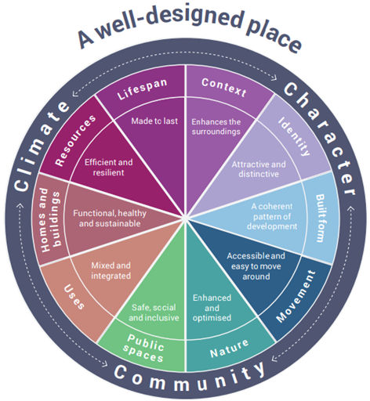

  - Phasing and programme

It is proposed that Homes England will act as master developer. Alongside the infrastructure delivery appointment Homes England will be appointing development partners who will be responsible for obtaining Reserved Matters approvals for their development parcel and satisfying relevant planning conditions/obligations in the S.106.

Homes England will retain the coordinating role in this process but there will be an expectation of cross team working where there is an overlap between infrastructure delivery and the wider development and the development of a collaborative phasing plan.

It is essential that infrastructure implementation and 3D earthwork modelling support the delivery of the wider development. To this end the programme must demonstrate the linkage and likely phasing between these elements and the delivery of the development parcels, and wider development in accordance with the planning conditions and Section 106 Agreement.

The Phasing Plan together with risk assessment will provide the platform for the management of the project as a whole.

Indicative phasing for development parcels

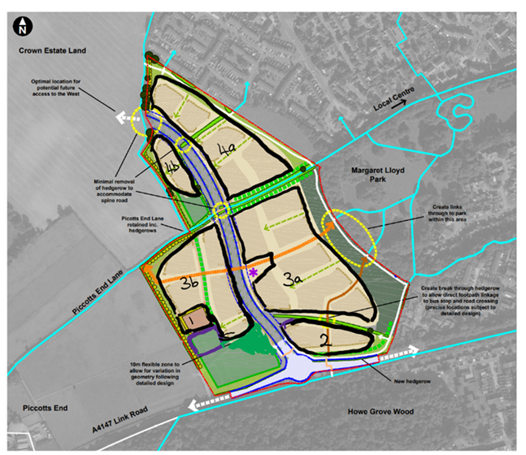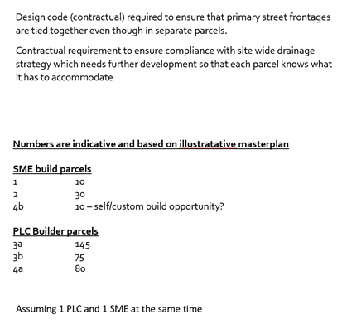

- Key Deliverables

The Key Deliverables each require a separate programme and resourcing schedule that demonstrate an understanding of the requirements of each and their fit within the context of the delivery of the overall project. They are:

1. Design the Spine Road and Access to the A4147 Link Road to serve Marchmont Farm and land to the north based upon the parameters established by the current outline application lodged with Dacorum Borough Council (19/02749/MOA) including footways, service media and landscaping to adoption standard.

o Design a Sustainable Urban Drainage System for the site including landscaping and habitat creation

o Undertake all necessary survey work to support design and delivery

o Secure all necessary consents and approvals.

o Provide an earthworks plan for the Access Spine Road and SUDS to minimise cost and visual impact and facilitate the delivery of homes

2. Design an upgraded pedestrian and cycle link along Piccotts End Lane

o Undertake all necessary survey work to support design and delivery

o Secure all necessary consents and approvals

3. Design a Gypsy and Traveller site at a location to be agreed including access road, street lighting, utilities, soft landscaping (hedge planting), hardstanding and utility building) for 5x pitches

o Undertake all necessary survey work to support design and delivery

o Secure all necessary consents and approvals

4. Design Emergency Access from site boundary to Laidon Square

o Undertake all necessary survey work to support design and delivery

o Secure all necessary consents and approvals

5. Produce a 3D earthworks model of the site to facilitate an Earthworks Strategy for the site to enable a balanced cut / fill across the site, to achieve the efficient grading of land, facilitate the delivery of homes and minimise cost and visual impact.

6. Produce contract documents, including works information, and support procurement of a contractor via competitive tender process for all works elements associated with items (1) to (4) above; and further provide NEC Project Manager and Supervisor services for duration of all works.

- Fees and Deliverables
Responses should ensure that each of the key deliverables are priced within the attached Resource and Pricing Schedule. A detailed programme and scope for the key deliverables will be agreed with the appointed consultant and on satisfactory completion of each stage the fee will be paid.
- Contract management and review points

Key milestones and delivery targets will be agreed at the inception stage with the appointment of the consultant and staged fee approvals will be made on the satisfactory completion of these milestones.

Review dates/break clauses will be incorporated into the appointment to ensure project requirements and client expectations are met. If required, these review points may be amended by Homes England.

At each review point, the appointed consultant will be required to demonstrate how they have delivered against project requirements in line with forecast spend and the milestones, and delivery targets that have been agreed with the successful consultant during inception.

- Other requirements and specific contractual terms (insurance, warranties etc.)
Warranties will be required for all reports provided by the selected professional services team in accordance with the Multi-Disciplinary Consultancy Framework documentation. These will be required to be assignable to Homes England and the preferred development partner and others (to cover other potential purchasers/funders/partners) so that they are able to rely on the information provided.

The liability limitation is as noted in the Multi-Disciplinary Consultancy Framework documentation. There will be no reduction in the liability cap due to the anticipated scale of this commission.

A Resource and Pricing Schedule will be required. An allowance for expenses should be included as part of the overall fee proposal. It is anticipated that fees will be paid monthly, up to the satisfactory completion of specific milestones/tasks/packages of work. The following gives an example of how this is anticipated to work - bidders are expected to break down each element including team members and fixed fees:

Milestone/ Work package | Duration | Outputs | Team member and time spent | Date of Completion | Fee and invoice date
Task | XX days | Report/ event | Names and days* | Date | £ amount and date

The Project Execution Plan must recognise that Homes England takes health, safety and inclusion seriously and expects Suppliers to do the same. All Suppliers must adhere to the Health and Safety obligations in the Framework Contract and the following Homes England policies where applicable:

- Homes England Safety, Health and Environment Policy
- Homes England Asbestos Policy
- Homes England CDM Policy

A process for knowledge and information management is needed. This will ensure that at the end of each milestone, key learning points and documents are collated, and a handover provided.

- Procurement Timetable
The procurement timetable that Homes England is working towards is set out below. Please note this has been updated from the Sifting Brief stage.
Stage | Timing
Sifting Brief Released | 11th May 2021
Sifting Brief Deadline | 21st May 2021, 17:00 hrs
Evaluation of Sifting Brief | w/c 24th May 2021
Notification of Sifting Brief Outcome | w/c 31st May 2021
ITT Issued to Selected Bidders | 8th June 2021
ITT Deadline | 22st June 2021, 17:00 hrs
Evaluation of Tenders | Commencing 22nd June 2021
Notification of Successful Bidders to be put forward to interview | By 29th June 2021
Interviews of Successful Bidders | w/c 5th July 2021
Notification of Preferred Bidder | By 12th July 2021
10 Day standstill period | 15th July 2021
Inception Briefing | w/ c 26th July 2021

- Instructions
Your response must be submitted via the e-tendering portal (ProContract).

All requests for further information in respect of this Stage 2 “Further Competition” must be sent using ProContract. No approach of any kind should be made to any other person within, or associated with, Homes England. Please do not contact Dacorum Borough Council, Hertfordshire County Council or any other stakeholders in relation to this tender.

Suppliers should specify in their clarification questions if they wish the clarification to be considered as confidential between themselves and Homes England. Homes England will consider any such request and will either respond on a confidential basis or give the Supplier the right to withdraw the clarification question. If the Supplier does not elect to withdraw the question and Homes England considers any clarification question to be of material significance, both the question and the response will be communicated, in a suitably anonymous form, to all prospective Suppliers who have responded.

All responses received and any communication from Suppliers will be treated in confidence but will be subject to the above.

Please note all communications during the tender period will be via the ProContract website. All bidders that have registered their interest for the Procurement will receive a direct email notification from ProContract on any updates via the suppliers registered email address. It is the Suppliers’ responsibility to check the ProContract website for any updates to the Procurement process. No claim on the grounds of lack of knowledge of the above-mentioned item will be entertained.

Please refer to ProContract for the ITT Deadline.

Please confirm if you have a conflict of interest with any other large sites in Hertfordshire.

- Evaluation criteria
Quality will account for 60% of the overall score. The following scoring methodology will apply:

5 – Excellent. Satisfies the requirement and demonstrates exceptional understanding and evidence in their ability/proposed methodology to deliver a solution for the required supplies/services. Response identifies factors that will offer potential added value, with evidence to support the response.
4 – Good. Satisfies the requirement with minor additional benefits. Above average. Demonstration by the Supplier of the understanding and evidence in their ability/proposed methodology to deliver a solution for the required supplies/services. Response identifies factors that will offer potential added value, with evidence to support the response.
3 – Acceptable. Satisfies the requirement. Demonstration by the Supplier of the understanding and evidence in their ability/ proposed methodology to deliver a solution for the required supplies/services.
2 - Minor Reservations. Some minor reservations of the Supplier’s understanding and proposed methodology, with limited evidence to support the response.
1 – Major Reservations/Non-compliant. Major reservations of the Supplier’s understanding and proposed methodology. Little or no evidence to support the response.
0 - Unacceptable/Non-compliant. Does not meet the requirement. Does not comply and/or insufficient information provided to demonstrate that the Supplier has the understanding or suitable methodology, with little or no evidence to support the response.

Please note if your response scores 0 0r 1 for any one question your overall submission will be deemed as a fail.

Number | Criteria | Demonstrated by | Weighting
1. | Proposal  Maximum of 10 sides of A4, font size 11. | - A Statement that outlines the method and approach for each of the required key deliverables. Explain how the commission will be undertaken, and by who to bring relevant experience.  - For each of the Key Deliverables provide a clear indication of capacity to undertake, innovate in the approach, add value and deliver good value for money.  - Explain how each Key Deliverable part of the commission will facilitate the delivery of a high-quality development, and deliverability to the market.  - Information on other Supplier input that may be required  - Identification of other information that may be required  - Demonstrate experience of a collaborative approach and close working relationships with multiple project consultants.  - Where appropriate identify the potential impact of external influences and stakeholders).  - Other commentary on the brief  - Supported by relevant examples where applicable  - Clear identification of exclusion/limitations not included within the bid. | 30%
2 | Proposed team  Maximum of 5 sides of A4, font size 11. | - Who will undertake the commission?  - Identify a clear project team structure chart and key accountabilities.  - Demonstrate the lead team member’s recent experience from similar projects.  - Give examples of lessons learned and evidence of collaborative working with stakeholders and third-party delivery partners to add value, ensure quality and mitigate risk.  - Explain how work packages will be coordinated through the project.  - Provide a Resource and Pricing Schedule for each key Deliverable (not included in the 5-side limit).  - Provide CVs for key members of staff (CV’s not included in the 5-side page limit). | 15%
3 | Project management arrangements  Maximum of 5 sides of A4, font size 11. | - Explain how the project initiation will be managed  - Summarise the approach you propose for project management to coordinate multiple workstreams and meet the project objectives to deliver at pace, achieve high quality design and ensure value for money.  - Explain how the client relationship and decision-making process will be managed across the project and how will the team adopt a collaborative approach to ensure effective decision taking and information sharing with multiple project consultants and prospective developers  - Outline the key project tools that you propose to use to effectively manage information, resources and actions within the project team and with external stakeholders.  - Support your answer with relevant examples where your team has added value to past projects that involved phased infrastructure delivery  - What monitoring arrangements will be put in place to ensure key milestones are met and value for money is achieved? | 10%
4 | Programme - key work packages, deliverables and timescales  Maximum of 5 sides of A4, font size 11. | - Provide a programme for the Key Deliverables that both responds to the current known milestones and key trigger points in the project and establishes a deliverable programme.  - Set out the key risks to the project to achieving this programme and how will these be managed.  - Identify opportunities to add value. | 5%

Price will account for 40% of the Overall Score. The lowest price will gain the maximum marks with other prices expressed as a proportion of the best score using the maths explained in the worked example.
Criteria | Demonstrated by | Weighting
Price | Completed Resource and Pricing Schedule | 40%

Worked Example
How your scoring will be used to give a weighted score
Bidder | Question | Score out of 5 | Weighting | Weighting Multiplier | Weighted Score | Total Weighted Score
Supplier A | 1 | 3 | 30% | 6 | 18 | 38
 | 2 | 4 | 15% | 3 | 12
 | 3 | 3 | 10% | 2 | 6
 | 4 | 2 | 5% | 1 | 2
Supplier B | 1 | 5 | 30% | 6 | 30 | 53
 | 2 | 4 | 15% | 3 | 12
 | 3 | 4 | 10% | 2 | 8
 | 4 | 3 | 5% | 1 | 3
Supplier C | 1 | 2 | 30% | 6 | 12 | n/a (fail)*
 | 2 | 1 | 15% | 3 | n/a
 | 3 | 2 | 10% | 2 | 4
 | 4 | 2 | 5% | 1 | 2
* in the example above Supplier C’s pricing will not be scored

Worked example of how price will be used to calculate a score

Bidder | Form of Tender price | Lowest price/Supplier’s price (as %) | Price Score (out of 40)
Supplier A | 350 | 350/350 = 100% | 100%*40 =40
Supplier B | 700 | 350/700 = 50% | 50%*40 = 20
Supplier C | 250 | n/a | n/a

Worked example of overall score and ranking

Bidder | Total Quality Score | Price Score | Total Score | Ranked Position
Supplier A | 38 | 40 | 78 | 1
Supplier B | 53 | 20 | 73 | 2
Supplier C | n/a | n/a | n/a | n/a

- Response form

To enable Homes England to evaluate your tender, we require Suppliers to respond to the questions below while referring to the evaluation section. Please refer to the evaluation section for page limits for each question (including illustrations). Any text beyond this will be ignored and will not be evaluated. (Minimum font size 11)
1. Proposal
2. Proposed team
3. Project management arrangements
4 Programme - key work packages, deliverables and timescales

Submission
ITT Deadline: 17:00 hrs on 22nd June 2021
All clarification questions relating to this tender must all be requested directly through ProContract.

Appendix A. Draft Planning Conditions for Outline Application 19/02749/MOA

Condition(s) and Reason(s):
1. Details of the appearance, landscaping, layout and scale (hereinafter called "the reserved matters") shall be submitted to and approved in writing by the local planning authority before any development takes place and the development shall be carried out as approved. Application for approval of the reserved matters shall be made to the local planning authority not later than 3 years from the date of this permission.
Reason: To comply with the provisions of Section 92 (2) of the Town and Country Planning Act 1990.
2. Application for approval of the reserved matters shall be made to the local planning authority before the expiration of three years from the date of this permission.
Reason: To comply with the provisions of Section 92 (2) of the Town and Country Planning Act 1990
3. The development hereby permitted shall be begun either before the expiration of three years from the date of this permission, or before the expiration of two years from the date of the approval of the last of the reserved matters to be approved, whichever is the later.
Reason: To prevent the accumulation of planning permission; to enable the Council to review the suitability of the development in the light of altered Circumstances and to comply with the provisions of Section 92 (2) of the Town And Country Planning Act 1990.
4. Details to be submitted for the approval of the local planning authority in accordance with Condition (1) above shall include the details of the following listed below for a maximum of 350 dwellings. The details shall be submitted for each relevant Phase based upon Phases 1, 2 and 3 of the Design & Access Figure 5.1 Indicative Phasing Plan or for a combination of Phases 1, 2 and 3, unless otherwise stated for ‘the whole’ development’ (or in accordance with another condition of this planning permission) with Phase 1 commencing first, followed by Phases 2 and 3 respectively:
- the layout based upon the details shown by the Illustrative Master Plan 39337-Lea84f and the relevant Development Principles of the Local Allocation LA1 Marchmont Farm Hemel Hempstead Master Plan July 2017;
- the existing and proposed finished levels, relevant cross and longitudinal sections and contours including buildings, gardens/ amenity areas, roads, parking areas, open space;
- the earthworks including geotechnical details /including land stability;
- full engineering/ geotechnical details of the whole spine road including footpaths, cycle way(s),verges, lighting, levels, sight lines, hard and soft landscaping, biodiversity measures and drainage;
- the emergency access linked to Laidon Square for the whole development including the details of the highway specification and how the surface water drainage is to be intercepted and disposed of separately and measures restricting its non-emergency access use;
- the full engineering/ geotechnical details of the non-spine road parts of the road layout including footpaths, cycle ways, verges, lighting, levels, hard and soft landscaping, biodiversity measures and drainage, including swept path assessment for fire tenders, other service/ delivery vehicles and buses, turning and any loading areas;
- the parking including electric charging points and secure cycle storage fully in accordance with Dacorum adopted Parking Standards (Nov 2020);
- the refuse facilities fully in accordance with Dacorum Borough Refuse Storage Guidance Note ( 2015);
- the drainage for all parking areas;
- all access arrangements including those for people with disabilities for the highways, dwellings, parking and open spaces;
- the design/ appearance/ materials, layout of all buildings and heights of buildings, most of which shall be no higher than two storeys with some 2 ½ storeys to 3 storeys as landmark buildings;
- the details of the Gypsy and Travellers Site including the precise location, size, access, access for persons with disabilities, servicing for fire and refuse vehicle turning , design, utilities buildings, the position of the 5 pitches, soft and hard landscaping/ boundary treatment, noise mitigation measures, on site connected utilities (gas, electricity, drainage, digital communications), amenity areas and storage areas;
- the sustainable urban drainage system including and a maintenance and adoption management scheme to confirm that the SuDS features can be maintained for the lifetime of the development subject to Condition 15;
- the foul drainage system and all other surface water drainage not subject to other conditions;
- the hard surfacing ;
- the means of enclosure ( walls, fences and hedges);
- the landscape planting plan including tree protection measures, any tree/hedgerow retention and removal of any trees /hedgerows, the planting of at least one tree per dwelling and a community orchard;
- a long term landscape and ecological / biodiversity management plan;
- a construction environmental management/ biodiversity plan with reference to on site species protection;
- the precise plans showing the details/ areas/ locations and designs of all the open spaces and associated drainage/ SuDS measures with full engineering details, associated soft and hard landscaping and ecological management measures;
- the play equipment for the approved open spaces;
- the noise mitigation measures;
- the ventilation measures to prevent the overheating of dwellings;
- the secured by design measures;
- the exterior lighting for all non-highway/ parking areas of the development parts of the development including the bus shelter/ bus stop;
- the full details of sustainable design and construction/ climate change in accordance with Policy CS29 of the Dacorum Core Strategy (2013), Hertfordshire Building Futures Design Guide, including modern methods of construction, the provision of a district and a low/ zero carbon heat infrastructure- district heating network;
- digital communications for all dwellings, and
- any other proposed and existing functional services above and below ground.

All the submitted details shall be in the form of scaled plans and/or written specifications. All the approved details shall be provided before the first occupation of any dwellings for the specified Phase hereby permitted unless otherwise in accordance with another condition (s) of this decision or agreed in writing by the local planning authority. This includes all highway / parking areas to be demarcated, levelled, surfaced and drained in accordance with the approved plans before for any use of the specified Phase. Once provided all the approved requirements shall be retained and maintained fully in accordance with the approved details.
Reason: To deliver a sustainable development in accordance with the National Planning Policy Framework’s, Dacorum Core Strategy’s (2013) saved Dacorum Borough Local Plan’s (2004), Site Allocation Development Planning Document’s and the Local Allocation LA1 Marchmont Farm Master Plan’s (2017) approach to sustainable development.
5. The emergency access shown by Plan No. 39337- Lea99b subject to Condition 4 shall be provided before the first occupation of the 300th dwelling at the site. Thereafter the approved scheme shall be retained and maintained at all times.
Reason: In the interests of public safety in accordance with/ with reference to Policies CS 8, CS12 of Dacorum Core Strategy (2013), saved Polices 51 and 54 of Dacorum Local Plan (2004), Local Allocation LA1 Marchmont Farm Master Plan’s (2017), The Grovehill Future Neighbourhood Plan (2018) ,the Local Transport Plan and the National Planning Policy Framework Part 9, in conjunction with the specialist advice of Hertfordshire County Council Highways (in liaison with Hertfordshire Fire & Rescue Service).
6. Notwithstanding the details shown by Plan No. 39337-Lea94 this planning permission does not include the emergency access shown from the Link Road.
Reason: The emergency access from the site to Laidon Square is the emergency access hereby approved as referred to by Condition 5. The Link Road access shown by the submitted plans is considered unsafe and shall not be used for emergency access purposes, in accordance with reference to Policies CS 8, CS12 of Dacorum Core Strategy (2013), saved Policies 51 and 54 of Dacorum Local Plan (2004), Local Allocation LA1 Marchmont Farm Master Plan’s (2017), The Grovehill Future Neighbourhood Plan (2018) the Local Transport Plan and the National Planning Policy Framework Part 9.
7. This planning permission is based upon the carrying out of Phase 1 (The Gateway as referred to by Figure 5.1 of the Design & Access Statement) being commenced first and no dwelling hereby permitted shall be occupied until the footpath links with Marlborough Rise and the bus lay by/ bus stop and shelter have been provided fully in accordance with details submitted to and approved in writing by the local planning authority based upon the footpath network shown by the Illustrative Master Plan39337-Lea84f. Thereafter the Marlborough Rise link and bus facility shall be retained at all times.
Reason: To deliver a sustainable development in accordance with Policies CS 8, CS12 and Local Allocation ( Hemel Place Strategy) p153) of Dacorum Core Strategy (2013),saved Polcies 51 and 54 and 79 of Dacorum Local Plan ( 2004) , Local Allocation LA1 Marchmont Farm Master Plan’s (2017), The Grovehill Future Neighbourhood Plan (2018) the Local Transport Plan and the National Planning Policy Framework Part 9.
Informative: These footpath links are expected to include the new lit footpath green shown by the Plan sent by the Local Planning Authority on 15 April 2021.

8. A programme/ timetable and schedule of works for the installation of new and the upgrading of all other footpath and cycle links serving the development hereby shall be submitted prior to the commencement of the roundabout access and the spine road. The development shall be constructed fully in accordance with the approved details and once installed shall be retained at all times.
Reason: To deliver a sustainable development in accordance with Policies CS 8, CS12 of Dacorum Core Strategy (2013),saved Policies 51 and 54 and 79 of Dacorum Local Plan (2004), Local Allocation LA1 Marchmont Farm Master Plan’s (2017), The Grovehill Future Neighbourhood Plan (2018) the Local Transport Plan and the National Planning Policy Framework Part 9.
9. The Gypsy and Travellers Site with all its services in accordance with the full requirements specified in Condition 4 shall be provided within Phase 1 of the development in accordance with the details submitted to and approved in writing by the local planning authority. The site shall be fully available no later than occupation of the 99th dwelling or 8 months from receipt of all required approvals to enable the construction of the Gypsy and Travellers’ Site, unless otherwise agreed in writing with DBC, whichever is the later and the site shall be retained at all times for the approved purposes.
Reason: In accordance with Policy CS22, Site Allocations Development Plan Document Policy LA1 and The Master Plan and Paragraph 61 of the National Planning Policy Framework.
10. Within 6 months prior to the first occupation of Phase 1, a detailed Travel Plan shall be submitted to the local planning authority. The development hereby permitted shall be carried out fully in accordance with the Travel Plan which shall be updated for each Phase, be based upon the Hertfordshire Council document 'Hertfordshire's Travel Plan Guidance' provide contact details of an appointed Travel Plan Coordinator.
Reason: To deliver a sustainable development/ to ensure that sustainable travel options associated with the development are promoted and maximised in accordance with Policies CS 8, CS12 of Dacorum Core Strategy (2013), saved Policies 51 and 54 and 79 of Dacorum Local Plan (2004), Local Allocation LA1 Marchmont Farm Master Plan’s (2017), The Grovehill Future Neighbourhood Plan (2018) the Local Transport Plan (2018) and the National Planning Policy Framework Part 9.
11. The landscape and ecological management plan subject to Condition 4 shall include the following.
- Description and evaluation of features to be managed.
- Ecological trends and constraints on site that might influence management.
- Aims and objectives of management.
- Appropriate management options for achieving aims and objectives.
- Prescriptions for management actions.
- Prescription of a work schedule (including an annual work plan capable of being rolled forward over a five-year period).
- Details of the body or organisation responsible for implementation of the plan.
- Ongoing monitoring and remedial measures.

The Plan shall also include details of the legal and funding mechanism(s) by which the long-term implementation of the plan will be secured by the developer with the management body(ies) responsible for its delivery. The plan shall also set out (where the results from monitoring show that conservation aims and objectives of the Plan are not being met) contingencies and/or remedial action to be identified, agreed and implemented so that the development will deliver the fully functioning biodiversity objectives of the originally approved scheme. The approved plan will be implemented in accordance with the approved details.
Reason: In the interests of the landscape and biodiversity in accordance with Policies CS12,CS25, CS26 and CS29 of Decorum Core Strategy (2013), Local Allocation LA1 Marchmont Farm Master Plan (2017), The Grovehill Future Neighbourhood Plan (2018) and the National Planning Policy Framework Part 15.
12. No development shall commence (including ground works, vegetation clearance) until a construction environmental management plan subject to Condition 4 has been submitted to and approved in writing by the local planning authority. The Plan shall include the following:
- Risk assessment of potentially damaging construction activities.
- An updated ecological survey identifying the presence of protected species and measures to mitigate against any harm.
- Identification of any “biodiversity protection zones”.
- Practical measures (both physical measures and sensitive working practices) to avoid or reduce impacts during construction (may be provided as a set of method statements).
- The location and timings of sensitive works to avoid harm to biodiversity features.
- The times during which construction when specialist ecologists need to be present on site to oversee works.
- Responsible persons and lines of communication.
- The role and responsibilities on site of an ecological clerk of works or similarly competent person.
- Use of protective fences, exclusion barriers and warning signs.

The approved Plan shall be carried out for the whole construction period strictly in accordance with the approved details.
Reason: In the interests of biodiversity in accordance with Policies CS12, CS26 and CS29 of Dacorum Core Strategy (2013), Local Allocation LA1 Marchmont Farm Master Plan (2017), The Grovehill Future Neighbourhood Plan (2018) and the National Planning Policy Framework Part 15.
13.The landscape management plan subject to Condition 4 shall include long term design objectives, management responsibilities and maintenance schedules for all landscape areas, other than small, privately owned domestic gardens, these shall be submitted to and approved by the local planning authority prior to the first occupation of a the first dwelling at the site. The landscape management plan shall be carried out as approved.
Reason: In the interests of the landscape environment and biodiversity in accordance with Policies CS12, CS25, CS26 and CS29 of Dacorum Core Strategy (2013), Local Allocation LA1 Marchmont Farm Master Plan (2017), The Grovehill Future Neighbourhood Plan (2018) and the National Planning Policy Framework Part 15.
14. If within a period of five years from the date of the planting of any tree or hedge that tree, part of the hedge or any tree or part of the hedge planted in replacement for it, is removed, uprooted or destroyed or dies (or becomes, in the opinion of the local planning authority, seriously damaged or defective), another tree or hedge of the same species and size as that originally planted shall be planted at the same place in the next planting season, unless the local planning authority gives its written consent to any variation.
Reason: : In the interests of the landscape environment and biodiversity in accordance with Policies CS12, CS25, CS26 and CS29 of Dacorum Core Strategy (2013), Local Allocation LA1 Marchmont Farm Master Plan (2017), The Grovehill Future Neighbourhood Plan (2018) and the National Planning Policy Framework Part 15.
15.The development permitted by this planning permission shall be carried out in accordance with the approved Flood Risk Assessment and Outline Drainage Strategy carried out by Wood reference 39337rr004_i4 Rev 3 dated January 2019 and the Technical Addendum, prepared by Wood, dated September 2019, and the following mitigation measures detailed within the FRA:
(1) Undertaking appropriate drainage strategy based on attenuation and discharge into Thames Water surface water sewer restricted to a maximum of 10.4l/s for all rainfall events up to and including the 1 in 100 year + climate change event.
(2) Providing attenuation to ensure no increase in surface water run-off volumes for all rainfall events up to and including the 1 in 100 year + climate change event. 3. Implementing drainage strategy as indicated on drainage drawing to include above ground features such as attenuation basins and swales. The mitigation measures shall be fully implemented prior to full site occupation and in accordance with the timing / phasing arrangements embodied within the scheme, or within any other period as may subsequently be agreed, in writing, by the local planning authority.
Reason : To prevent flooding by ensuring the satisfactory storage of/disposal of surface water from the site in accordance with Policies CS29 and CS31 of Dacorum Core Strategy (2013), Local Allocation LA1 Marchmont Farm Master Plan (2017) and the National Planning Policy Framework Part 15.
16. No development shall take place until the final design of the drainage scheme is completed and sent to the LPA for approval. The surface water drainage system will be based on the submitted Flood Risk Assessment and Outline Drainage Strategy carried out by Wood reference 39337rr004_i4 Rev 3 dated January 2019 and the Technical Addendum, prepared by Wood, dated September 2019. The scheme shall also include:
(1) Calculations to demonstrate how the system operates during a 1 in 100 year critical duration storm event including drain down times for all storage features.
(2) Full detailed engineering drawings including cross and long sections, location, size, volume, depth and any inlet and outlet features. This should be supported by a clearly labelled drainage layout plan showing pipe networks. The plan should show any pipe 'node numbers' that have been referred to in network calculations and it should also show invert and cover levels of manholes.
(3) Demonstrate appropriate management of the surface water flowpaths on site.
(4) Demonstrate an appropriate SuDS management and treatment train and inclusion of above ground features.
(5) Details regarding any areas of informal flooding (events those exceeding 1 in 30 year rainfall event), this should be shown on a plan with estimated extents and depths.
(6) Details of final exceedance routes, including those for an event which exceeds to 1:100 + cc rainfall event.
Reason To prevent flooding by ensuring the satisfactory storage of/disposal of surface water from the site in accordance with Policies CS29 and CS31 of Dacorum Core Strategy (2013), Local Allocation LA1 Marchmont Farm Master Plan (2017) and the National Planning Policy Framework Part 15.
17. Upon completion of the drainage works a management and maintenance plan for the SuDS features and drainage network must be submitted to and approved in writing by the Local Planning Authority. The scheme shall also include: The management and maintenance plan shall include:
(1) Provision of a complete set of as built drawings including the final drainage layout for the site drainage network.
(2) Maintenance and operational activities for the lifetime of the development. 3. Arrangements for adoption and any other measures to secure the operation of the scheme throughout its lifetime.
Reason : To reduce the risk of flooding to the proposed development and future occupants and to prevent flooding by ensuring the satisfactory maintenance of the surface water network on the site in accordance with Policies CS29 and CS31 of Dacorum Core Strategy (2013), Local Allocation LA1 Marchmont Farm Master Plan (2017) and the National Planning Policy Framework Part 15.
18. No development, shall take place until a Phase I Report to assess the actual or potential contamination at the site has been submitted to and approved in writing by the Local Planning Authority. If actual or potential contamination and/or ground gas risks are identified, further investigation shall be carried out and a Phase II report shall be submitted to and approved in writing by the Local Planning Authority prior to the commencement of the development. If the Phase II report establishes that remediation or protection measures are necessary, a Remediation Statement shall be submitted to and approved in writing by the Local Planning Authority.
For the purposes of this condition:
(i) A Phase I Report consists of a desk study, site walkover, conceptual model and a preliminary risk assessment. The desk study comprises a search of available information and historical maps which can be used to identify the likelihood of contamination. A simple walkover survey of the site is conducted to identify pollution linkages not obvious from desk studies. Using the information gathered, a 'conceptual model' of the site is constructed and a preliminary risk assessment is carried out.

(ii) A Phase II Report consists of an intrusive site investigation and risk assessment. The report should make recommendations for further investigation and assessment where required.
(iii) A Remediation Statement details actions to be carried out and timescales so that contamination no longer presents a risk to site users, property, the environment or ecological systems.
Reason: To ensure that risks from land contamination to the future users of the land and neighbouring land are minimised, together with those to controlled waters, property and ecological systems, and to ensure that the development can be carried out safely without unacceptable risks to workers, neighbours and other off-site receptors in accordance with Policy CS32 of the Dacorum Borough Core Strategy (2013) and Paragraphs 178 and 180 of the National Planning Policy Framework (2019).
19. All remediation or protection measures identified in the Remediation Statement referred to in Condition 8 above shall be fully implemented within the timescales and by the deadlines as set out in the Remediation Statement and a Site Completion Report shall be submitted to and approved in writing by the Local Planning Authority prior to the first occupation of any part of the development hereby permitted.
For the purposes of this condition: a Site Completion Report shall record all the investigation and remedial or protection actions carried out. It shall detail all conclusions and actions taken at each stage of the works including validation work. It shall contain quality assurance and validation results providing evidence that the site has been remediated to a standard suitable for the approved use.
Reason: To ensure that risks from land contamination to the future users of the land and neighbouring land are minimised, together with those to controlled waters, property and ecological systems, and to ensure that the development can be carried out safely without unacceptable risks to workers, neighbours and other off-site receptors in accordance with Policy CS32 of the Dacorum Borough Core Strategy (2013) and Paragraphs 178 and 180 of the National Planning Policy Framework (2019).
20. The development hereby permitted shall not commence until a Construction Traffic Management Plan has been submitted to and approved in writing by the Local Planning Authority in consultation with the Highway Authority. Thereafter, the construction of the development shall only be carried out in accordance with the approved Plan. The Construction Traffic Management Plan shall include details of:a. Construction vehicle numbers, type, routing;
b. Traffic management requirements;
c. Construction and storage compounds (including areas designated for car parking);
d. Siting and details of wheel washing facilities;
e. Cleaning of site entrances, site tracks and the adjacent public highway;
f. Provision of sufficient on-site parking prior to commencement of construction activities;
g. Post construction restoration/reinstatement of the working areas and temporary access to the public highway.
Reason: In order to protect highway safety and the amenity of other users of the public highway and rights of way in accordance with Policies CS 8, CS12 and CS32 of Dacorum Core Strategy (2013), saved Polices 51 and 54 and 79 of Dacorum Local Plan (2004), Local Allocation LA1 Marchmont Farm Master Plan’s (2017), The Grovehill Future Neighbourhood Plan (2018) the Local Transport Plan and the National Planning Policy Framework Part 9.
21.Notwithstanding the provisions of the Town and Country Planning (General Permitted Development) Order 2015 (as amended) (or any Order revoking or re-enacting that Order with or without modification) the garage(s) hereby permitted shall be kept available at all times for the parking of vehicles associated with the residential occupation of the dwelling(s) and they shall not be converted or adapted to form living accommodation without the express permission of the local planning authority following the submission of a planning application.
Reason: In order to ensure a satisfactory level of off-street parking and to protect highway safety and the amenity of other users of the public highway, in accordance with saved Policies 51 and 54 of the Decorum Borough Local Plan (2004), Policy CS8 of the Decorum Borough Core Strategy (2013), Paragraphs 108 and 110 of the National Planning Policy Framework (2019) and the Decorum Borough Parking Standards Supplementary Parking Document (2020).
22. Notwithstanding the provisions of the Town and Country Planning (General Permitted Development) Order 2015 (as amended) (or any Order amending or re-enacting that Order with or without modification) no development falling within the following classes of the Order shall be carried out without the prior written approval of the Local Planning Authority for Phases 1 and 2 referred to by the submitted Design & Access Statement:
Part 1, Schedule 2 Classes A, B, C, E and AA (where for Class E within rear gardens less than 11.5 m in depth and where the garden has a change in levels).
Reason: To enable the Local Planning Authority to retain control over the development in the interests of safeguarding the residential and visual amenity of the locality in accordance with Policy CS12 of the Dacorum Borough Core Strategy (2013) and Paragraph 127 of the National Planning Policy Framework (2019).
23. Subject to the requirements of the other conditions of this planning permission the development hereby permitted shall be otherwise carried out fully in accordance the following plans:
39337Lea82b-Site location plan
Site Access Roundabout
131121/A/49 Revision A (Appendix F of the Transport Statement)
39337-Lea99b Emergency Access Plan from Laidon Square
39337-Lea84f
Reason: For the avoidance of doubt.

Appendix B. Draft S106 Heads of Terms

LA1 Draft Heads of Terms

Affordable Housing

1. 40% to be affordable.

2. 75% of the affordable homes to be rented and 25% shared ownership or other forms of intermediate housing.

3. Each phase ( based upon the Design & Access Statement Figure ) to have 40% affordable 75% of the affordable homes to be rented and 25% shared ownership or other forms of intermediate housing.

4. Each phase to have a mix of dwelling sizes.

5. The affordable housing to be indistinguishable from the market housing in terms of design and to be dispersed across each phase.

On Site Open Space/ Sustainable Urban Drainage System

1. To be provided in accordance with the Fields in Trust Beyond the Six Acre Standards and a detailed plan showing the precise area based upon the submitted Design & Access Statement.

2.The provision of the Open Space at Margaret Lloyd Park Extension and LEAP ready to use before the occupation of any dwelling in Phase 1 fully in accordance with an agreed Open Space Condition Statement before the transfer to the Council and not to use any part of the Extension for works traffic or construction compounds.

3. The provision of all other area Open Space/’standard SUDS areas including any play equipment ready to use fully in accordance with an agreed Open Space Condition Statement before the transfer to the Council and not to use any part for works traffic or construction.

4. Agreement of any Open Space Areas which require additional maintenance costs commuted payments in additional to standard CIL payments. This will be for any area where there will be identified ongoing ‘ nonstandard’ maintenance costs requiring specialist engineering for SUDS with an inbuilt indemnity clause(s). The expected required additional programme of engineering works will be specified over a period of 25 years prepared by a specialist.

5. In the event that 4 is not agreed any such area of Open Space shall be transferred to a Management Company/ Organisation ( and any successor) based upon the agreement of that Company/Organisation to maintain the Open Space in perpetuity in accordance with a monthly management plan. The plan shall be submitted to and agreed with the Council before the Open Space is transferred to the Management Company/ Organisation.

6. Please Note : All Open Space Areas which are transferred to the Council based upon the are through the CIL Regulations payments for the provision and maintenance of public open space, Local Area of Play (LAP), Local Equipped Areas of Play (LEAP) of Play(NEAP) on Strategic and Local Allocations for Green Infrastructure and Open Space Including outdoor sports pitches.

Off Site Footpath Improvements in Margaret Lloyd Park

The carrying out of these during the construction of Phase 1 of the development by the Developer under the supervision of the Council fully in accordance with a scheme submitted to and approved in writing by the Council. The approved scheme shall show the precise location of the footpaths and a full schedule of works, including all ecological and arboricultural impacts and programme. The footpaths shall include a link to the extended Margaret Lloyd Park.

A commuted payment shall be agreed for the regular maintenance of the footpaths.

This is based upon the details referred to by the attached plan showing:

Woodland Walk Way: Part upgrade/part new. Yellow.

Unlit Upgraded : Existing walkway. Black.

New Footpath Path. Unlit. Blue.

Informal link between Margaret Lloyd Park and the Park Extension: Mauve.

Off Site Footpath Works

A lit link footpath cycleway between the site and Henry Wells Square involving the footpath upgrading and lighting by the Developer fully in accordance with details agreed with Hertfordshire County Council Highways fully in accordance with a programme/ timetable and no later than the first occupation of Phase 1.

This shall be provided at the same time as the following shown by the attached plan for the on site work

New Footpath: Unlit. Blue.

New Footpath: New Footpath Lit. Green.

Junction of Marlborough Rise and footpaths to be upgraded.

Biodiversity Net Gain off Site Contribution at Howe Grove Wood Local Nature Reserve (shown by a Plan)
For £43,000 to be paid following the occupation of the first dwelling and to be subject to agreed Ecological Biodiversity Management Plan which shall be carried out in accordance with a submitted and agreed Biodiversity Enhancement Management Plan excluding access improvements. The Plan will include the Aims and Objectives and a structured Work Schedule/ Programme for Each Year including educational benefits.

Gypsy & Traveller Site for 5 Pitches in Perpetuity

To be provided at all times and during the early part of the development.

Please note: The associated recommended conditions are:

9. The Gypsy and Travellers Site with all its services in accordance with the full requirements specified in Condition 4 shall be provided within Phase 1 of the development in accordance with the details submitted to and approved in writing by the local planning authority. The site shall be fully available no later than occupation of the 99th dwelling or 8 months from receipt of all required approvals to enable the construction of the Gypsy and Travellers’ Site, unless otherwise agreed in writing with DBC, whichever is the later and the site shall be retained at all times for the approved purposes.
Reason: In accordance with Policy CS22, Site Allocations Development Plan Document Policy LA1 and The Master Plan and Paragraph 61 of the National Planning Policy Framework.

Part of 4 - details of the Gypsy and Travellers Site including the precise location, size, access, access for persons with disabilities, serving, design, the position of the 5 pitches, soft and hard landscaping/ boundary treatment, noise mitigation measures, on site connected utilities (gas, electrify, drainage, digital communications), amenity areas, and storage areas;

Off Site Junction Improvements

These are for the following carried out by the Developer before the first use of the Spine Road/ Main Street and the occupation of any dwelling and the Gypsy and Travellers Site fully in accordance with the requirements of Hertfordshire County Council Highways.
- Link Road/Leighton Buzzard Road/Galley Hill A4146,
- Aycliffe Drive/Link Road/Cambrian Way, and
- St Agnells Lane/Redbourn Road/Link Road A4147.

These shall be in conjunction with the carrying out of the construction of the roundabout junction and pedestrian crossing which shall be installed fully in accordance with the requirements of Hertfordshire County Council Highways before the first use of the Spine Road/ Main Street and the occupation of any dwelling and the Gypsy and Travellers Site

Travel Plan
A financial contribution £6,000.
Note: This is in conjunction with the recommended Condition 11:
11. Within 6 months prior to the first occupation of Phase 1, a detailed Travel Plan shall be submitted to the local planning authority. The development hereby permitted shall be carried out fully in accordance with the Travel Plan which shall be updated for each Phase, be based upon the Hertfordshire Council document 'Hertfordshire's Travel Plan Guidance' provide contact details of an appointed Travel Plan Coordinator.

Public Transport

Bus Diversion.
A financial contribution of 170,000 per year for three years / £480,000.
A contribution towards the provision of new bus stop to the east of the site access equating to a contribution of £10,000 as well as upgrading of the existing bus stop in Washington Avenue to provide easy access kerbing for a fee of £8,000. HCC would seek delivery of the improvements via a Section 278 Agreement with a bond for the associated amount for the works via the Section 106 Agreement, should the delivery via Section 278 not be possible/come forward.

HCC Highways is considering the £30,000 per annum value for revenue – possibly approaching this with a more flexible arrangement.
Please Note:
7.This decision is based upon the carrying out of Phase 1 (The Gateway as referred to by the Design & Access Statement) being started first and no dwelling hereby permitted shall be occupied until the footpath links with Marlborough Rise and the bus lay by, bus stop and shelter have been provided fully in accordance with details submitted to and approved in writing by the local planning authority based upon the footpath network shown by the Illustrative Master Plan39337-Lea84f . Thereafter the Marlborough Rise link and bus facility shall be retained at all times.
Please Note:
1. These are Index linked figures.

2. According to the Council’s 123 List the Council considers that in most cases the preferred route for securing infrastructure improvements associated with large sites, particularly the development of Strategic and Local Allocations, will be through the use of S.106 agreements. Where such S.106 agreements would exceed the CIL Liability of the site it may be possible to gain relief from CIL through use of the Exceptional Circumstances Relief policy.

Appendix C. Detailed Technical Design – Scope of Works

Overarching – the highway and technical designs need to be fully coordinated, achieve all relevant technical approvals and form the basis of works information for the procurement of contractor(s) to deliver the identified works.
Detailed designs, specifications and workstreams
This will include the following as a minimum:
- Gap analysis and advise on any further information / survey needed to achieve project objectives and deliverables.
- Develop a Civil 3D model and establish BIM level 2 procedures and processes.
- Develop an 3D Ground model to enable:
  - Global site earthworks strategy
  - Identifying site preparation and groundwork details
  - Balanced site cut and fill etc.
  - Phased approach to enable delivery of infrastructure works
- Strategic Construction Environmental Management Plan, considering:
  - Site access
  - Construction haul road
  - Site clearance
  - Temporary works
  - Environmental impacts and mitigation
- Highway (inc. any separate non-motorised user routes) design should include:
  - Typology, layout and levels.
  - Geometric design (horizontal and vertical alignment) of highways with tie-in to existing roads, connections and new access arrangement to future development parcels.
  - Road drainage layout and detailed design.
  - Utilities / services layout (ensuring all potential clash points are identified and managed).
  - Street lighting, road marking & crossing layouts Street trees and other Lighting Road restraint systems
  - Street furniture layouts and details
  - Clash detection and potential conflicts (including visibility splays etc.) relative to all utilities, services, drainage, street furniture and street trees/landscaping are identified and managed.
  - Construction details
  - Structures detailed design (if and where needed) relative to bridge(s), culverts, retaining walls etc.
- Ground improvement details where applicable.
- Drainage, to include
  - Highway drainage including SuDS: swales, scrapes and SUD’s channel planting plans, surface water ponds and attenuation basins.
  - Site wide strategic SuDS.
- Landscaping and ecology, to include:
  - Hard landscaping layout incorporating construction details / finishes.
  - Soft landscaping layouts and planting plans and schedules.
  - Tree and Hedgerow protection/translocation measures.
- Fully co-ordinated setting out of all aspects of the design.
- Construction details of all aspects of the design.

Production Information
All drawings to include as a minimum:

- Unique drawing number with suitable revision annotation plus historical dated revision description to allow detail of drawing revision to be captured (i.e. should not just say “Drawing Updated”). Revisions to be clouded on drawing with revision prefix adjacent.
- Include a clear and concise drawing title with “Drawn by” and “Reviewed By” spaces to allow tracking
- Clearly noted drawing size with usable scale and/or scale bar plus North arrow.
- Annotation, dimensions, line types and hatching to be neatly set out and readable when printed to scale in hard copy.
- Provide design information in hard copy (if requested) and electronic format.
- Electronic drawings to be produced as scalable PDF’s and DWF’s (as required). File names to include full unique drawing number, revision and drawing description. Drawings to be uploaded to a file sharing system made available, by the Principal Designer, for this commission.

Infrastructure Works Tender and Award
This will include the following as a minimum:

- Preparing al project Tender documentation. This will include all Contract Documentation, specification, drawings, Risk Assessments and Method Statements, Health and Safety Plan, Site Waste Management Plan etc. Any other documentation necessary for Tender purposes to be highlighted, referenced and completed.
- Administering and carrying out Tender exercise using Pro-Contract (Homes England e-tendering portal), including setting up of project, answering any contractual queries, updating bidders on decisions and completion/closure of procurement exercise. Guidance on the use of Pro-Contract is available from Homes England procurement team.
- Coordination, vetting and appraisal of returned Tenders and completion of Tender report(s) for recommendation of successful Contractor(s).
- Assisting Homes England Financial Appraisal Team with financial verification checking of preferred Contractor(s) post tender and ahead of Contract Award.
- Assisting Homes England Project Manager with internal approval procedures and writing of papers, including Approval to Tender and Approval to Appoint a Contractor.
- Liaison with Homes England appointed Solicitor pre and post tender award to carry out legal contract checks and ensure the works are procured and managed effectively.

Contract Management
This will include the following as a minimum:

- Provide Project Management and Contract Administration in accordance with NEC3/4 EEC Contract (Option A or C).
- Project Management and Supervision of works through to completion. This will extend to include the defects correction period (normally 12 months) if required by the works.
- Monitor and ensure compliance with contractual programme, cost and specification to achieve key milestones and project critical deliverables.
- Obtain a detailed construction phase programme from the Contractor and periodical revisions to the construction phase programme as the Project progresses. Monitor the construction phase programme against actual progress and inform the Client as to progress.
- Raising any risks, issues or additional work requirements with Homes England Project Manager at the earliest opportunity.
- Manage and coordination with CDM Principal Designer, to ensure effective delivery of the project.
- Assessment and verification of Contractor interim payment certificates and certifying payments, including final account and payment of interim and final retention.
- Develop and maintain the Project cost plan and the Project cash flow forecast for the duration of the Project.
- Facilitate, set up and manage value engineering exercises where appropriate.
- Facilitate, set up and manage early warning and risk reduction meetings.
- Advise on the cost of variations to the works prior to the issue of instructions under the Building Contract.
- Agree the cost of instructions, excluding loss and expense claims, issued under the Building Contract.
- Advise on the rights and obligations of the parties to the Building Contract.
- Prepare recommendations for interim payments to the Contractor and the release of retention funds.
- Advise the Client in regard to payment notices, payless notices and other similar notices of default.
- Prepare for issue payment notices, pay less notices and other similar notices of default.
- Prepare the final account or similar financial statement. Facilitate agreement to the final account or similar financial statement from the parties to the Building Contract.
- Where relevant, prepare recommendations for the payment of liquidated damages by the Contractor

Contract Completion
This will include the following as a minimum:

- Final sign off of site works and Issue of completion certification, in accordance with the chosen Form of Contract.
- Liaison with Homes England Estates Team for snagging, final treatments and hand back of site.
- Monitoring, assessment, design and management of works during Defects Correction Period, through to final sign off and completion.
- Ensure completion of final reports and files (e.g. Technical Studies, H&S File) to facilitate development of the cleared site.
- Completion of Consultant Warranty and support with obtaining Contractor Warranty(s) for future development. Note : the future Developer of the site will not normally be known on completion of the site works, but there is provision in all Homes England Contracts for Collateral Warranties to be provided at any point in the future.

General Services
- Carrying out duties as Designer (CDM-D) and Principal Designer (CDM-PD) in accordance with current CDM Regulations 2015 and to reflect residual risk items on design information, relative to professional discipline.
- Organise, Chair and minute regular Design and Coordination Meetings throughout the duration of the projects as necessary.
- Lead on value engineering and buildability reviews in a timely manner to achieve a cost effective solution and provide advice relative to whole life costing.
- Ensure that risk and opportunities are being managed throughout the duration of the project.
- Advise on the need for and the scope of services to be provided by other consultants, specialists, and the constructors and suppliers as necessary.
- Liaise with other Consultants and specialist designers/suppliers to ensure integration of design proposals generally.
- Advise as necessary on design team work (including specialist designers/suppliers) commenting on drawings produced, such that their works can be properly integrated into the works.
- Develop the specification, tendering, supervision and procure ground investigations as required to support all aspects of the design (if required).
- Advise and agree the details of the type of construction, quality of materials and standard of workmanship.
- Assess any alternative designs, materials or products proposed and advise accordingly. To include durability, longevity and environmental analysis.
- Advise on the need to obtain statutory approvals, licenses, consents, orders and permits as appropriate.
- Advise in writing of any significant changes in design which may affect the cost or programme at the earliest opportunity.
- Submit all necessary information to the Planning Authority to obtain planning approval and/or seek discharge of conditions or reserved matters to an existing Planning Approval.
- Submit all necessary information to the County Council, or other stakeholders or adopting authorities, to obtain Technical Approval relative to Highways Act including S.38 and S.278 as required.
- Submit all necessary information to the County Council, or other stakeholders or adopting authorities, to obtain technical approval for any necessary stopping up or highways diversion orders for S.247 and S.248 (as required).
- Submit all necessary information to the County Council to obtain Approval In Principle relative to all bridge and/or other structures design and final Technical Approval (as required).
- Prepare and manage technical submissions to any relevant stakeholders and asset owners for any existing utilities diversions or build over agreements that are required. Implications of any diversions to be fed into cost plan programme.

enquiries@homesengland.gov.uk
0300 1234 500
gov.uk/homes-england

