Creative Director and Programmer - £55,000pa
24 to 30 months starting September 2020

Thank you for your interest in this exciting opportunity

The process for you to respond to this is through ‘The Chest’ which is operated by ‘Due North’ and is a portal to access opportunities such as this.

All correspondence for this Creative Director and Programmer opportunity will take place via this portal and we hope the guidance below helps you to access all you need.

There are contacts in this guide if you need a little more assistance so please get in touch if you need any help.

Step One – Registering on ‘The Chest’

It may be that you are already registered onto ‘The Chest’. If so, you can go straight to Step Two. If not please follow these steps to get yourself registered:

- Please use this link to register for free. https://procontract.due-north.com/register
- Complete the registration form which asks for basic information and you can select categories you are interested such as:
  - 931 417 000 Culture
  - 923 200 000 Arts facilities
  - 821 517 00 xxxx
- Once you’ve submitted your registration request you’ll get an email (usually within an hour) so you can complete the registration.
- Then you are set up and can access information about the Creative Director and Programmer opportunity

Help available: If you have any difficulties in registering on “The Chest” then please contact the Due North support team on 0330 005 0352 (08:30 - 17:30) or via ProcontractSuppliers@proactis.com or directly to http://proactis.kayako.com/default. For critical and time-sensitive issues (normally requiring resolution within 60 minutes) call 0330 005 0352.

Step Two – Registering your interest in the Creative Director and programmer opportunity

Once you are registered log into Home page and click on the blue hyperlink called “Find opportunities”

In the “Narrow your results” section on the left hand side of the screen, in the Portals field select “The Chest” then use the green “Update” button at the bottom of this section.

In the “Narrow your results” section on the left hand side of the screen, in the Organisations field select “Knowsley Council” and use the green “Update” button at the bottom of this section.

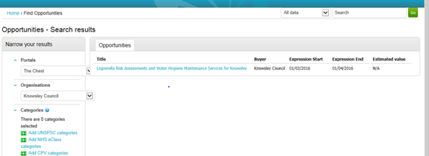

You will then be able to see the opportunity. Click on the title of the opportunity to open up the details. On the right hand side of the screen, you will see a green button to “Login/register an interest in this opportunity”

Step Three – Submitting your application

Once you have expressed your interest in this opportunity in the system, you need to go back to the home page of your account (making sure that you are logged in). Once there, you will need to go to:

- My Activities
- Active Activities
- Select Knowsley MBC from the list
- All of your opportunities for Knowsley will then appear
- You need to then find the opportunity
- Click on the blue Hyperlink (Which is usually the contract title) this will take you to a screen for the Creative Director and Programmer opportunity.
- In the bottom box on this screen, you need to click ‘Start’ this will then give you access to all of the relevant documentation.

It is Bidders responsibility to ensure they access and download the form from The Chest once they have been published by Knowsley MBC.

