KENT COUNTY COUNCIL
SPECIFICATION

[Contract No: SC21053]
Adult Social Care – Technology Enabled Care Build and Test Pilot

CONTENTS

Contents
1. PURPOSE 3
2. BACKGROUND TO THE AUTHORITY 3
3. BACKGROUND TO THE REQUIREMENT/ OVERVIEW OF REQUIREMENT 5
4. THE REQUIREMENT 7
5. TECHNICAL STANDARDS AND EXPECTATIONS 9
6. KEY MILESTONES 10
7. AUTHORITY’S RESPONSIBILITIES 10
8. REPORTING 10
9. CONTINUOUS IMPROVEMENT 11
10. SOCIAL VALUE 11
11. STAFF AND CUSTOMER SERVICE 11
12. SERVICE LEVELS AND PERFORMANCE 12
13. SECURITY REQUIREMENTS 13
14. SAFEGUARDING 13
15. PAYMENT 14
16. LOCATION 14
17. APPENDICES 14

PURPOSE
  - The Authority wants to undertake a build and test model for one year to understand the benefits of utilising Technology Enabled Care to support the achievement of outcomes for people within Adult Social Care (ASC) in Kent.

  - The Authority’s Making a Difference Every Day approach requires a significant shift on to digital Technology Enabled Care Service and the adoption of innovative solutions and products to meet a person’s needs which is underpinned by strengths-based practice and a person-centred focus.

  - In order to support this, the Authority is seeking a Provider(s) that will be responsible for:

- Sourcing, identifying, recommending and providing access to a wide range of digital Technology Enabled Care solutions and products to meet a person’s needs through a build and test / pilot / proof of concept to inform the wider business case. This includes working with any incumbent providers to ensure the successful delivery.

- Development of data, analytics, reports and insights to help shape and contribute towards the creation of the authority’s data strategy.

- Identifying and developing a cultural change programme to embed Technology Enabled Care across social care pathways in Adult Social Care.

- Defining the Design model for how Technology Enabled Care could be expanded across with wider health and social care system.

- Work with KCC Technology Facilitators to embed and test how technology can be part of the practice assessment process.

- Supporting individually funded technology pilots in other settings including but not limited to Extra Care residential schemes.

BACKGROUND TO THE AUTHORITY
  - Social care and health services across Kent face significant challenges as the population is living longer and with more complex needs, which his increasing demand on the health and care sector. Further pressures are added due to a workforce shortage in the care sector. Kent is the most populated county in England with 1.55 million residents. Of these, 35,385 people in Kent are supported by Adult Social Care with 20,719 people over the age of 65. Funding pressures continue to dominate our operating environment along with increasing expectations in terms of our ability to continue to deliver and improve services. All this is set against the backdrop of tremendous change, not only in the health sector but also in the technology and tools available for us to provide more personal, accessible and joined up support.

  - Due to central government restrictions previously in place and actions to mitigate the risk of spreading the virus during the COVID-19 pandemic, it has resulted in additional opportunities to explore digital technologies to continue to support the citizens of Kent.

  - The Making A Difference Every Day approach will be the main driver of change within Adult Social Care over the next few years. The programme aligns with KCC’s Strategic Reset Programme and will contribute towards the delivery of the key ambitions of the Authority. The programmes strongly focus on supporting our residents and how the service delivery experiences of residents and the people who use our services could be enhanced. Further information can be found under Appendix 1.

  - The Making A Difference Every Day approach aims to achieve the following key outcomes for the people we support, our workforce and the partners we work with:

- We want the people we support to:
  - Maximise their independence and resilience so they can live the life they want.
  - Have choice and control over their outcomes, the support they can access, and how they access it.
  - Be listened to and able to shape what we do and how we do it.
  - Experience support centred on them and their wider support network which understands them as individuals, sees that we value equality and difference and that we support them in a way that is based on their strengths.

- We want our workforce to:
  - Be empowered and confident in their role, delivering innovatively and creatively using all available resources including digital tools.
  - Feel proud to work for Social Care and Kent County Council.
  - Be clear on their role and contribution to our wider vision and purpose in the system.
  - Productive and satisfied in their career and ongoing development.

- We want the Authority and wider system to:
  - Make best use of available resources and be more sustainable as a result of effectively delivering outcomes and preventing demand.
  - Offer a seamless experience for the people we support by working closely together.
  - Be clear on our respective strengths and contributions.
  - Drive innovation and be recognised for our collaborative ways of working as one system
  - Ensure care and support is more predictive, proactive and preventative for the people we support.

BACKGROUND TO THE REQUIREMENT/ OVERVIEW OF REQUIREMENT
  - Technology Enabled Care is critical to the Authority’s vision for the social care and health landscape in Kent where it wants to harness the positive impact digital technology can have to enable independent living, provide greater choice and control, and optimise a person’s outcomes whilst reducing the demand for other traditional forms of care and support.

  - Technology Enabled Care could come in the following, but is not limited to, forms:
  - Assistive technology - (e.g. smart devices such as televisions speakers, and home hubs, video doorbells, medication dispensers, remote door entry, robotics, wearables etc.)

  - Mobile Applications (e.g. promotion of health, for wellbeing, undertaking daily activities etc.)

  - Remote monitoring and communication (e.g. tablets, video phones, virtual calls to formal and informal network, sensory impairment communication tools, environment sensors, personal sensors, alarms etc.)

  - Technology Enabled Care could be utilised or requested for those in the following, but not limited to, locations:
  - Community (for purposes inside and outside a person’s home)

  - Residential (Supported Living, Care Home, Extra Care)

  - Hospitals (Community hospitals, discharge pathways)

  - To support the vision statement against the Making a Difference Every Day approach, Technology Enabled Care will:

  - Enable people to improve or maintain their independence for as long as possible in the environment they want.

  - Empower people and enable greater choice and control

  - Be an integral part of the care pathway and tool for the workforce to support people

  - Ensure digital is considered for all when it comes to meeting identified outcomes for the person

  - Be outcomes focused, where the most appropriate technology is provided to meet the persons needs and outcomes

  - Be embedded within operational practice of social care professionals

  - Reduce isolation by connecting people to their communities, formal and informal support networks.

  - Prevent escalation of need

  - Look at the possibilities of reducing the cost of packages of care resulting in cashable savings and / or cost avoidance

  - Embrace the latest innovations in technology as well as alternative provisions to meet people’s care and support needs. Ensuring that the service is not confined by one or a few solutions, with a broad ecosystem of providers and types of technologies

  - Be committed to delivering at scale across the entire health and care system with partners and providers in Kent

  - Provide insights to support continuous improvement in care commissioning and operational practices

  - Although Kent is made up of 12 districts, for the purposes of the build and test pilot, the Provider(s) is expected to work specifically in 3 proposed areas of Kent; Thanet, Dover, and Folkestone and Hythe.

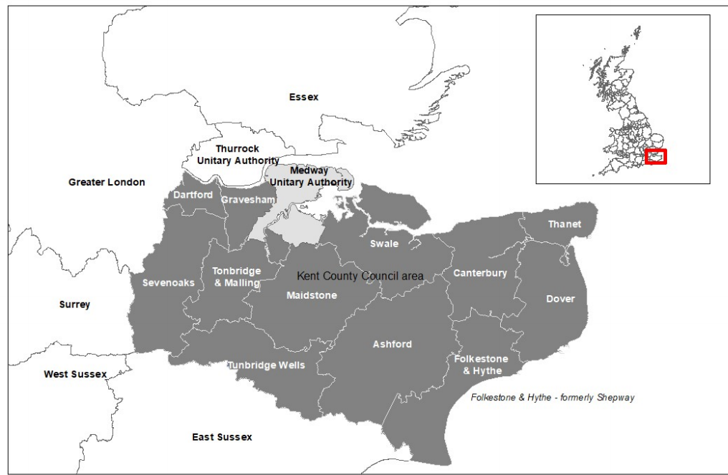
Figure 1 - Map of Kent

THE REQUIREMENT
  - The Authority is seeking a Provider(s) to undertake a build and test model for Technology Enabled Care in the 3 proposed areas of Kent to support strengths-based practice and help shape the wider Technology Enabled Care Service in Kent.

  - The Provider(s) will undertake a review of processes and pathways to determine how to embed technology within these, cognisant of Strengths Based approaches and initiatives already underway at the Authority.

  - The Provider(s) will develop a single point of contact to allow health and social care professionals, end-users and citizens of Kent to seek information and advice around Technology Enabled Care Service.

  - The Provider(s) will create a communication plan and create content with the Authority to support the promotion of the Technology Enabled Care build and test pilot.

  - The Provider(s) will work with the Authority, partners and providers to promote the latest and existing Technology Enabled Care products and how these can support people and their outcomes. This will include horizon scanning and embracing innovative solution to meet people’s needs.

  - The Provider(s) and the Authority will design an easy, intuitive and accessible method for receiving requests / orders electronically from the Authority’s workforce and provide an acknowledgment of receipt.

  - The Provider(s) shall conduct an initial and any follow up intervention appraisals, when required, to support the initial assessment undertaken by the Authority including providing options to the requestor on a range of products

  - The Provider(s) shall be responsible for the following activities associated to the Technology Enabled Care products:
    - Logistics, including but not limited to the following:
          - Purchases / Orders
          - Packaging
          - Delivery
          - Collections
          - Setup onsite
          - Maintenance (including replacing damaged products)

    - Installations, including but not limited to, providing accessible user guidance so that the person that the solution is being provided to is clear on how the technology works.

    - Decommissioning services when the technology is no longer suitable for the persons situation (e.g. moved to residential care if receiving support at home, death etc.). Data quality will be maintained during this time to ensure records held by the provider and the authority match at all times.

    - De-installations of solutions provided including, but not limited to, recycling of any equipment to provide best value to the Authority. The technology provider must decontaminate, sterilise, and clean returned and recycled solutions.

    - Support with all aspects of networking and connectivity, including but not limited to, personal (e.g. setting up a contact or alert network of people) and technical (e.g. connecting to broadband, via Bluetooth, to a monitoring network), so that the solutions provided link via the appropriate networks and connections.

  - The Provider(s) will provide a monitoring service that can fulfil the requirements of the Technology Enabled Care service. This will include but not be limited to; reactive and proactive response that is available for 365 days of the year, 24 hours a day.

  - The Provider(s) will support the Authority in engaging and communicating with the care providers in Kent who currently deliver support to those identified to be in the cohort.

  - The Provider(s) will support the Authority to define a benefits framework and then continue to monitor and evaluate the benefits and outcomes being delivered through deployments. This will include financial and non-financial benefits for the Authority and the wider health and social care system.

  - The Provider(s) will support the Authority to undertake a full evaluation at the end of the build and test pilot to inform the benefits, lessons learnt, risks and impact on a future wider deployment of Technology Enabled Care.

  - The Provider(s) will transfer knowledge to the Authority’s staff to carry out monitoring and evaluation internally.

  - The Provider(s) will source and provide the latest digital products to meet the needs of the people identified through the build and test pilot. This includes ensuring that it complies with relevant standards and testing.

  - The Provider(s) will define the cultural change journey required to embed technology within assessments, pathways and social worker practice, including targeted engagement and communications with these teams.

  - The Provider(s) will develop a design model for how technology enabled care could be expanded across the health and care system. This will include, but not be limited to:
    - What a Technology Enabled Care Service is and how it can benefit people, partners, providers and the wider health and social care system.

    - How the offer is delivered, including the delivery and commercial model(s), facilitating innovation and user-centred design and solutions.

    - Determining the infrastructure, data management and governance required for successful roll out, considering GDPR, data sharing and ethics.

    - Assist in the development of policies, procedures and practice guidance for the implementation and use of technology.

  - The contract is for a 1-year period with the expectation that much of the requirement is delivered within the initial 6-8 months. See milestone plan in section 6. This is likely to be dependent on the realisation of the expected benefits and delivery against the Service Levels defined in section 12 of this document.

  - The Provider(s) will work with the Authority to develop a plan to scale the Technology Enabled Care countywide and roadmap for delivery.

  - The Provider(s) will present to the Authority private pay initiatives and concepts as it is committed to enabling people to live as independently as possible in an environment they want to be in, and in doing so becoming proactive and predictive to look at preventing ill health. The Authority recognises the opportunity that technology can play in doing this and is committed to developing an offer for those who are not assessed as eligible for the Technology Enabled Care Service.

TECHNICAL STANDARDS AND EXPECTATIONS
  - An IT Specification has been provided at Appendix 2. The Provider(s) will ensure compliance with this document and the requirements specified within. This will not form part of the evaluation at the SQ stage.

  - The Provider(s) will ensure device agnosticism for the associated Technology Enabled Care Service products and systems.

KEY MILESTONES
  - The Potential Provider must note the following project milestones that the Authority will measure the quality of delivery against:

Milestone | Description | Timeframe
1 | Agreed area / cohort | Month 1
2 | Technology sourced/identified | Month 1
3 | Referral process and support material for workforce defined and communicated | Month 1
4 | Benefits framework & approach to evaluation agreed | Month 1
5 | Build and test pilot commences | Month 2
6 | Cultural change journey defined | Month 4
7 | Design model for how Technology Enabled Care could be expanded across the health and care system agreed and approved | Month 6-8
8 | Develop a plan to scale Technology Enabled Care wider than the build and test pilot and roadmap for delivery | Month 6-8
9 | Evaluation of technology at 6-month point | Month 8-10 (6 months from deployment)

AUTHORITY’S RESPONSIBILITIES
  - The Authority will endeavour to provide access to stakeholders and information in a timely manner.

REPORTING
  - The Provider(s) will ensure the Technology Enabled Care products used and the data produced from the products are consolidated into a single and secure cloud-based reporting platform. Data and reporting must be flexible, clear and concise that is simple to understand and interpret.

  - The Provider(s) may be required to report into the Making a Difference Every Day Programme Board.

  - The Provider(s) may be required to provide progress updates as part of Section 75 reporting.

CONTINUOUS IMPROVEMENT
  - The Provider(s) will be expected to continually improve the way in which the Technology Enabled Care Services are to be delivered throughout the Contract duration.

  - As a part of the Contract Meeting/monitoring process the Provider(s) shall propose quality improvements that it intends to implement and develop during the course of the Contract. These improvements will be discussed and agreed by the Authority.

SOCIAL VALUE
  - The Provider(s) will ensure that they support the Authority’s Commissioning Framework principles for social value which are listed below:
    - Local Employment
          - Creation of local employment and training opportunities to reduce unemployment and raise local skills.

    - Local Economy
          - Buying locally where possible to support local business growth

    - Community development
          - Development of resilient local community and community support organisations, especially in those areas and communities with the greatest need.

    - Good Employer
          - Support for staff development and welfare within providers’ own organisations and within their supply chain.

    - Green and Sustainable
          - Protecting the environment within the providers’ own organisation and within their supply chain.

STAFF AND CUSTOMER SERVICE
  - Provider(s) staff assigned to the Contract shall have the following relevant knowledge and experience to deliver the Contract

  - The Provider(s) will only employ in connection with the Service, persons for whom he has obtained satisfactory character references.

  - The Provider(s) shall ensure that all staff and volunteers employed by them in the provision of the Service have induction training and an ongoing training programme appropriate to the Service.
  - The Provider(s) will train and equip all delivery staff in the skills and techniques of fitting and installing Technology Enabled Care products, ensuring that no personnel will undertake any activity unless appropriately trained/ qualified and certified as appropriate to do so e.g. electrical, plumbing or gas.

  - The Provider(s) will ensure that all staff are trained to ensure that they are sensitive to a person’s situations/circumstance, particular importance should be given to ensure that the person’s dignity is not compromised i.e. adequate and appropriate communication is provided, products are not left on doorsteps, products which could be perceived as of a sensitive nature or potentially embarrassing to recipients should be thoughtfully supplied (consideration of packaging as applicable) etc.

  - The Provider(s) is to ensure that all complaint handling procedures comply with the Authority’s complaints procedure, and relevant Health and Social Care legislation.

SERVICE LEVELS AND PERFORMANCE
  - The Authority will measure the quality of the Supplier’s delivery according to the timeframes detailed in 6.1 of this document.

  - There will be robust outcome focused performance framework that is supported by meaningful KPI’s

  - The reporting process will be agreed with the Provider(s) on mobilisation:

KPI/SLA | Service Area | KPI/SLA description | Target
1 | Benefits realisation  (non-financial) | Demonstrable delivery of outcomes to people through Technology Enabled Care | 100%
2 | Benefits realisation  (financial) | Demonstrable delivery of benefits including cashable savings through Technology Enabled Care | 100%
3 | Cultural change | The Authority’s staff, partners & providers involved in the build and test pilot understand the potential of Technology Enabled Care and there is an approved and agreed culture change journey defined for the wider Technology Enabled Care Service in Kent | 100%
4 | Design model for how Technology Enabled Care could be expanded across the health and care system agreed and approved | Agreed and approved Technology Enabled Care design model for the health and social care system including the delivery and commercial models, benefits and costs across the system | 100%
5 | Develop a plan to scale Technology Enabled Care wider than the build and test pilot and roadmap for delivery | Agreed and approved plan to scale Technology Enabled Care wider than the build and test pilot and roadmap for delivery.  Lead on development/ Work in partnership with the Authority on the wider Business Case for TEC. | 100%
6 | Social Value & Sustainability measures | The Provider(s) is expected to propose social value and sustainability measures as part of their response. | 100%

SECURITY REQUIREMENTS
  - The provider may be required to access Authority’s premises (offices) during the contract period, to attend meetings with Authority representatives. In this event the provider will be expected to arrange the visit with the Authority in advance and follow the current protocols of that building, including but not limited to, signing in and out, wearing PPE and wearing a visitors badge.

SAFEGUARDING
  - The Authority and Provider(s) share a responsibility in safeguarding children and adults from abuse and to ensure that every person in society is treated with dignity and respect and protected from others who may abuse them. Where contractors come into contact with children or vulnerable adults in the course of their work have a duty of care to safeguard and promote their welfare and to work to prevent, detect and report neglect and abuse.

  - The Authority requires its Provider(s) to comply with its policy on the Safeguarding Vulnerable Adults (SVA) and Safeguarding Vulnerable Children (SVC), or any subsequent replacement regulations/guidelines, particularly when incidents of alleged abuse are reported. Upon request, the Service Provider shall make available to the Authority details of the procedures it has in place to satisfy the requirements of the policy;

PAYMENT
  - Payments will always be made in arrears and each invoice must clearly detail a valid purchase order of the Authority.

  - Payment can only be made following satisfactory delivery of pre-agreed certified deliverables and milestones as per 6.1 and set out in the pricing schedule.

  - Before payment can be considered, each invoice must include a detailed elemental breakdown of work completed and the associated costs.

LOCATION
  - Due to the COVID-19 pandemic, the majority of the Authority’s staff are working remotely. It is expected that the Provider(s) will work remotely, where possible, until the point at which the Authority’s staff return to the office at which point the appropriate risk assessment may have to be completed in line with the Authority’s Health and Safety procedures.

  - In the event the Authority returns to its offices during contracted period, the primary location where the services will be carried out is likely to be at Invicta House, County Hall, Maidstone, Kent, ME14 1XX, but this may be subject to change.

APPENDICES

Appendix | Document
Appendix 1 – Additional information on the Adult Social Care Making A Difference Every Day approach
Appendix 2 – IT Specification

