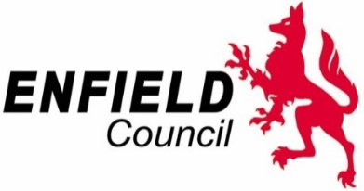

INVITATION FOR MARKET ENGAGEMENT

The London Borough of Enfield would like to engage the market in relation to the provision of a Voluntary and Community Sector service for Outcome 3: Supporting People to Improve their Health and Wellbeing and Improving Self-management.

Interested potential providers are invited to attend a Market Engagement Event on Wednesday 18th December 2019 between 15.00 -16.00 in the Conference Room at the Enfield Civic Centre, Silver Street, Enfield EN1 3XA.

Attendance is by registration only. Interested organisations must respond through the London Tenders Portal https://www.londontenders.org/ by 5pm on Monday 16th December 2019. Please respond through the messaging page of this portal. Registration for attendance may not be accepted after this deadline. However, if you are interested but are unable to attend the event on the day, please respond accordingly. Details of the presentation will be made available after the event for everyone interested.

