Residential Design Codes Brief
Bristol City Council
October 2023
Bristol City Council Regeneration Team wish to procure two design standards documents to support work in the City Centre regeneration area. These are:
- City Centre (Broadmead) Residential Design Code
- Urban Family Living Residential Design Guide
Further information is set out below on the purpose, objectives and outputs needed for each document.

Purpose and background
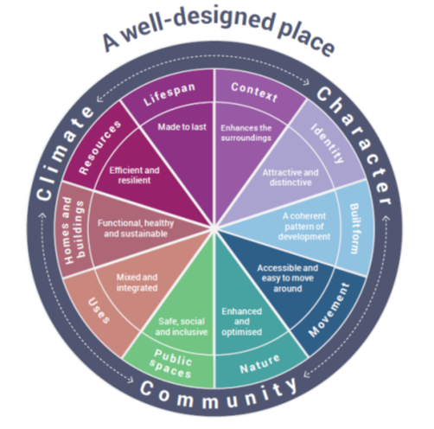
It is expected that both documents will reference and respond to the National Design Guide 10 characteristics.
The City Centre Residential Design Code will be a place-specific code, whereas the Urban Family Living code is to be applicable for other parts of the city and regeneration areas where higher density living is anticipated. They are both likely to provide a baseline for future policy. The successful applicant will be provided with the brief for the planned city-wide Bristol Design Code, so that both documents can relate to each other where possible. The diagram below shows where these area and topic design codes could sit in relation to other local design guidance.
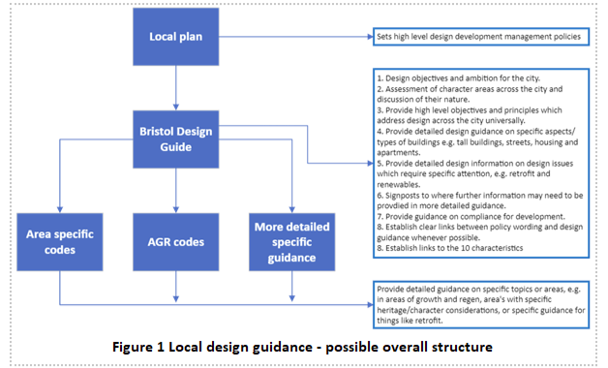

Budget: £25,000 for each design code, £50,000 total. This is a maximum budget.
Consultants should show how by delivering both projects they can deliver best value and cross-project benefit.

Programme: Both pieces of work must commence at the start of December 2023, with approx. a 12-15 week programme, ending in early March 2024.
Indicative project timescales:
- Stage 1 (0 – 3 weeks) – Inception meeting/workshop with Project Group, brief finalisation, background research and analysis. Workshop with Registered Provider group to understand needs, issues, aspirations for Family Guide.
- Stage 2 (3 – 6 weeks) – First Draft Reports with recommendations, workshop with BCC Project Group and Registered Provider group to discuss and review.
- Stage 3 (7 – 10 weeks) – Final reports developed and issued for review.
- Stage 4 (10 – 15 weeks) – Broader stakeholder review/sign off and feedback, followed by minor amendments.

BCC Project Group
A working group will be created for the project to ensure that departments are able to contribute to the content and development of the codes. This will include:
- Housing strategy and enabling team
- Regeneration team
- Property and commercial team
- Urban design team
- Planning policy team
- Highways
BCC will be able to support with organising meetings required with local RPs for the family living design code.
Consultant team:
Specialists in the following areas are expected to make up the project team:
- Residential architecture, including experience in affordable housing and high-density, city centre housing, accessible/inclusive design
- Retail / city centre architecture and urban design
- Sustainable design
- Public realm and landscape design
We expect the project to be managed by a single point of contact in the consultant team to provide efficient and clear communication. Similarly, BCC will have a lead Project Manager as a main point of contact.
Meetings:
- Allow for fortnightly catch ups with the Project Manager
- Minimum of 2 workshops with BCC Project Group
- Minimum of 2 workshop with Registered Provider group

- City Centre Residential Design Code

Project purpose
With taller and denser development coming forward in the city centre area, particularly where BCC is a majority landowner, this design code will set out the design standards required for new residential development on BCC freehold land.
Objectives
- This will accompany the Tall Building Strategy (currently being developed) and it will focus on requirements for high density residential development in order to support the delivery of high quality homes in the city centre.
- The design code needs to align and respond to the strategies set out in the City Centre Development and Delivery Plan (due to go to Cabinet for endorsement in December 2023)
- The design code is expected to align with the National Design Guide 10 characteristics.
- It will also align with the themes and strategies in the Bristol Urban Living Supplementary Planning Document (SPD) (adopted in 2018), but will set out more definitive and improved design, space and access standards that are fit for purpose to ensure residents and building users can have a healthy and high quality of life in a denser neighbourhood.
- While the focus will be on residential development, the inter-relationship with other uses that are typical in a city centre environment, including retail, leisure, community and office uses, needs to be factored into the design code. An approach to the ground floor design of non-residential uses will be paramount.

Further information:
This design code is expected to reference the work currently taking place to deliver a Tall Building Strategy, which looks at evidence around creating development that ensures safeguarding an optimum and appropriate microclimate for daylight, sunlight, wind tunnelling (minimisation of), aspect and proximity to high quality green space.
It is also expected to build from the objectives already set out in the City Centre Development and Delivery Plan – including strategies on use, public realm, movement, community and culture, use and green infrastructure.
The work will require an initial workshop with the BCC Project Group to help inform the content and key priorities. A second workshop later in the programme will provide a valuable check-in and review opportunity with the same officers on the emerging content.
It is expected that the code will use existing, tried and tested, and well-referenced design practice and guides to inform the work, including the London Housing Design Guide and any others that the consultant may feel are relevant. The aim is to use well-evidenced design standards and solutions where built schemes have been viable and deliverable in similar contexts.
An example of likely contents may include:
- Design features / standards of designing residential over ground floor retail uses
- Non-residential ground floor design including active edges, lighting, entrances, openings and key high street design standards
- Appropriate residential mix
- Guidance on how homes can achieve the energy consumption and embodied carbon targets within the new Local Plan
- Guidance on how to ensure homes are resilient to climate change and minimise the risk of overheating
- On plot green infrastructure
- Surrounding public realm
- Approach and standards for open space (public, communal and private)
- Entrances – main, communal and front doors
- Communal area design
- Bike and pram parking, storage solutions and refuse and recycling spaces and access
- Internal layouts
- Space standards and approach to habitable rooms
- Appearance, style, character, materials

Output
A pdf design code to be used internally by BCC as part of setting standards and requirements for all new development within its freehold. It is likely to be referenced by Planning teams as part of developing new design policy in the future.
The code should have a clear and coherent layout, using drawings, illustrations and images to explain and define design standards. Precedents and examples of high-quality schemes will be important.

- Urban Family Living Residential Design Guide

Introduction
Unlike other cities in the UK and Europe, Bristol is less experienced in the design and delivery of residential apartments that are aimed at the needs of families in central urban areas. Currently the market is not delivering enough 2, 3, or 4 bedroom homes in the city centre.
A design code is required, developed with support and input from local Registered Providers, to define clear design standards required to ensure that family living is intrinsically brought forward as part of all residential development in urban areas. It must lead to the creation of homes that are sought after, high quality and deliver an optimum quality of life. This is critical to ensure we have mixed and vibrant communities and neighbourhoods through central Bristol.
The design code must consider internal and external designs, spaces, layouts, routes and connections and required associated infrastructure and spaces.
This output will be used by the Housing Delivery team as the standards required for Affordable Home provision in the city. It will also be used by the Regeneration and Property team as part of BCC’s freehold requirements in the city centre for larger family homes.

Project Needs
Building on the work of the Urban Living SPD we are wanting to understand how best to accommodate families of all sizes within higher density urban environments and ensure they are at the heart of city living.
Bristol has an enormous amount of regeneration underway and aspires for a vibrant, inclusive and sustainable city centre and wishes for families to be a part of that, not only accommodated in low density accommodation on the sub-urban edges of the city. In addition, with the introduction of the clean air-zone and other initiatives designed to lower levels of car use, well located accommodation with facilities for non-vehicular transport and equipment for children or those with disabilities are also required.
We are looking for a commission that provides additional detail and value to our Urban Living SPD and serves as an aid for the City Council and Registered Provider partners to ensure that appropriate, liveable affordable family homes can be delivered as part of high density development.

Objectives
- To deliver a portfolio of worked design examples of appropriately sized family accommodation that can be incorporated into higher density development, that meets the needs of infants, children, and older family members
- To consider how design both internally and externally can enhance the experience of families to safely access and enjoy their home environment

Outputs
- To provide Bristol City Council and partners with a portfolio of proven designs that support family living within high density environments,
- To consider how best to provide communal and private space for families to use alongside other residents, within and outside of buildings, including management arrangements that ensure the space is safe and well-used.
- To liaise and consult with Bristol HomesWest providers over the challenges of managing larger families in high density developments and the design mitigations expected to ensure the success and sustainability of these resulting tenancies.
- To ensure accommodation is safe and accessible for those with prams and infants and young children.
- To evaluate a range of other local authority planning guidance and good practice that promotes family living and make recommendations for Bristol City Council to enhance its policy.
- Provide a design guide and example layouts to support the delivery of appropriate affordable family housing provision in high density developments through planning gain that RP partners are happy to acquire and manage as family homes.
- To ensure the homes can meet emerging planning policy sustainability standards and are resilient to climate change
- To provide designs that are inclusive of allocated cycle storage on each floor.
- To ensure adequate amenity space is provided and avoid any areas segregated by tenure
- To consider how study areas may be incorporated within residential accommodation.

Existing Strategies
We draw your attention to some of our key planning documents for reference, including some of our spatial framework documents where much of our high-density development will go ahead. Our next Local Plan will cover the period from 2024 to 2040.
Bristol’s Local Plan is made up of a Core Strategy setting out the overall approach to planning in Bristol. Our Local Plan is currently being reviewed and has recently been issued for consultation. Affordable Housing elements within the Local Plan are BCS 17 & 18.
Key development documents.

