Waste Collection Services in Lichfield District Council and Tamworth Borough Council

Soft Market Testing

Section 1 Introduction
- General requirements
The purpose of this document is to describe the waste collection services required in order that suppliers can indicate their interest and experience of providing these services.
Please note that this market testing exercise is not an invitation to tender or a request for formal expressions of interest. This document does not form any part of an invitation to tender. Lichfield District Council is issuing this request for information only. Responses from suppliers will be used to inform market research only and to help make any future procurement process more focused and efficient. No supplier selection or supplier preference is implied.

- Confidentiality and Freedom of Information (FOI)
Please note that all information included in this soft market testing documentation is confidential and only for the recipients’ benefit. No information included in this document or in discussions connected to it may be disclosed to any other party without prior written authorisation.
It is important that dialogue between the Council and interested parties is focused and meaningful. We also recognise that this process should be mutually beneficial and that we will necessarily disclose to each other confidential information. Please be assured that all sensitive information disclosed at this stage will be treated as commercially confidential. Should you have any concerns about this please feel free to mark specific material as commercially confidential.

- Background
Lichfield District Council and Tamworth Borough Council are keen to explore options around the future operation of their waste collection service. This service is currently shared and operates across the two Council areas. The Councils are considering all options for a replacement service and would like to find out what the market can offer. In particular, the Councils are keen to build a service that can respond to future challenges such as changes in legislation and the associated costs of change, as well as other issues such as an ageing workforce.
This soft market testing exercise seeks engagement from the market in order to inform the strategy for waste collection services in order to shape a procurement exercise which is anticipated to be published before the end of 2023.

- SMT Timetable
The Council appreciates the effort and valuable information that will be provided by suppliers in responding to the questionnaire. These responses will help shape the future procurement though it should be noted that potential responders will not be prejudiced in any future procurement processes either by responding or not responding.
Following the issuing of the questionnaires, the project team will hold a clarification Q&A session followed by review of initial responses. Suppliers will then be invited to virtual individual interview sessions to further discuss responses.

SMT Indicative timetable

Stage | Date
Publish PIN Notice / Issue of soft market testing information and questions | 1 February 2023
Q&A Session – virtual event  Suppliers will be invited to attend a virtual engagement session for any clarifications they may have. | 15 February 2023
Deadline for receipt of responses to Soft Market Test | 12 midday  6 March 2023
Supplier individual discussions – Virtual event | 8 – 10 March 2023

Section 2 Identification of Requirement

- Background to the Opportunity
Lichfield and Tamworth are district councils located in the county of Staffordshire, north of Birmingham.
Lichfield: Tamworth:
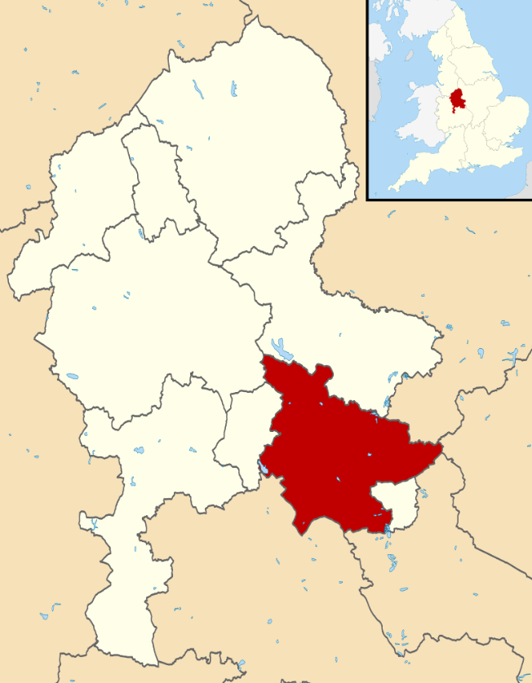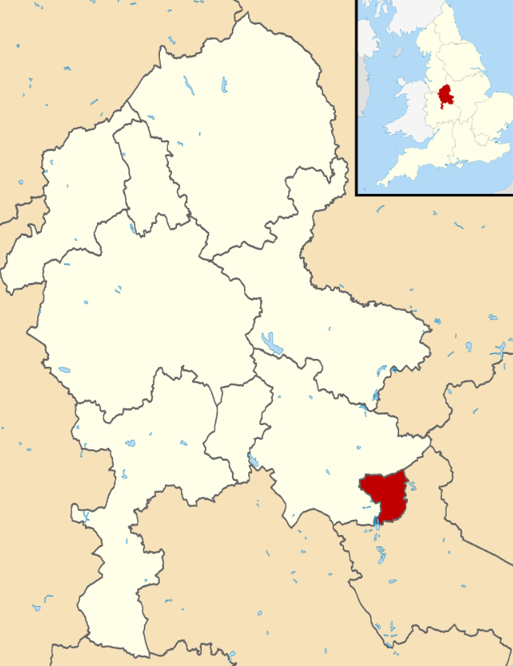
Lichfield is predominantly rural covering around 33,000 hectares and with a population of around 103,000. Tamworth by contrast is urban in nature covering around 3000 hectares with a population of around 75,000.
Lichfield services 45,577 households, Tamworth 34,137. Of those, the majority are part of the standard kerbside collection service, with only 1824 households in Lichfield and 1506 households in Tamworth receiving a non-kerbside service.

- Service details
The Councils joint service collects residual, dry recycling and garden waste on a weekly alternating basis, i.e. residual is collected one week, and recycling the next. Recycling is collected commingled, with plastic containers, aluminium foil, food trays, cans, glass bottles and jars with lids, aerosol and roll on cans collected in a bins, paper card and shredded paper collected in a separate bag. Garden waste is also collected on a fortnightly basis and is a chargeable service.
As part of its household service, the council also offers a bulky waste collection for disposal.
Receptacles for waste vary in size for each waste type collected. Residual waste is collected in 240L, 360L, 660L and 1100L bins. Residents are provided with bins depending on the number of people in their household; a 1 person household would receive 140L bin, a 2 person household 180L and a 3 person and above 240L. If there are 6 or more residents in the home, or a medical issue, additional capacity will be provided as required. Recycling is collected in 240L and 360L bins and 64L sacks.
Garden waste is collected predominantly in 240L bins, but there are also 140L and 180L bins in operation. Where residents require additional capacity they are given 2 x 140L bins.
- Resourcing
The service is provided through an establishment staff of 55 driver/loaders and 30 loaders, with 13 back office staff.
The service uses the following vehicles :- 1 x 15t RCV, 1 x 16t RCV, 3 x 18t RCV, 14x26t single RCV, 11 x 26t twin pack RCV. The twinpack RCVs are used for recycling, single RCVs for residual and garden and remaining RCVs for rural collections.
- Performance
Total tonnes of waste collected per annum | 2021/22  Lichfield & Tamworth 71,970 tonnes
 | Lichfield  43113.71 tonnes | Tamworth  28776.76 tonnes
Recycling and composting rate | 2021/22  Lichfield & Tamworth 43.4%
 | Lichfield  45.64% | Tamworth  40.16%

- Depots & Delivery Points
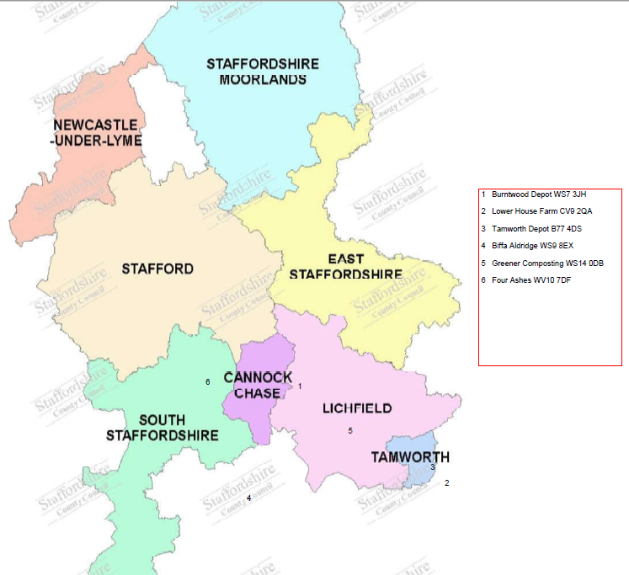
Section 3 Supporting Information

Section A: Organisation and Contact Details

Question | Response
Company Name
Company Address
Company Telephone Number
Contact Name
Job Title
Email Address
Contact Telephone Number
Website address
What if any local connections do you have with the Authority?

Section B: SMT Questions for completion
The questions at Appendix 1 are designed to provide details to the councils of your current offering and future interest in the Councils waste collection services. Please note the following:
- This shouldn’t be onerous for your organisation; abbreviated and note form answers using bullet points will suffice. Lengthy answers are not required to these questions.
- Questions have been put into nine themed sections, it would be much appreciated if as many as possible could be answered.
- Suppliers are not being judged on the length of answers or flowing prose, succinct answers is the preferred format.

Appendix 1 -Information to be sought from Waste Collection Companies
- Experience and Future Presence in Sector:
- Briefly summarise your organisation’s general experience of managing waste services contracts for UK Local Authorities. A list of bullet points outlining contracts and indicating will suffice.
Answer:

- What do you think your organisation offers Local Authorities that your competitors don't? How do you differentiate from them.
Answer:

- What would your organisation advocate are the benefits of an outsourced service over an in-house service?
Answer:

- Would the provision of a depot(s) by the Councils be desirable/a key determinant in assessing the attractiveness of any future waste collection contract with them?
Answer:

- Equally, does your organisation have depots that could be used to support a contract with Lichfield and Tamworth.
Answer:

- Operations Management and Staff Recruitment

Many sectors have in recent years experienced staffing shortages and retention challenges across all levels of their organisations. Please set out

- Where has your organisation experienced such staffing challenges and how have you responded?
Answer:

- Where services have suffered from management and supervision under-performance, what measures has your organisation taken to improve this at both the point of transfer and also on an on-going basis.
Answer:

- Food Waste and Recycling
- The Councils are considering the introduction of food waste collections to all residential properties and potentially the commercial market also. Does your organisation operate food waste collections for other Local Authorities? If so, what features from the best performing schemes your organisation would you propose for Lichfield/Tamworth? Would you implement a new service on one date or on a phased basis? What kind of vehicles would you use to collect food waste?
Answer:

- Would you be interested in jointly investing in food waste infrastructure supported by a long term food waste collection and disposal contract
Answer:

- How would your organisation propose bulky waste collections are managed to increase recycling levels from this service?
Answer:

- What would your organisation’s approach be to reducing contamination levels in dry recyclables and other recycling services?
Answer:

- Does your organisation have any experience of household collections of marginal items of the recycling waste stream that are not collected within the established kerbside collection scheme such as household batteries, WEEE (small and large) and textiles? Are there any other materials your organisation would propose be included in household kerbside collections?
Answer:

- Is your organisation able to offer/provide access to new recycling and/or food waste disposal outlets to deliver enhanced financial and environmental outcomes for the Councils?
Answer:

- Commercial Waste Services
- Would your organisation want the Council’s commercial waste collection operation included in any contract?
Answer:

- What range of Commercial waste collection services does your organisation operate i.e. contractor owned, agents of a Council? Where has your organisation improved the financial performance of a Council’s commercial portfolio after it has been transferred to you?
Answer:

- What challenges does your organisation see with increasing commercial recycling services to include food waste collections
Answer:

- Fleet:
- There are a number of views in the industry as to what the future of alternative fuels to conventional diesel looks like given the wide variety of vehicles used for waste collection and street cleansing. What is your organisation’s view in the short and longer term of the best fuel to use e.g., electricity or hydrogen and set out why you think this is the best approach for Local Authorities and contractors?
Answer:

- Provide examples of where your organisation has switched to alternative fuels setting out what vehicles were switched?
Answer:

- Impact of upcoming legislative changes
- The sector will have to shortly accommodate changes arising from the Environment Act 2021 such as Consistency of Collections, Extended Producer Responsibility and Deposit Return Schemes. How does your organisation see these impacting on waste / recycling streams
Answer:

- How should any contract with Lichfield / Tamworth Councils accommodate the impending changes within the contract?
Answer:

- Contract procurement, length, mobilisation and structure
- Which procurement procedure (e.g., Competitive Dialogue, Competitive Procedure with Negotiation, Restricted Procedure) would your organisation suggest the Councils should follow to achieve their procurement objectives and gain best value? Please briefly state your reasons.
Answer:

- Would your organisation be willing to invest in depots and other infrastructure? If so on what basis?
Answer:

- What would be the ideal length of contract for delivery of these services?
Answer:

- What would be your organisation’s minimum mobilisation period for a contract of this nature and size?
Answer:

- What would your organisation see as the key challenges and risks in delivering on a contract of this nature and size?
Answer:

- Would a stand-alone food waste collection service, contractually separate from other collection services be commercially viable and operationally deliverable?
Answer:

- If this is attractive, would your organisation also want the treatment of food waste included in the contract? If so what length of contract would you require?
Answer:

- Redline Issues

- Please outline your organisation’s current redline issues in contracts of this nature?
Answer:

- Please outline your organisation’s preferred price indexation mechanism for the contract?
Answer:

- Please outline your organisation’s preferred approach to developing a performance framework that drives service improvement
Answer:

- Social Value / Net Zero Target

- How would your organisation propose to deliver Social Value to this contract, improving the social, environmental and/or economic position in the local area.
Answer:

- The Councils are committed to becoming net zero carbon boroughs by 2050, how would your organisation support this objective through the contract and what are your organisation's net zero objectives?
Answer:

