HOW TO ACCESS THE OPPORTUNITY

This procurement will be conducted via ‘The Chest’, operated by Proactis, which is the North West portal for tender/business opportunities. All documentation and correspondence will be issued electronically via this portal.

*** If you are already registered on “The Chest” then please go straight to step 2 ***

1. Registration on The Chest
Any suppliers who seek to join the opportunity must ensure their organisation is registered on “The Chest” in order to access the form to be submitted. Please use the link below to register for free and you will be able to download the form;

https://procontract.due-north.com/register

If you have any difficulties in registering on “The Chest” then please contact the Proactis support team on 0330 005 0352 or via procontractsuppliers@proactis.com.

2. Register an Interest
Once the opportunity has been published, you can register an interest:-

From the Home page, click on “Find opportunities”

In the “Narrow your results” section on the left hand side of the screen, in the “Organisations” field select “Knowsley Council” and use the green “Update” button at the bottom of this section.

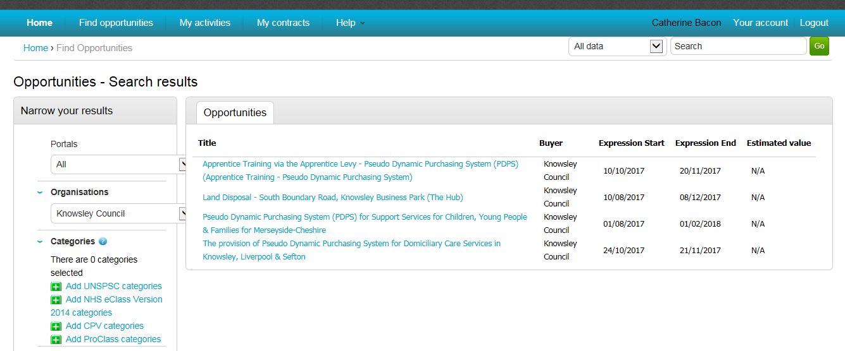

You will then be able to see the live opportunities. Click on the title of the opportunity to open up the details. On the right hand side of the screen, you will see a green button to “Register interest in this opportunity”, click this button to register your interest.

3. Downloading the form
Once you have expressed your interest in this opportunity you will see a screen saying “Expression of interest successful”. This screen provides details of how you can access the documentation. You can either view it straight away by clicking the link next to “to view this event now, click here”. If you want to come back to it at a later date, you can access it via the home page of your account (making sure that you are logged in). Once there, you will need to go to:

- My Activities
- Active Activities
- Select Knowsley Council from the “Buyer” list on the right hand side
- All of your opportunities for Knowsley Council will then appear
- You need to then find the opportunity
- Click on the blue Hyperlink (Which is usually the contract title) this will take you to a screen similar to the following screen:

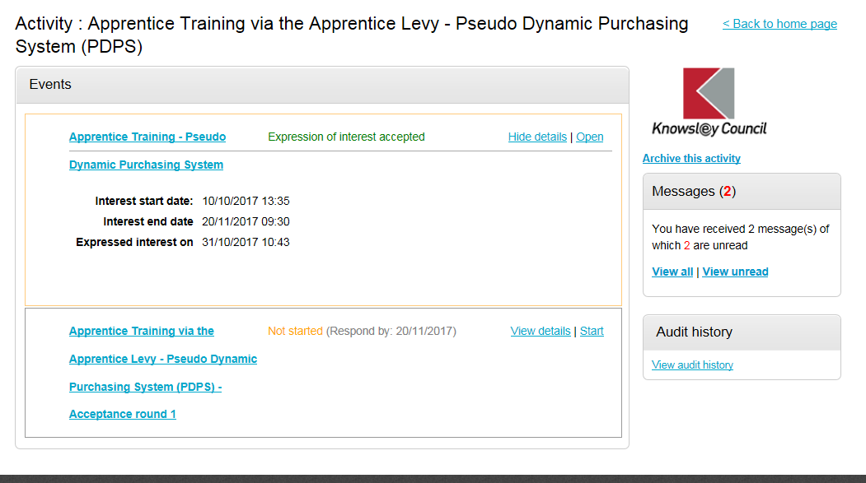

In the bottom box on this screen, you need to click ‘Start’ this will then give you access to all of the relevant documentation.

It is Bidders responsibility to ensure they access and download the form from The Chest once they have been published by Knowsley MBC.

