GOSPORT BOROUGH COUNCIL
INVITATION TO QUOTE (ITQ)
DATE OF PUBLISH: 14th SEPTEMBER 2022
PROCUREMENT AND MANAGEMENT OF THE LIFT CONTRACT AND ASSOCIATED WORKS
RESPONSE DEADLINE: 12 NOON 7th OCTOBER 2022

- INTRODUCTION AND BACKGROUND

  - Contents of this ITQ

This Invitation to Quote (ITQ) comprises:
- This main ITQ document t/w:
  - Appendix A - Specification
  - Appendix B – Supporting Document (Locations of Lifts, short description and Location Plans)
- Appendix C – Reference Questionnaire
- Quotation Response Document:
  - Schedule 1 – Quotation Response
  - Schedule 2 - Confidentiality Statement
  - Schedule 3 - Form of Quote

  - Introduction

Gosport Borough Council, as part of its Housing and Corporate Assets, includes a number of Sheltered Schemes, Hostels and the Town Hall. All of which include vertical lifts. This is an opportunity for a suitably qualified Lift consultant to assist the Property Services Team at Gosport Borough Council in managing the passenger lifts throughout the Borough. As well as providing a cost for this service, the bidders will need to demonstrate their expertise in the field and be at the forefront of their technical knowledge when dealing with and managing the complexities of Lift Procurement, Service and Maintenance.

The Council is conducting this ITQ to consider quotations for the Monitoring and Management of the Lifts at sites in Gosport as set out in Appendix A and B, and is seeking responses in relation to the cost of service provision, technical capability, capacity and professional ability of Respondents.

This ITQ contains further information about the procurement process, the services, and the requirements for Respondents to complete. Each Respondent’s response should be detailed enough to allow the Council to make an informed selection of the most appropriate solution.

2. SCOPE

Gosport Borough Council is committed to providing an environment for visitors, staff and residents to be able to freely access multiple levels for accommodation and amenities where the staircases may not be appropriate.

The Council requires that all lifts located within a communal or in a publicly accessed area to be repair free, have a call out facility in place in and out of hours and be fully compliant to the many stringent regulations in place for lifts in public locations. To reduce the risk of repairs and failure, there will be regular service regime to pro-actively identify any risks of failures and repairs completed accordingly. The current contract for Lift Repair and Maintenance is coming to an end soon therefore procurement is required for a new Lift Contractor.
The Property Services Team requires the assistance of a Lift Consultant to be able to lead on and manage this service. This, in the first instance, will be the Procurement of the new Lift Maintenance contract due for expiry on 31st March 2023. From completion of procurement, the Consultant will then manage any handover matters with the incumbent contractor, settling in of the new Contractor then monitor and manage the Lifts and associated works throughout the duration of their contract.
2.1 Methodology and Required Standards
The following work is required:

• Complete the procurement and associated contract documents as Agent to the Council for the new lift contract commencing from 1st April 2023. Procurement of the new lift contract to commence from October 2022 and be completed by March 2023.
• Closely work with the incumbent lift Maintenance contractor to ensure that all handover documents are provided prior to the end of the contract (during March 2023).
• Ensure that the incumbent contractor continues to provide the service up to the expiry date of 31st March 2023 and manage any transition arrangements from incumbent to new contractor.
• Draw up, formalise and arrange completion of all documents associated with the new contract for Lift Maintenance (from 1st April 2023 to 31st March 2028) including facilitating the signing of contracts by all parties.
During the new contract, works are to include:
• Provision of Technical support when required.
• Arranging and leading on Quarterly meetings with Lift Service Providers.
• Regularly review KPI’s detailed in the contract documents regarding the Lift Contractors.
• Evaluation of Insurance Reports provided by the Councils’ Insurers and liaising with Client and Contractors about appropriate actions.
• Comment on all issued quotations including liaison with Contractors for completion.
• Annual Survey to be conducted of all lifts looking at the Quality of the Service being provided by the contractor. This Survey will also look at the general condition of each lift whereby a report is provided with recommendations for planned works across 1, 3, 5 and 10 year intervals.
• Provide specifications as required for new or refurbished Lifts as the need or planned programme requires. This will include negotiation of costs with Lift Contractor and overseeing the completion of the individual project.
2.2 The respondents are expected to provide evidence as part of their submission that they meet the minimum Required Standard:
Lift Specific Requirements:
Knowledge of the Lifting Operations and Lifting Equipment Regulations (LOLER)
Knowledge of the Equality Act, Part M of the Building Regulations, EN 81 Part 70 and the design guidance, British Standard BS 8300: 2018 Parts 1 & 2 when considering Disabled users in publicly accessed lifts.
Have extensive knowledge of the Lift Regulations 2016
Knowledge of Contracts especially centred on specialist works including Lifts
Be able to provide Quality Assurance to ISO 9001
Be a member of SAFE contractor, Construction Line or other similar accreditation
Work activities that are Managed and Monitored are to be in line with:
The Management of Health and Safety at Work Regulations 1999
The Work Place (Health, Safety and Welfare) Regulations 1992
The Personal Protective Equipment at Work Regulations 1992
The Manual Handling Operations Regulations 1992
The Provision and Use of Work Equipment Regulations 1998
Knowledge of the CDM regulations 2005 and previous experience of working as a Principal Designer in Lift replacement.
All risk assessments for activities to be kept up to date

2.3 Health and Safety Requirements

In addition to working in accordance with the legal regulations in 2.1 and 2.2, the successful Respondent will work in accordance with, and be able to demonstrate:

Risk assessments for all activities undertaken as standard and also with reference to COVID 19 or any other public health risks should they arise

Confined Spaces
Exposure Hazardous Materials
Electrical Apparatus
Fire Safety

2.4 PPE Requirements

All operatives prior to access must notify Property Services in advance of attendance so that the induction document can be completed and approved. Due to potentially lone working within a confined space, signing in and out is required at the site location with an expected duration of inspection/ works provided so that attendance can be monitored.

All attendee’s must be provided with and use / wear appropriate Personal Protective Equipment (PPE) when entering confined areas such as Lift Service Cupboards or Lift Shafts. All PPE shall be to relevant British Standard or equivalent. All operatives shall wear appropriate safety footwear and Hi-Visibility waistcoat or jacket of the appropriate class at all times for the duration of working on site. All operatives should be trained in the use of the PPE.

2.5 Site Visits and Queries

Should the respondent have any queries or require to visit either one or all the locations to clarify the information provided in this document and Appendix B, then they should make contact with property.services@gosport.gov.uk at their earliest convenience but must be before the “deadline for receipt of clarifications” indicated in the Timetable in 3.1.

2.6 Contract Term and Insurance Requirements

The successful Respondent will maintain the following Insurance cover for the duration of the Contract term and subsequent advisory period and provide evidence of cover to the Council prior to commencement of the contract term and at any time when requested by the Council:
Public and products Liability:  Employers Liability Insurance:  Professional Indemnity: | £10 million  £5 million  £2 million
Following selection of the successful Respondent, the Council proposes to enter into a Contract with the Respondent for a period of 5 years with the option to extend a further year. The Contract will use the Councils’ Standard Terms & Conditions for Services backed up by a Purchase Order covering the 5 year period then the further year subject to approval.

The anticipated commencement date is 31st October 2022 with an expiry of 30th October 2027 or 30th October 2028 if extended by a further year.

3. TIMETABLE

3.1 Key dates

This procurement will follow a clear, structured and transparent process to ensure a fair and level playing field is maintained at all times, and that all Respondents are treated equally.

The key dates for this procurement (Timetable) is as follows:
Event | Date
Publish Invitation to Quote on Proactis | Wednesday 14th September 2022
Deadline for receipt of clarifications | Friday 23rd September 2022
Deadline for receipt of Quote | 12noon Friday 7th October 2022
Evaluation of quotes | Tuesday 10th October 2022
Notification of contract award decision | Friday 14th October 2022
Service commencement date | Monday 31st October 2022

Any changes to the procurement Timetable shall be notified to all Respondents as soon as practicable.
3.2 Deadline for receipt of Quotes

Responses to this ITQ must be submitted in the manner prescribed under Paragraph 4.1 no later than the deadline, noon, Friday 7th October 2022.

Any quote received after the deadline shall not be opened or considered. The Council may, however, in its own absolute discretion extend the deadline and in such circumstances the Council will notify all Respondents of any change.

3.3 Case Studies and References

Respondents are required to provide 2 case studies of recent works that are deemed to be similar to the consultancy that is requested within this document.

Contact details are to be provided with each case study in order for references to be cross checked with the completed reference questionnaire (Appendix C)
Case Studies and References will be scored as part of the evaluation process described under paragraph 6

To support these case studies you must complete Section 1 of the reference questionnaire (Appendix C) for each referee (1 per case study), which you should then forward to your referees. They must complete Section 2 and send the completed questionnaire (with both sections) DIRECTLY to procurement@gosport.gov.uk .

It is then the respondents’ responsibility to check that the Council has received the required number of references in the required format before the closing date of this opportunity, please do this by e-mailing as above. This e-mail must only be used for reference issues, any other questions regarding this opportunity must be raised via the Proactis messaging facility. In urgent time limited circumstances please call 02392 545610.
Please be aware that if we do not receive a returned questionnaire for each case study this will invalidate your bid and it will not proceed to evaluation.

3.4 Contract award

The Council may award Contract(s) on the basis of a Quote submitted in accordance with the instructions below.

Contract award is subject to the formal approval process of the Council. Until all necessary approvals are obtained no Contract will be entered into.

Once the Council has reached a decision in respect of a contract award, it will notify all bidders of that decision via Proactis and before entering into any Contract(s).

3.5 Debrief

Respondents will receive notification as to whether their quote has been successful.

4. RESPONSE COMPLETION INFORMATION

4.1 Formalities

All documents comprising the Quote must be submitted through the Proactis portal and will remain unopened until the deadline has passed.

The following requirements must be adhered to when submitting a Quote:

• Any additional pre-existing material which is necessary to support the quote should be included as schedules with cross-references to this material in the main body of the Quote. Cross-references to this ITQ should also be included in the quote whenever this is relevant.
• Where documents are embedded within other documents, Respondents must upload separate copies of the embedded documents.
• The quote must be in English and drafted in accordance with the drafting guidance set out in this ITQ.
• A table of contents must be provided.
• The quote must be fully cross-referenced.
• A list of supporting material must be supplied.

The quote must be clear, concise and complete. The Council reserves the right to mark a Respondent down or exclude them from the procurement if its quote contains any ambiguities, caveats or lacks clarity. Respondents should submit only such information as is necessary to respond effectively to this ITQ. Quotes will be evaluated on the basis of information submitted by the Deadline.

The Respondent must download, complete and include a duly executed Form of quote (Schedule 3)

Where the Respondent is a company, the quote must be signed by a duly authorised representative of that company.

Where the Respondent is a consortium, the quote must be signed by the lead authorised representative of the consortium, which organisation shall be responsible for the performance of the Contract. In the case of a partnership, all the partners should sign or, alternatively, one only may sign, in which case he must have and should state that he has Council to sign on behalf of the other partner(s). The names of all the partners should be given in full together with the trading name of the partnership. In the case of a sole trader, s/he should sign and give his/her name in full together with the name under which s/he is trading.

4.2 Executive Summary
Each Respondent must also provide an executive summary of its quote. Each Respondent must include in its executive summary:

• An outline of the way in which the Council’s requirements are to be met by its proposal.
• A summary of all the services offered by the Respondent in response to the ITQ.
• An overview of the Respondent’s overall costs and proposals in relation to pricing.
• A clear statement of whether it is a consortium or a group of companies with one supplier.
• A clear statement of its commitment to meet the Council’s requirements and the pricing, payment and performance model.
• Confirmation that the quote will remain open for a period of 90 days.

If changes subsequently occur in relation to the statements set out in the executive summary, the applicable Respondent must promptly notify the Council of them. The Council reserves the right to disqualify any Respondent that fails to duly notify the Council.

4.3 Submission of Quotes

Each Respondent must submit a Quote meeting the Council’s minimum requirements, operating as a standalone bid and not be dependent on any other bid or any other factors external to the Quote itself.

That is, the quote must be capable of being accepted by the Council in its own right.

4.4 Warnings and disclaimers

While the information contained in this ITQ is believed to be correct at the time of issue, the Council, its advisors and any other awarding authorities will not accept any liability for its accuracy, adequacy or completeness, nor will any express or implied warranty be given. This exclusion extends to liability in relation to any statement, opinion or conclusion contained in or any omission from, this ITQ (including its appendices) and in respect of any other written or oral communication transmitted (or otherwise made available) to any Respondents. This exclusion does not extend to any fraudulent misrepresentation made by or on behalf of the Council.

If a Respondent proposes to enter into a Contract with the Council, it must rely on its own enquiries and on the terms and conditions set out in the Contract(s) (as and when finally executed), subject to the limitations and restrictions specified in it.

Neither the issue of this ITQ, nor any of the information presented in it, should be regarded as a commitment or representation on the part of the Council (or any other person) to enter into a contractual arrangement.

4.5 Confidentiality and Freedom of Information

This ITQ is made available on condition that its contents (including the fact that the Respondent has received this ITQ) is kept confidential by the Respondent and is not copied, reproduced, distributed or passed to any other person at any time, except for the purpose of enabling the Respondent to submit a quote.

As a public body, the Council is subject to the provisions of the Freedom of Information Act 2000 (FOIA) in respect of information it holds (including third-party information). Any member of the public or other interested party may make a request for information.

Respondents should be aware that, in compliance with its transparency obligations, the Council routinely publishes details of its contract(s), including the contract values and the identities of its suppliers on its website without consulting the provider of that information.

The Council shall treat all Respondents’ responses as confidential during the procurement process. Requests for information received following the procurement process shall be considered on a case-by-case basis, applying the principles of FOIA, which permits certain information to be withheld, for example where disclosure would be prejudicial to a party’s commercial interests, and in accordance with the Council’s transparency obligations.

Therefore, Respondents are responsible for ensuring that any confidential or commercially sensitive information, the disclosure of which would be likely to diminish the Respondents competitive edge, has been clearly identified to the Council in the template provided at Schedule 2.

4.6 Publicity

No publicity regarding the Services or the award of any Contract will be permitted unless and until the Council has given express written consent to the relevant communication. For example, no statements may be made to the media regarding the nature of any quote, its contents or any proposals relating to it without the prior written consent of the Council.

4.7 Respondent conduct and conflicts of interest
Any attempt by Respondents or their advisors to influence the contract award process in any way may result in the Respondent being disqualified. Specifically, Respondents shall not directly or indirectly at any time:
• Devise or amend the content of their quote in accordance with any agreement or arrangement with any other person, other than in good faith with a person who is a proposed partner, supplier, or provider of finance.
• Enter into any agreement or arrangement with any other person as to the form or content of any other quote, or offer to pay any sum of money or valuable consideration to any person to effect changes to the form or content of any other quote.
• Enter into any agreement or arrangement with any other person that has the effect of prohibiting or excluding that person from submitting a quote.
• Canvass the Council or any employees or agents of the Council in relation to this procurement.
• Attempt to obtain information from any of the employees or agents of the Council or their advisors concerning another Respondent or quote.

Respondents are responsible for ensuring that no conflicts of interest exist between the Respondent and its advisers, and the Council and its advisors. Any Respondent who fails to comply with this requirement may be disqualified from the procurement at the discretion of the Council.

4.8 Council’s rights

The Council reserves the right to:

• Waive or change the requirements of this ITQ from time to time without prior (or any) notice being given by the Council.
• Seek clarification or documents in respect of a Respondent’s submission.
• Disqualify any Respondent that does not submit a compliant quote in accordance with the instructions in this ITQ.
• Disqualify any Respondent that is guilty of serious misrepresentation in relation to its quote, expression of interest, or the Invitation to quote process.
• Withdraw this ITQ at any time, or to re-invite quotes on the same or any alternative basis.
• Choose not to award any Contract as a result of the current procurement process.

Make whatever changes it sees fit to the Timetable, structure or content of the procurement process, depending on approvals processes or for any other reason

4.9 Bid Costs
The Council will not be liable for any bid costs, expenditure, work or effort incurred by a Respondent in proceeding with or participating in this procurement, including if the procurement process is terminated or amended by the Council.

5. EVALUATION MODEL

5.1 Award Criteria and Evaluation Criteria
Any Contract(s) awarded as a result of this procurement will be awarded on the basis of the offer that meets or exceeds the quality requirements and is the most economically advantageous to the Council.

The Award Criteria are:

- Confirmation that all of the specification requirements can be fulfilled. Only respondents achieving 100% pass rate of the mandatory criteria will be considered for the next evaluation stage. Quotes failing to achieve this pass rate will be rejected from the process at this stage
- 20% Quality based on 2 case studies/ references
- 80% Price

Scores are arrived at following the application of the Evaluation Criteria set out below to the Respondent’s quote.

Respondents are required to submit a quote strictly in accordance with the requirements set out in this ITQ, to ensure the Council has the correct information to make the evaluation. Evasive, unclear, incomplete or hedged quotes may be discounted in evaluation and may, at the Council’s discretion, be taken as a rejection by the Respondent of the terms set out in this ITQ.

The Evaluation Model showing the Evaluation Criteria and the maximum scores attributable to them is set out below.

 | 5.2 Criteria | Weighting
 | 5.2.1 Quality  Quotes will be evaluated in accordance with the scoring model set out at Section 5 of the ITQ as to the proposed method for delivery of the Contract in accordance with this ITQ including:  a) Proposed Performance  - Answer the questions set out in 6.1 Mandatory Criteria  b) Past Performance  - Case Studies including References from 2 companies in accordance with reference form Schedule 1 | Pass or Fail  20%
 | 5.2.2 Price  All prices shall be stated in pounds sterling and exclusive of VAT  Information required from Respondents: | 80%
- Price to manage and deliver the procurement of the new 5 year Lift Contract to commence from 1st April 2023 for the Repairs, Servicing and associated works of 9no. Vertical lifts and 1no. Single stairlift as set out in Appendix B (Weighting 40%).
Cost
Procurement of Lift Contract

- Price of Consultancy per year, based on the assets provided in Appendix B for management and monitoring of the Contracts and respective Contractors. To include liaison with the outgoing Lift Contractor from 31st October 2022 up to 31st March 2023 and new Lift Contractor from 1st April 2023 to 31st March 2028 and any associated reactive duties arising from repairs or arising from any Insurers requirements as per table below (Weighting 20%).
Management and Monitoring of Lift Contracts | Cost
Year 1
Year 2
Year 3
Year 4
Year 5
Additional Year subject to approval
Total cost for 6 years

- Price to complete an annual Condition Survey of each lift then submit in the form of a report, detailing any defects and recommendations for repairs and/ or planned refurbishment or replacement (Weighting 20%).
Condition Survey Lift Assets | Cost
Year 1
Year 2
Year 3
Year 4
Year 5
Additional Year subject to approval
Total cost over 6 years

6. Evaluation process

6.1 Mandatory Criteria

The section below sets out the Mandatory criteria that Providers must pass in order to qualify for consideration in the procurement process. All providers must complete MR 1 to MR 3.

General Mandatory Requirements
Ref | Requirement | Please confirm compliance and insert (x) into the appropriate box
MR 1 | The Provider confirms acceptance of the Specification as set outlined in this ITQ document and Appendix A | YES  (PASS)
NO
(FAIL)
MR 2 | The Provider confirms capability to deploy specialist services and expertise to support the lift contract as outlined in this ITQ document and Appendix A | YES  (PASS)
NO
(FAIL)
MR 3 | The Provider accepts the Health and Safety and Insurance requirements as outlined in this ITQ document and provides copies of all associated accreditations to demonstrate suitability | YES  (PASS)
NO
(FAIL)

6.2 Quality Criteria

The quality evaluation will be scored in accordance with the tables below, the sub-criteria to be applied, and their relative weightings, are as follows:
Quality Criteria | Weighting
Past performance (Case Study and References) | 20%
Total | 20%

Quality criteria will be evaluated from the references received on the basis of the following methodology:
Score | Criteria
4 | Excellent - offers more than the expected level of quality / capability, in a way that delivers clear additional benefits to the Council.
3 | Good – fully satisfactory, appears to meet all the expected level of quality / capability in all aspects
2 | Fair - demonstrates some merit and adequately meets the expected level of quality / capability but, in one or more aspects, suggests minor shortcomings of understanding or approach which may have a minor impact on service delivery or performance.
1 | Poor - fundamentally fails to meet the expected level of quality / capability in one or more aspects, which may have a significant impact on service delivery or performance.
0 | No information provided or an entirely unacceptable or irrelevant response

Where a quote scores less than 100% of the mandatory proposed approach questions, the quote will be rejected from the evaluation process. 0 or 1 marks for any of the quality criteria, and where this score is assigned due to a serious failure to meet one or more of the basic requirements specified, the Council will disqualify the supplier’s quote.

6.3 Price Evaluation
Price will be awarded on the basis of the total price. The lowest priced response will receive the maximum available score for price. Respondents are required to provide pricing per year and the total price:
Cost (80%)
- Procurement works (40%)
- Contract Management and Monitoring (20%)
Year 1
Year 2
Year 3
Year 4
Year 5
Year 6 (if extended)
Total cost for 6 years
- Annual Condition and Quality Survey (20%)
Year 1
Year 2
Year 3
Year 4
Year 5
Year 6 (if extended)
Total cost over 6 years
Total Cost of Lift Consultancy

Higher-priced offers will receive a score proportionate to the lowest offer, calculated as follows:
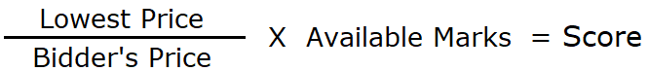

Appendix A - SPECIFICATION

Quality (Weighting 20%)
Case Studies/ Reference- demonstrate suitability of works
Please provide 2 case studies of recent works that are deemed similar to the consultancy that is requested within the ITQ.
Contact details are to be provided with each case study in order for references to be cross checked with the completed reference questionnaire (Appendix C)
Case Studies and References will be scored as part of the evaluation process described under paragraph 6.2 of the ITQ.
To support these case studies you must complete Section 1 of Appendix C and send the entire document (Appendix C) to your relevant referee. The referee must complete Section 2 and submit the completed document directly to the Council. Full instructions are included in the ITQ and Appendix C.

Cost (Weighting 80% - refer to 6.2 in the ITQ for how this will be evaluated)
Part a- Provide a one off cost to provide the following:
• Complete the procurement and associated contract documents as Agent to the Council for the new lift contract commencing from 1st April 2023 for a five year period. Procurement period of the new lift contract to be 6 months commencing from October 2022 and to be completed by March 2023.
• Closely work with the incumbent lift Maintenance contractor to ensure that all handover documents are provided prior to the end of the contract (during March 2023).
• Ensure that the incumbent contractor continues to provide the service up to the expiry date of 31st March 2023 and manage any transition arrangements from incumbent to new contractor.
• Draw up and formalise and arrange completion of all documents associated with the new bespoke contract for Lift Maintenance (from 1st April 2023 to 31st March 2028) including facilitating the signing of contracts by all parties.
Part b- provide a cost annually over a 5 year period for works to be carried out during the new contract. Works are to include:
• Provision of Technical support when required.
• Arranging and leading on Quarterly meetings with Lift Service Providers.
• Regularly review KPI’s detailed in the contract documents regarding the Lift Contractors.
• Evaluation of Insurance Reports provided by the Councils’ Insurers and liaising with Client and Contractors about appropriate actions.
• Comment on all issued quotations including liaison with Contractors for completion.
Part c- provide a cost to complete the following over the 5 year period:
• Annual Survey to be conducted of all lifts looking at the Quality of the Service being provided by the contractor. This Survey will also look at the general condition of each lift whereby a report is provided with recommendations for planned works across 1, 3, 5 and 10 year intervals.

Appendix B
Procurement for Lift Consultant July 2022
Please see below brief details of the lifts located throughout our Schemes, Hostels and Gosport Council Offices (Town Hall) for using as a reference for building up your costs for the quotation.
Locations to be managed (all locations are in Gosport)
• Woodlands House PO12 4BE - 1 x Passenger Lift (3 storeys)
This property was constructed in the early 1980’s in traditional construction and provides accommodation and other limited facilities for Housing tenants. Comprises of 29 flats which predominately caters for elderly residents. The communal areas consist of 3 stair core areas and 1no. vertical lift capable or serving all three floors. The lift is a Hydraulic Lester Hybrid that was upgraded and refurbished in 2009. The internal car is approximately 1050mm x 1500mm with a maximum occupancy for lift 8 persons or 630kg.
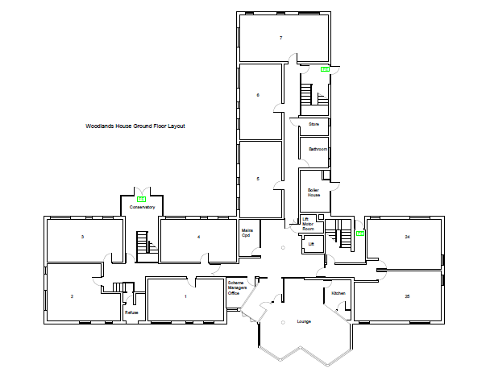
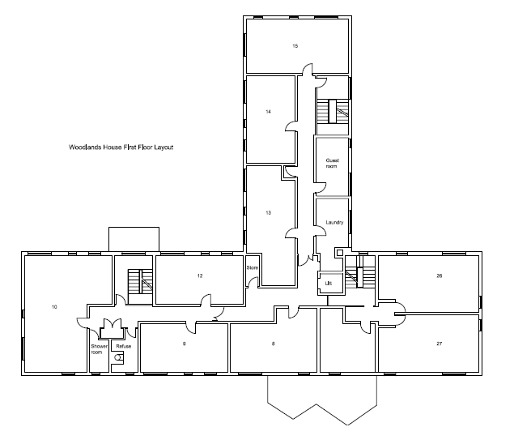
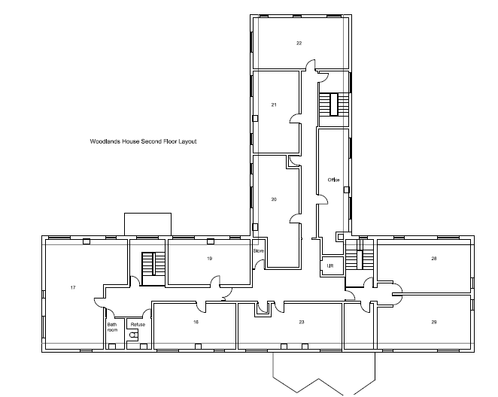
• Fortune House PO12 3UZ - 1 x Passenger Lift (2 storeys)
This property was constructed in the early 1980’s in traditional construction and provides accommodation and other limited facilities for Housing Tenants. Comprises of 33 flats which predominately caters for elderly residents. The communal areas consist of 3 stair core areas and 1no. vertical lift capable or serving both floors. The lift is a Hydraulic Lester Hybrid that was upgraded and refurbished in 2008. The internal car is approximately 1100mm x 1500mm with a maximum occupancy for lift 8 persons or 630kg.
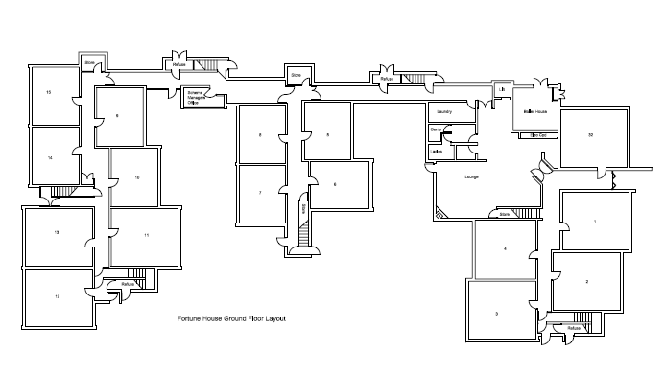
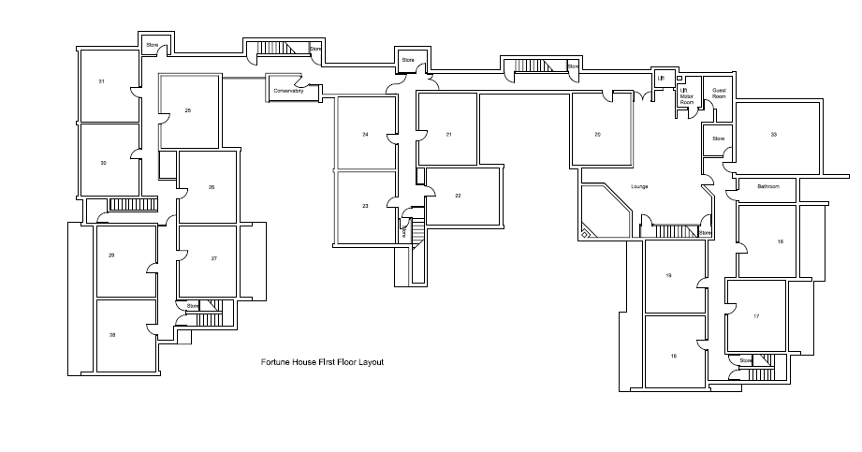

• Agnew House PO12 4FR - 1 x Passenger Lift (3 storeys)
This property was constructed in the 1970’s in traditional construction and provides accommodation and other communal bathing and cooking facilities for Housing Tenants. Comprises of 55 sleeping units which predominately caters for homeless and vulnerable residents. The communal areas consist of 3 stair core areas and 1no. vertical lift capable or serving all three floors. The lift is a MRL Traction Unit that was newly fitted as part of the overall refurbishment of the Hostel in in 2013. The internal car is approximately 1100mm x 1500mm with a maximum occupancy for lift 6 persons or 450kg.
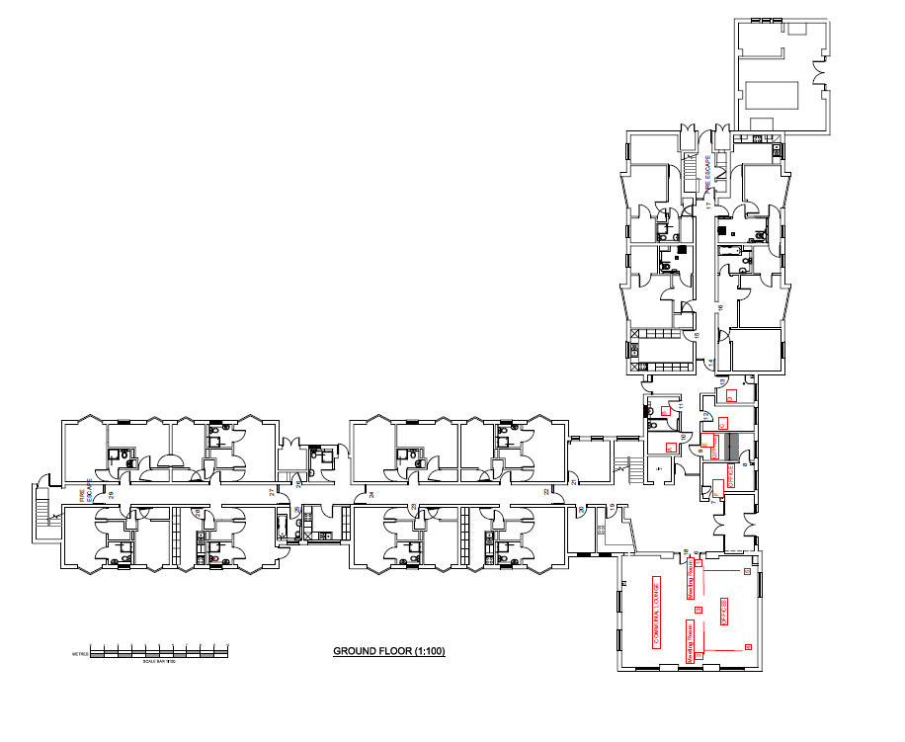
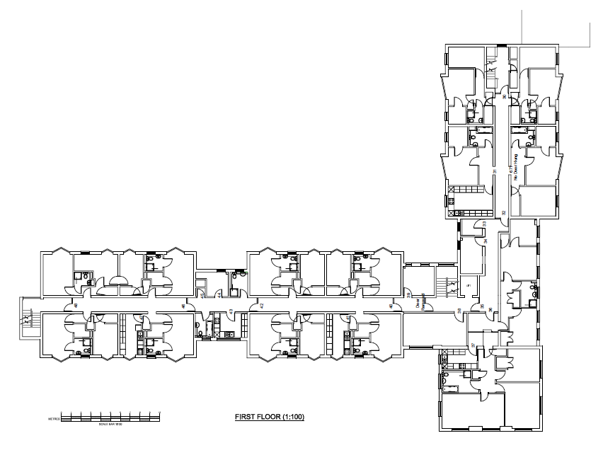
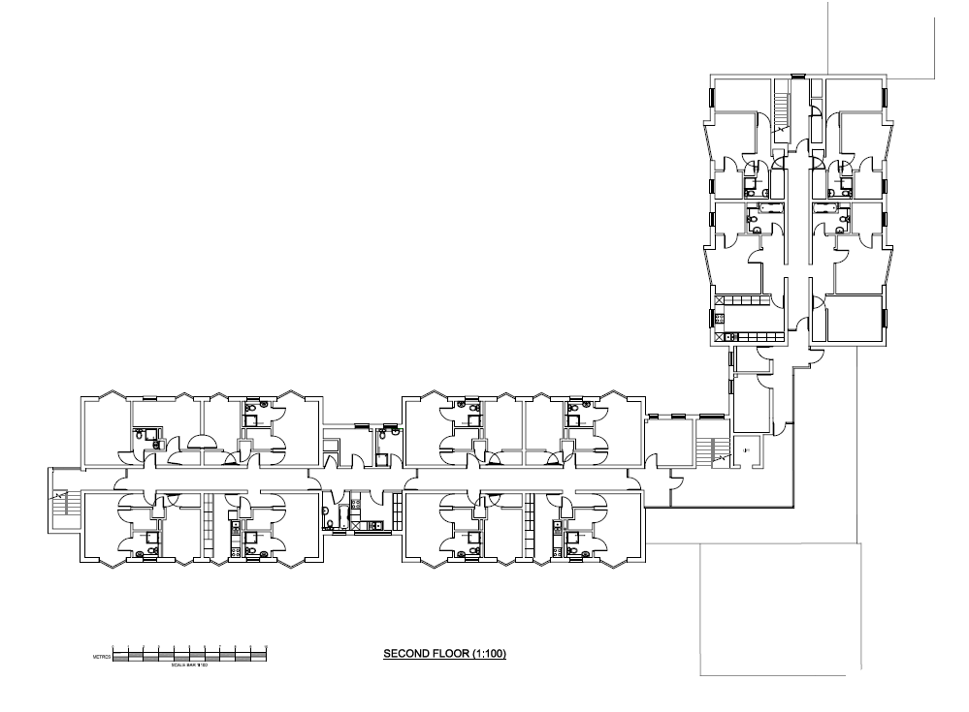

• Behrendt House PO12 4RS - 1 x Passenger Lift (2 storeys)
This property was constructed in the 1970’s in traditional construction and provides accommodation and other limited facilities for Housing Tenants. Comprises of 14 flats which predominately cater for elderly residents. The communal areas consist of 2 stair core areas and 1no. vertical lift capable of serving both floors. The lift is a Stannah Hydraulic unit that was installed in 1990. The internal car is approximately 850mm x 1450mm with a maximum occupancy for lift 6 persons or 450kg.
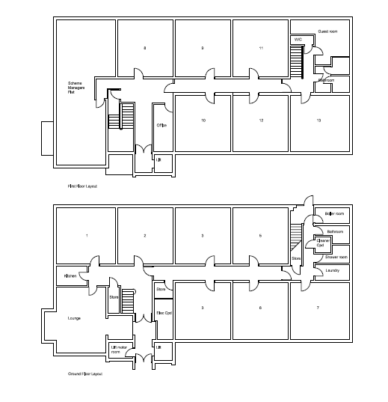

• Alec Rose PO12 1LZ - 1 x Passenger Lift (2 storeys)
This property was constructed in the 1960’s in traditional construction and provides accommodation and other limited facilities for Housing Tenants. Comprises of 27 flats which predominately cater for elderly residents. The communal areas consist of 2 stair core areas and 1no. vertical lift capable or serving both floors. The lift is a Hydraulic Stannah Unit that was installed in 1999 then later upgraded and refurbished in 2016. The internal car is approximately 850mm x 1450mm with a maximum occupancy for lift 6 persons or 450kg.
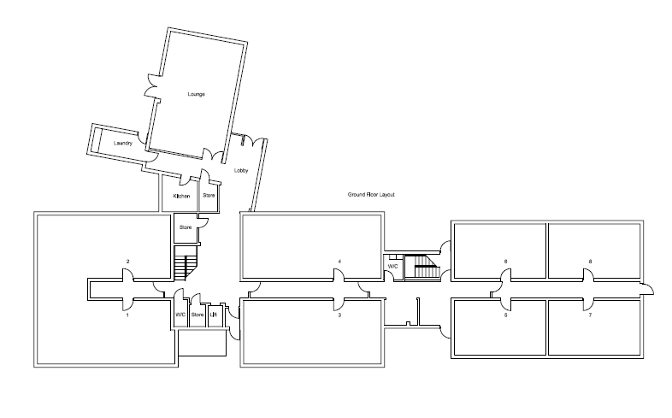
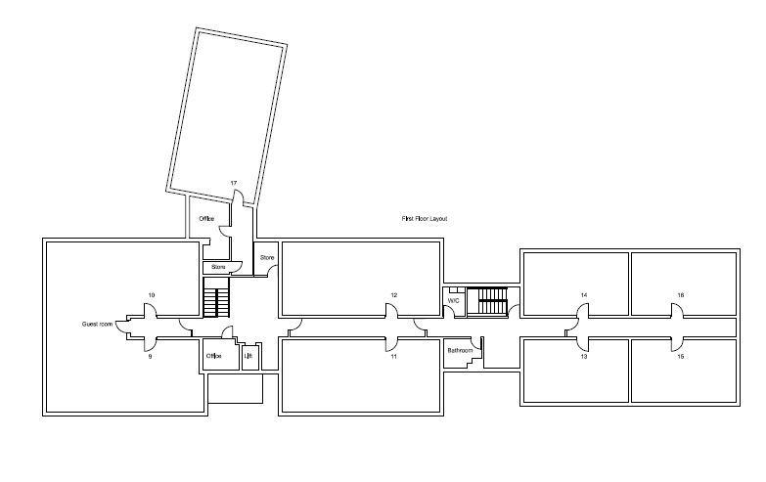
• Gloucester House PO12 1RP - 1 x Passenger Lift (2 storeys) + 1 x Stairlift (straight)
This property was constructed in the late 1980’s in traditional construction and provides accommodation and other limited facilities for Housing Tenants. Comprises of 36 flats which predominately caters for elderly residents. The communal areas consist of 3 stair core area and 1no. vertical lift capable or serving both floors. The lift is a Hydraulic Lester Hybrid that was upgraded and refurbished in 2012. The internal car is approximately 1100mm x 1500mm with a maximum occupancy for lift 8 persons or 630kg.
Due to the vulnerability of residents on First floor and the concerns over the vertical lift failing, the Scheme arranged for a straight stairlift to be installed at the staircase located at the furthest end of the Scheme. As this is in the communal area, this is serviced and repaired as part of the overall Lift contract and therefore is required to checked annually for compliance. This is a Stannah single chair straight stairlift.
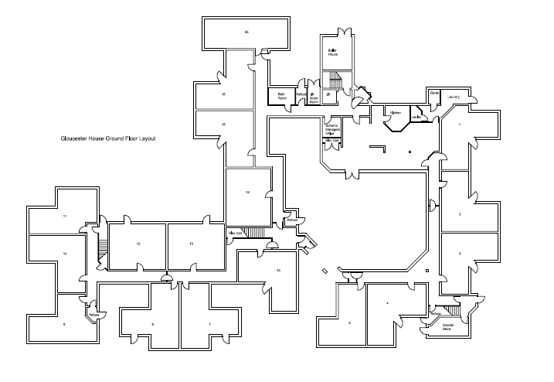
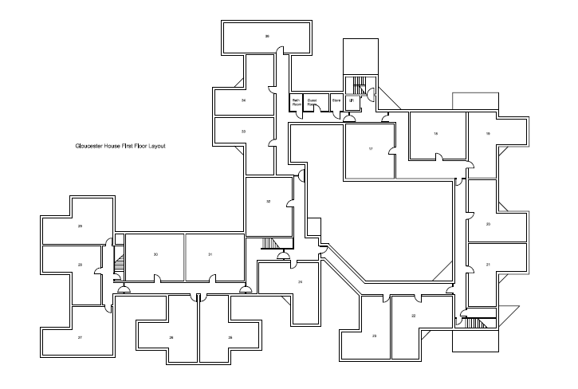

• Gosport Town Hall PO12 1EB - 3 x Passenger Lifts (2 at 3 storeys and 1 at 4 storeys)
The Town Hall was constructed in the 1960’s in a modular framed and infill construction and provides accommodation for staff and other limited facilities across Ground to Third Floors (4 Storeys). The communal corridors areas consist of a number of protected staircases and 3no. vertical lifts, 2 of which require access via 3 steps and only serve ground to second floors whereas the other lift is capable of providing access to all 4 floors (Ground to Third Floor).
The Public lift (serving all floors) is a Wittur Traction that was newly installed in 2017. The internal car is approximately 1050mm x 1400mm with a maximum occupancy for lift 8 persons or 630kg.
The second lift (Left side) was installed in 1963 Otis Traction Unit later modernised in 1995. The internal car is approximately 1100mm x 650mm with maximum occupancy of 6 persons and is only able to service floors Ground through to 2nd.
The third lift (Right side) was installed in 1963 Otis Traction Unit later modernised in 1995. The internal car is approximately 1100mm x 650mm with maximum occupancy of 6 persons and is only able to service floors Ground through to 2nd.
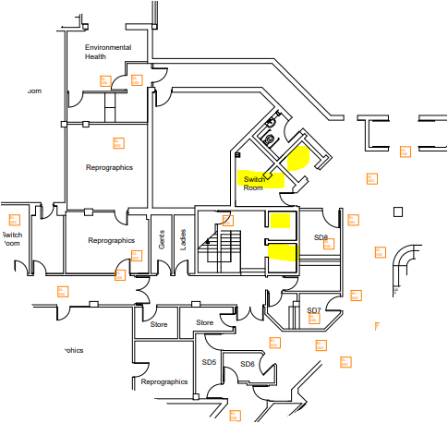
Section of Ground Floor plan showing “Public” lift (adjacent to WC) and a pair of lifts accessed by 3 steps.
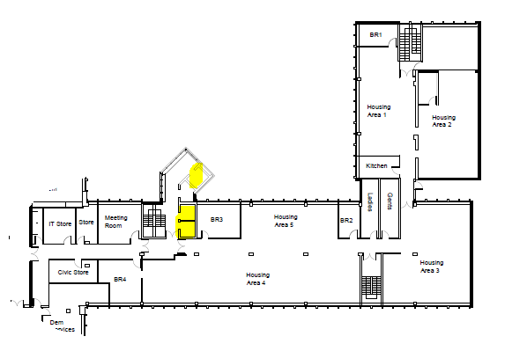
Section of First floor showing lift
