How to submit your Market test response

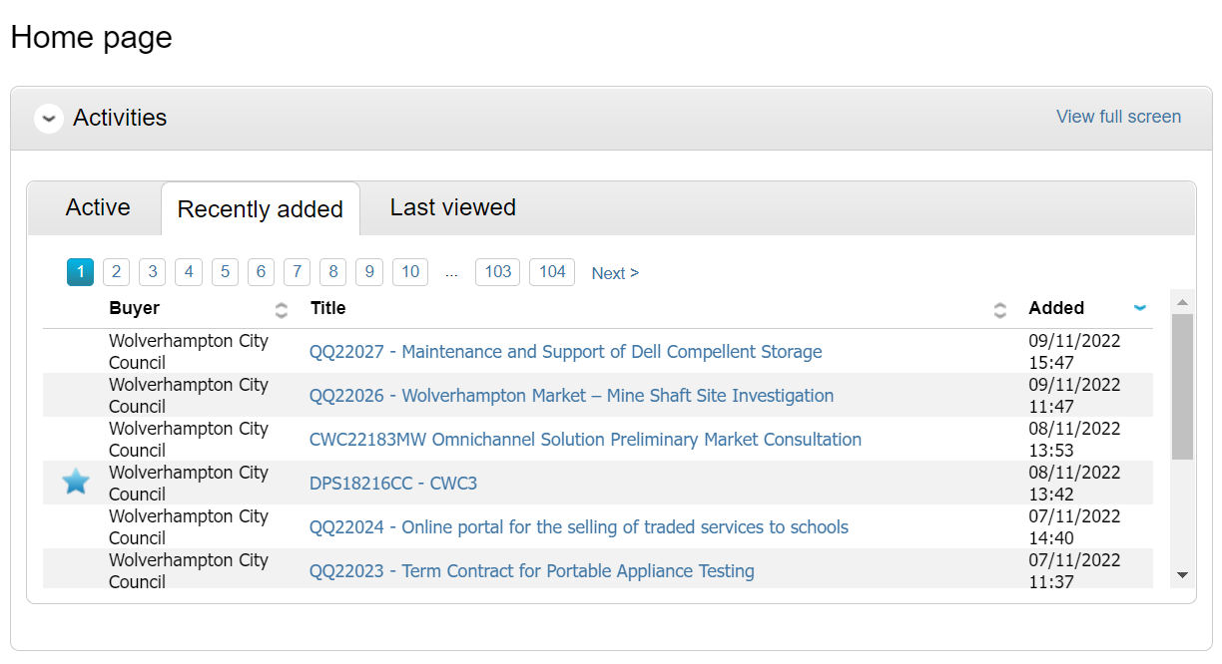
Click on the Preliminary Market Test link you want to respond to.
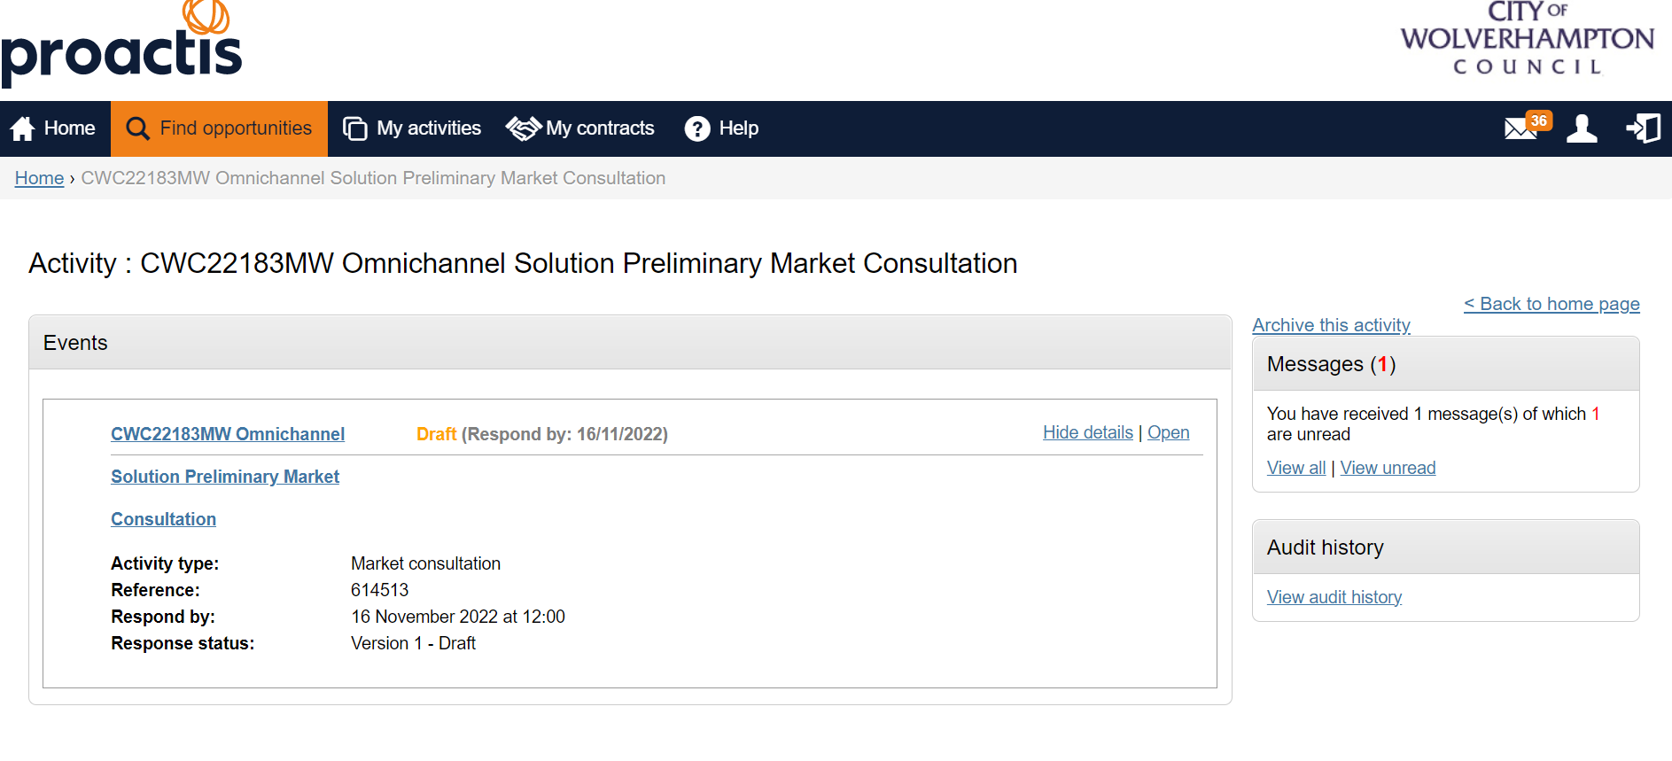
Click Open

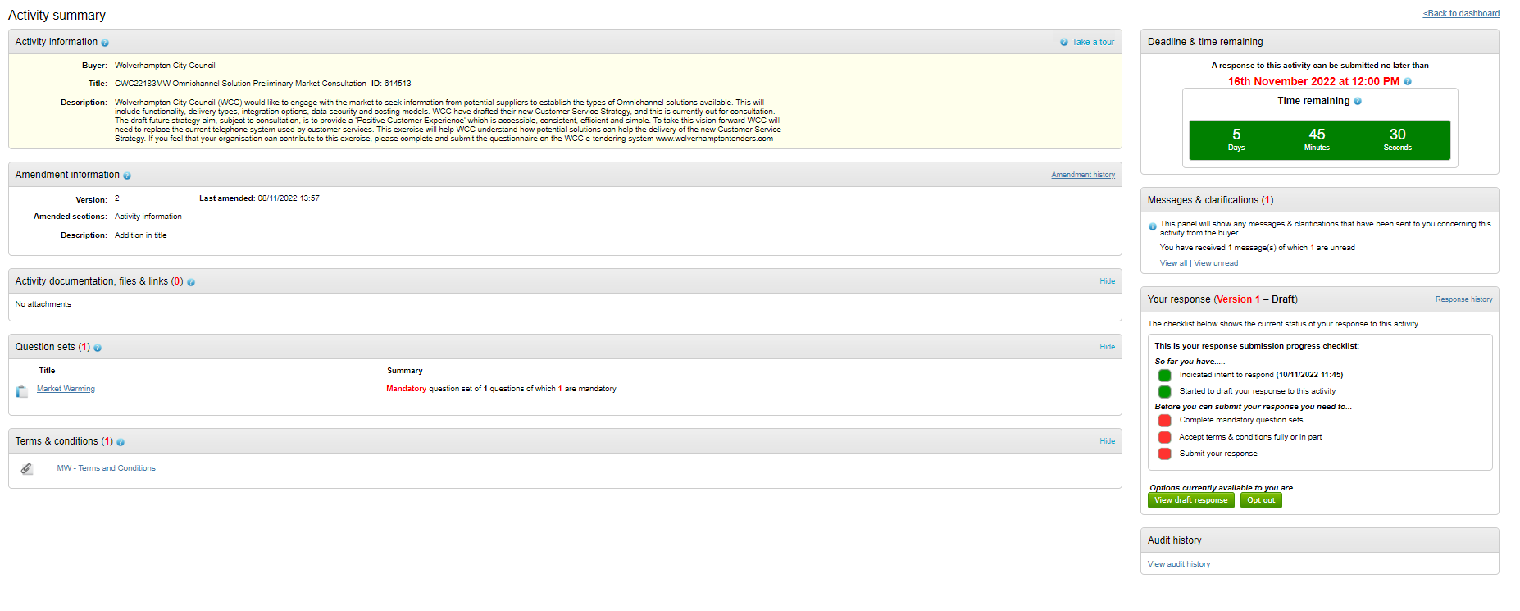
Click view draft response

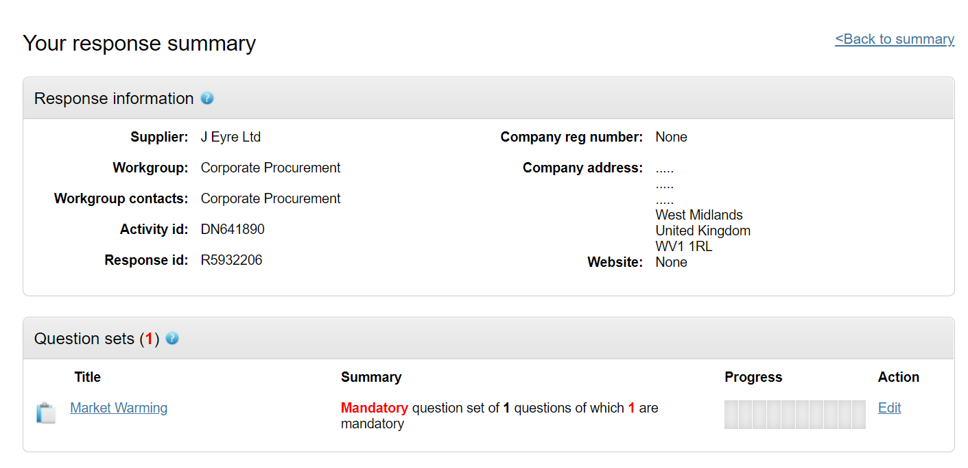
Click Edit
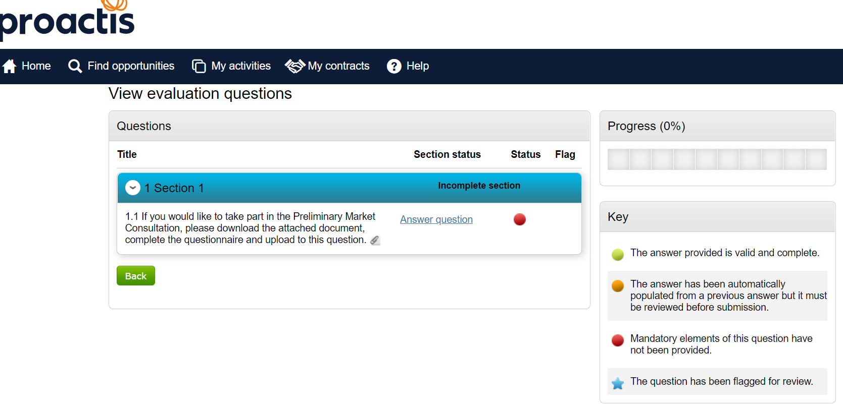
Click Answer question
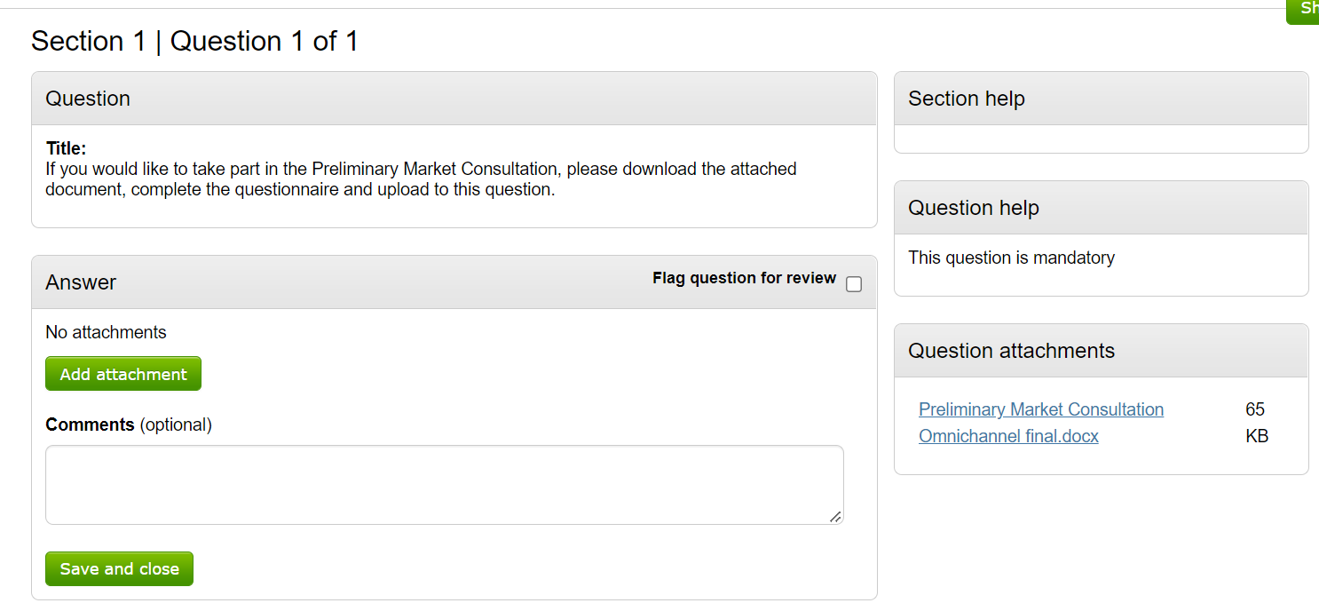
Download the document(s) and add in your response.
Upload your completed document here

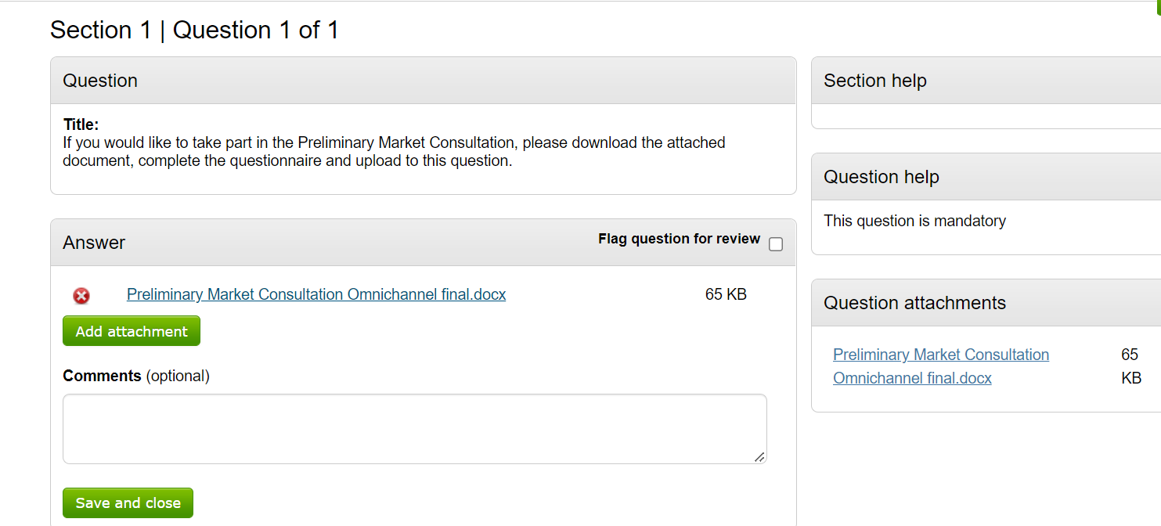
Your uploaded attachment(s) should appear here
Click Save and close
Following this you will need to accept the terms and conditions. There are no terms for this market test, this is just a mandatory question that can’t be removed.

Click on submit response

