PRE TENDER MARKET ENGAGEMENT QUESTIONNAIRE
Lincolnshire County Council is in the process of re-commissioning and procuring a contract(s) to deliver a Domestic Abuse Support Service. To that end we are seeking to understand the market’s preferred approach to a number of important issues to inform the decision making process. Below is a market engagement questionnaire.
Part 1 is a summary description of the services required and relevant background information. Part 2 is a series of questions upon which we would like to understand the preferred approach of the market. Please be as open as possible and include problems that may be encountered. As the Council wishes to proceed expeditiously, we are seeking responses to the questionnaire by 17:00 on Thursday 24th March 2022. We may also have some follow up questions, if so, an appointment will be made to speak with you by telephone or face to face as appropriate.
The responses will be collated and anonymised before being provided to the core decision making team. We are keen to understand a true reflection of the market's views; your answers will have no influence on your further participation in this process, and all responses will be treated as confidential and commercially sensitive. We are grateful for your participation in this questionnaire.

Domestic Abuse in Lincolnshire
Domestic abuse has a significant impact upon the communities and public services of Lincolnshire. Estimates from the Crime Survey for England and Wales (CSEW) year ending March 2020 suggests 5.5% of adults aged 16-74 will have experienced domestic abuse in the last year. This national figure would equate to roughly 30,200 adults aged 16-74 experiencing domestic abuse in Lincolnshire (assuming a similar prevalence in Lincolnshire compared to the England and Wales average).
The true number of victims of domestic abuse is also likely to be higher when children are included. CSEW figures suggest that 41% of partner abuse victims suffered abuse while their children were in the house, and that 21% of victims disclosed that the children did see or hear what happened. (Source: Office of National Statistics) If only one child was present at each of the 21% of domestic abuse victimisations in Lincolnshire each year, this would mean that 5,500 children witnessed domestic abuse in their home each year. This means that the true number of Lincolnshire residents affected by domestic abuse each year is likely to be upwards of 35,700 adult and child victims.

Current Domestic Abuse Support Services
LCC currently commissions services to support adults and children across the county who are experiencing/have experienced Domestic Abuse. These services include:
- A countywide Outreach Support Service with dedicated provision for Children and Young People
- An Independent Domestic Violence Advisor Service (IDVA)
- Refuge Services
LCC are in the process of re-commissioning the Outreach and IDVA elements of their service offer. These contracts have been in place since August 2018.
The current Domestic Abuse Services are procured as separate lots for:
1. IDVA Services
2. Outreach Services
The Council also has a countywide contract in place for Refuge Services, which does not form part of this re-commissioning activity.
The Perpetrator programme and Victim Support in Lincolnshire currently sit with the Office of the Police and Crime Commissioner (OPCC) and do not form part of this re-commissioning activity.
To read the full specification for both the IDVA and the Outreach services please see imbedded documents below.
Summary scope – IDVA service
The IDVA Service is commissioned to support victims (men, women and young people aged 16 and over) who reside within the geographical boundaries of Lincolnshire, and who have been referred to a Lincolnshire Multi-Agency Risk Assessment Conference (MARAC).
An IDVA provides confidential advice, information, advocacy, and support to service users about the range, effectiveness, and suitability of options to reduce their risk and ensure their safety and that of their child(ren) and vulnerable associates. Interventions are based on a thorough understanding of a range of issues and assists individuals and their families to access criminal and civil justice remedies, housing, counselling, advice, health, and other support services.
The service also proactively participates in multi-agency responses to child and adult safeguarding by attending, where appropriate, meetings such as MAPPA (Multi-Agency Public Protection Arrangements) Anti-Social Behaviour Risk Assessment Conferences (ASBRACs), Child Protection, Child in Need and Team Around the Child meetings, representing the service user at these meetings.
Dedicated Hospital IDVA posts have also been funded during the current contract term to reduce the immediate risk of harm and homicide and improve the physical and mental health outcomes of those affected by domestic abuse and receiving treatment. The hospital-based IDVA's provides immediate support and advice to victims to improve their safety and advocacy, as well as link them and their families to longer-term specialist community-based support services.
A two-year funding award from the Ministry of Justice has meant recently a Court IDVA, Child and young person IDVA and Rural IDVA has been added to the service.
Current Service Referral Demand (main service and hospital IDVA)
 | Quarter 1 | Quarter 2 | Quarter 3 | Quarter 4
2020-21 | 172 | 259 | 230 | 237
2021-22 | 242 | 222 | 242 | Not yet available

Summary scope - Outreach services
The countywide Outreach Domestic Abuse Support Service is commissioned to work with all adults (16 years and upwards) victims of domestic abuse both male and female and any child(ren) in the family setting. Those assessed (using the Domestic Abuse Stalking and Harassment risk assessment tool (DASH 2009) as high risk of serious harm or death are referred to MARAC. Victims accepted by MARAC are supported by the Independent Domestic Violence Advisor service (IDVA) described above.
The key expectations of the current service are;
- To triage referrals to ensure that they are prioritised and managed in an appropriate and timely manner.
- Risk Assess and produce safety plans with all victims of DA who engage with the service.
- To assess emotional health and wellbeing of victims and develop and review support and safety plans.
- Support plans include direct support; one to one and group therapeutic interventions and supporting to access signposted agencies.
- Support victims with court proceedings and applying for civil injunctions
- Work with parents to support and develop skills to support their child(ren) affected by domestic abuse and to help them stay safe.
- Complete Early Help Assessments and act as lead professional where necessary.
- Support is for a maximum of six months
The children and young people element is available to those aged 5 to 16 years, whose non abusive parent is already accessing Outreach support, as well as Looked After Children, those under a Special Guardianship Order (SGO) and adopted children. The support is suitable for those assessed as having higher levels of need or experiencing the more serious effects of domestic abuse. Those children and young people are provided specialist 1:1 therapeutic support and interventions that focus on the needs of the child, considering factors such as age and vulnerability.
Current Service Referral Demand
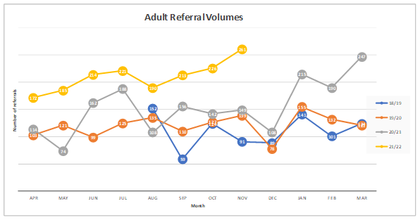
The Outreach services has seen an increase in referral demand in recent years, as depicted in Figure 1 below. Analysis of the source of the demand growth identified a complex picture noting the impact of the Covid-19 pandemic and from December 2020 revised internal processes impacting the volume of referrals from Lincolnshire Police.
Figure 1
 | Quarter 1 | Quarter 2 | Quarter 3 | Quarter 4
2020-21 | 350 | 452 | 399 | 652
2021-22 | 571 | 624 | 1062 | Not yet available

Referrals for the Outreach service are currently received from Lincolnshire Police, health sources, community services and self-referrals. Most of these referrals are made by a partner agencies (80% currently), suggesting that in the majority of outreach cases some form of agency intervention has already occurred. The current service model is focused on responding to referral volumes from these key sources and does not include any expectation to conduct pro-active outreach to identify potential victims.
The vast majority of cases currently supported by the Outreach service are classified as Standard and Medium risk via the Domestic Abuse Stalking and Harassment risk assessment tool (DASH 2009). The current risk profile is shown in the chart below:
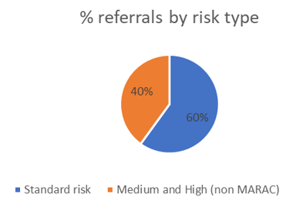

For targeted CYP services the level of current demand is shown below:
 | Quarter 1 | Quarter 2 | Quarter 3 | Quarter 4
2020-21 | 70 | 37 | 124 | 72
2021-22 | 64 | 82 | 74 | Not yet available

Proposed New Service Model
Set out below is the Council’s current thoughts on the New Service Model.
Aim and Objectives
- To support the Council and the Lincolnshire Domestic Abuse Partnership to meet its Domestic Abuse Act 2021 duties.
- To support the Lincolnshire Domestic Abuse Partnership to meet the aims and ambitions of the Preventing Domestic Abuse Strategy (2021-24) including stopping domestic abuse through education, prevention, and holistic interventions.
- To embed preventative and early intervention approaches into service delivery.
- To deliver strength based and person-centred interventions to meet the diverse needs and desired outcomes of victims.
- To champion raising awareness and understanding of domestic abuse.
- To contribute to developing and enhancing delivery and performance intelligence on domestic abuse incidence, interventions, and outcomes for victims across Lincolnshire.
New Service Model

Please see below a diagram representing the vision for the Domestic Abuse Support Services. Note this is purely indicative and is intended to assist you in understanding the Councils current thinking around the service model:
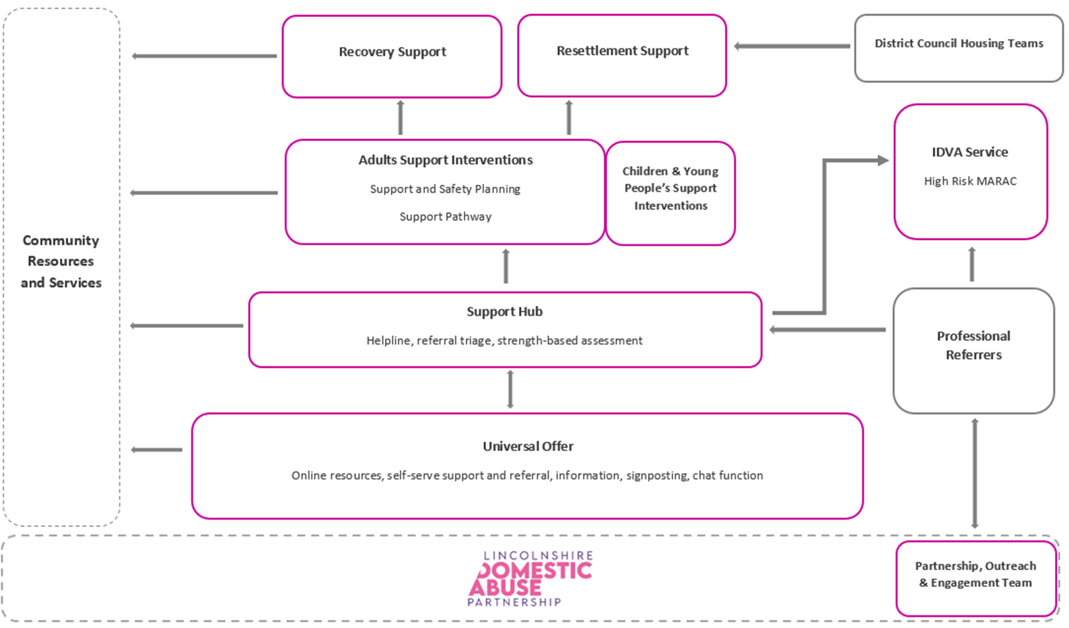

The proposed elements of the Lincolnshire Domestic Abuse Support Service are:
- A Universal digital based support offer to all victims of domestic abuse in Lincolnshire
- A Support Hub, including helpline, effective triage function and strength-based assessment provision
- Community based support intervention pathways for adults and children/young people
- Resettlement Support
- Recovery Support
- An IDVA Service
These are set out in more detail below;
Universal Digital Support Offer
- Development of dedicated service website, including access to self-serve information, a range of online resources for victims, their family and friends and professionals
- Chat function
- Signposting and online self-referral function to specialist intervention support pathways
- It is intended that this support offer will meet the needs of a proportion of victims without the requirement for further specialist interventions. This will assist in managing the service demand for lower risk cases through the eligibility determination beyond the universal support.

Support Hub
- Providing a helpline service for advice, support, and self-referral if necessary
- Effective triage and risk prioritisation of all self and professional referrals
- Strength-based assessment and eligibility determination for specialist interventions. The service will have trigger points for intervention to help prevent escalation of volume, complexity and severity of abuse while helping to control demand.

Community based specialist support intervention pathways
- Offering person-centred support and safety planning for adults and associated children and young people, leveraging community assets.
- A range of specialist creative intervention and support pathways to meet the holistic needs and self-determined outcomes of victims
- Regular support plan reviews
- Effective joint working with partner agencies also supporting victims needs

Resettlement Support
The new Domestic Abuse Act 2021 has placed a requirement on Local Authorities in relation to safe accommodation and support. Elements of that will sit with the refuge services, however it is proposed that the DASS will have a role in supporting people experiencing domestic abuse who are transitioning into accommodation.

The intention is for this new service element to have direct links with the Housing authorities in relation to homelessness and provide support to people transitioning into independent accommodation. With the ability to offer support to District partners on initial contact if needed and longer-term support to help them transition into appropriate accommodation. It would be preferred if this new service element could also offer longer term support to service users accessing other DASS interventions that have particular barriers preventing them from moving on successfully.

Recovery Support
- Longer-term emotional and wellbeing support element post specialist intervention to support victims with civil injunctions, legal cases, transitions or continuing complex needs support.
- Opportunity for peer support

IDVA Service
- Specialist IDVA intervention support to all cases at Lincolnshire MARAC
- To ensure the views of identified high risk victims of domestic abuse are represented at the MARAC
- Strength-based, outcome focused assessment and support, to increase the safety of identified high risk victims and their child(ren) and vulnerable associates.
- Provision of appropriate information, advice and support to identified high risk victims in relation to civil and criminal justice system and access to other support services.

Links to the Lincolnshire Domestic Abuse Partnership
There is further funding available through the Lincolnshire Domestic Abuse Partnership to employ a team of Partnership, Outreach and Engagement officers to focus on targeted work alongside the DASS Provider. It is envisaged this team will support the development of partner referrals and joint working and facilitate targeted engagement within areas of the county and victim profiles that may benefit from specialist proactive interventions. A comprehensive review of demand and prevalence intelligence suggests this will include but is not limited to;
- Boston and Spalding areas with a focus on those with English as secondary language
- The East Coast and those with disability/long term illness
- Lincoln’s younger adults and/or student population

Indicative Demand
The IDVA service currently receives approximately 900 referrals a year with engagement levels of around 50%. The current Outreach service model has seen referral demand increase over recent contract years as set out above (1,500 in 2020-21 and 2,200 in initial three quarters of 2021-22).
The development of a universal digital support offer is intended to support the management of future demand to prioritise short term specialist interventions to those with complex needs and high-risk circumstances. The trigger points to access specialist interventions beyond universal support is to be developed and refined as part of this and further engagement activity.
There is scope for demand on the current iteration of services to increase further from current levels. Health referrals, while relatively high in the national context, are not as high as might be expected based on victim disclosure rates to health professionals. Referrals from GP services are especially low. Equally, the creation of the Partnership, Outreach and Engagement officers within the Lincolnshire Domestic Abuse Partnership is likely to increase self-referrals within target populations and potentially amongst partner agencies.

Indicative Budget
The indicative budget for the Domestic Abuse Support Services, including the resettlement support element is £1,172,400 (inc. VAT) per year;
- £300,000 (inc. VAT) IDVA Element
- £632,400 (inc. VAT) Community Outreach Services Element
- Further monies up to £240,000 (inc. VAT) may be available for re-settlement support (DA Act 2021)

Indicative Project Timescales

- Finalise specification and procurement documentation by August 2022
- Tender process (including evaluation) – September 2022 to November 2022
- Supplier mobilisation – January 2023 through to March 2023 (12 weeks)
- Contract commencement – 1st April 2023

Current Spec Outreach Current Spec IDVA

PART 2
Questionnaire
Q1 | CONTRACT DURATION  The authority would like to understand the views of prospective providers regarding letting the contract for an initial term of 3 years with an option at the authority’s discretion to extend by up to a maximum of a further 2 years (3+1+1).  (a) Is this a reasonable term to let a contract on with a view to achieving a value for money contract and if not, why not?  (b) What other term, if any, would offer best value to the authority and why?
A1(a)
A1(b)
Q2 | CAPACITY AND COVERAGE  Would you be equipped to provide for the full scope and demand of Domestic Abuse Support services required in Lincolnshire as indicated in Part One?  - The current services are provided through two separate contracts: IDVA and Outreach; would you as a provider be able to provide the services with existing resources or will you be looking to deliver the services in partnership with another provider/s?  - Would you seek to collaborate with a third party provider to deliver the service, or aspects of the service through arrangements such as sub-contracting, on your behalf?  - Are there any weaknesses regarding the model we have described for our approach in terms of the impact on the individual elements described?
A2(a)
A2(b)
A2 (c)
Q3 | DELIVERABILITY  Currently the proposed annual budget would be £1,172,400 (inc. VAT). This is balanced between the current IDVA and Community outreach service and includes childrens and resettlement support services.  - Please provide your views on the commercial viability and attractiveness of delivering an effective service at the volume and within the budget indicated. Please bear in mind the additional resettlement monies that the Council has received to meet the obligations under the new DA Act 2021.  - Within the proposed model for the service there is an emphasis on using other services provided in the community and within the partnership effectively to manage demand. From your experience how can this be harnessed to manage demand effectively?  - Being mindful of the Lincolnshire demography and the prevalence of specific risk factors what would be the best model for delivering an equitable service across the county?  - Within an essentially reactive referral model, what would be the best way to ensure equity in achieving improvements in outcomes? Bearing in mind the obligations of the referral agencies to the individuals.  - Do you have your own case management system? If so, what is the name of the system? Have you used case management systems belonging to the contractor?
A3 (a)
A3 (b)
A3 (c)
A3(d)
A3(e)
A3 (f)
Q4 | PAYMENT MECHANISM  The authority is considering the most suitable payment mechanism to put in place to ensure delivery of the best value service (for example single rate payments according to categories of service delivery, and the use of performance incentivisation (enhancements for quality standards)  - In your view, what payment mechanism(s) would work best in the interests of both the authority and the provider?  - In your experience what model has worked well to deliver targeted services?
A4 (a)
A4(b)
Q5 | CONTRACT PERFORMANCE MONITORING  Contract performance monitoring is critical to this service provision. KPI’s will be used to assess provider progression and performance.  - Are there any specific performance indicators that you believe would support the DA model best?  - What key outcomes might usefully be incorporated to measure the impact that this service has on individual and population level outcomes?
A5(a)
A5 (b)
Q6 | CONTRACT ATTRACTIVENESS  What are the key factors influencing the attractiveness of this type of contract for your organisation? (for example, contract term, potential scope to transfer staff from incumbent provider, other commercial factors)
A6
Q7 | MOBILISATION  We have currently built in a period of 17 weeks between contract award and contract start date.  a) Do you think this will be an adequate period to enable your organisation to begin delivery of Domestic Abuse support services?  b) What would you advise we do to ensure that the mobilisation goes smoothly?  c) Is there anything else we need to consider?
A7(a)
A7(b)
A7 (c)
Q8 | OTHER INFORMATION  Are there any other issues the council should take into account when compiling the contract in order to achieve best value from its delivery? E.g., with reference to the DA Act 2021 obligations, use of Technology, timescales etc.  If more than one, please list in priority order with the most important first and give a brief explanation of each.
A8

Please return this questionnaire no later than 17:00 on Thursday 24th March 2022 through the Pro-Contract portal at https://procontract.due-north.com/Login
We may have some follow up questions; it would be appreciated if you provide contact details below:
Contact Name
Company
Telephone
Email

Equally, if you would like further information to assist you in responding to this questionnaire, please contact Reena Fehnert through the Pro-Contract portal at https://procontract.due-north.com/Login or by email at reena.fehnert@lincolnshire.gov.uk

