Blackpool Opportunity

PROMENADE SOUTH

Land between South Pier and Sandcastle Waterpark, Promenade, Blackpool, FY4 1BB

- Location

Situated approximately 1.5 mile south of Blackpool Tower, located on a busy area of the Promenade between South Pier, Sandcastle Waterpark and opposite the Velvet Coaster.

- Site description
A relatively level ‘P’ shaped site of approximately 3,000 sq m (0.75ac), measured externally, fronting directly onto the Promenade and backing onto the Beach with access. This prominent site is located between the popular attractions of South Pier and Sandcastle Waterpark and is opposite The Velvet Coaster and Blackpool Pleasure Beach. Mains electricity is available close by and there is access to Public Toilets opposite. The site is fully hard surfaced.
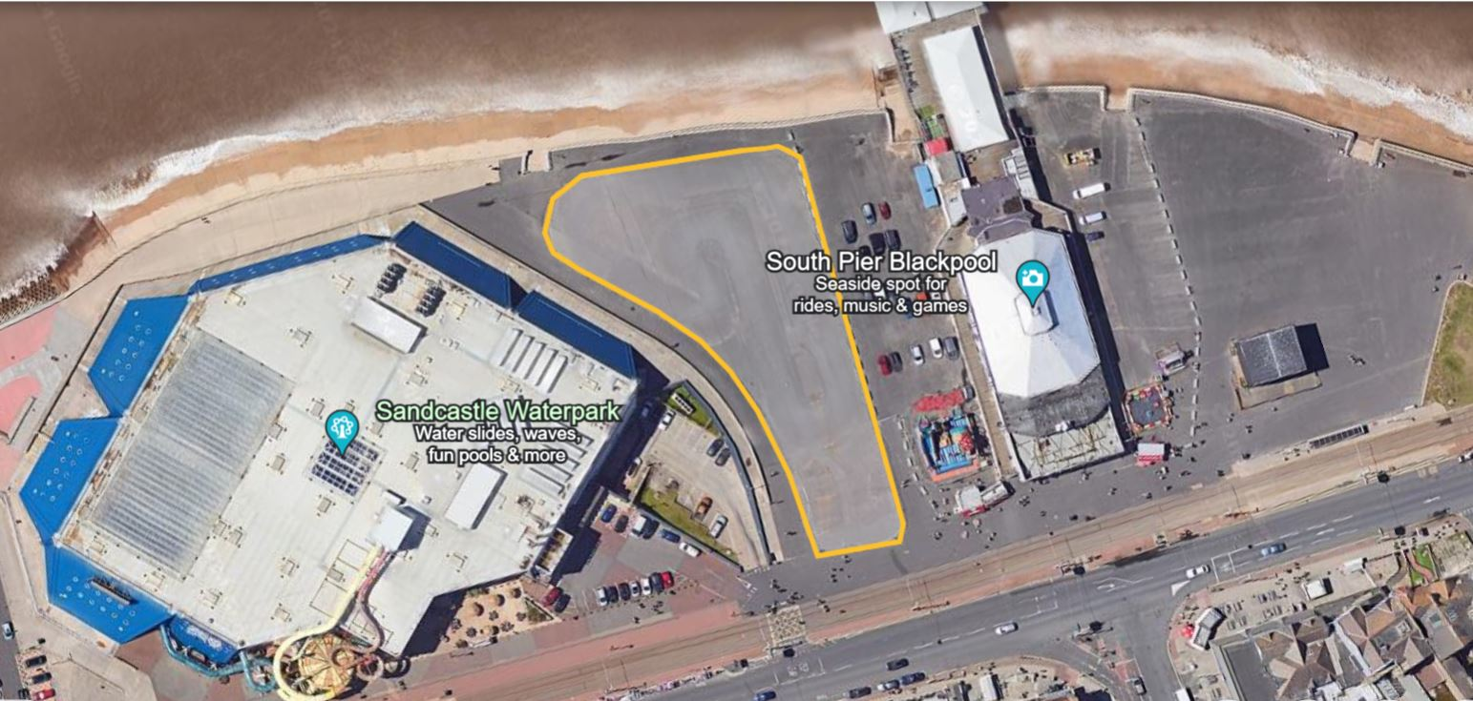

- Opportunity and Use

Potential leisure use (traditional multi-ride fairground use will not be considered).
The majority of the site sits within Flood Zone 3 and therefore any proposals for the site need to take this into account, together with relevant planning considerations.
Any proposed development must;
- Be of a high quality.
- Have due consideration to the Impact on the Area (i.e. sea wall and tramway etc.)
- Have regard to the Civil and / or Structural Engineering impact on the site.
The successful applicant will be responsible for obtaining any necessary planning and other statutory consents.

- Terms
A contracted out lease for a term up to 15 years will be considered subject to negotiation with the successful applicant on a fully repairing basis.
Offers are invited for the site by way of an annual rent payable quarterly in advance. The Council may consider a turnover rent.
The Tenant will also be liable for meeting all other outgoings to include utilities and business rates.
The Council’s legal fees and surveyors costs are to be paid by the successful applicant.

- Timescales
Application closing date Midnight 18th July 2024
Applications assessed w/c 22nd July 2024
Organisations notified of outcome w/c 29th July 2024
Deadline for receipt of clarifications 1 week prior to application closing date

Any clarifications must be sought no later than one week before the application closing date. For any enquiries please contact: Christopher Wilcock MRICS, Estates Surveyor at estates.enquiries@blackpool.gov.uk or 01253 478753.

- Assessment Process

Interested parties should submit an application which will be assessed by a panel of officers from Blackpool Council. Applications will be assessed using the headings outlined below.

- Proposed Use / Current Delivery / Proposed Use
Examples of what we’re looking for:

- What you are proposing to use the site for? Will it have a unique appeal and be different from what Blackpool already has to offer? What will it look like? How noisy will it be? What is the quality of the build?
- Provide information about any leisure attractions you currently operate.
- Provide information that will help us understand your business, its vision, aims and objectives and what type of organisation you are.
- You may support your response with drawings, specifications or photographs showing your proposal.

Please insert your response below:

- Staff Management and Community Benefit
What we’re looking for:

- Information on your management approach in relation to staffing.
- What benefits could your proposal bring to the wider community?

Please insert your response below:

- Finances
What we’re looking for:

- In this section we require a 3 year income and cash flow projection. Please include descriptions and any assumptions you have made to support the forecasts.
- Information about what capital investment you will be making, and details of any funding that you will be obtaining.
- Details of the company / legal entity that will be entering into the lease for the land.

Please insert your response below:

- Rent Proposed
What we’re looking for:

- Provide a profile of the rent that you will pay to the Council over your proposed term.

Please insert your response below:

- Contact Details and Declaration
- I declare that to the best of my knowledge the responses submitted and information contained in this document are correct and accurate.
- I declare that, upon request and without delay I will provide the certificates or documentary evidence referred to in this document.
- I understand that the information will be used in the selection process to assess my organisation’s suitability.
- I understand that the authority may reject this submission in its entirety if there is a failure to answer all the relevant questions fully, or if false/misleading information or content is provided in any section.
- I am aware of the consequences of serious misrepresentation.

Section 1 | Contact details and declaration
 | Question | Response
1.3(a) | Contact name
1.3(b) | Name of organisation
1.3(c) | Role in organisation
1.3(d) | Phone number
1.3(e) | E-mail address
1.3(f) | Postal address
1.3(g) | Signature  (electronic is acceptable)
1.3(h) | Date

If the preferred bidder fails to obtain planning permission for their proposed use and / or the lease negotiations are not concluded within a reasonable timescale, the Council reserves the right to make an offer to the next preferred bidder but may choose to re-advertise the opportunity. The Council may post evaluation decide to contact bidders to discuss splitting the site between two appropriate bidders to make best use of the available land.

NB please retain a copy of this form for your records and should your circumstances or contact details change then please let the appropriate contact officer know.

Any information you provide on the form will be held by Blackpool Council for the purposes of assessing the application and decision making process. If successful it will be held for the term of the lease. If unsuccessful it will be held for 5 years.

Please Note: The information provided in this document is set out as an outline only, for guidance and does not constitute nor constitutes part of an offer or contract. All descriptions, dimensions, references to condition and other details, are given in good faith and believed to be correct, but all interested parties should not rely on them as statement or representation of fact, but must satisfy themselves by inspection, enquiry or otherwise as to the correctness of each of them.

