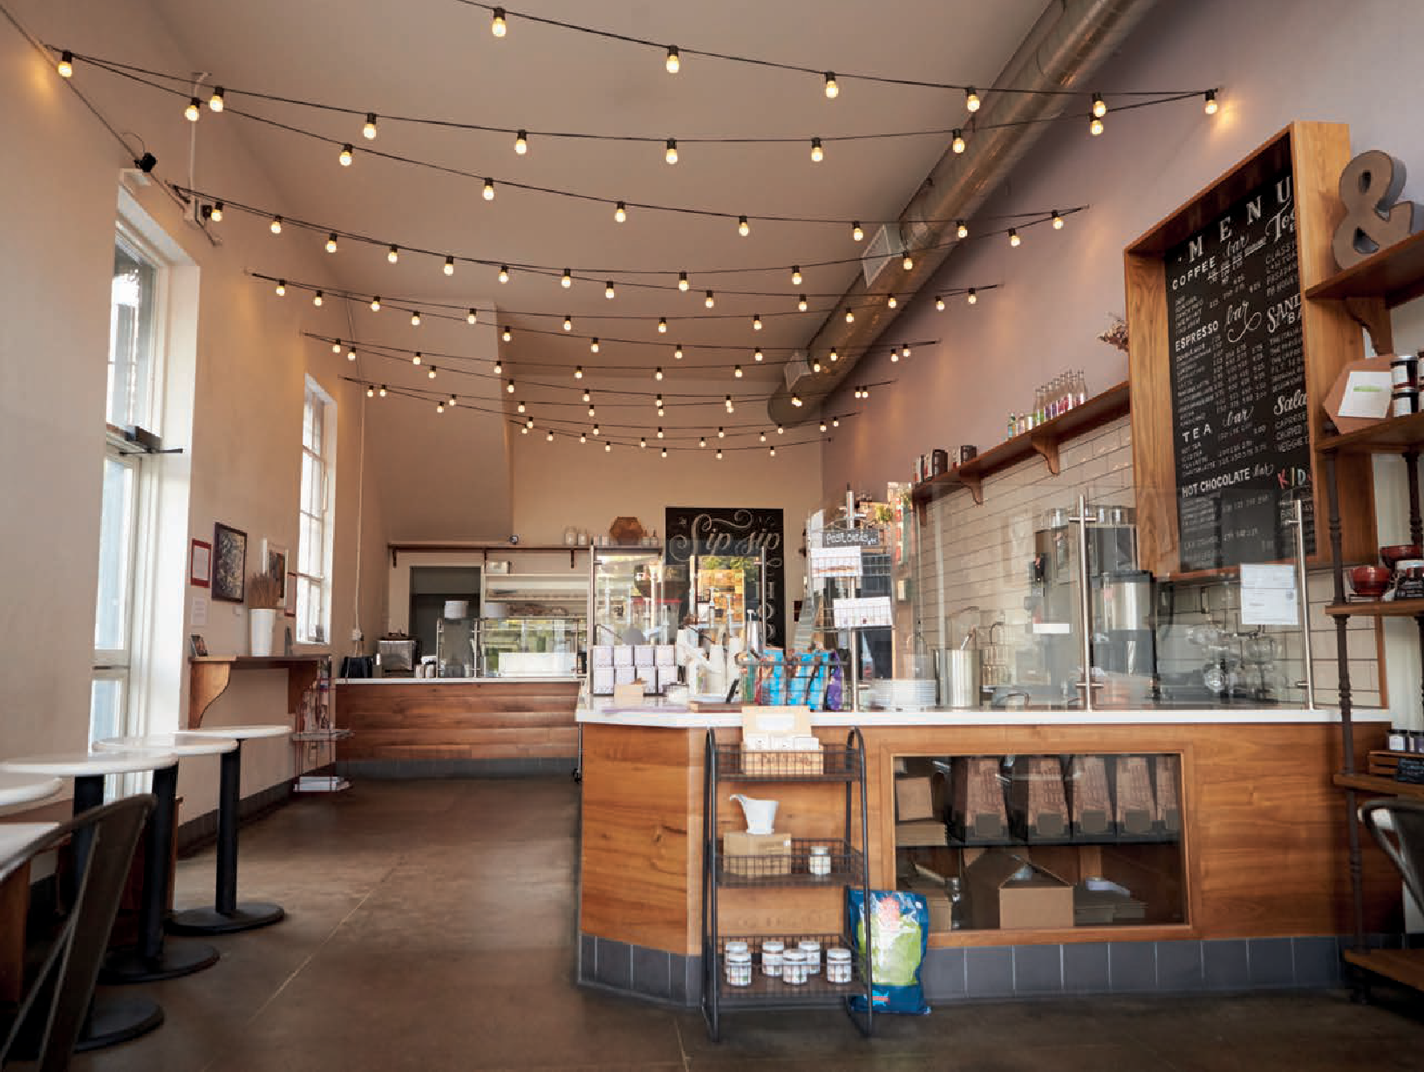
ELMSBROOK CAFÉ BICESTER
REQUEST FOR PROPOSAL

About Elmsbrook Café
A2Dominion is offering a unique opportunity to create a brand-new, vibrant café at the heart of the Elmsbrook Community - the first phase of the NW Bicester Eco Town.

The café, which is 134m2 excluding facilities, is being designed and built with space for a commercial kitchen and will provide space for
40-50 covers (approx.). The café provider will be required to fit out the kitchen and dining area.

The flexibility of the new space means a business has the potential to stamp their own brand on the venue in partnership with A2Dominion and exponentially grow their business. The café would be available for occupation in Spring 2023.

Other amenities include:

- Outdoor seating to the front of the café

- Catering opportunities for large events

- Disabled access and parent and child facilities

- Visitor’s car/ cycle parking

- Electric vehicle charging.
Our vision
The café will be a vibrant new destination at the heart of the Elmsbrook Community. It will
promote healthy living with a range of handmade, seasonal, locally sourced food and beverages and be sustainability conscious.

The café will be a place where everyone feels at home, catering for residents, visitors and the Perch Eco Business Centre - it will connect the neighbourhood. It will cater for breakfast on the go or be somewhere to relax with a hot cup of coffee and pass the time. Somewhere to meet
and socialise over a leisurely lunch or an inspiring change of scenery from the home office.

The café will become a place where people form a sense of belonging with those around them and somewhere people identify with Elmsbrook.
It will offer a comfortable, relaxed, laid-back dining area with seating spilling out onto Charlotte Avenue, ideal for catching the morning/afternoon sunshine and watching the world go by.

As well as increasing access to delicious, affordable, healthy food, the café will deliver themed events, celebrations and pop-ups that promote positive wellbeing and foster a sense of community. It will continue to evolve in response to local needs.

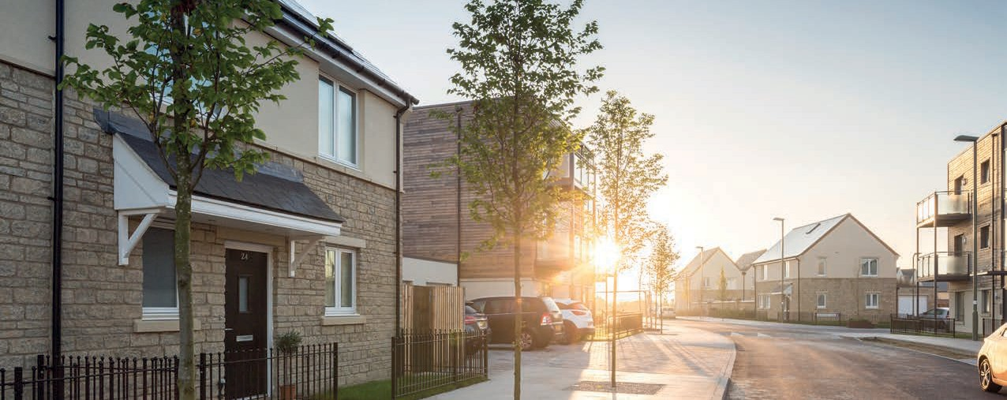

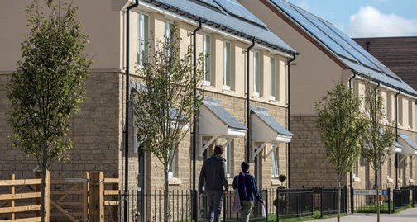
Location
The café will be located on Charlotte Avenue, the main road through Elmsbrook, and will be the focal point of the new local centre. It is positioned next to a vibrant community hub and
adjacent to the Perch Eco Business Centre which opened in 2019.

Opposite the café is land permitted to further development with flexible commercial use.
Gagle Brook Primary School is 200m further down the road with a spacious play park and fitness equipment a stone’s throw from the café.

Elmsbrook is a beautiful true zero carbon development of 393 sustainable homes and green space, the first of its kind in the UK. The land surrounding Elmsbrook will deliver more homes in the future which will also be accessed via Charlotte Avenue.

Elmsbrook is neighboured by Bure Park, Caversfield and Southwold and is a 10 minute cycle or 25 minute walk from Bicester Town Centre. The Elmsbrook bus which runs every 30 minutes has a stop opposite the café.
What can A2Dominion offer?
A2Dominion is a residential property group that currently has over 38,000 homes across London and southern England. We reinvest all our profits into building more new homes and supporting the communities in which we work.

We are vastly experienced in managing commercial spaces and working with our reputable brand could truly enhance your business and its potential sales. A2Dominion plans to offer:

- Subsidised rent and business rates period open to negotiations

- Marketing and PR of the café through our B2B networks and contacts

- Ongoing collaboration to ensure the café’s continued success

- A five or ten year lease, duration open to negotiations.

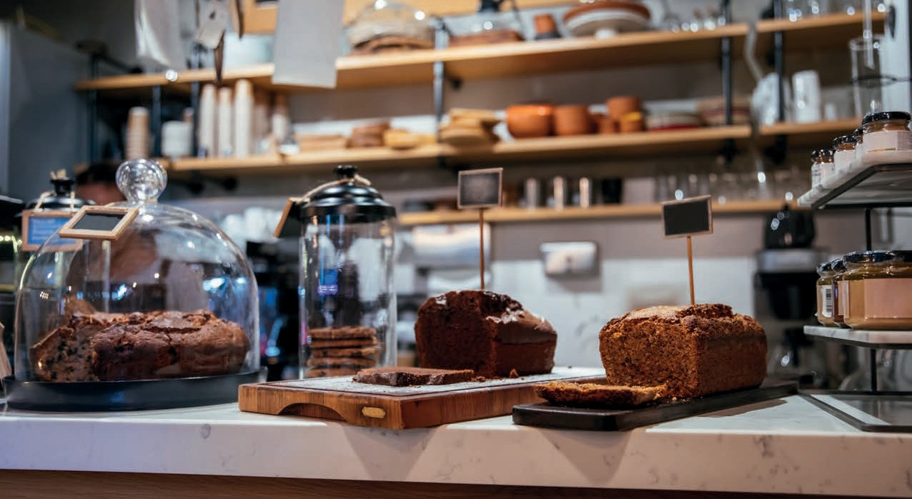

What we need from you
A2Dominion is seeking requests for proposals from an experienced catering and hospitality business who want to deliver this exciting new café at Elmsbrook. We’re looking for a business who can:

- Operate an effective commercial café offering a range of quality products including healthy,
handmade, seasonal locally sourced food and beverages for consumption in the restaurant or take away

- Demonstrate that their business model is financially viable

- Develop a compelling marketing campaign to raise the profile of the café

- Work collaboratively with the A2Dominion and the Community to create a café that promotes health and wellbeing and is in-keeping with the sustainable and community ethos of Elmsbrook.

To view our request for proposal documents and submit your application, you will need to register on the ProContract Portal at procontract.due-north.com. The project reference number is DN593184.

Once you have registered, you will be notified when documents have been uploaded and when the application window is open.

For further information, please contact Claire Bartlett on claire.bartlett@a2dominion.co.uk

