Parks North – Route to Lakeside
<--(2)
Trees
(1)-->
(1) View SE to embankment
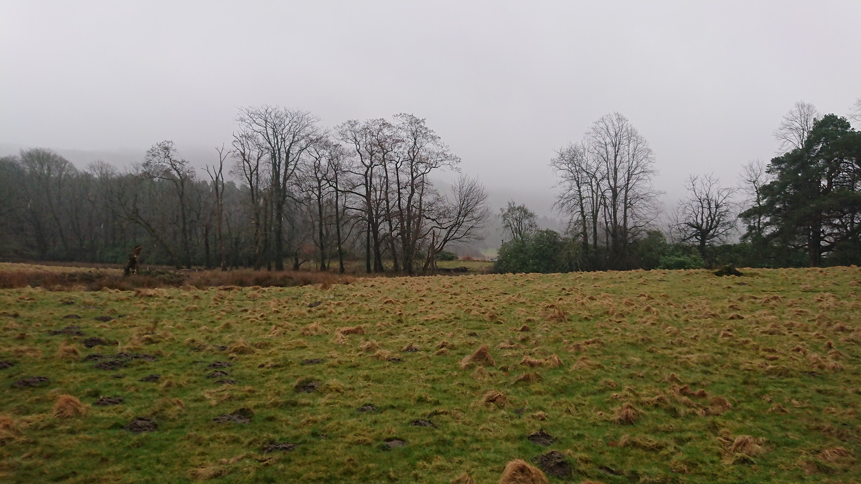
(2) View W from embankment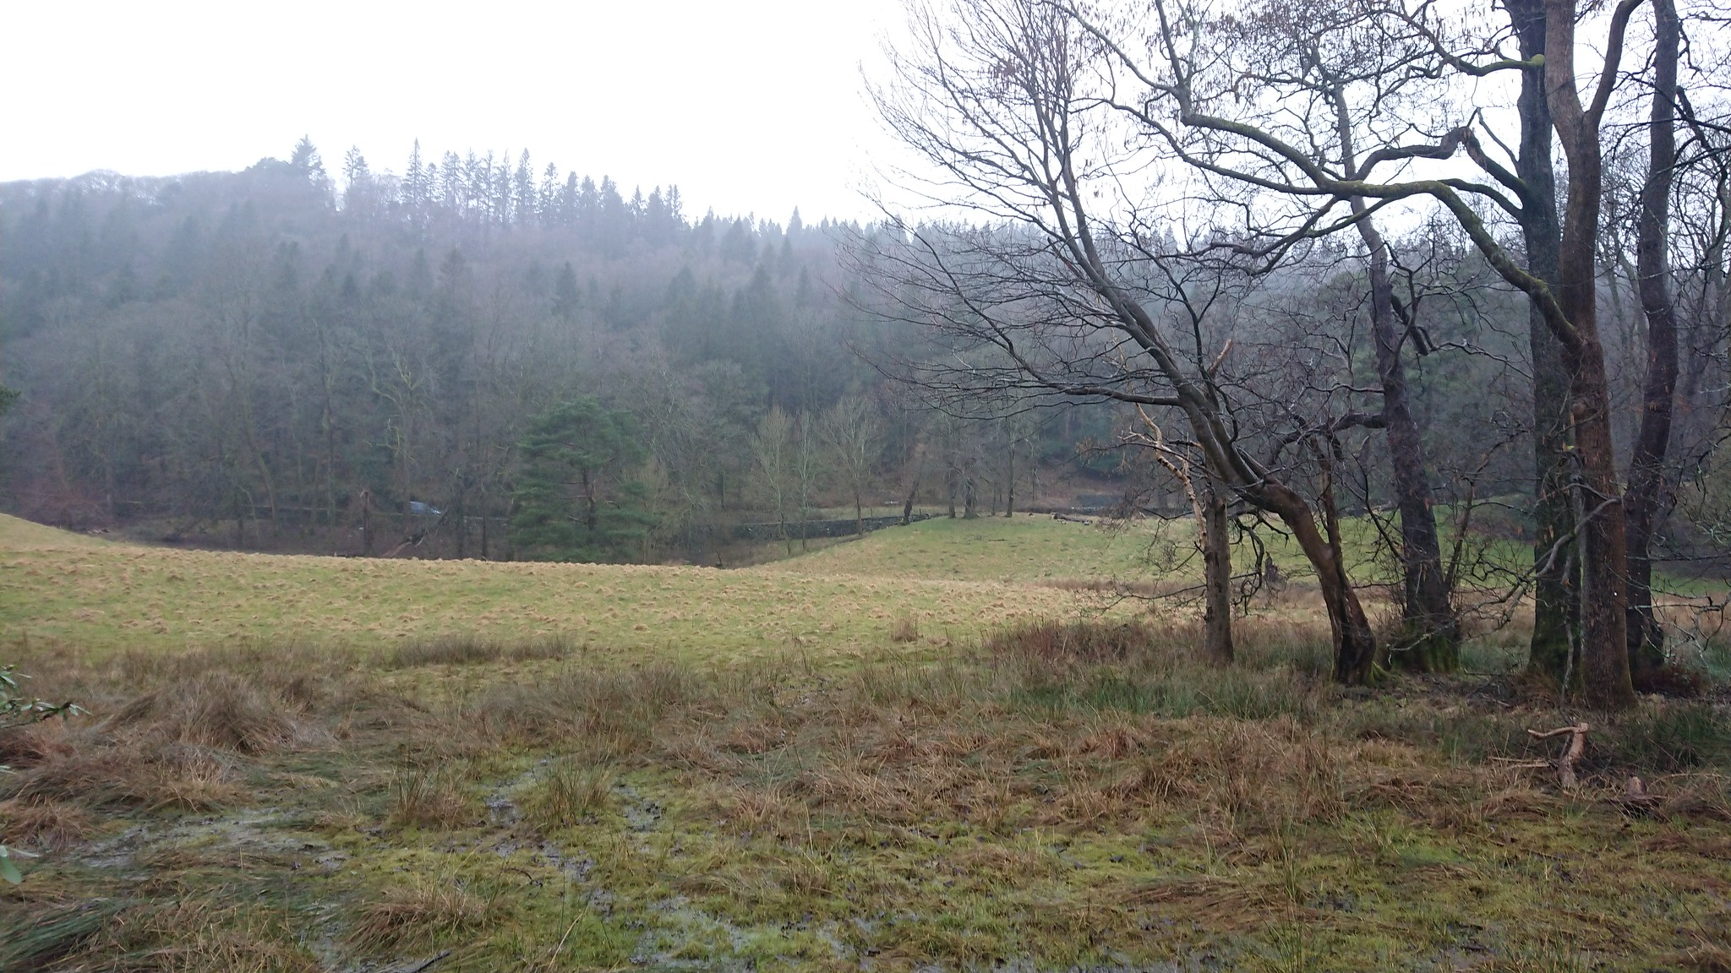
(3)-->
(3) View NE along embankment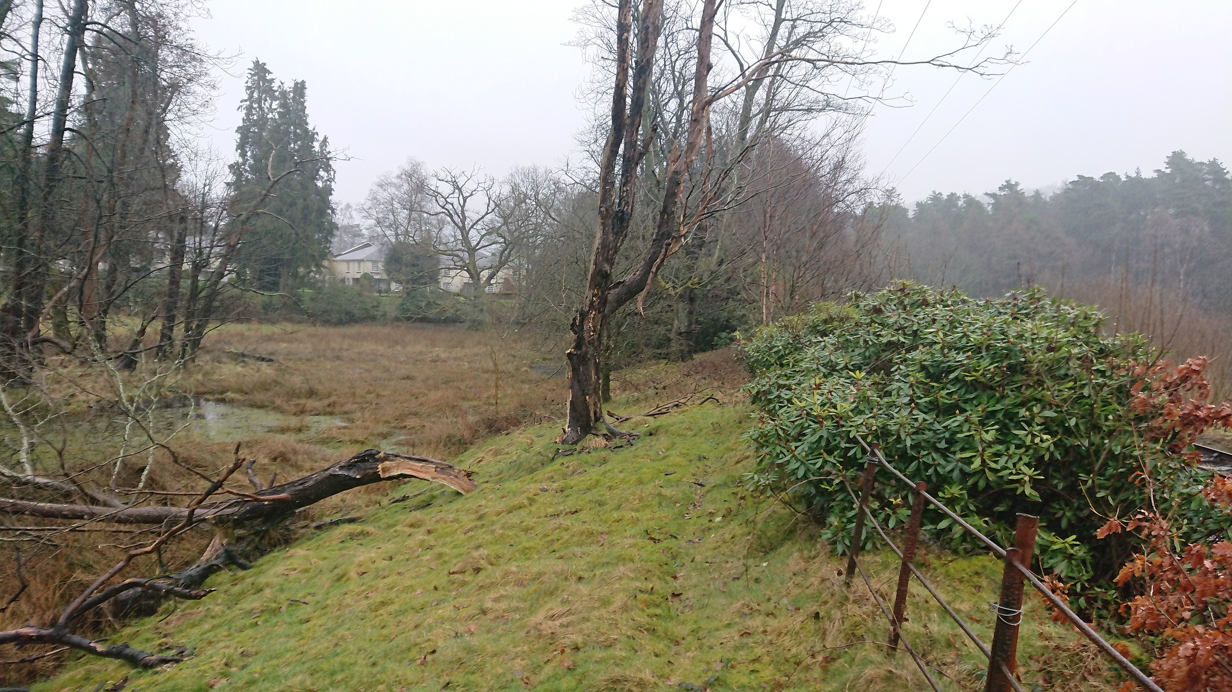

Railway Embankment – Parks Side
West East  Waterlogging  Dead / dying trees  Old Parkland Fence  Railway | 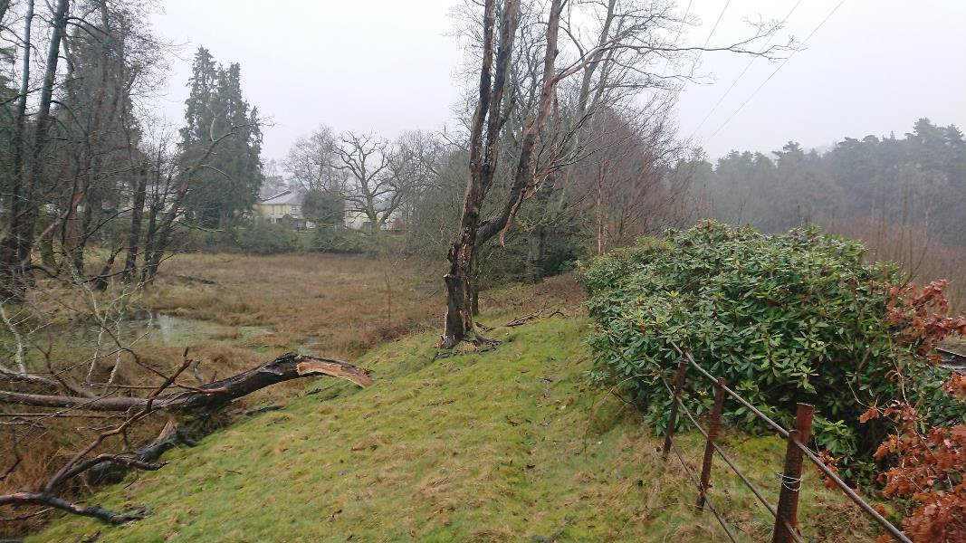  (1)  (1)
Section W-E through embankment | View N along Embankment
Waterlogging  (2)  (3)  (4)  (5)  Railway | (5)  (4)  (2)  (3)
- Clear vegetation – dead / dying trees and all rhododendron
- Remove existing fence and relocate to edge of revetment
- Form new path surface 2-3m wide as appropriate. Edge to W with Riprap for natural outcrop feel as required
- New lower fence at base of embankment
- Plant new embankment trees

Embankment Section – no rhododendron
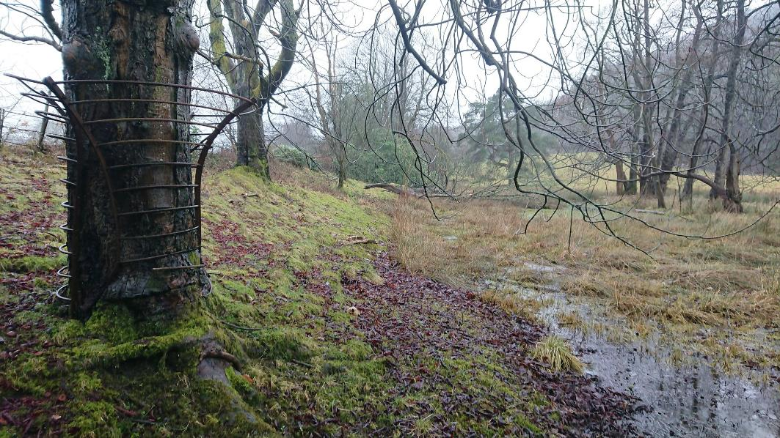 | 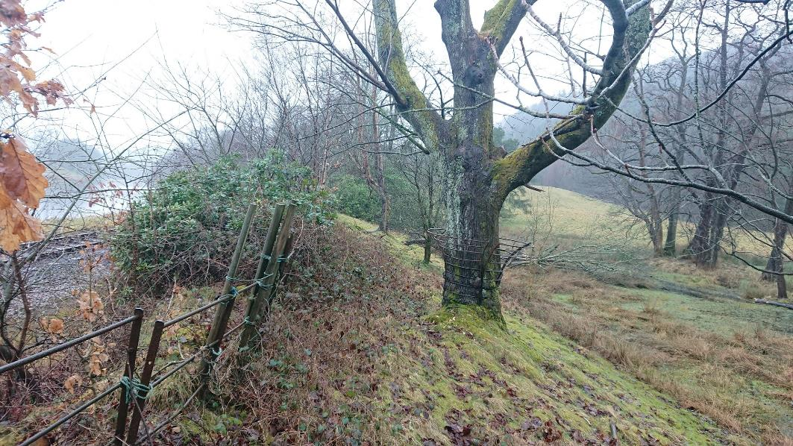
- View S along embankment from end of rhododendron. Shows mature tree with tree guard growing into it. Tree will be removed and guard retained for use. | - View S along embankment from centre of rhododendron. Shows mature tree with tree guard growing into it. 1m between fence and edge of railway line.
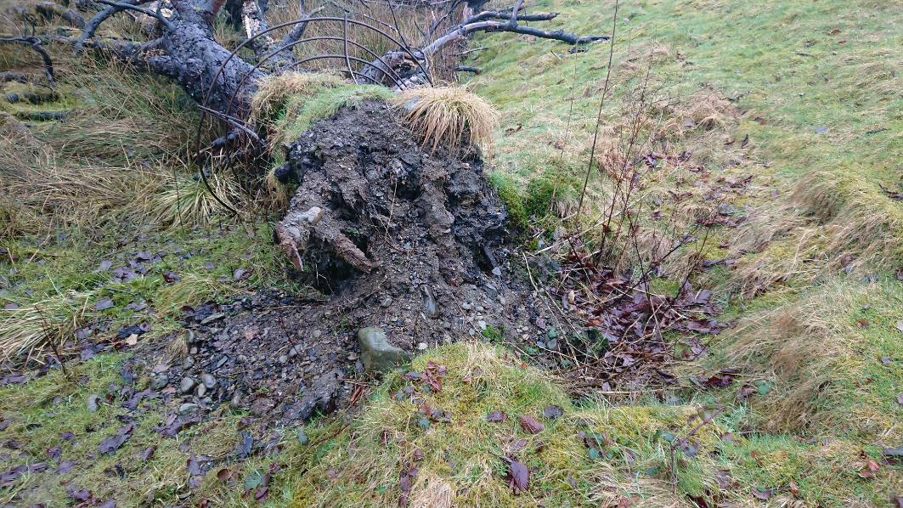 | 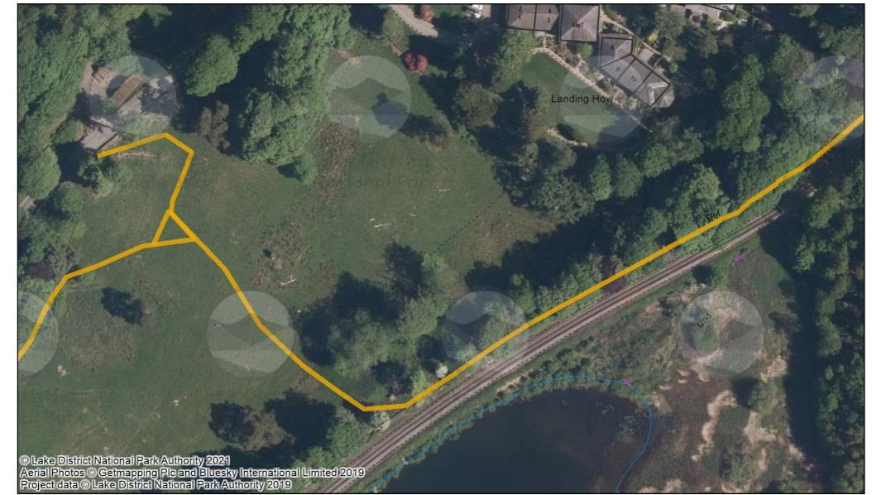  G  F  E  D  A  B  C
- View N along embankment showing fallen tree with grown in tree guard | Photograph locations on aerial image. Route alignment to the west of this image is incorrect. Revised alignment is as per planning application drawing.

Embankment Section – rhododendron
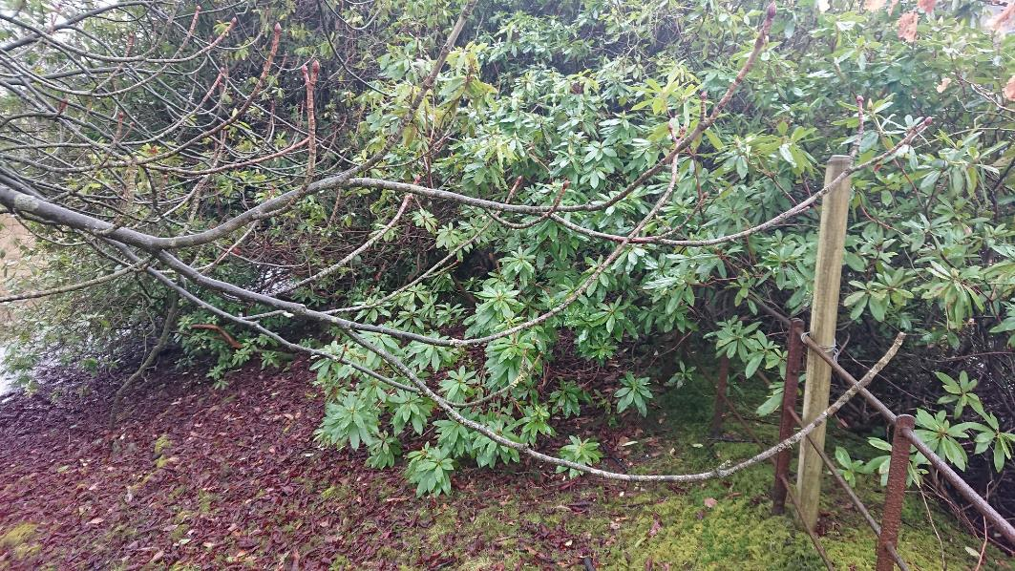 | 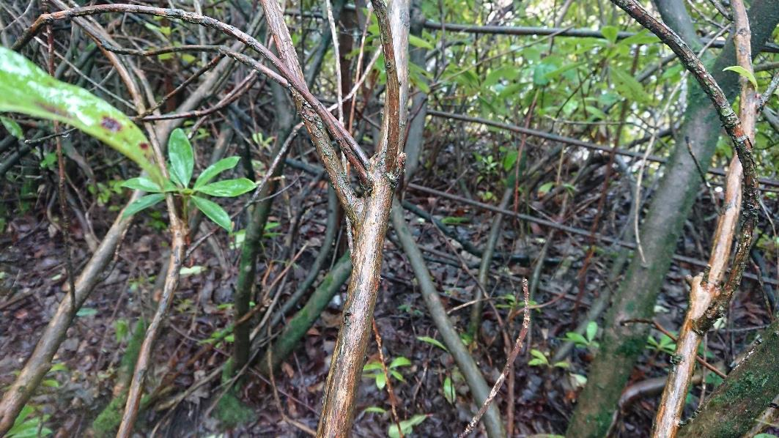
- View N at start of rhododendron | - View W from at Parkland fence towards the railway line. Fence is 1.25m from line at this point
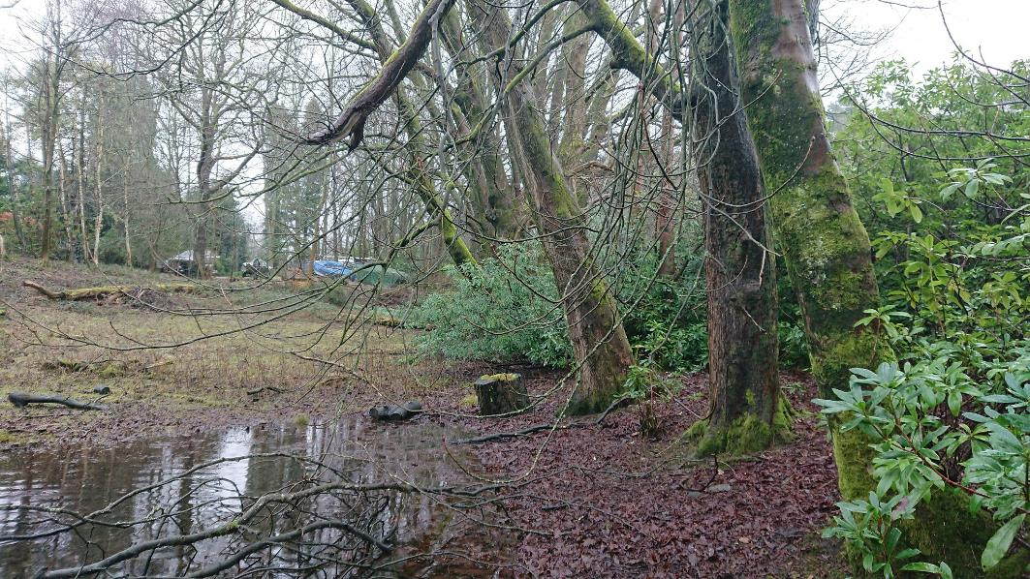 | 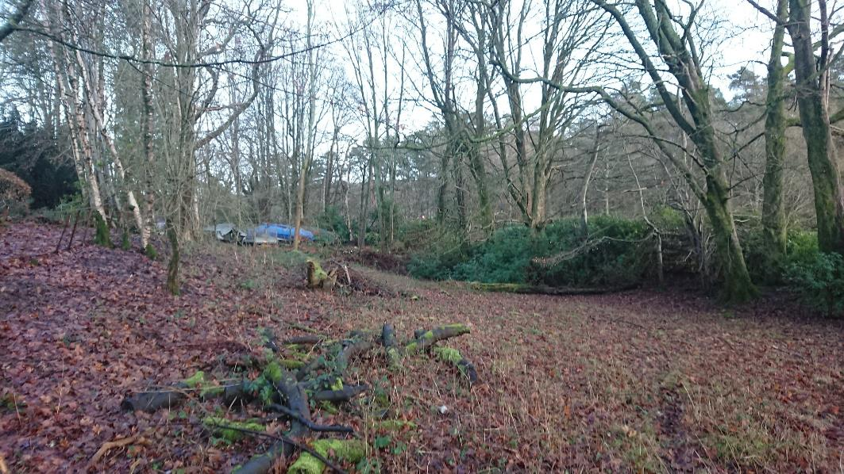
- View N Trees at Landing How – path would be to the E of trees (right in this photograph) | - View N Trees at Landing How – path would be to the E of trees (right in this photograph)

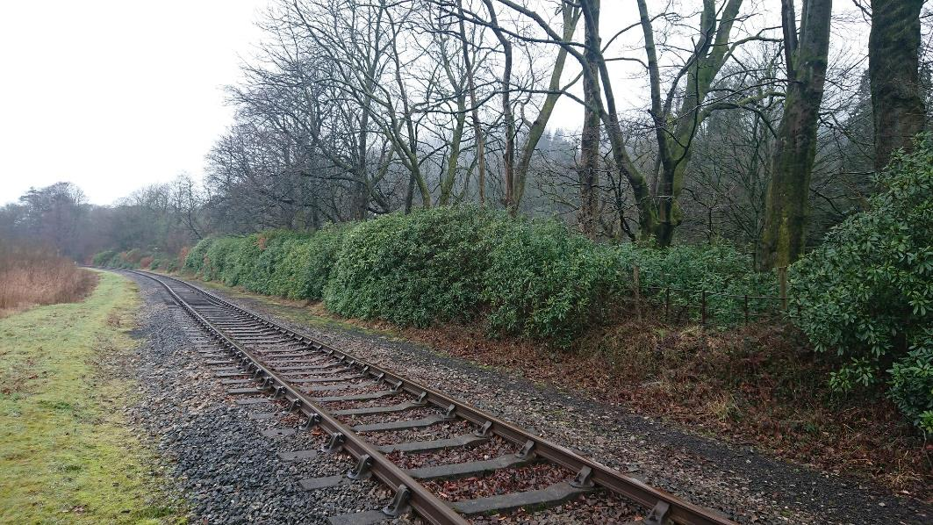 | 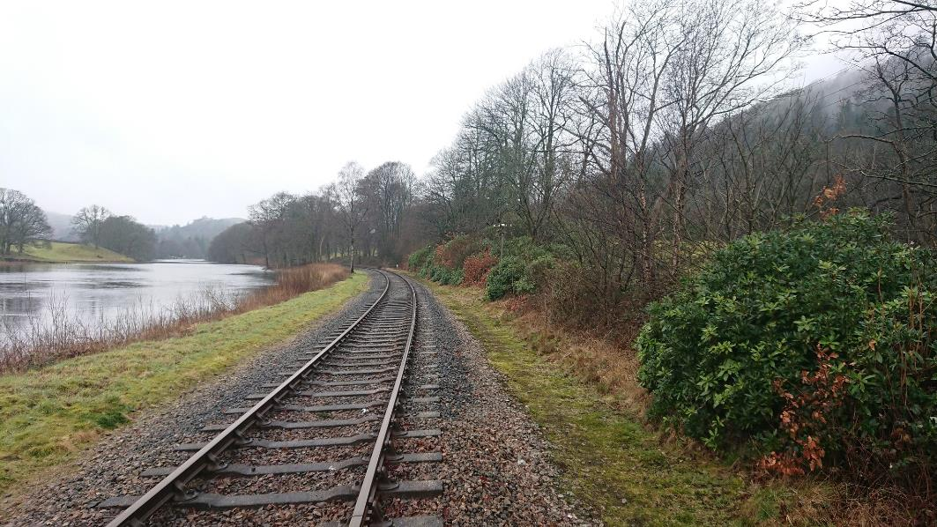
View S along railway from location G. Rhododendron to be removed. Trees were practical to be retained. | View S along railway from location D
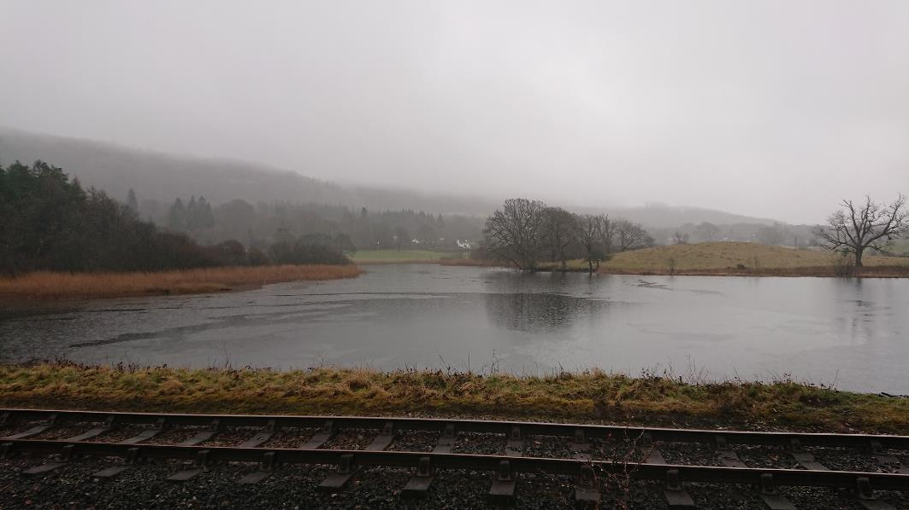 | 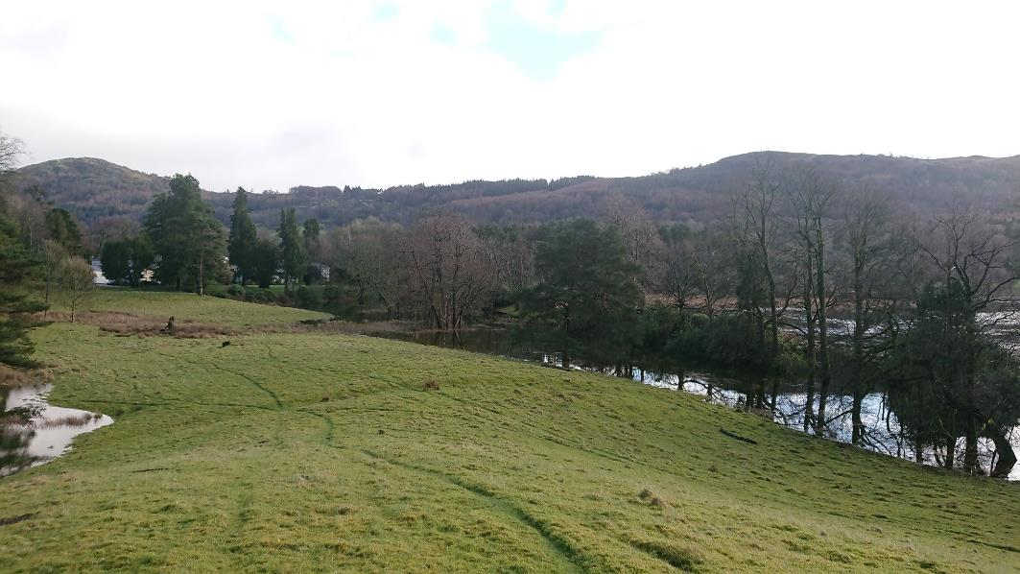  2  1
View E from new path (previously un accessible view point opened out to enjoy lake & railway) | View N show path / Landing How and seasonal flooding area. W-E alignment shown.  1 – aggregate path (3m in 4m fenced corridor – stock net fencing  2 – new 2.5mt boardwalk with rails each side. Upto 750mm above surface level. Normal 100yr flood +300mm.

