Call Reference: DN298006

Met Office tendering on behalf of BEIS.
Expressions of Interest title: Tropical Error Covariances for Data Assimilation
To register your interest, see notes at the end of this page. Registering interest requires no proposal detail at this stage and carries no obligation to bid.

Estimated value: £300k (£12.5k in FY17/18, £150k in FY18/19, £137.5k in FY19/20)

The grant is currently expected to be up to £300k for a 2 year period.

Key Dates

Estimated Publish of Call:  (Start of bidding period). | 09/10/2017  A notification email will be sent to parties who have formally registered their interest by way of clicking on the ‘Register Interest’ button displayed below the opportunity on the ProContract portal
Estimated Bidding Period: | 6 weeks
Estimated Award of Call: | December 2017
Estimated Delivery Period: | 01/03/2018 – 29/02/2020
Background
The Met Office anticipates holding a call for research proposals in October 2017. In preparation for the call, the Met Office is inviting expressions of interest from UK researchers.

The Weather and Climate Science for Service Partnership for Southeast Asia (WCSSP Southeast Asia), supported by the UK Government’s Newton Fund, is a research programme that will support the development of capability to underpin services to provide better advice of high impact weather and climate events and, therefore, will support climate and weather resilient economic development and social welfare.

Summary of WCSSP Southeast Asia aims
This project aims to develop underpinning capability in modeling at the global, regional and local scale, and advance the understanding of high-impact weather events in order to support services to improve advice and mitigate the impacts of extreme weather and climate events.

Specific aims include; improving the understanding of the impact of large scale atmospheric processes on the weather and climate of Southeast Asia, assessment and improvement of Unified Model performance at both convective and non-convective scales, improving the understanding of the local impact of tropical weather systems and improving the interpretation of global and convective scale forecasts.

For further information please visit the programme website -
http://www.metoffice.gov.uk/research/collaboration/newton
Submissions will be sought on ‘Tropical Error Covariances for Data Assimilation’:

Rationale:
The specification of appropriate background error covariances is an essential component of the data assimilation process required to provide accurate analyses to initialize numerical weather prediction (NWP). Whilst significant work has been done in this area for global and mid-latitude applications, understanding of the nature of tropical forecast errors, and their modelling within data assimilation schemes, is a very new area. Numerous recent convective-scale applications of the Met Office’s Unified Model in Southeast Asia, combined with data from a mature global ensemble (MOGREPS-G) provide a wealth of training data to assess the nature of tropical forecast errors.

Required activity:
This project will focus on data assimilation in the tropics with an overall aim to improve weather forecasting over Southeast Asia, with particular focus to Malaysia, Indonesia and Philippines. This project will investigate the dynamic, flow-dependent relationships implicit within convective-scale tropical error structures and their interactions with larger scales (e.g. Tropical Cyclones, Cold surges, etc). The successful applicant will be expected to work closely with scientists within the Met Office’s Data Assimilation and Ensembles R&D section to understand the nature of tropical forecast error covariances and contribute to their modelling within the data assimilation system.

Specific examples of this may include:
- Use of tropical NWP training data to identify key relationships in the modeling of forecast error covariances appropriate for convective-scale NWP in the tropics
- Assessment of data assimilation performance and summary of key challenges in Southeast Asia and the wider tropics
- Talking with scientists in both the UK and Southeast Asia to gather requirements for data assimilation in tropical environments
- Contributions to the development and application of appropriate background error generation software within operational or future generations of NWP models.

Anticipated outputs or results:

Outputs could include:
- New information about the impact of data assimilation and error covariance generation on weather forecasts over Southeast Asia
- Identification of key improvements in the data assimilation system that have the greatest impact on convective-scale NWP skill in the tropics
- Development and potentially implementation of new background error generation software for application to operational forecasting.

Background on the Newton Fund
The Newton Fund builds scientific and innovation partnerships with 16 partner countries to support their economic development and social welfare, and to develop their research and innovation capacity for long-term sustainable growth. It has a total UK Government investment of £735 million up until 2021, with matched resources from the partner countries.
The Newton Fund is managed by the UK Department for Business, Energy and Industrial Strategy (BEIS), and delivered through 15 UK Delivery Partners, which include the Research Councils, the UK Academies, the British Council, Innovate UK and the Met Office. The Newton Fund is part of the UK’s official development assistance (ODA) and therefore requires that the UK funding is awarded in a manner that fits with ODA guidelines.
For further information visit the Newton Fund website (www.newtonfund.ac.uk) and follow via Twitter: @NewtonFund.

Background on the WCSSP Programme
The Met Office is administering the Newton Fund through the Weather and Climate Science for Service Partnership Programme (WCSSP Programme), comprising projects to develop partnerships harnessing UK scientific expertise to build the basis for strengthening the resilience of vulnerable communities to weather and climate variability. WCSSP Southeast Asia is a project in the WCSSP Programme.
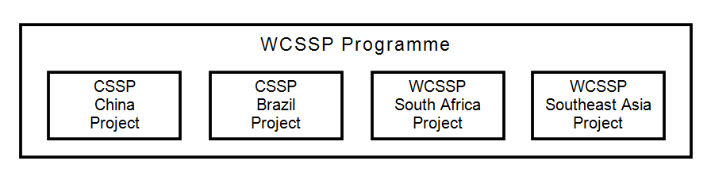

How to Apply:

The above Expression of Interest is advertised on the Met Office ProContract e-Tendering portal called ProContract. To access and register your interest you will need to log onto the ProContract portal via this link: tenders.metoffice.gov.uk You may need to search for the Call reference DN298006.

You will need to register your company (if you have not already done so) and register your interest against the opportunity before you are able to access the tender documents.

If you require guidance or ‘how to’ instructions – see the supplier manuals on the right hand side of the supplier home page.

Online Discussions between Bidders and the Met Office:

There is a Discussions function on ProContract which shall be used to provide all further information regarding this opportunity including any changes to time scales, scope or clarifications. This function must be used by bidders to submit all clarification questions.

