In-Line Neutral Sections
Challenge Statement
Network Rail and the Connected Places Catapult are publishing this notice to explore the state of the market in relation to the business challenge described below.
The purpose of this notice is to provide potential suppliers with an overview of the challenge and seek responses that explain the capabilities of products and solutions available in the marketplace or near-market prototypes. All applicable solutions are sought and there is no presumption that respondents will have previous experience operating in a rail environment.
Please respond by completing the template attached to this notice.
Context
Network Rail (NR) is responsible for 20,000 miles of rail lines in the UK, of which around 40% is electrified. An annotated image of the overhead line environment (OLE) is included in Figure 1 (see Appendix A). The contact wire is designed to conduct electrical energy which the trains collect (as electrical current) from the overhead line through a pantograph (see Figure 2).
For the purpose of power distribution, the electrification of the entire network is divided into sections powered from different grid sources (example sections shown in Figure 3). Due to the challenge and risks associated with connecting separately powered AC sections, the individual sections must be electrically insulated from each other, which is achieved using a neutral connection known as a Neutral Section. This Neutral Section provides the electrical isolation between sections while still maintaining tension in the contact wire and allowing the train pantograph to pass seamlessly between the individually powered sections of the OLE.
The contact wire is susceptible to early failure due to the development of fatigue cracks, primarily at the intersection between the cable and the Neutral Section (Figure 4). The passage of trains at speeds of up to 200km/h induces a pressure wave into the OLE, and the extra mass of the neutral section compared with the contact wire results in a different dynamic response of the overall OLE at these sections. As a result, high stresses are believed to be induced in the contact wire around the connection, leading to fatigue cracks and ultimately failure. As a result, the contact wire around these Neutral Sections must be periodically inspected and replaced as preventative maintenance, resulting in significant additional cost. In addition, greater wear is seen on the contact wire on approach to the Neutral Section as a result of the higher mass per unit length.
The project primarily aims to find alternative design solutions or modifications to the current approaches for providing electrical isolation between individually electrified sections of the OLE, in a way which reduces the formation of cracks in the contact wire. Solutions could be complete replacements for the existing Neutral Section equipment used, or modifications to the existing equipment in a way which reduces the causes of early failure. Alternatively, technical solutions to align the phases of the individual power supplies, thus avoiding the need for a neutral section entirely, will also be considered. A secondary but not critical ambition of the project is to find technologies which may provide advanced detection or prediction of developing cracks.

Design Status Quo
There are three types of neutral sections; two of the inline type and one overlap or carrier wire (CWNS) type. Network Rail currently use two different suppliers for the inline Neutral Section insulators, Arthur Flury (Figure 4) and BICC (Figure 5).
These neutral sections are of a greater mass per unit length than the contact wire to which they are connected. Typically, the weight of the contact wire per unit length is approximately 1kg/m, while the corresponding unit weight of the Neutral Sections is of the order 3kg/m. As trains pass at speed along the lines, the pantograph exerts an upwards force onto the OLE. In turn, this upward force induces a pressure wave ahead of the pantograph into the OLE. As the unit mass of the neutral sections is greater than that of the surrounding contact wire, this results in a different dynamic response of the neutral section from the contact wire, which induces large forces into the connections between the neutral section and the contact wire.
The contact wire is physically less robust than the neutral section, and therefore some flex is concentrated in the contact wire at the point it connects into the neutral section. Over time this flex leads to fatigue cracks in the contact wire, which if left unchecked can lead to failure of the contact wire. This fatigue failure is similar to that seen in other clamped sections of the contact wire (Figures 6 & 7).
To avoid the creation of electrical arcing as the pantograph transitions from the contact wire to the neutral section, the current draw from the train through the pantograph is reduced to zero in advance of the transition. This is achieved by a line-side magnet which trips an electrical breaker on the train on approach to the neutral section, and a second magnet which re-engages the electrical breaker in the train (Figure 8); both named APC magnet. At the point when the pantograph passes from the contact wire to the Neutral Section, there should be no current draw from the OLE by the train, and hence no arcing.
Regardless of which type of Neutral Section is used, the fundamental failures of the contact wire around the Neutral Section are common to all. As a result, inspection of the Neutral Section and surrounding area is carried out in conjunction with inspection of the entire OLE infrastructure. This means period visual inspection from line-side. Additionally, inspection is conducted by the New Measurement Train (NMT) every 12 months, which includes upward facing video cameras to take images of the overhead lines. Furthermore, due to the known likelihood of crack development, the Neutral Sections are periodically replaced, approximately every 2 years.
Solution
NR are seeking innovative solutions to the challenge described above. NR apply non-destructive test equipment to inspect their infrastructure, however a reduction in the likelihood of cracks developing is the goal. This could be achieved through a novel design of electrical isolation applied in place of the current Neutral Sections or could be a modification or addition to the current infrastructure in a way which reduces the likelihood of crack development.
In the ideal, the overall solution to the challenge will possess the following attributes:
- Must maintain electrical isolation between two independently fed 25kV 3-phase sections of the contact wire
- Maintain tension in the contact wire sections of the OLE (which can be up to 16.5kN) with an appropriate safety margin
- Provide a stepless transition from the contact wire to the neutral section and back to the contact wire. Thus, the pantograph passes seamlessly from one section of the OLE to the next, without inducing any additional loads into the pantograph structure
- Be tolerant to the passage of pantographs across the lower surface at speeds of up to 200km/h
- Once installed, the solution should not require maintenance beyond periodic inspection and replacement at end-of-life
- Be capable of deployment across the whole NR network, integrating with current specification contact wire
- Normally an individual neutral section should provide an electrical isolation (air clearance) spacing of 540mm unless precautionary devices such as arcing horns are included in the design; in which case the air clearance shall be greater than 200mm.
- It should be possible to configure the solution to provide a neutral section of OLE up to 200m in order to support the passage of trains with multiple pantographs which may be electrically connected within the train
Desirable but non-essential attributes may include:
- A mechanism or approach to provide a prediction (not detection) of cracks developing
Requirements
You are requested to submit a response to the challenge statement identified. All responses are required to be completed within the Word template provided with this PIN and must not exceed
20 pages.
All responses will be collated, and the information will be evaluated for us to have a clear understanding of potential development opportunities and the technical readiness of
possible solutions.

Appendix A
This section includes images and diagrams referred to in earlier sections of this document. In addition.
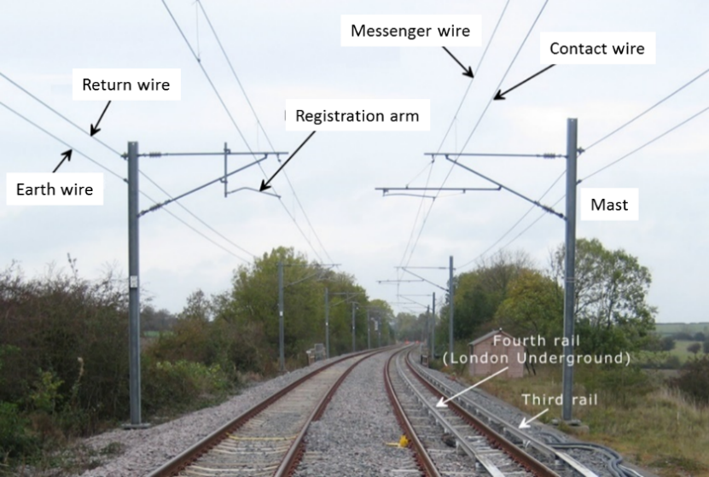
Figure 1: Annotated picture of the overhead line environment. Adapted from: http://www.railway-technical.com/_Media/ole-at-old-dalby-labels-prc_med_hr.png
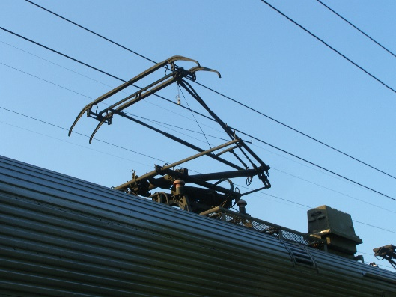
Figure 2: Pantograph, in an operational environment.
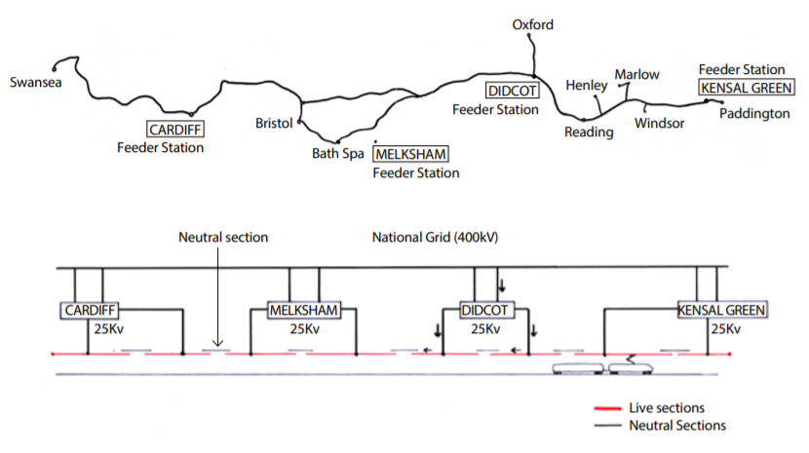
Figure 3: Concept of separately powered OLE sections, showing neutral sections

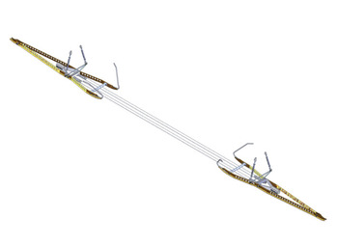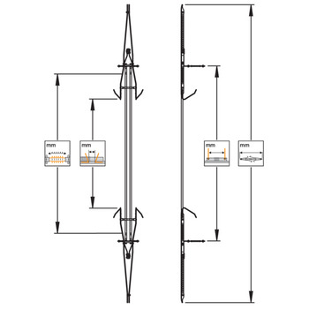
Figure 4 – Arthur Flury neutral section

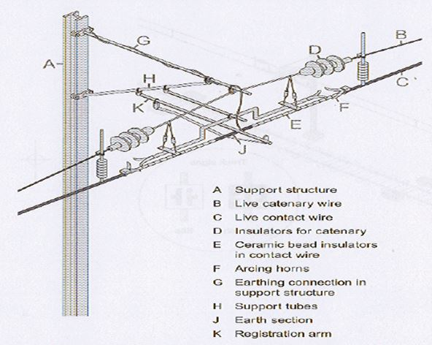
Figure 5 – BICC Glass Bead neutral section

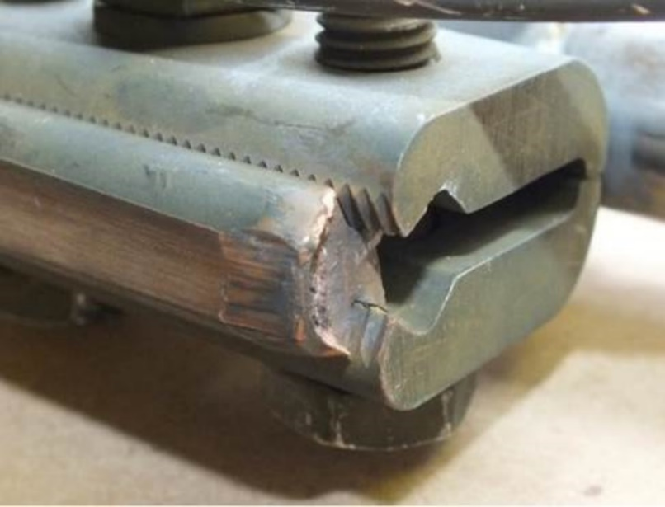
Figure 6: Typical example of contact wire failure at clamped sections of the OLE
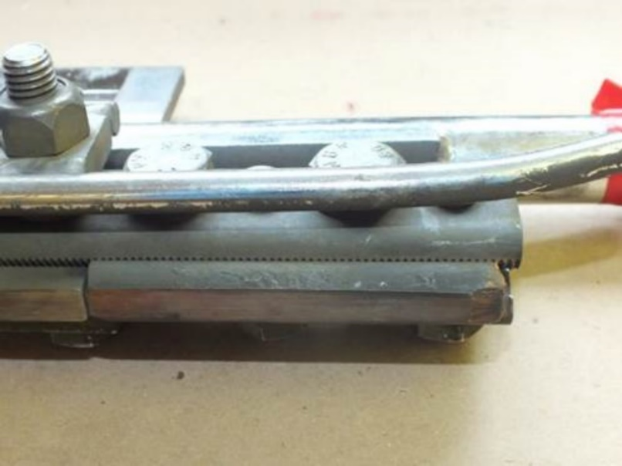
Figure 7: Clamp used to splice sections of the contact wire, underside

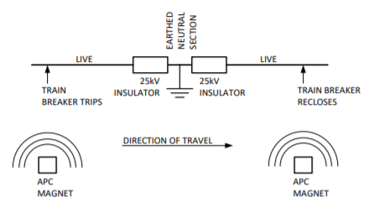
Figure 8: Principle of operation of a Neutral Section

