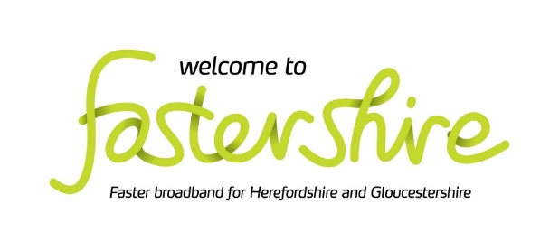

State Aid Consultation
Marches & Gloucestershire
Viable Clusters Broadband Project
Change Request

REQUEST FOR INFORMATION

1. INTRODUCTION

In 2018 Herefordshire Council contracted with Airband Community Internet to deliver the greater part of the
Marches & Gloucestershire Viable Clusters Broadband Project (MGVCBP) using funding is from the European Agricultural Fund for Rural Development (EAFRD) programme managed by DEFRA through the Rural Payments Agency.

A number of areas that were tendered originally were not bid for and Herefordshire Council are now seeking to invest up to 10% of additional funding through a change request to extend the contract with Airband into some of those areas within the Forest of Dean.

These areas were included within the original intervention area for the MGVCBP project as these were identified as NGA White via the original consultation that closed in January 2018. This means that the premises did not receive a broadband service from any broadband infrastructure provider with a download speed of at least 30Mbps at that time. As more than 3 years has passed since the closure of the original consultation and before commitment of the additional funding we wish to confirm that the NGA White status remains as required by the National Broadband Scheme 2016.

This State Aid Consultation has been published in order to establish the location of existing and planned (next 3 years) commercial coverage of broadband services across the potential change request intervention area by all existing and any prospective, NGA broadband infrastructure providers.

2. GEOGRAPHICAL SCOPE

The consultation focuses on 993 UPRNs which are included in a Response Template spreadsheet which is available to suppliers via Herefordshire Council’s Pro-Contract portal.
The geographical scope of the MGVCP project is defined at a premise level. This is for the benefit of all, not least private providers. Whilst the partners wish to avoid any overspill into the network footprint of commercial or other subsidised providers they are unwilling to allow citizens’ premises to fall through the gaps as a result of either defining postcode areas as either in or out of scope where only partial coverage exists. As any submission will be treated as commercially sensitive and only re-presented on an aggregated basis, we trust that providers understand our reasoning and comply in good faith.

The Maps below identify the location of each premise under consideration for inclusion in the change request.

Map 1 spatial distribution of the potential change request UPRNs Cluster C3

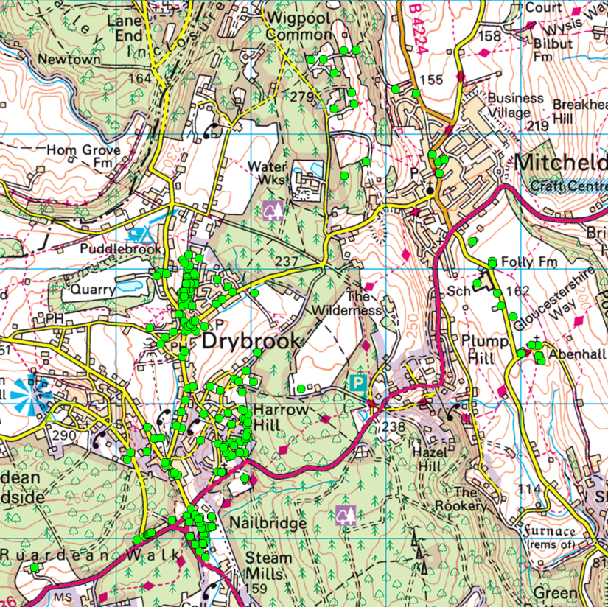

Map 2 spatial distribution of the potential change request UPRNs Cluster G6

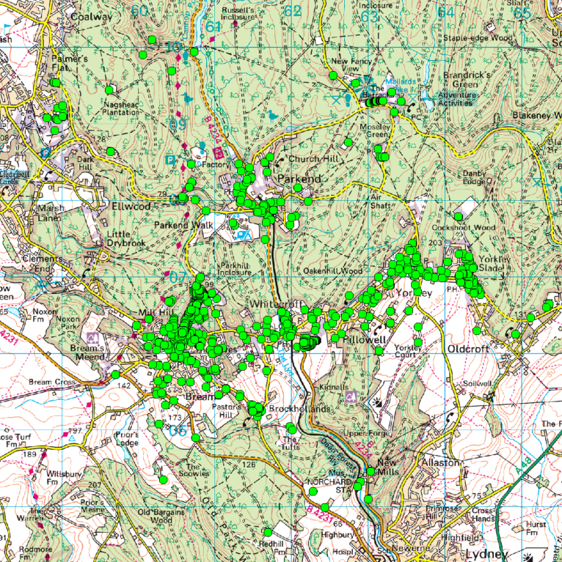

3. YOUR RESPONSE REQUIRED

We are sending this State Aid Consultation invite to all recognised broadband infrastructure and internet providers in our area. In addition, we are publishing this document on the Fastershire website.

The Response Template incorporating our proposed change request Intervention Area premises is available via our Pro-Contract portal. Please see below for details about Pro-Contract and how to gain access to the Response Template. When responding, we would be grateful if you could confirm your organisation's name and address, as well as the name, position and contact details of the person responding on behalf of the organisation.

More specifically, we require responses to the following questions by 12:00 pm on June 11th 2021.

- Please use the Response Template spreadsheet to identify any premises which benefit from current or will benefit from planned investment in broadband infrastructure (basic broadband, NGA and Gigabit capable broadband) in the proposed MGVCP change request Intervention Area.
- Please follow the instructions within the Response Template to ensure your response can be used to refine the potential Intervention Area.
- In the case of planned investment, we are particularly interested in plans for the coming three years (to May 2024).
- Beyond the completion of the Response Template, suppliers are encouraged to provide any information to support the claimed coverage. This should be uploaded with the Response Template to Pro-Contract and include but not be limited to:
  - Maps showing existing basic broadband, NGA and Gigabit Capable broadband coverage and separately maps detailing the planned investment in the basic broadband, NGA and Gigabit Capable infrastructure networks for at least the next three years;
  - Exact details of premises passed or covered, including information on the number of premises passed (in the case of a fixed network) or covered and able to receive services (in the case of a wireless/satellite network);
  - Details of the technology and where these claim to be NGA and Gigabit Capable, demonstrate how they meet the minimum standards as set-out in the BDUK Technology Guidelines;
  - Description of the services / products currently offered and separately those to be offered within the next 3 years;
  - Installation and rental tariffs for those services/products clearly identifying whether they are inclusive or exclusive of VAT;
  - Upload and download speeds typically experienced by end users;
  - Appropriate indicators of quality of the service e.g. contention ratio or bandwidth allocation per end user;
  - Evidence to substantiate actual or planned coverage claims including business cases and evidence of available funding to enable plans to be fulfilled;
  - Details and timing of roll-out for future investment;
  - Confirmation from an authorised signatory that all information provided is of suitable accuracy; and
  - Any other supporting evidence as you consider appropriate e.g. public websites.

4. PROCONTRACT ACCESS

Go to www.supplyingthesouthwest.org.uk and click on “Supplier Registration” located on the left hand side. This will open a new page and welcome you to the Supplier Registration Wizard.

Click on “Next” (at the bottom of the page) to access the registration from which comprises of 5 steps for you to complete. You MUST complete all the mandatory fields that are indicated with a red asterisk *

Step one is Contact Information & Security – These details will be the main contact details used for any procurement exercise. The email entered here will be the email address that messages are sent to confirming registration details, and all other system communications that may take place in all tender process. We recommend using a generic email to cover for leave and sickness.

Step Two is Company Information – If any of the fields do not apply to your company enter n/a

Step Three is Category Selection - This is where you can register your company to receive automatic e-mail notifications of new opportunities that have been published that may be of interest to your company. For this project ensure that you are registered under Category Code 72000000: IT services: consulting, software development, Internet and support; and, 32000000: Radio, television, communication, telecommunication and related equipment

Step Four is Council Selection - This is where you select the Area/Council that you want to receive automatic e-mail updates from. For this project select Herefordshire Council.

Step Five is Conditions and Privacy – This is where you need to agree to Proactis’ (the host company of ProContract) Terms and Conditions and the privacy policy. If you do not agree to these you will be unable to use the system.

Once this registration is complete, you will receive a confirmation e-mail and a further two e-mails informing you of your username and password.

If you require any assistance regarding the Supplying the South West Portal or ProContract System then please contact Proactis on ProContractSuppliers@proactis.com You may also raise a support tick through their Support Helpdesk at - http://proactis.kayako.com/procontractv3/Core/Default/Index

The Response Template will be released to providers via ProContract once a signed Partners Standard Form PSMA Contractor License has been submitted. The Contractor License is a requirement of the licensing arrangements in place with the owner of the premise data (Ordnance Survey).

The Pro-Contract site is independent from the Herefordshire Council’s own email/web site and allows access and retrieval of large files such as the Response Template..

Please note that the data you provide in your response will be treated as commercially confidential to Herefordshire Council and its Local Authority partners, albeit that it may be necessary to share some/all of your response data with our professional advisors and/or DCMS/BDUK, Ofcom, BIS State Aid Branch and the European Commission in the course of seeking State Aid.

If you have any questions about any of the above, please contact Matt Smith at Fastershire matthew.smith@herefordshire.gov.uk

https://www.gov.uk/government/publications/2016-nbs-tech-guidelines

