The Portal - Supplier Guide

  - How to Respond to a Project
Contents

Before you Begin 3
Login 4
Supplier Home Page 6
Response Wizard 11
Submit Response 15
Edit Response 16

Before you Begin

PLEASE NOTE THAT THE EXAMPLES IN THIS DOCUMENT USE SCREENS FOR BATH AND NORTH EAST SOMERSET, WHEN YOU ARE FOLLOWING THE EXAMPLES YOU SHOULD REPLACE BATH AND NORTH EAST SOMERSET WITH NORTH SOMERSET.

Before you prepare and submit a reponse to a procurement project, please note the following important information.

- If you are responding to an advertised opportunity, please Express an Interest to ensure you receive notifications if any updates are published and you have access to project messages which may contain further clarification information.

- Clarification questions are permitted but must be submitted through the messaging section of ProContract.

- Please read all project documents carefully and provide all relevant information.

- Late submissions are not permitted. ProContract will prevent any responses from being submitted late. Please ensure enough time is given for responses to uploaded into the system.

Login

- From the Supplying the South West portal (www.supplyingthesouthwest.org.uk), click on ‘Suppliers’ Login’.

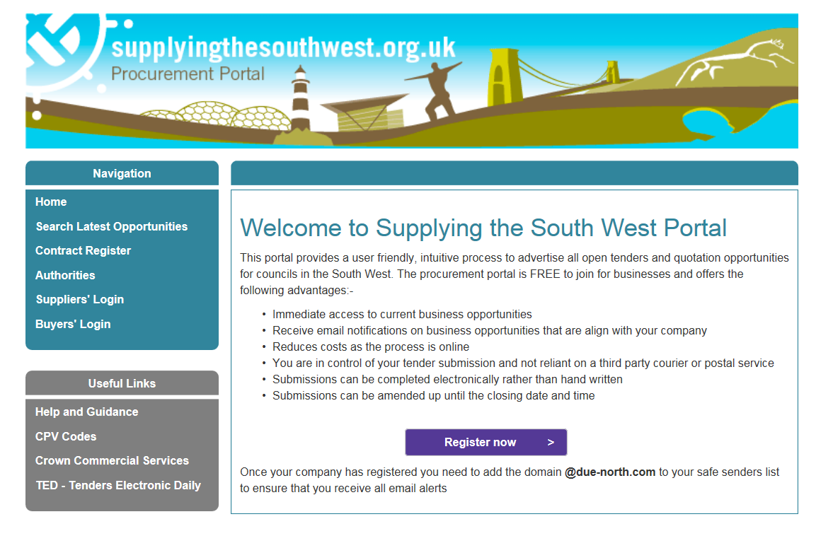

- If previously registered, click on the ‘Login’ button.

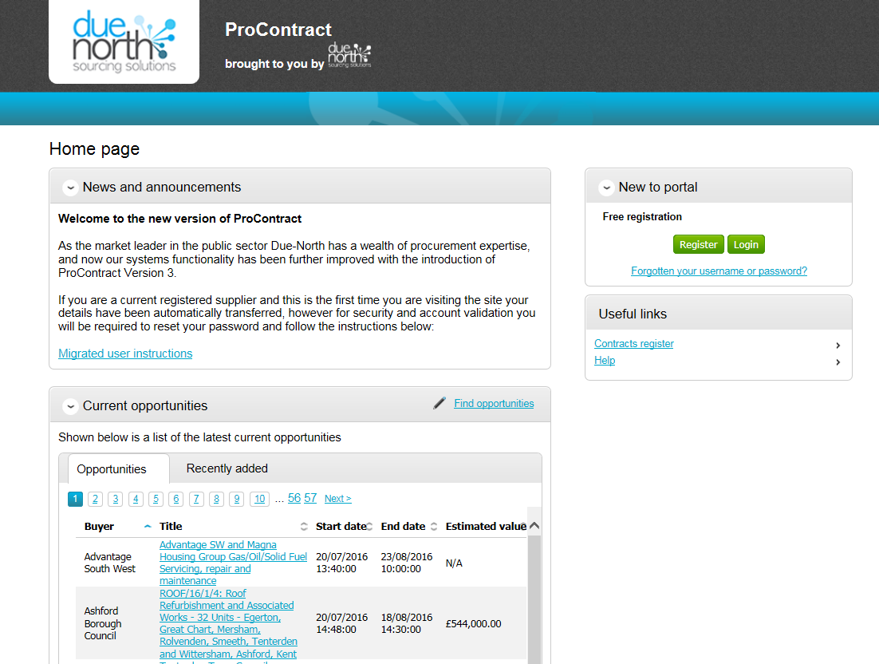
- Enter your username and password to log in.

If you have already registered and have forgotten your details, please use the ‘Forgotten your username or password?’ link to get a username reminder and reset your password.

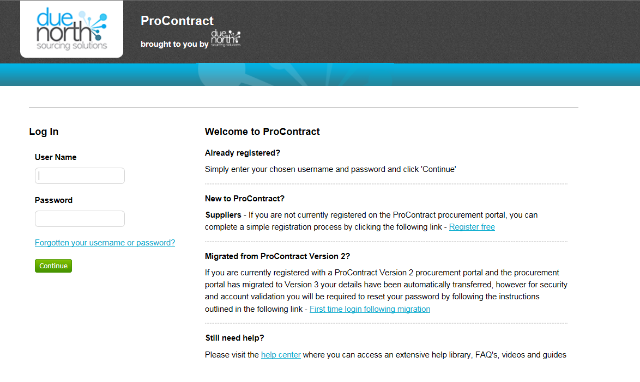

If you have not registered before, click the “Register” button and complete the portal registration process.

Supplier Home Page

- To search for an advert, click on ‘Find Opportunities’.

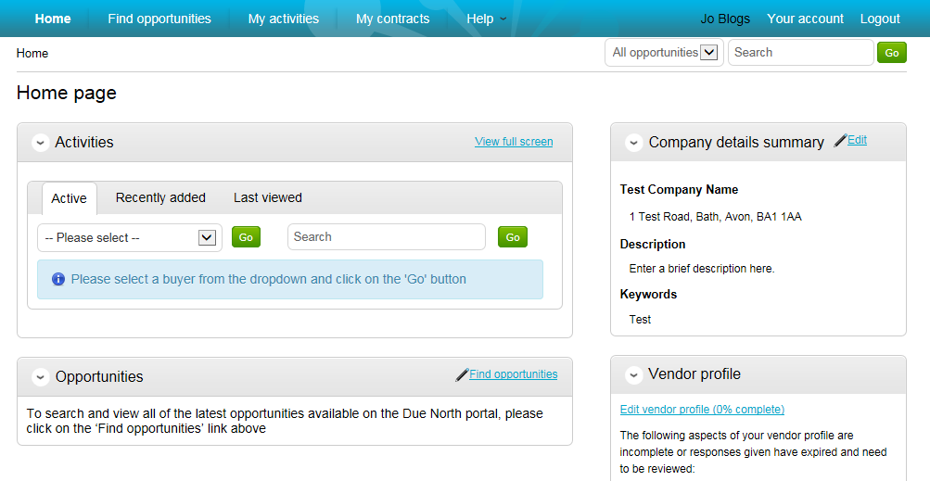

  - Opportunities / Adverts

(In this example, the project “Test Procurement Project” is used.)

- To search for a North Somerset opportunity, select Supplying the South West portal and North Somerset Council in the ‘Narrow your results’ section and then click on the green ‘Update’ button at the bottom.

- Click on the blue project title for the opportunity you are interested in to open the advert.

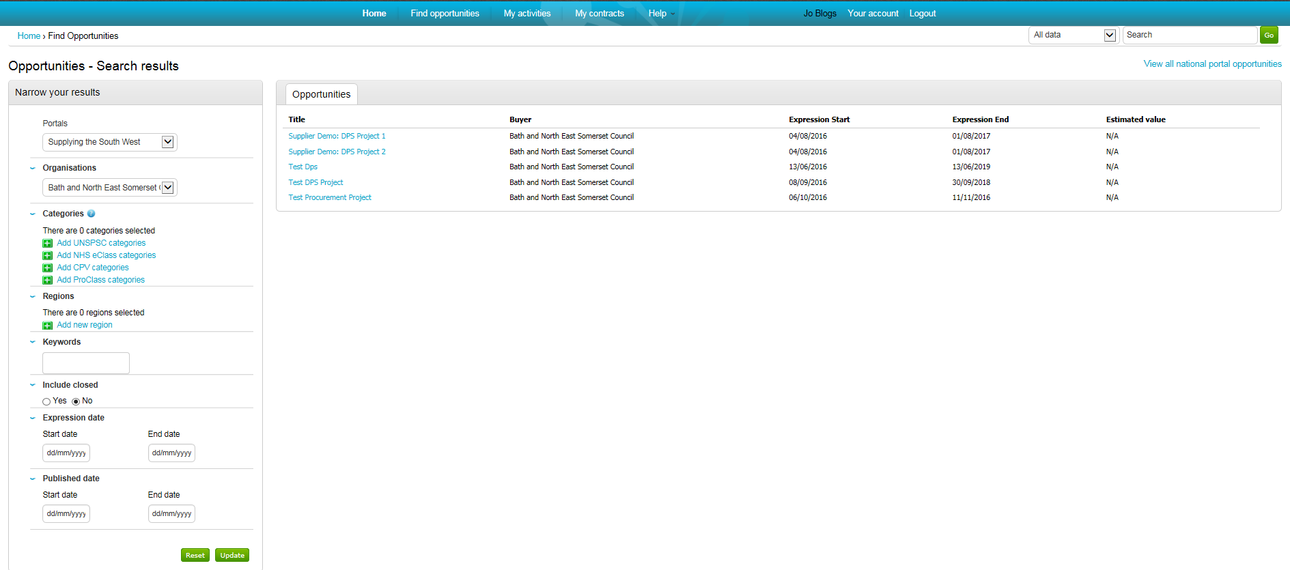

The Project opportunity will be displayed.

Please read the contract details carefully as the description sometimes provides additional instructions for registering interest.

- Click on ‘Register interest in this opportunity’ to get full access to the project.

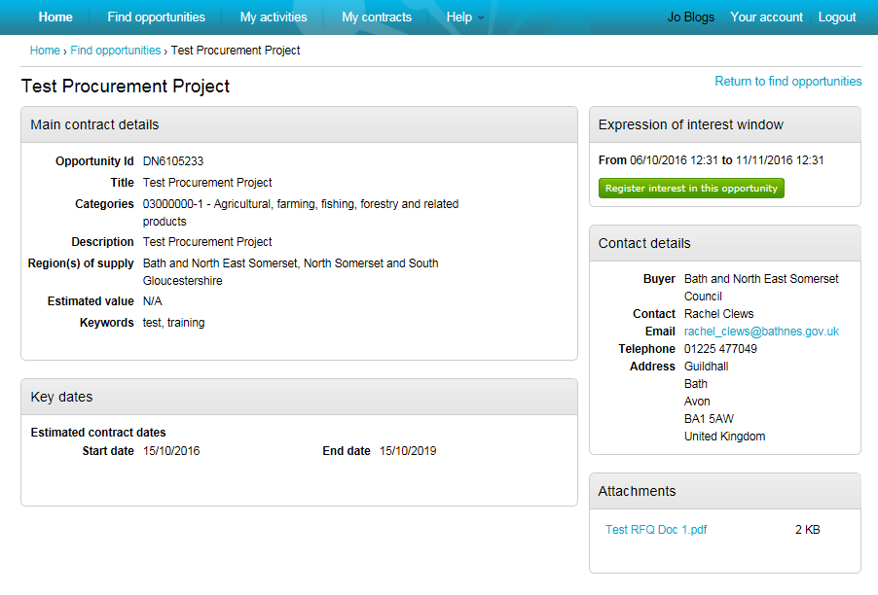

You will then see confirmation of your expression of interest.

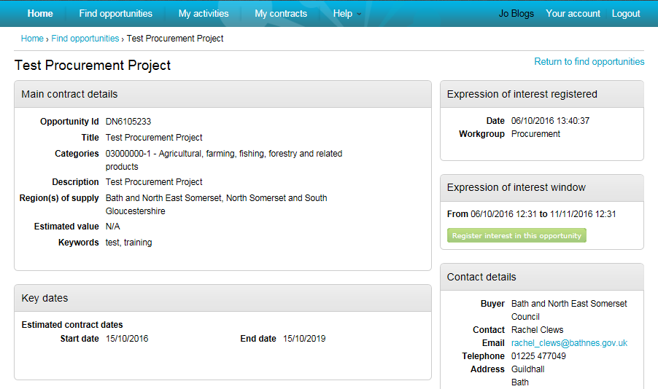

- Go back to your home page by clicking on ‘Home’ to see all your projects and select the ‘Recently added’ tab.

You will see the project listed with the date of your expression of interest.

- Click on the blue project title to open it up. When the project opens up, this takes you to the ‘Project Dashboard’.

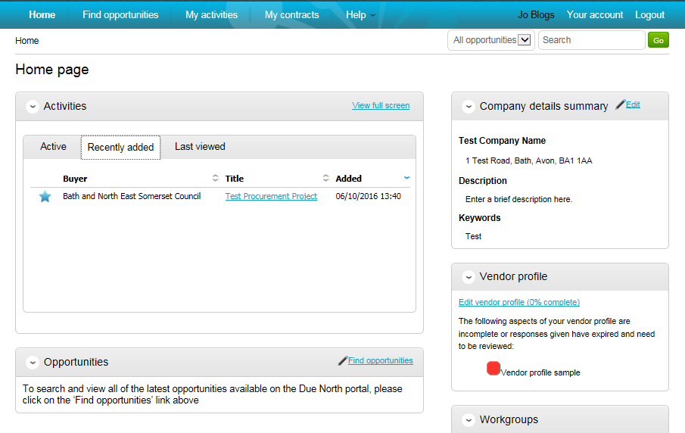

  - Project Dashboard

The project dashboard has a list of events (eg, steps or activities) that you will need to work through and a messaging area that you can use to ask any clarification questions to the Project Team at North Somerset Council.

  - Events

The first event is the Expression of Interest, which you have already completed from the opportunity page.

The second is the Quote or Tender event that will need to be completed. Full project documents can be accessed through this event.

  - Messages

Please note all queries regarding the project must go through the Messaging section of ProContract. Questions are private to the Project Team in the Council. Project specific questions cannot be answered over the telephone.

- To access project specifications and documents, click on ‘Start’.

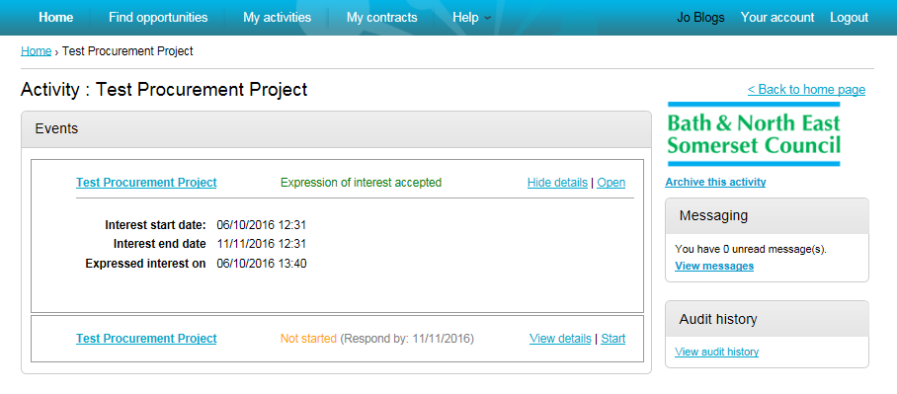

Response Wizard

  - Questionnaire / Quote / Tender Event

This screen provides all information for the questionnaire, quote or tender, including submission deadline countdown timer, and all project attachments.

It also provides a link to the Messaging section.

Please read all project attachments carefully. If you have any questions related to the procurement, please submit them using the messaging section.

Please note, Project Officers at North Somerset cannot respond to procurement related questions via email or telephone. This is to ensure transparency for all potential suppliers.

- When you are ready to submit your quote or tender, click on ‘Start my response’ to open the response wizard.

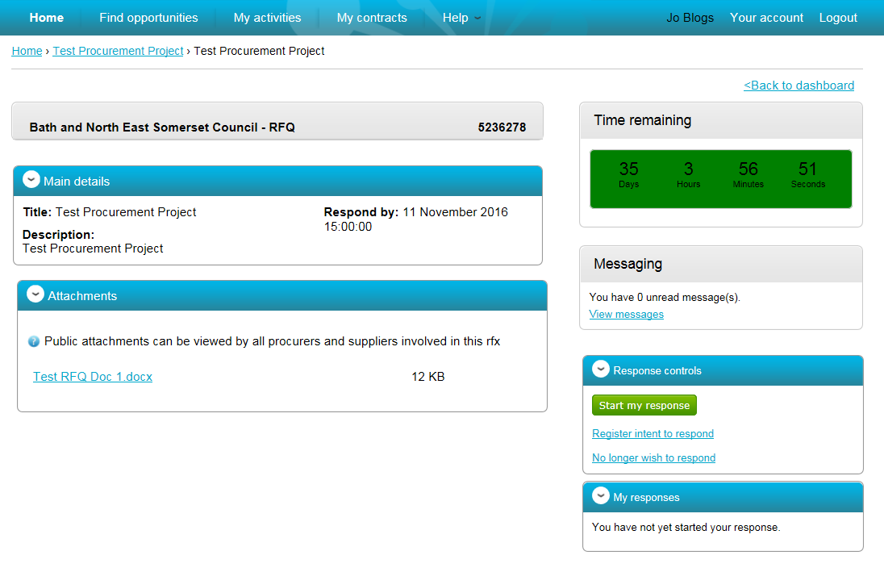

  - Response Wizard

- Please read the information provided and click on ‘Continue’.

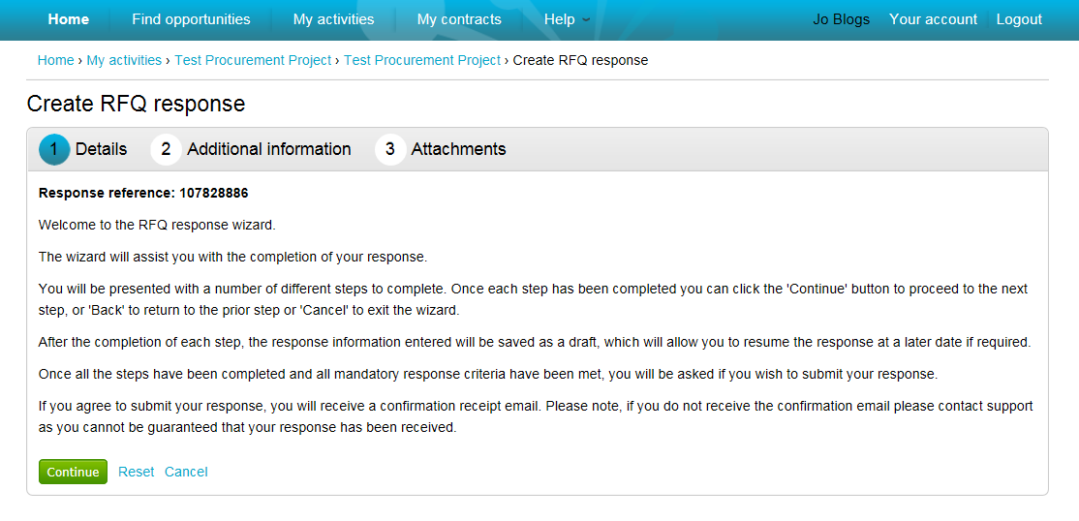

- Just click on ‘Continue’ to add any additional information.

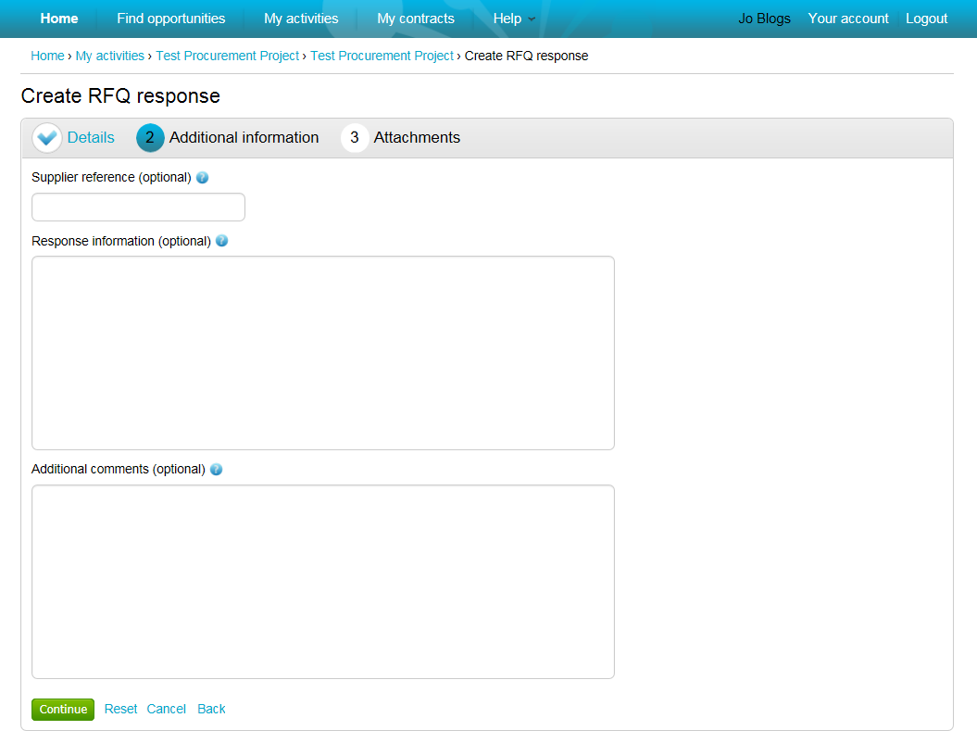

We suggest you leave these optional sections blank as this does not form part of a tender response. Just click on ‘Continue’.

- Click on ‘Add attachment’ in order to add your response (for example, your completed questionnaire, pricing schedule and any other requested documents).

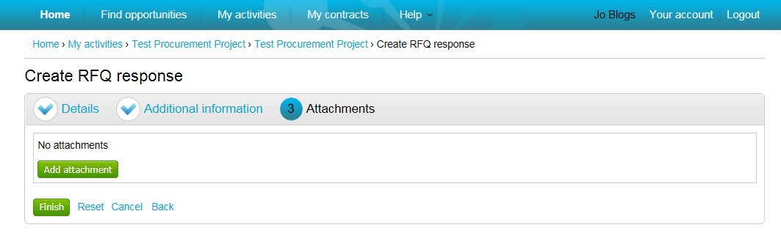

- Click on ‘Add files’. You will then be able to access your computer’s hard drive where you have saved the attachments.

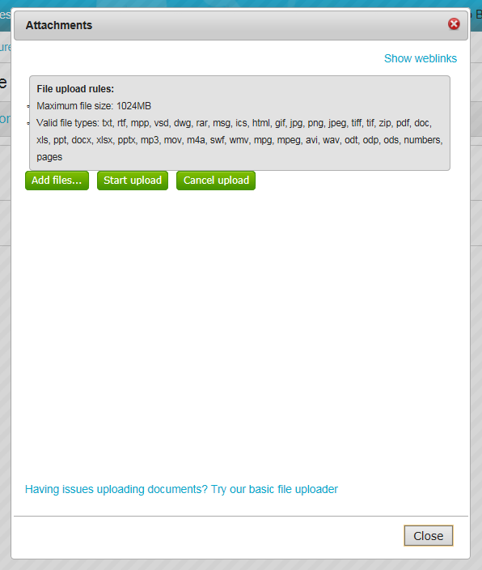

- Select the relevant documents and Click on ‘Start upload’.

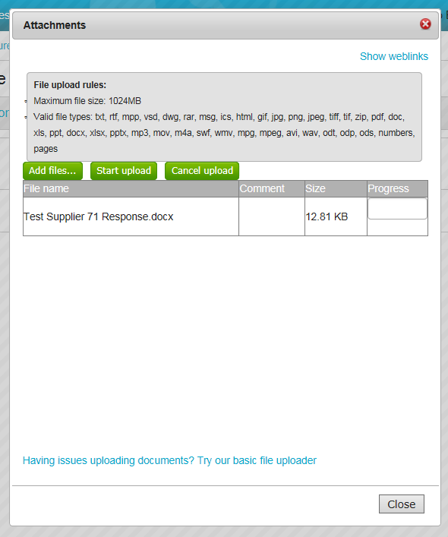
- When all files have been added and uploaded, click on ‘Finish’, to complete the response wizard.

Please note your response will still be in Draft state.

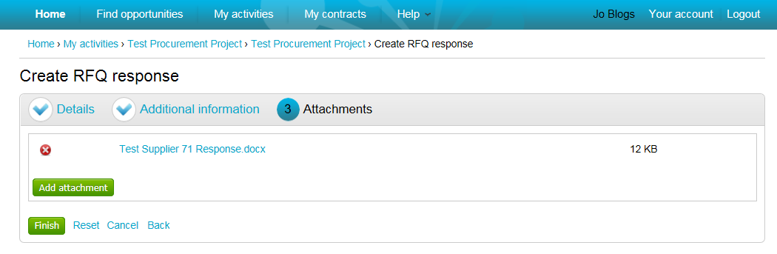

Submit Response

Your response is still in Draft.

- Click on ‘Submit response’, to send your attachments to the Project Team at North Somerset Council.

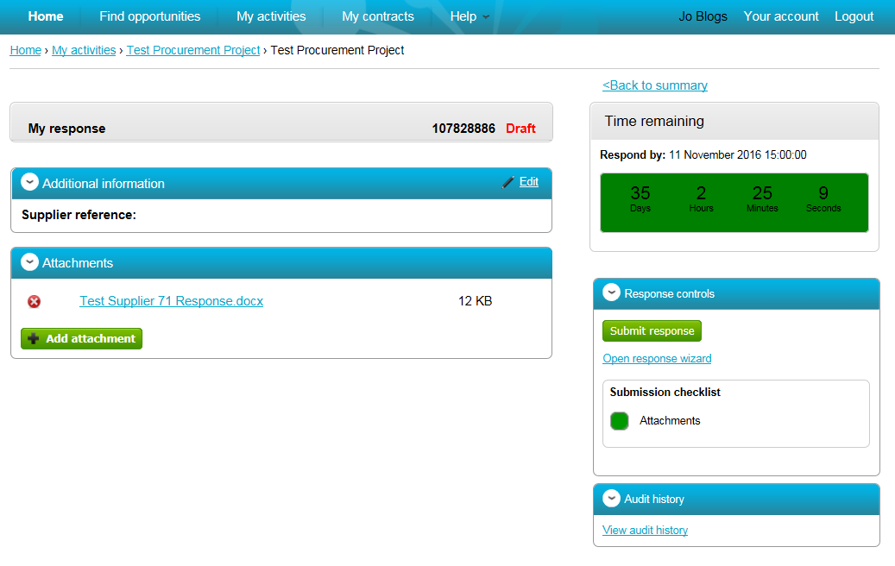

Once submitted, you will see a submitted status and you will receive an automated email confirming your submission.

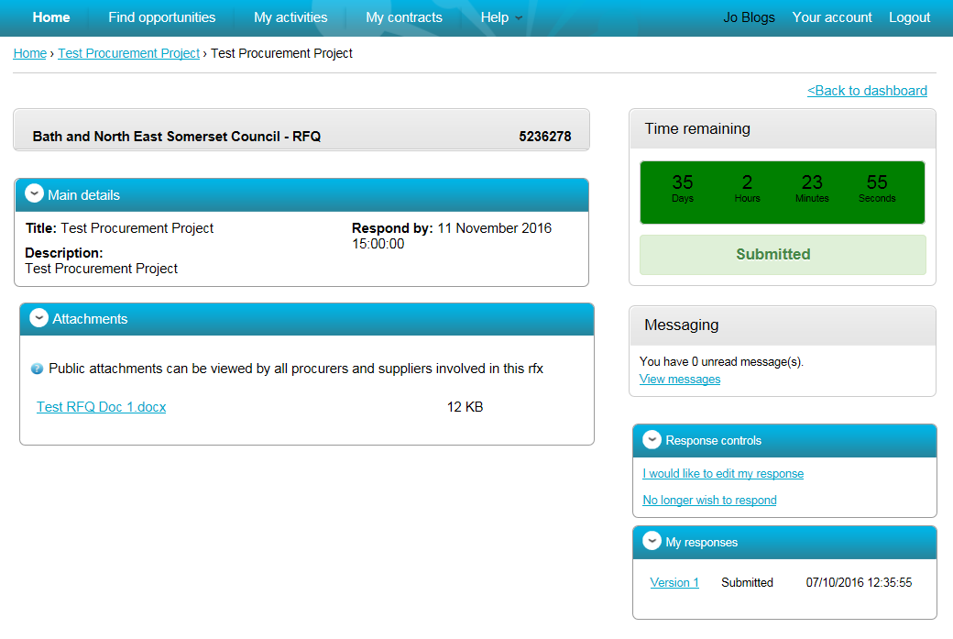

Edit Response

- If you need to edit a submitted response before the submission deadline, click on “I would like to edit my response”.

Your project will then go back into Draft state and you can work through the submission wizard to upload or delete attachments.

Remember to submit your response after you finish!

