Brief for Refurbishment of Peckham Park Outdoor Gym

Introduction
This brief invites experienced outdoor gym companies to provide a quotation to replace and refurbish the Peckham Rye Park outdoor gym.

Background
The project will refurbish and improve the existing outdoor gym facility in Peckham Park London SE15, which consists of two sections; a trail and a curved section with a number of equipment pieces. – refer to photo supplied in Appendix 1.
The original equipment was installed in 2010 and is to be improved to provide a more modern and robust facility for the community. The original items installed are:
- Leg Press
- Lat Pulldown
- Bike
- Chest Press
- Pull Up Bars
- Cross Trainer
- Parallel Bars
- Recumbent Bike
- Ab Bench
Objectives
We are seeking the services of an outdoor gym company to replace and refurbish the space with modern equipment that meets the current relevant outdoor gym safety standard – BS EN 16630:2015.
We are seeking an outdoor gym design that allows for community workouts that is inclusive of different age profiles and varying physical abilities. This must include a rig / multi-use frame that allows for calisthenics, bands and cable attachments.
Additionally, the outdoor gym design must include bike and cross trainer(s) as these are popular pieces of cardio equipment.
Strategy & Policy
Where relevant, requirements, guidance and objectives from the following strategies and policies must be taken into account:
- The Equality Act 2010
- The London Plan 2021
- Southwark Climate Strategy

Scope of Services
- The project should upgrade all of the items of equipment in situ with modern equivalent pieces (where needed) and an appropriate safety surface, and proposals for new items where the budget / physical space allows. Submit a design plan (with drawings) of how you will improve the gym area, itemising the equipment selected, the specific type of safety surfacing, and providing an itemised budget of equipment / surface / install etc; to deliver the brief (our ideal price is £40,000 + VAT).

- This Gym equipment refurbishment should cater for adults (14yrs+) with a wide range of physical abilities, from fit young adults through to older adults with a long-term health condition or disability. Submit evidence stating why each piece of equipment was chosen; this should explain the number of people that can exercise at one time, the range of age and physical abilities that are catered for, including how the design will improve inclusivity by people with a disability or long-term health condition.

- It is expected that people with little or no experience of using fitness equipment will be daunted by using an outdoor gym / starting a routine, as they will not have the confidence or skills to achieve their health goals. Therefore, clear and simple information / resources about starting a fitness regime at this site must be provided as part of the project to minimise this barrier in as many different formats as possible. Submit evidence illustrating how your project provides access for people to different instructional / user focused resources to enable novice users to understand and use the fitness equipment / start a workout plan (note – our preference is that this goes beyond installations at the site and includes content that can be accessed digitally). Also, what your company will do to raise awareness of a new facility with local people / health professionals and the wider community.

- Please supply guarantee information with time periods for the following (a-f), and your timeline for the project start and finish:

  - Structural steel
  - Welding
  - Paint
  - Rust
  - Bearings
  - Fixings

- Please supply information on the methodology for installation, including how the site will be secured, how members of the public will be protected from harm, how the surrounding green space will be protected from damage by footfall / vehicles during installation.

Please note – A site visit / survey shall be undertaken by the successful company to agree with the Client the confirmed refurbishment of the outdoor gym.

Services – The Council does not have any plans identifying underground services on this site. Therefore all appropriate Health and Safety measures shall be undertaken by the Contractor prior to any works taking place.
Programme
It is hope that the works can start before the end of Autumn 2022, though a small adjustment to this timescale may be possible.

Risks
There are no risks relevant to these services.

Tender evaluation methodology
The process for selecting and awarding the contract to a tender for this project is included in the document; ‘Dulwich and Peckham outdoor gym renovation – Tender Evaluation Methodology’.

Project Particulars
Equal Opportunities
This scheme must seek to enable easy access for people with disabilities or limited mobility, and fully comply with the Disability Discrimination Act. Particular user groups that will need to be catered for include older people, wheelchair use and for people with limited or partial sight.
The company will be required to advise on appropriate measures for the scheme to aid equality of access and enjoyment.
Agenda 21
Where possible, materials specified in the scheme should be obtained from sustainable sources. Of particular importance will be consideration of whole-of-life costs associated with the improvement works and the implications for future maintenance

Quotation Procedure
Submit your tender documents with price quotation to the council’s procurement portal - https://procontract.due-north.com/Home/About
The following documents should be returned with your quotation:
- Your pre-selection criteria answers
- Your fee proposal
- Your answers to the Quality Evaluation

Appendices
- Appendix 1: Peckham park outdoor gym photos and map
- Appendix 2: Tender evaluation methodology

Appendix 1
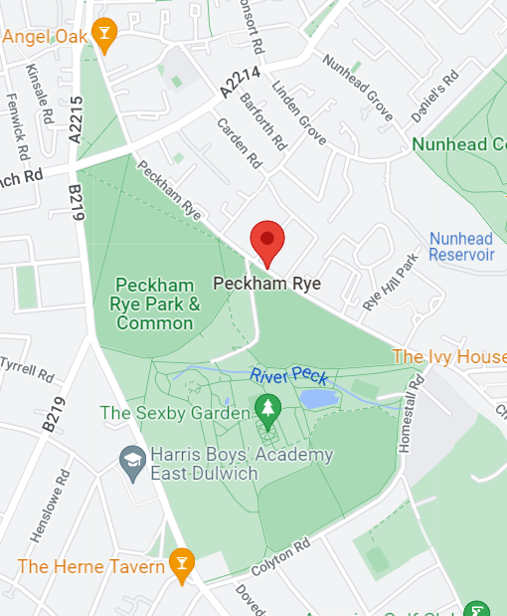

(Purple star denotes the location of the gym within the park)

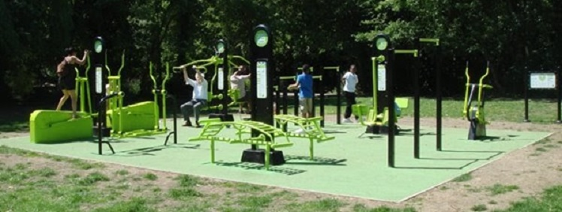
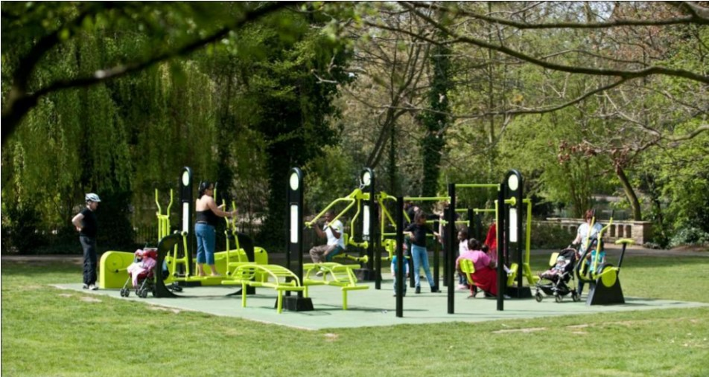

Appendix 2 – Tender Evaluation Methodology

