IT Disaster Recovery Plan
(Redacted SG and SA)

Details: Pendle

Author:

19th September 2018

Contents
1 DR Documentation 4
2 Scope 5
3 Escalation 5
4 Failure of a Liberata IT Data Centre - Actions 5
5 Liberata IT Disaster Recovery Process Model 6
6 Liberata IT Major Incident Team (MIT) 7
7 Liberata IT Major Incident Team (MIT) Agenda 9
8 Designated Incident Management Conference Bridge Numbers / Command Centres 10
9 Staff Incident Helpline 11
10 Liberata IT Service Desk Automated Emergency Messaging 12
11 Liberata IT & Management Staff Contact Details 12
12 Third Party Support Contact Details 14
13 Risks 32

Version Control Front Sheet
Confidentiality Statement

All information contained in this documentation is provided in commercial confidence for the sole use of Liberata UK Limited. The pages of this document shall not be copied published or disclosed wholly or in part to any party without Liberata UK Limited’s prior permission in writing, and shall be held in safe custody. These obligations shall not apply to information, which is published or becomes known legitimately from some source other than Liberata UK Limited.

Copyright © 2018
Liberata UK Limited
Registered office: 5th Floor, Knollys House, 17 Addiscombe Road, Croydon, CR0 6SR

Change History
Version | Date | Author | Change Details / Reason for Change
1.0 |  |  | Draft
1.1 |  |  | Risk register added
1.2 |  |  | PBC DR Solution Changed
1.3 | 15/10/19 |  | Finalise document

Distribution

Version | Date | Author | Distribution List
1.0 | 17/10/2018
1.0 | 17/10/2018
1.1 | 22/10/2018
1.2 | 15/09/2019
1.3 | 15/10/2019

Authorisation

Role | Name | Signature/Reference | Date
Head of IT Operations |  | As per release email | 15/10/19
IT Service Support Manager |  | As per release email
Application Support Manager |  | As per release email

DR Documentation

This Plan and essential Liberata IT Disaster Recovery (DR) documentation is retained at Scope.

1.1 Guidance for invocation of Liberata Disaster Recovery Arrangements in the event of a catastrophic loss/ failure of Liberata IT Data Centres.

Escalation

A Major Incident(s) involving Liberata IT Sites that cause or is likely to endanger personnel / cause serious disruption / loss of service; exceeding the capability to be resolved through standard management arrangements should be immediately escalated as per section 4.0.

Failure of a Liberata IT Data Centre - Actions

If evacuation of the site is necessary all personnel should evacuate the site in accordance with site health safety procedures.

To invoke a Liberata IT Disaster Recovery Response a call needs to be logged with IT Service Desk on 08456033805.

Liberata IT Service Desk shall then escalate details of serious incidents that compromise IT Data Centre(s) to the Service Desk manager (See section 5).

The service desk manager will assess the situation and escalate to the Head of IT Operations, IT Infrastructure Manager and Applications Manager if required.

The service desk manager will assess the situation and escalate to the Major Incident Team (MIT) - Head of IT Operations, IT Infrastructure Manager and Applications Manager if required.

The service desk manager will assess the situation and escalate to the Major Incident Team (MIT) - Head of IT Operations, IT Infrastructure Manager and Applications Manager if required.

The MIT will decide whether to invoke DR see section 5.

Upon making a decision to invoke a Disaster Recovery Response the Liberata IT Head of IT Operations Manager or nominated deputy shall convene an Incident Management Team (pre nominated individuals for this team are specified at section 6.

Figure 1 outlines at a high-level escalation / invocation / management process for implementing a Trustmarque IT Disaster Recovery invocation.

Liberata IT Disaster Recovery Process Model

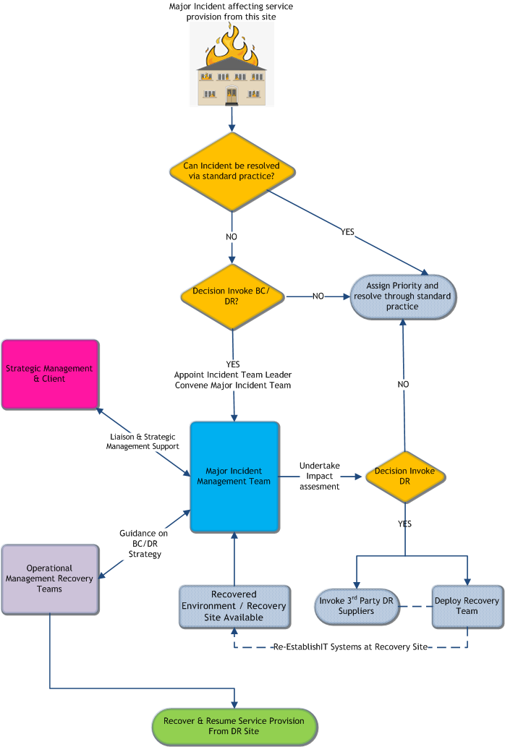

Liberata IT Major Incident Team (MIT)

Membership of the Liberata IT MIT is as follows:

Liberata IT Disaster Recovery Major Incident Team
Role | Name | Contact
Head of IT Operations (MIT Leader)
Infrastructure Manager
Service Desk Manager (Communications)
Applications Manager/Lead
Senior Infrastructure Officer
Business Representative(s)

Upon contacting individuals provide information on the situation and provided details of how / when / where the MIT will convene (see section 6.0).

The table below outlines the composition and responsibilities of the Incident Management Team:

Role | Responsibilities
MIT Leader | - Leads & co-ordinates the Incident Management Team  - Designates Command Centre  - Has overall control over business operations during and after the incident until the situation has returned to normal  - Is the point of contact and provides relevant communication to the Burnley/Pendle / Liberata Senior Management Team(s)  - Appoints / Liaises with the Recovery Team(s).  - Ensures communications to appropriate stakeholders are maintained.  - Debriefs and stands down Incident Management Team at conclusion of incident.
Infrastructure Manager | - Provides an interface / liaison point between MIT & Recovery Management Teams (providing a runner function between both)  - Supports communication between Incident Management Team Leader & Recovery Management Team Leader  - Reports to the MIT on operational progress being made by Recovery Management Teams  - Reports to the Recovery Management Team tactical direction for the response agreed by the MIT  - Acts in a troubleshooting capacity were issues arise and maintains a point of contact for escalations  - Maintains the Command Centre operations for the duration of the incident  - Ensures the process of events is recorded, possibly with assistance from recovery team, to provide detail for Insurance claims and as input into Post Incident Report  - Provides advice concerning externally contracted Disaster Recovery arrangements  - Primary escalation point for operational matters, in the event a situation exceeding operational capabilities (i.e. a DR scenario) the Infrastructure Manager shall escalates details of an incident to the Incident Management Team Leader for a decision on invocation of the DR plan.
Service Desk Manager (Communications) | - Responsible for all internal and communications with the client.  - Updates service desk  - Receives updates from the Infrastructure and/or Applications manager.
Applications Manager/Lead (Recovery Team leader – Apps & DB) | - Co-ordinates the Recovery of Applications (with the Infrastructure Manager)  - Supports communication between Incident Management Team Leader & Recovery Management Team Leader  - Reports to the MIT on operational progress being made by Recovery Management Teams  - Reports to the Recovery Management Team tactical direction for the response agreed by the MIT  - Acts in a troubleshooting capacity were issues arise and maintains a point of contact for escalations  - Provides advice concerning externally contracted Disaster Recovery arrangements  - Secondary escalation point for operational matters, in the event a situation exceeding operational capabilities (i.e. a DR scenario) the Application Manager shall escalates details of an incident to the Incident Management Team Leader for a decision on invocation of the DR plan.
Senior Infrastructure Engineer (Recovery Team leader Infrastructure) | - Implements technical recovery tasks  - Updates the Infrastructure manager with progress  - Escalates any issues to the Infrastructure manager
Business Representative(s) | - Provide feedback on status of their respective business areas staff, any critical deadlines potentially at risk.  - Ensures the Team Leader is kept up-to-date on progress and issues.  - Co-ordinates the activities of the business units and those responsible for recovery.  - Provides feedback to IMT for their units.

Liberata IT Major Incident Team (MIT) Agenda

An outline agenda for use by the Incident Management Team is set below, it outlines what the Incident Management Team must cover and decisions it must arrive at during its first meeting:

Primary Incident Management Team
Agenda

- Incident Log Opened
- Designated Command Centre (see section 8.2)
- Situation Report – current status (standing item)
- Account for staff welfare issues / casualties / fatalities
- Impacts / estimation of outage
- Decision made on Disaster Recovery – Standby > Invoke > Stand-down Third Party Recovery
- Appoint Technical Recovery Team Leader / Team
- Liberata IT Service Desk (Relocation / Automated Emergency Messaging)
- Implement emergency change freeze
- Communications (internal / external / pre-prepared media statements)
- Sustainability of the Incident Management Team / Recovery Teams (personnel interests / commitments / welfare - are people able to participate, implement rotas for protracted incidents)
- Frequency of future meetings
- Time / location of next meeting

Designated Incident Management Conference Bridge Numbers / Command Centres

If convening an Incident Management Team remotely via conference call the following incident bridge numbers have been allocated:

Access Number:

Pin:

Provider: | TMS

If convening the Incident Management Team physically the following sites have been designated as command centres:

Primary Command Centre  (If incident does NOT threaten Liberata IT sites and personnel on site). A decision on most appropriate Liberata IT site to run incident from will be made by the MIT Leader. | Fleet St Depot  Fleet Street  Nelson  Lancashire  BB8 7YQ  Tel: 01282 661199
Alternative Command Centre(s) | Number 1 Market St  Liberata IT 2nd Floor  1 Market Street  Nelson  BB9 7LJ  Tel: 0845 6033805

Staff Incident Helpline

Staff Incident helpline should be updated to provide communications to staff in the event of a major incident significantly affecting IT Services. This can be used to provide updates with advice & guidance to staff / wider business.

Liberata IT Staff Incident Helpline

0845 6033805

Backup Number

01282 477325

Trustmarque Service Desk

0203 735 3122

Liberata IT Service Desk Automated Emergency Messaging

In the event of an incident leading to IT Disaster Recovery situation there will be wide spread IT disruption to client services.

Demand on IT Service desk is likely to significantly increase as clients begin to report disruption. In effort to reduce demand on the IT service desk and provide initial information to end users of the situation and emergency the following message(s) has been pre-recorded and can be invoked:

[Welcome to the Liberata IT Service Desk. Unfortunately we are currently experiencing difficulties and are unable to answer your call at this time. Work is being carried out to remedy this situation. We apologise for any inconvenience this causes. Please call back later].

Delay to answering phones:

[Welcome to the Liberata IT Service Desk. Unfortunately we are currently experiencing difficulties which may result in a delay to answering your call at this time. Work is being carried out to remedy this situation. We apologise for any inconvenience this causes. Please hold and we will answer your call at the earliest time].

Liberata IT & Management Staff Contact Details (redacted)

Name |  | Role | Main office | Mobile / Phone | Email
 | IT Infrastructure Manager |  | Both
 | Senior Infrastructure Engineer |  | Pendle
 | Business Systems CRM & Web Offcer |  | Burnley
 | ICT Service Desk Support |  | Pendle
 | ICT Service Desk Support |  | Both
 | Contract Director |  | Both
 | Application Support & DBA |  | Pendle
 | Business Analyst |  | Both
 | Infrastructure Engineer |  | Pendle
 | Application Support & DBA |  | Pendle
 | Infrastructure Engineer |  | Burnley
 | IT Support Officer |  | Burnley
 | Desktop Support Engineer |  | Pendle
 | Senior IT Support officer |  | Burnley
 | Head Of Operational IT |  | Both
 | Application Support and DBA |  | Burnley
 | Service Desk Manager |  | Both
 | Application Support and DBA |  | Burnley
 | Business Applications Manager |  | Both

Third Party Support Contact Details (redacted)

System | Company | Contact details | Site | Email
Network, Telephony, Linux | Trustmarque |  | Pendle
Telephony, VOIP, Wireless | GCi |  | Burnley
Telephony, Data Circuits | BT |  | Both
Hardware support | CDW |  | Both
DR Hardware | Convenco |  | Pendle
Structured Cabling & P2P Wireless | DB Data Comms |  | Both
Civica Comino | Civica |  | Both
Civica Icon | Civica |  | Both
Civica Financials | Civica |  | Both
BACAS | Clear Skies |  | Pendle
Etarmis | HFX |  | Pendle
Uniform | Idox |  | Both
JADU | Spacecraft |  | Pendle
Xpress | Xpress Software Solutions Ltd |  | Both

Section B

Disaster Recovery Pendle Borough Council

B.1. Pendle Council Disaster Recovery Procedures

B1.1 This section covers specific disaster recovery procedures for incidents affecting Pendle Borough Council.

Pendle Council
1 Market Street
Nelson
BB9 7JA

B1.2 Pendle Council IT services operating out of Pendle 1 Market Street and Pendle Town Hall subscribe to offsite virtual replication to the DR centre situated at the following address:

Fleet St Depot
Fleet St
Nelson
BB8 7YQ

There is no supply of physical hardware required via client specific third party DR contracts.

B.2. Pendle Council Invocation Procedures

B2.1 Collectively the Liberata Major Incident Management team will decide whether to invoke data centre failover procedures.

B2.2 For Pendle Council, the following individuals are authorised to invoke Data Centre Failover / Third Party DR Contracts:

Head of IT Operations
IT Infrastructure Manager
Service Desk Manager

B2.3 Please note: Senior IT infrastructure support engineers are also listed on the third party external DR contracts and can instigate invocation of external DR contracts and internal DR upon a direct request from any member of the Liberata IT Major Incident Team.

B.3. Liberata IT technical recovery team

B3.1 Upon Disaster Recovery Invocation the Liberata Major Incident Team shall appoint Technical Recovery Leads as follows:

Role | Primary Lead | Secondary Lead
IT Technical Recovery Team Coordinator
Infrastructure Lead
Application / DBA Lead
Desktop Lead
Service Desk Lead

B3.2 Technical Recovery Team Leads shall:

- Report/be accountable to ICT Lead on the Incident Management Team (providing regular updates)

- Appoint / resource / rota and deploy IT Technical Recovery Personnel/Team(s) to implement technical recovery of IT systems at recovery sites

- Ensure all scheduled Client / Third party changes are frozen (please refer to the latest forward schedule of change issued)

B3.3 Contact details for Liberata IT employees are available on the Liberata file share and can be provided by the Liberata IT service desk based at Pendle. These are also attached in section 10 above.

B.4. Backup and Replication

B4.1 Back-up media is kept at Fleet St DR site. All system data from 1 Market St is replicated to the Fleet St DR site. This data is replicated to the HPE MSA SAN and also to the Synology NAS drives at this site. Veeam backup and recovery is used to perform all backup and replication operations. A backup server is also located at the DR site at Fleet St. IT Support staff have IT admin laptops which they take home every night. These have the necessary tools/utilities pre-installed to manage the Pendle Council recovery operations. All system documentation is also available on the Liberata network and can be accessed via Liberata devices either via VPN or Liberata network.

All physical server data from 1 Market Street is backed up locally and then to a Synology NAS device situated at Fleet St. Veeam backup and recovery is used to perform all backup operations. A backup server is also located at 1 Market Street. This is a HP ProLiant ML380 G8 running Veeam Backup version 9.5. This has 22TB of local storage, which is used for all initial backup jobs. All system documentation is available on the Liberata UK network.

There is a VCenter server located at the production site only. A full copy of this VM is located at Pendle Town Hall on the Synology NAS device.

The backup strategy documentation below provides details of all the backup jobs that are conducted for Pendle Council. It also details all the recovery points and the recovery source and targets. The Veeam backup and replication management console is hosted on PENPBCBKP001 at 1 Market Street (production site) and can be used for most short term recovery operations.

Pendle Council was previously dependent on tape backups and these were kept offsite via a contracted service with Iron Mountain. This service has been cancelled since the Liberata and Trustmarque split as the service was still geared towards a shared service datacentre recovery in Sheffield. The tape backup server and tape backup units are kept at the 1 Market Street. However, most backup operations now are replication jobs and backup to disk.

B.5. Disaster Recovery of Pendle Council (1 Market St and Town Hall)

B5.1 IT Technical Leads will coordinate and manage recovery in accordance with Technical documentation.

B5.2 There are three major components to be brought into service in the event of a disaster recovery event:

Network

The recovery site for Pendle Council is Fleet St Depot. The site has a 1Gbps point to point circuit terminates at 1 Market St (provided by Storm). This circuit connects to 1 market St for data and Internet break out as well as being used for all backup and replication operations. There is a Trustmarque supported 6MB MPLS link from Fleet St to the Pendle VRF, which provides routing of telephony back to Nelson Town Hall. There is also a separate fibre broadband circuit provided by NSN, which provides separate Internet breakout in case 1 Market St circuit is not available. This is protected by a Cisco Meraki MX series firewall.

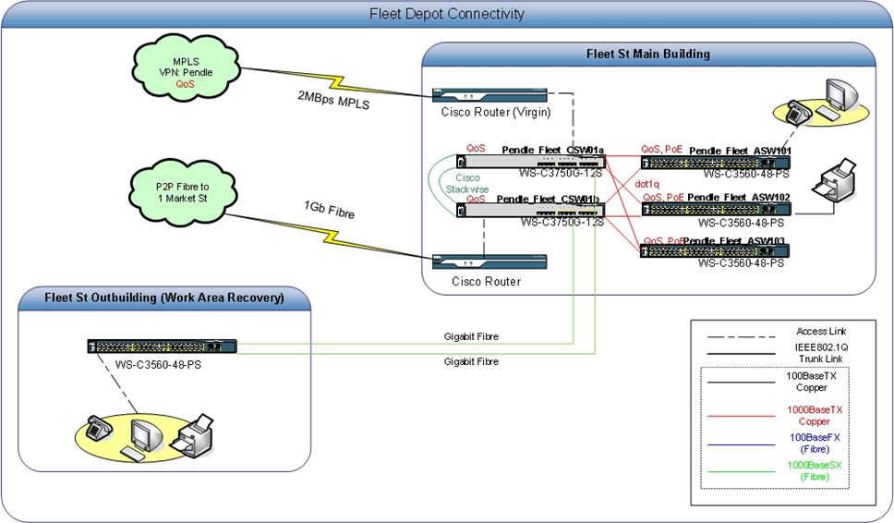

The core switches consist of CSW01a and CSW01b, which provide direct connectivity to the annex building where the work area recovery is to be located. The SAN and server infrastructure is connected to FLEET_DRSW01 and FLEET_DRSW02 switches. Server VLAN’s presented on these switches are VLAN 4, 21 and 31. The iScsi network 1 and 2 for the SAN, Esx hosts and Synology NAS are also presented on these switches.

In the work area recovery area (Annex building) there is a Cisco Catalyst C3560 48 Port POE access switch, which links back to the main Comms room via fibre. The site already has a server and storage (iscsi) VLan’s established. Data network is also available at the site. This means that the core network infrastructure is already present at the site. Although there is a data and printer Vlan present at this site to accommodate work areas recovery, the Council has not yet defined how many workstations and phones are required.

Storage

All VSphere and Hyper-V virtual servers are replicated between the 1 Market St and Fleet St data centres, from each customer’s primary site to their secondary site. There is a HP EVA SAN (usable capacity 24TB) at the production site that hosts all the VM’s. These VM’s are replicated to a 20TB HP MSA SAN at Fleet St. All physical servers are backed up between 1 Market Street and Pendle Town Hall. Initially these backups are dropped to locally attached storage on the backup server, which is a (25TB). All the locally backed up VM’s from the 1 Market St are then also backed up to the Synology NAS device at Pendle Town Hall. These are currently in the process of being moved to the Fleet St Depot, where there is a Synology NAS RS815+ device at the secondary site for all backup jobs which is 21TB in size.

Upon declaration of a disaster:

- Any running virtual machines in the primary location will be shutdown, if accessible. This prevents more than one instance running should the primary location suddenly be restored to service. If a failover plan is in operation this process will be automated.

- The backup process for each customer’s data store will be disabled. This prevents conflicts should the primary location be restored to service.

- Veeam Failover plan(s) will be instigated if available.

- Please see section B6 which discusses replica failover in more detail.

Compute

Compute exists in each data centre as a pool resource. Compute resource has been scaled to size of environment and what critical operations/services need to be available over a short period of time until the production site is fully recovered.

- Each virtual machine exists in primary and secondary locations. The secondary locations customer virtual machines will then be started from the previously replicated storage snapshot using Veeam. Start-up order will be defined against individual VM’s and systems.

- Please see section B6 which discusses replica failover in more detail.

B5.3 The following key systems will be recovered in order and priority will be given to critical systems as per the annual BIA assessment for Pendle. This document is available on the Liberata network file share.

i. Network
ii. Active directory (Including Azure AD connect – (However dependent on Internet breakout)
iii. DHCP, DNS servers
iv. Messaging (This is on O365 cloud so any local dependent servers e.g. Hybrid will be recovered)
v. Databases
vi. Application servers
vii. File servers
viii. Print facility

B.6. Veeam Failover to Recovery Site (Fleet St Depot)

B6.1 If a VM becomes unavailable or fails in case of a disaster, you can fail over to a VM replica and quickly restore services in the production environment. When you perform failover, the VM replica takes over the role of the original VM. As a result, you have your VM up and running within a few minutes, and users can access services and applications they need with minimal disruption.

Physical servers will be recovered from the Synology NAS backup device (PENPBCNAS002).

Logon to backupserver (Fleet St) and launch Veeam backup & replication management console. Use the VMware Failover wizard to fail over the VM replica.

• Launch the Failover wizard
• Select VMs and restore points
• Specify a failover reason
• Review summary and finish working with the wizard

There is also an AD and DHCP failover plan created on the Veeam backup & replication console, which can be instigated and will restore the VM replica’s in order of priority. This takes into account the time delays required for dependent servers. Following this an assessment can be made to ascertain, which applications need to be re-instated as priorities will have changed following the previous BIA assessments. Please see the service area recovery timetable in section B7, which has been put together following BIA.

B.7. Recovery Timetable

B7.1 The recovery timetable is based on the latest Business Impact Analysis (BIA) that was done with Pendle Council in 2013. These systems underpinning these service areas will only be recovered once the core IT infrastructure discussed in section A5 is fully operational.

The business representative listed in section 6 will provide guidance as to which systems need to be recovered in order of priority.

Liberata commissioned Trustmarque to carry out the BIA for Pendle Council in 2013 and the results of that analysis is listed below.

“Based on recovery time objectives service areas have determined during the BIA a recovery order for service activities has been collated below. The Recovery Time Objective provides an indication of the time frame within which the service function needs to be operational within (this could be at a reduced level of service initially).”

Priority | Team / Business Unit | Service / Activity | Systems | RTO
1 | Housing Needs (Homelessness) | Homeless people needing to contact the council / people sleeping rough needing urgent assistance (reliance on telephony) | Civica APP (Flare)  Civica Authority Financials  Microsoft Office (Email) | 4 Hrs
1 | Environmental Protection | Public health Issues or issues that present public health threat. | Civica Comino  Microsoft Office (Email)  Idox | 24 Hrs
1 | Treasury Management | Management of cash flow including loan debt, payments etc. Dependency on whether needing to contract. Dr Fund. | Civica Authority Financials  Civica Icon  Sage 50  Microsoft office | 24 Hrs
1 | Environment & Recreation Services (Operations) | Domestic Refuse Services (includes recycling). Commercial Waste Collections. Street Cleansing and Gritting. | Civica APP  GGP GIS Mapping  Microsoft Office  Citrix  Idox | 24 Hrs
1 | Bereavement Services | Muslim Burials within 1 days and burials with 3 days | Telephony | 24 Hrs
1 | Housing Standards & Improvements | Illegal eviction / needs for housing requirements e.g. loss of heating etc. | Civica APP (Flare)  Civica Authority Financial  Microsoft Office (Email) | 24 Hrs
2 | Communications | Marketing, Graphics, website publishing. Any major issues or public relation requirements for the council | Internet (Access to JADU / Vuello)  Civica Comino  Intranet PBC  MS Office | 48 Hrs
2 | Economic Development & Tourism | Funding bids against submissions | Civica APP  Civica Authority Financial  Microsoft Office | 3 Days
2 | Housing Improvement Team | Housing | Civica APP  Civica Authority Financial  Microsoft Office | 3 Days
2 | Building Control | Dangerous buildings inspections would be immediate (but no requirement for office space, although requirement for structural engineer on call – mobile working) | Map Info  Newhart XAssist (back office system linked to Comino)  Comino  Limehouse  Planning Portal  Submit a Plan  MS Office  Idox | 7 Days
2 | Food Health & Safety | Infectious diseases outbreaks need health and safety accidents in work immediate attention, reports of serious food safety breach require immediate attention | Civica Comino  Civica APP  MS Office | 7 Days
2 | Parks & Recreation | Community Halls  Landscape Maintenance  Parks outreach  Parks development Officer | Civica Financials  MS Office (Email) | 7 Days
2 | Environmental crime | Environmental crime | Civica APP  GGP GIS Mapping  Microsoft Office  Citrix  Idox | 7 Days
2 | Audit & Performance | Client Unit - Mandatory 10 percent checks on Liberata Revs and Bens (statutory function)  Performance of the Liberata Contract  Internal Audit / for Liberata / Council  Performance of Council Services | MS Office  Access all IT systems provided by Liberata  Internet  IWorld  Comino  Covalent | 7 Days
3 | Planning | Development Management Function & Enforcement  Conservation and Tree Service  Forward Planning Function | Map Info  Newhart XAssist (back office system linked to Comino)  Comino  Limehouse  Planning Portal  Submit a Plan  MS Office (Email)  Idox  Internet Access | + 2 Weeks
3 | Democratic & Legal Services | Land Charges  licensing apart from Taxis  Democratic Services - Committee Admin, Elections and General Office  Mayoralty and Caretakers  Print Unit  Legal Services | Xpress (Elections System)  Swift  LALPAC | + 2 Weeks

B.7. Work Area Recovery

The work area recovery site for Pendle Council is currently Fleet St Depot Annex Building. There are desks and network infrastructure in place at this location, however, no end user devices have been allocated yet. This is due to the Council wanting to identify key users for a BC/DR scenario and issues these staff with laptops and mobile phones that the staff take home each day and can be used in an event of a BC/DR event. This list is still yet to be provided of key users and devices required.

Risks
IT Risk Register
Likelihood |  |  |  |  |  |  | Impact |  | Severity (L*I)
1 | 0-20% |  |  |  |  |  | 1 | Negligible | 1-8 = Monitor
2 | 21-40% |  |  |  |  |  | 2 | Minor | 9-18 = Mitigate
3 | 41-60% |  |  |  |  |  | 3 | Important | 19+ = Correct
4 | 61-80% |  |  |  |  |  | 4 | Significant
5 | 81-100% |  |  |  |  |  | 5 | Major
Date Raised | Risk Category | Risk Description | Owner | Status | Likelihood | Impact | Severity | Action Plan | Action Owner
 | Operational | No Internet breakout at DR site | Burnley | Open | 5 | 4 | 20 | The Council has accepted this risk. | Rob Dobson
 | Operational | No Telephony breakout at DR Site | Burnley | Open | 5 | 5 | 25 | The Council has accepted this risk. Previously discussed diverting calls to mobiles. | Rob Dobson
 | Operational | DR site is too close to the Production site. | Burnley | Open | 1 | 5 | 5 | The Council has accepted this risk. | Rob Dobson
 | Operational | No work area recovery defined. | Burnley | Open | 4 | 3 | 12 | The Council has accepted this risk. | Rob Dobson
 | Operational | No Telephony breakout at DR site | Pendle | Open | 5 | 5 | 25 | TBC | TMS/PBC
 | Operational | DR Site access | Pendle | Open | 3 | 4 | 12 | Site access is currently only via the client. | PBC
 | Operational | No Veeam replication only backup for physical servers. RTO longer. | Pendle | Open | 4 | 5 | 20 | Virtualise physical servers where possible. | Ali Akram
 | Operational | Work area recovery devices not clearly defined | Pendle | Open | 5 | 4 | 20 | Awaiting updated information from Council regards what is required for work area recovery. | Shane Agnew

